

INSTRUCTIONS AND WARRANTY

MODEL NO. 14572-57

DESCRIPTION: 2 Slice Allure Toaster

Congratulations on purchasing our 2 Slice Allure Toaster. Each unit is manufactured to ensure safety and reliability. Before using this appliance for the first time, please read the instruction manual carefully and keep it for future reference.

FEATURES OF THE ALLURE TOASTER

IMPORTANT SAFEGUARDS
When using any electrical appliance, basic safety precautions should always be followed including the following:
- Please read the instructions carefully before using any appliance.
- Always ensure that the voltage on the rating label corresponds to the mains voltage in your home.
- Incorrect operation and improper use can damage the toaster and cause injury to the user.
- The toaster is intended for household use only. Commercial use invalids the warranty and the supplier can not be held responsible for injury or damage caused when using the appliance for any other purpose than that intended.
- Avoid any contact with moving parts.
- This toaster is not intended for use by persons (including children) with reduced physical, sensory or mental capabilities, or lack of experience and knowledge, unless they have been given supervision or instruction concerning use of the appliance by a person responsible for their safety.
- Children should be supervised to ensure that they do not play with the toaster.
- Check the power cord and plug regularly for any damage. If the cord or the plug is damaged, it must be replaced by the manufacturer or a qualified person in order to avoid an electrical hazard.
- Do not use the toaster if it has been dropped or damaged in any way. In case of damage, take the unit in for examination and/or repair by an authorised service agent.
- To reduce the risk of electric shock, do not immerse or expose the motor assembly, plug or the power cord to water or any other liquid.
- Never immerse the unit in water or any other liquid for cleaning purposes.
- Do not put the appliance in liquid; do not use it in a bathroom, near water, or outdoors.
- Remove the plug from the socket by gripping the plug. Do not pull on the cord to disconnect the toasters from the mains. Always unplug the unit when not in use, before cleaning or when adding or removing parts.
- The use of accessory attachments that are not recommended or supplied by the manufacturer may result in injuries, fire or electric shock.
- A short cord is provided to reduce the hazards resulting from becoming entangled in or tripping over a longer cord.
- Do not let the cord hang over the edge of a table or counter. Ensure that the cord is not in a position where it can be pulled on inadvertently.
- Do not allow the cord to touch hot surfaces and do not place on or near a hot gas or electric burner or in a heated oven.
- When using a single toasting slot, do not let anything get into the other slot, as both slots will be “live” when the lever is lowered.
- Do not use the toaster near or below curtains or other combustible materials.
- Be careful when touching the areas around the toasting slots as they can get very hot.
- Do not cover the toaster or put anything on top of it.
- If the bread gets jammed, unplug the toaster, let it cool, and carefully remove the bread. Do not use any sharp metals, you could damage the elements.
- Do not toast “buttered” items, it may cause a fire.
- Do not use torn, curled, or misshapen bread, you may jam the toaster.
- Do not use the toaster on a gas or electric cooking top or over or near an open flame.
- To avoid a fire, a build up of crumbs and to remain hygienic, clean the crumbs out of your toaster frequently.
- Do not use the toaster unless the crumb tray is fitted and closed.
- Use of an extension cord with this toaster is not recommended. However, if it is necessary to use an extension lead, ensure that the lead is suited to the power consumption of the toaster to avoid overheating of the extension cord, appliance or plug point. Do not place the extension cord in a position where it can be pulled on by children or animals or tripped over.
- This toaster is not suitable for outdoor use. Do not use this appliance for anything other than its intended use.
- DO NOT carry the toaster by the power cord.
- Do not leave this toaster unattended during use. Always unplug the unit when not in use or before cleaning.
- Always operate the toaster on a smooth, even, stable surface. Do not place the unit on a hot surface.
- Ensure that the switch is in the “Off” position after each use.
- The manufacturer does not accept responsibility for any damage or injury caused by improper or incorrect use, or for repairs carried out by unauthorised personnel.
- In case of technical problems, switch off the machine and do not attempt to repair it yourself. Return the toaster to an authorised service facility for examination, adjustment or repair. Always insist on the use of original spare parts. Failure to comply with the above mentioned pre-cautions and instructions, could affect the safe operation of this machine.

PARTS DIAGRAM

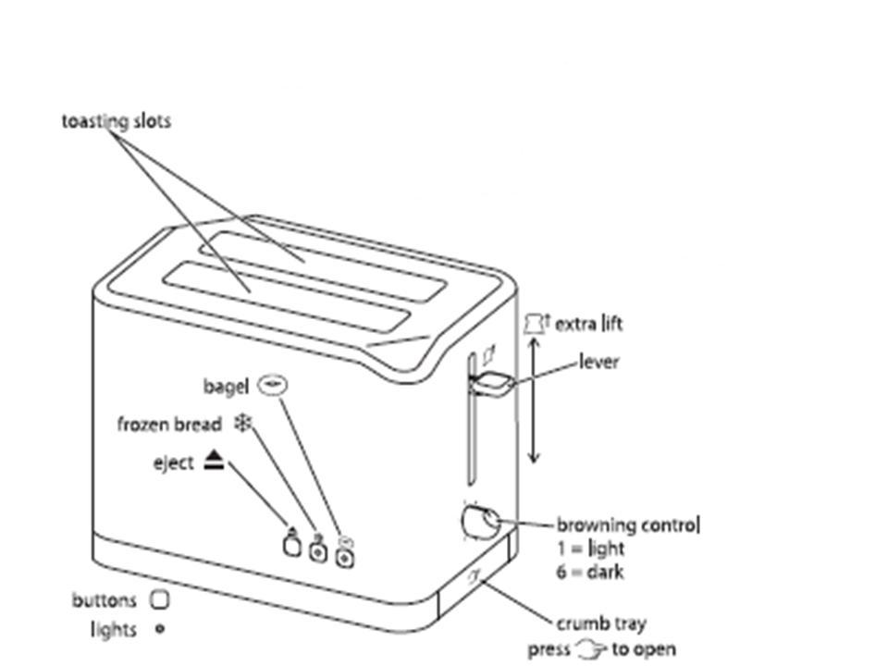

OPERATING INSTRUCTIONS
Before using for the first time
- Place the toaster upright on a firm, level, heat-resistant surface.
- Insert the plug into the main socket.
- Set the browning level to maximum (6).
- Operate the appliance empty, to cure the new elements.
- This may give off a smell, but it is nothing to worry about. Ensure the room is well ventilated.
Toasting Bread
- Turn the browning control to the required setting (1=light, 6=dark).
- Insert the bread into the toasting slots (maximum thickness 28mm).
- Press the lever down fully.
- It will not lock down unless the toaster is connected to the electricity supply.
- Once the toast is done, it will pop up and the elements will turn off.
- To stop toasting, press the button. The toast will pop up, and the elements will turn off.
Extra lift
- After toasting small items (bagels, crumpets, etc) the lever may be raised further, to allow them to be removed easier.
Frozen bread
- This feature takes the guesswork out of toasting frozen bread.
- Leave the browning control at your favoured setting, insert the frozen bread, and lower the lever, then press the button.
- The light will come on, and the toasting time will be altered automatically to give the same degree of browning you get with unfrozen bread.
Caution: Do not try to defrost bread-this may damage the toaster, it may even cause injury.
- Toasting frozen bread changes ice to steam, which escapes via the toasting slots
- Defrosting bread on a low setting changes ice to water, which may drip over the electronics and the elements

Bagel
- Only the brown outside surfaces of bagels should be toasted, the soft inner surfaces shouldn’t be browned.
- Split your bagel and put the two halves into the slots with the brown outsides facing the centre elements.
- Leave the browning control at your favoured setting, lower the lever, then press thebutton. This heats only the centre elements.
- Thelight will glow, the brown outsides of the bagel will be toasted, and the cut sides will be warmed.
Reheating toast
- Use the lowest setting. Only reheat plain, “unbuttered” toast.
Hints and tips
- If toasting more than one slice, use slices of similar size, thickness and freshness.
- Old (yesterday’s) bread contains less moisture, so makes crisper toast.
- Old or thin bread cooks faster than fresh or thick bread. Use a lower setting.
- Sweet bread products (tea cakes, fruit loaf, etc) brown much more quickly than ordinary bread, so should be toasted on a lighter setting.
Crumbs
- Clean the crumbs out of your toaster frequently, to avoid a build up of crumbs. This is unhygienic and could cause a fire hazard.
- Unplug the toaster and let it cool down.
- Press and release the crumb tray to unlock it.
- Remove and empty the crumb tray.
- Wipe with a damp cloth, dry, then replace it in the toaster.
- Don’t use the toaster unless the crumb tray is fitted and closed.

CLEANING AND MAINTENANCE
- This toaster is for household use only and is not user-serviceable.
- Do not open or change any parts by yourself. Please refer to a qualified electrical service department or return to the supplier if servicing is necessary.
- Always remember to unplug the unit from the electrical outlet when not in use and before cleaning. Ensure that the speed control is set to “0”.
- The body of the toaster should be cleaned with a damp cloth. Do not let water enter the toaster.
- Do not use bleach or other abrasive substance or solvents to clean your appliance as it can be damaging to the finish.
- Do not immerse the toaster in water or any other liquid, or hold it under a running tap to clean.
- To remove stubborn spots/marks, wipe the surfaces with a cloth slightly dampened in soapy water or mild non-abrasive cleaner. Rinse and dry a clean, dry, soft cloth.

STORING THE APPLIANCE
- Unplug the unit from the wall outlet and clean all the parts as instructed above. Ensure that all parts are dry before storing.
- Store the toaster in its box or in a clean, dry place.
- Never store the toaster while it is still wet or dirty.
- Never wrap the power cord around the appliance.

SERVICING THE APPLIANCE
There are no user serviceable parts in this appliance. If the unit is not operating correctly, please check the following:
- You have followed the instructions correctly
- That the unit has been wired correctly and that the wall socket is switched on.
- That the mains power supply is ON.
- That the plug is firmly in the mains socket.

If the appliance still does not work after checking the above:
- Consult the retailer for possible repair or replacement. If the retailer fails to resolve the problem and you need to return the appliance, make sure that:
- The unit is packed carefully back into its original packaging.
- Proof of purchase is attached.
- A reason is provided for why it is being returned.

If the supply cord is damaged, it must be replaced by the manufacturer or an authorised service agent, in order to avoid any hazard. If service becomes necessary within the warranty period, the appliance should be returned to an approved Amalgamated Appliance Holdings Limited service centre. Servicing outside the warranty period is still available, but will, however, be chargeable.

CHANGING THE PLUG

Should the need arise to change the fitted plug, follow the instructions below.
This unit is designed to operate on the stated current only. Connecting to other power sources may damage the appliance. Connect a three-pin plug as follows:
The wires in this mains lead are coloured in accordance with the following code:
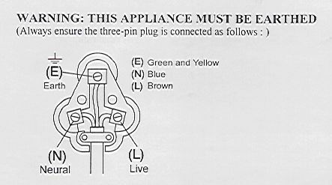
Green/Yellow = Earth
Blue = Neutral
Brown = Live

PLEASE AFFIX YOUR PROOF OF PURCHASE/RECEIPT HERE
IN THE EVENT OF A CLAIM UNDER WARRANTY THIS RECEIPT MUST BE PRODUCED.

W A R R A N T Y

Amalgamated Apliance Holdings Limited (“the Supplier”) warrants to the original purchaser of this product (“the Customer”) that this product will be free of defects in material and workmanship which under normal, personal, family or household purpose manifest themselves within a period of 365 days from the date of purchase or in respect of commercial or professional purposes, manifest themselves within a period of 90 days from the date of purchase. Any claim in terms of the warranty must be supported by a proof of purchase. If such proof is not available, then notwithstanding anything to the contrary herein, the Supplier’s normal charge for service and/or spares will be payable by the Customer upon collection of the repaired product. If a claim is made in terms of the aforesaid warranty within the first 7 days from the date of purchase, the faulty product will be exchanged (provided that the product is in its original packaging with all accessories). Failing return of the product within 7 days, the Supplier’s liability shall be limited on return to the Supplier of the product or parts thereof, to the replacement or repair (in the sole discretion of the Supplier, or its duly authorised service dealer) of the product to eliminate any defect in workmanship or materials found to be due exclusively to any acts or omissions on the parts of the Suppliers, of which defects the Supplier shall have been notified in writing by the Customer within the aforesaid warranty period. The warranty provided herein and the obligations of the Supplier as aforesaid are in lieu of, and the Customer waives, all other warranties, guarantees, conditions or liabilities, express or implied, arising by law or otherwise, including without limitation, any obligation of the Supplier in respect of any injury, loss or damage (direct, indirect or consequential) arising out of the use of, or inability to use, this product and whether or not occasioned by the Supplier’s negligence (gross or otherwise) or any act or omission on its part. The warranty does not include and will not be construed to cover products damaged as a result of disaster, misuse, abuse or any non-authorised modification of the product. The warranty does not include replacement of light bulbs, heater bars, paper bags or any glass, plastic bowl or jug or other expendables. During the warranty period the product should be taken to a service centre of the Supplier or one of its duly authorised service agents. The Supplier neither assumes nor authorises any other person to assume for it, any additional liability in connection with the sale or servicing of its products.

AMALGAMATED APPLIANCE HOLDINGS (PTY) LTD

JOHANNESBURG TEL NO. (011) 490-9000
29 HERONMERE ROAD
P O BOX 39186
BOOYSENS, JOHANNESBURG, 2016

CAPE TOWN TEL NO. (021) 535-0600

DURBAN TEL NO. (031) 792-6000

