

INSTRUCTIONS AND WARRANTY

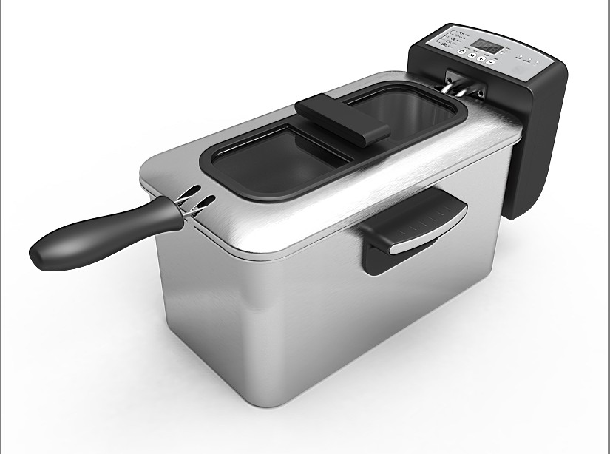

MODEL NO. RDF300

RUSSELL HOBBS 3.0L DIGITAL DEEP FRYER

Congratulations on purchasing our Russell Hobbs 3.0L Digital Deep Fryer. Each unit is manufactured to ensure safety and reliability. Before using this appliance for the first time, please read the instruction manual carefully and keep it for future reference.

FEATURES OF THE RUSSELL HOBBS 3.0L DIGITAL DEEP FRYER

- 3.0 Litre Oil Capacity
- Digital LED display
- Dishwasher safe cooking basket and enamel cooking pot
- Stylish black and stainless steel finish
- XL viewing window
- Fully programmable (temperature and time)
- Temperature can be set between 110℃ and 190℃
- Disassembles fully for easy cleaning
- Overheat protection technology
- Convenient cord storage
- Immersion heating element makes direct contact with oil for ultra-fast heating
- Cooking guide on front panel
- 2000W
- For domestic use only

TECHNICAL SPECIFICATIONS

Rated Voltage: 220-240V
Rated Frequency: 50/60Hz
Rated Power: 1830-2180W

IMPORTANT SAFEGUARDS

When using any electrical appliance, basic safety precautions should always be followed including the following:

- Please read the instructions carefully before using any appliance.
- Always ensure that the voltage on the rating label corresponds to the mains voltage in your home.
- Incorrect operation and improper use can damage the appliance and cause injury to the user.
- The appliance is intended for household use only. Commercial use invalids the warranty and the supplier cannot be held responsible for injury or damage caused when using the appliance for any other purpose than that intended.
- Avoid any contact with moving parts.
- This appliance is not intended for use by persons (including children) with reduced physical, sensory or mental capabilities, or lack of experience and knowledge, unless they have been given supervision or instruction concerning use of the appliance by a person responsible for their safety.
- Children should be supervised to ensure that they do not play with the appliance.
- Check the power cord and plug regularly for any damage. If the cord or the plug is damaged, the manufacturer or a qualified person must replace it in order to avoid an electrical hazard.
- Do not allow this appliance to touch curtains, wall coverings, clothing, dishtowels or other flammable materials during use. Caution is required on surfaces where heat may cause damage -an insulated heat pad is recommended. Never place the appliance on a plastic, fabric or carpeted surface while cooking.
- The appliance is not intended to be operated by means of an external timer or separate remote-control system.
- Do not touch hot surfaces – use handles.
- Always lift the lid away from your face as escaping steam or oil may cause injury or scalding.
- Keep hands, arms, face etc clear from the escaping steam or oil when opening the lid.
- DO NOT place the product near flammable materials.
- Let the deep fryer cool down completely before you clean it or put it away.
- Extreme caution must be used when moving a deep fryer containing hot liquids. It is recommended that you do not move the appliance when it is full, when switched on or before it has cooled down.
- Do not use the appliance if it has been dropped or damaged in any way. In case of damage, take the unit in for examination and/or repair by an authorised service agent.
- Do not use harsh abrasives, caustic cleaners or oven cleaners when cleaning this appliance.
- To reduce the risk of electric shock, do not immerse or expose the appliance, plug or the power cord to water or any other liquid.
- Never immerse the unit in water or any other liquid for cleaning purposes.
- The appliance cannot be partially or fully immersed in water for cleaning.
- Remove the plug from the socket by gripping the plug. Do not pull on the cord to disconnect the appliance from the mains. Always unplug the unit when not in use, before cleaning or when adding or removing parts.
- The use of accessory attachments that are not recommended or supplied by the manufacturer may result in injuries, fire or electric shock.
- A short cord is provided to reduce the hazards resulting from becoming entangled in or tripping over a longer cord.
- Do not let the cord hang over the edge of a table or counter. Ensure that the cord is not in a position where it can be pulled on inadvertently.
- Do not allow the cord to touch hot surfaces and do not place on or near a hot gas or electric burner or in a heated oven.
- Do not use the appliance on a gas or electric cooking top or over or near an open flame.
- Use of an extension cord with the appliance is not recommended. However, if it is necessary to use an extension lead, ensure that the lead is suited to the power consumption of the appliance to avoid overheating of the extension cord, appliance or plug point. Do not place the extension cord in a position where it can be pulled on by children or animals, or tripped over.
- This appliance is not suitable for outdoor use. For household use only. Do not use this appliance for anything other than its intended use.
- DO NOT carry the appliance by the power cord.
- Do not leave the appliance unattended during use. Always unplug the unit when not in use or before cleaning.
- Always operate the appliance on a smooth, even, stable surface. Do not place the unit on a hot surface.
- Ensure that the switch is in the “Off” or “O” position after each use.
- Do not let the deep fryer heat without oil in it, or with the oil below the Min level. This will cause the thermal cut-off to switch the unit off, and may damage the unit.
- Do not connect the deep fryer to the power supply without oil in the unit.The manufacturer does not accept responsibility for any damage or injury caused by improper or incorrect use, or for repairs carried out by unauthorised personnel.
- In case of technical problems, switch off the machine and do not attempt to repair it yourself. Return the appliance to an authorised service facility for examination, adjustment or repair. Always insist on the use of original spare parts. Failure to comply with the above mentioned pre-cautions and instructions, could affect the safe operation of this machine.

PARTS DIAGRAM

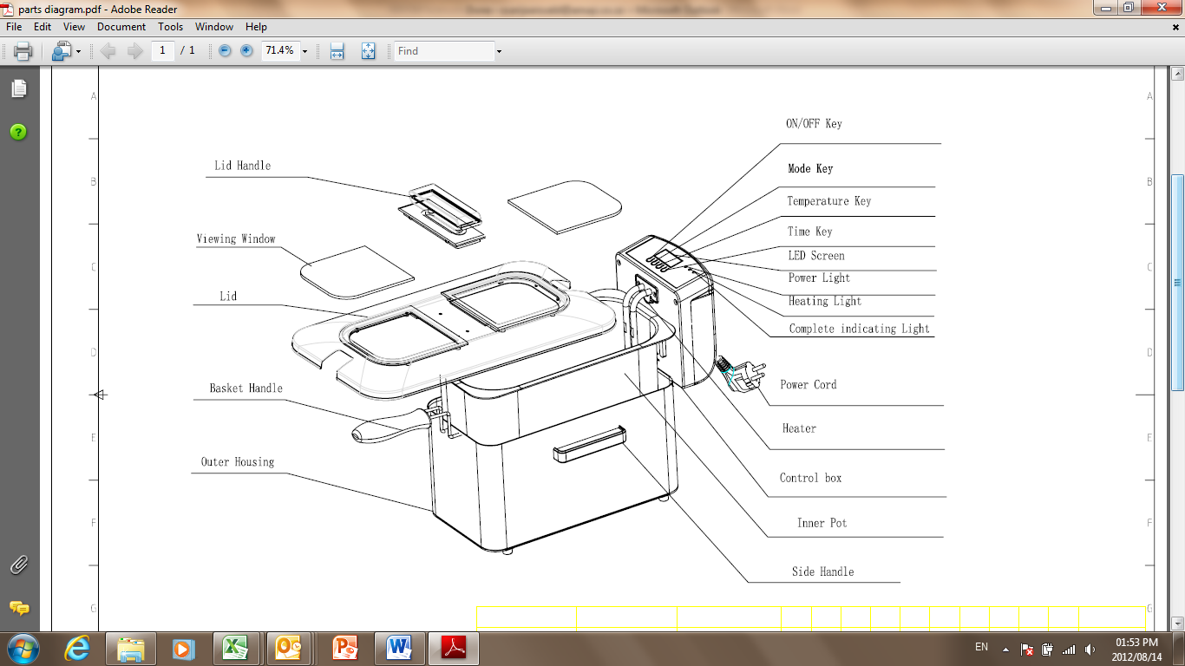

Display Guide
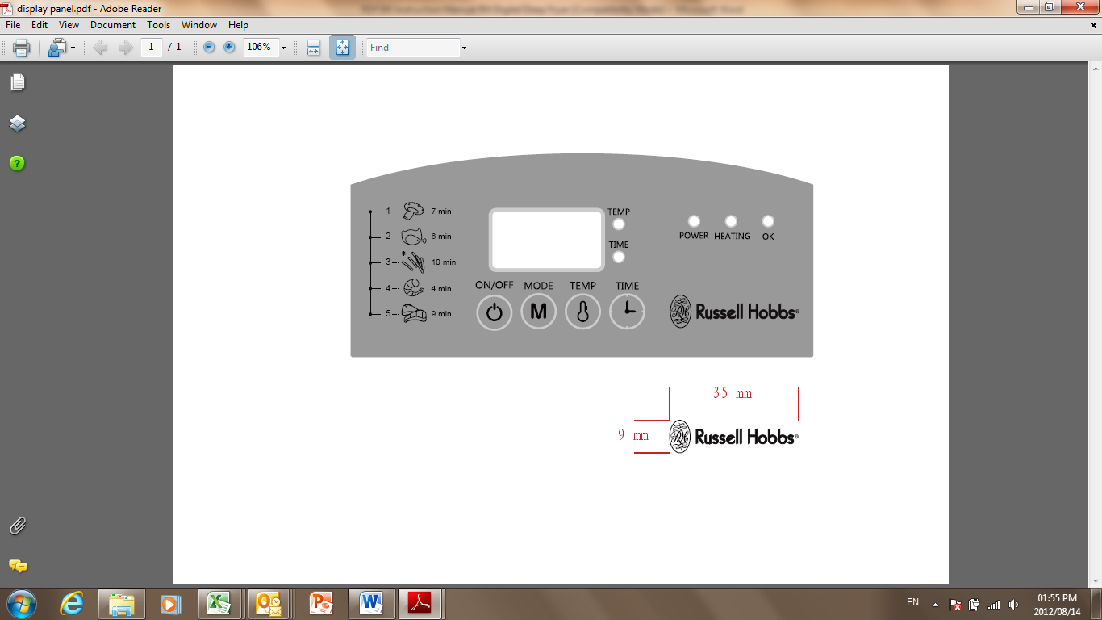
1. Standby Mode:
The deep fryer will emit a single “beep” for 1s. Here the green power light will come on and the display will show “-1-”.

2. Selecting Modes:
Note: Each mode has a matching preset time and temperature, please check the section “Preset Time and Temperature”.
Press the “Mode” button whilst in standby mode to make a mode selection. The display will show “-1- to -5-“. Press it again and the display will show “-1-“.
Press the “Temp” button in standby mode. Here the display will show the preset temperature and the corresponding red temp indicator light will turn on. Press the “Temp” button once to increase the temperature by 5℃. Use the “Temp” button to adjust the temperature from 110℃ to 190℃. When the temperature selection reaches 190℃, press the “Temp” button again and the temperature will revert back to 110℃.
Press the “Time” button whilst in standby mode and the display will show the preset time. Here the corresponding red time indicator light will turn on. Press the “Time” button once to increase the time by 1min. Use the “Time” button to adjust the time from 1min to 99min. When the time selection reaches 99min, press the button again and it will revert back to 1min.
Display format: NNX (N refers to min, X refers to no display). For example, 10X implies 10 minutes. If you hold the “Time” button in for a longer period you will notice that the time selection will increase quickly.
Throughout the process, the digital display will show 0.5s which means the appliance is in operation. 0.5s will flash on the display indicating that it has stopped operation.

3. Heating Mode
After selecting your chosen mode, press the ON/OFF button and the display will show the current oil temperature. Here the green power light and the yellow HEATING indicator light will turn on. The deep fryer now begins the heating process.

During the heating process, press the “Mode” button. Notice that there is no change on the display or the setting. Press the “Time” button and the display will show the preset time. Press the “Temp” button to show the preset temperature. Note: the display will show the current temperature for 5s without you having to press any button.
During this process, the green power light and the yellow heating light will continue to glow and the display will not flash.

4. Waiting Mode
Once the oil reaches the preset temperature then the deep fryer will “beep” (0.3s, stop 0.3s). The display will now show the current temperature.
Should the deep fryer be left without any selection for 1min then it will automatically switch to standby mode.

5. Frying Mode
After entering waiting mode, press the “ON/OFF” button. The deep fryer will stop its “beeping”. During this time, the display will show the preset time. The red OK light will glow. The time display format: NNX or Nnn (N refers to the remaining minutes,
N refers to the remaining seconds, X refers to no display). Time precision requirements ±3%.
During the frying process, press the “Time” button and the display will show the preset time. Here the red time light will glow. Press the “Temp” button and the display will show the preset temperature. Should the deep fryer be left without any selection for 1min then it will automatically switch to the current temperature.
Once the fryer reaches the required preset temperature, the heating element will switch off. If the oil temperature drops, the element will automatically turn on once again reach the required preset temperature. E.g. This may occur when adding food preparation to the cooking oil. At this time, the display will show the countdown timer.
Once the deep fryer has reached the end of its preset time, it will emit ten “beeps” (beep 2s, stop 1s). It will stop heating up and the red OK light will turn off. The display will show the last set state and switch to setting mode.
Press the “ON/OFF” button when the fryer is working and the deep fryer will stop the heating process. The display will show the default code and switch to setting mode.

Mode Preset Time and Temperature
MODE | TEMP（°C） | TIME（min）
1 | 150 | 5
2 | 160 | 6
3 | 170 | 10
4 | 180 | 4
5 | 190 | 6

OPERATING INSTRUCTIONS

NOTE: Do not use this product to heat water. Never plug the control panel into a wall
socket if it is not installed in the outer housing.
- Clean the unit thoroughly before using for the first time.
- Place the deep fryer on a dry, stable surface.
- Remove the lid from the deep fryer and take out the accessories.
- Fill the deep fryer with the required amount of oil or fat. The level of oil or fat should be above the minimum mark and below the maximum mark. Do not mix different kinds of oil and/ or fat.
- Select the temperature, as per the food you are cooking. The cooking temperature guide on the control panel and the table below can be used for guidelines. Wait for the selected temperature to be reached, the ‘Heating’ light will go off when the temperature is reached.
- Place the food for frying in the basket, and slowly lower the basket into the deep fryer. It is best to use dry foods, as moist foods will make the oil splash out of the deep fryer, which is hazardous.
- Place the basket into the deep fryer using the handle only. The deep fryer will maintain the selected temperature, and thus the ‘Heating’ light will go on and off as the product reheats the oil.
- When the correct frying time has elapsed, slowly raise the basket out of the deep fryer, allowing excess oil to drain off the food.

FRYING TEMPERATURE GUIDE

TYPE OF FOOD | FRYING TEMPERATURE (ºC)
Cheese croquettes | 170
Cheese fritters | 180
Chicken | 160
Doughnuts | 190
Fish | 170
Fish sticks | 180
Fondue parmesan | 170
Meat croquettes | 190
Meat/fish/potato croquettes | 190
Potato chips | 190
Pre-fry chips | 170
Scampi fritters | 180

FRYING TIPS
- Use a maximum of 200grams of food per each litre of oil.
- With frozen products, use only 100grams of food per each litre of oil, as the food will cool the oil. Always remove excess ice from frozen foods before frying.
- Oil or fat can be reused after deep frying. Drain the oil to remove any food particles and store in an airtight container. When the oil starts to discolour and turn brown, it is time to throw it away and use fresh oil. The oil can last up to 10 uses, depending on the type and quality of oil.
- Do not mix old and new oil.

CLEANING AND MAINTENANCE
- Remove the electrical plug from the outlet.
- Ensure that the temperature selection is set to “0ff”, and that all oil or fat has been poured out of the unit.
- Gently lift the basket, inner enamel bowl and element out of the stainless steel bowl. The inner enamel bowl, basket and stainless steel bowl can be washed in warm soapy water. Element can be wiped down with a warm damp cloth, but do not immerse the back of the element in water or any other liquid, or hold it under a running tap to clean.
- Do not use bleach or other abrasive substance or solvents to clean your appliance as it can be damaging to the finish.
- To remove stubborn spots/marks, wipe the surfaces with a cloth slightly dampened in soapy water or mild non-abrasive cleaner. Rinse and dry a clean, dry, soft cloth.
- Allow the unit to dry completely before storage. It is advisable not to leave any oil or fat in the deep fryer when storing.

STORING THE APPLIANCE

- Unplug the unit from the wall outlet and clean all the parts as instructed above. Ensure that all parts are dry before storing.
- Store the appliance in its box or in a clean, dry place.
- Never store the appliance while it is still wet or dirty.
- Never wrap the power cord around the appliance.

SERVICING THE APPLIANCE
There are no user serviceable parts in this appliance. If the unit is not operating correctly, please check the following:
- You have followed the instructions correctly
- That the unit has been wired correctly and that the wall socket is switched on.
- That the mains power supply is ON.
- That the plug is firmly in the mains socket.

If the appliance still does not work after checking the above:
- Consult the retailer for possible repair or replacement. If the retailer fails to resolve the problem and you need to return the appliance, make sure that:
- The unit is packed carefully back into its original packaging.
- Proof of purchase is attached.
- A reason is provided for why it is being returned.

If the supply cord is damaged, it must be replaced by the manufacturer or an authorised service agent, in order to avoid any hazard. If service becomes necessary within the warranty period, the appliance should be returned to an approved Tedelex Trading (Pty) Limited service centre. Servicing outside the warranty period is still available, but will, however, be chargeable.

CHANGING THE PLUG

Should the need arise to change the fitted plug, follow the instructions below.
This unit is designed to operate on the stated current only. Connecting to other power sources may damage the appliance. Connect a three-pin plug as follows:
The wires in this mains lead are coloured in accordance with the following code:
Green/Yellow = Earth
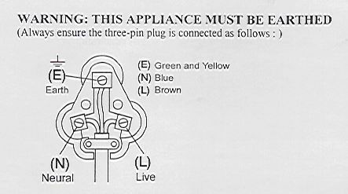
Blue = Neutral
Brown = Live

PLEASE AFFIX YOUR PROOF OF PURCHASE/RECEIPT HERE
IN THE EVENT OF A CLAIM UNDER WARRANTY THIS RECEIPT MUST BE PRODUCED.

W A R R A N T Y

- Tedelex Trading (Pty) Limited (“Tedelex”) warrants to the original purchaser of this product (“the customer”) that this product will be free of defects in quality and workmanship which under normal personal, family or household use and purpose may manifest within a period of 1 (one) year from the date of purchase (“warranty period”).
- Where the customer has purchased a product and it breaks, is defective or does not work properly for the intended purpose, the customer must notify the supplier from whom the customer bought the product (“the supplier”) thereof within the warranty period. Any claim in terms of this warranty must be supported by a proof of purchase. If proof of purchase is not available, then repair, and/or service charges may be payable by the customer to the supplier.
- The faulty product must be taken to the supplier's service centre to exercise the warranty.
- The supplier will refund, repair or exchange the product in terms of this warranty subject to legislative requirements. This warranty shall be valid only where the customer has not broken the product himself, or used the product for something that it is not supposed to be used for. The warranty does not include and will not be construed to cover products damaged as a result of disaster, misuse, tamper, abuse or any unauthorised modification or repair of the product.
- This warranty will extend only to the product provided at the date of the purchase and not to any expendables attached or installed by the customer.
- If the customer requests that the supplier repairs the product and the product breaks or fails to work properly within 3 (three) months of the repair and not as a result of misuse, tampering or modification by or on behalf of the customer, then the supplier may replace the product or pay a refund to the customer.
- The customer may be responsible for certain costs where products returned are not in the original packaging, or if the packaging is damaged. This will be deducted from any refund paid to the customer.

TEDELEX TRADING (PTY) LTD (JOHANNESBURG)

JOHANNESBURG TEL NO. (011) 490-9000
CAPE TOWN TEL NO. (021) 552-5161
DURBAN TEL NO. (031) 792-6000

www.amap.co.za
www.russellhobbs.co.za
www.facebook.com/RussellHobbsSA

Parabéns pela aquisição da Fritadeira Digital de 3.0L Russell Hobbs. Cada unidade é fabricada para dar segurança e confiabilidade. Antes de usar o aparelho pela primeira vez, leia cuidadosamente o manual de instrução e guarde-o para futuras referências.

CARACTERÍSTICAS DA FRITADEIRA DIGITAL DE 3.O L RUSSELL HOBBS

- 3.0 litros de capacidade de óleo
- Mostrador LCD Digital
- Cesta e pote esmaltado que podem ser levados ao lava-louças
- Elegante acabamento em aço inoxidável preto
- Visor XL
- Totalmente programável (temperatura e tempo)
- Temperatura pode ser ajustada entre 110℃ e 190℃
- Filtro de alumínio substituível
- Desmonta completamente para uma limpeza mais fácil
- Tecnologia de proteção contra superaquecimento
- Lugar conveniente para guardar o fio
- Componente aquecedor de imersão entra em contato direto com o óleo para tornar o aquecimento ultrarrápido
- Guia de cozimento no painel frontal
- 2000W
- Para uso doméstico apenas

ESPECIFICAÇÕES TÉCNICAS

Voltagem: 220-240V~ Frequência: 50/60Hz Potência: 1830-2180W

PRECAUÇÕES IMPORTANTES

Ao usar um aparelho elétrico, devem-se tomar precauções básicas de segurança, incluindo o seguinte:

- Leia as instruções cuidadosamente antes de usar qualquer aparelho.
- Sempre se certifique se a voltagem na etiqueta de classificação corresponda à voltagem principal da sua casa.
- O uso incorreto ou impróprio pode danificar o aparelho e causar danos ao usuário.
- O aparelho é para uso doméstico apenas. O uso comercial invalida a garantia e o fornecedor não será responsável por danos ou prejuízos causados pelo uso inapropriado do aparelho.
- Evite qualquer contato com as partes removíveis.
- Este aparelho não deve ser usado por pessoas com capacidade física, sensorial ou mental reduzida (inclusive crianças) ou por pessoas com falta de experiência e conhecimento, a menos que elas tenham supervisão ou recebam instruções concernente ao uso do aparelho por uma pessoa responsável pela segurança delas.
- As crianças devem ser supervisionadas para que não brinquem com o aparelho.
- Verifique regularmente o fio e a tomada. Se o fio ou a tomada estiverem danificados, o fabricante ou uma pessoa qualificada deverá substituí-los para evitar problemas elétricos.
- Não deixe este aparelho encostar em cortinas, papel de parede, roupas, panos de prato ou outros materiais inflamáveis durante o uso. Requer-se cautela nas superfícies que podem ser danificadas pelo calor – recomenda-se uma almofada térmica. Nunca coloque o aparelho numa superfície de plástico, tecido ou acarpetada enquanto estiver cozinhando.
- Este aparelho não foi projetado para funcionar com um timer externo ou um sistema separado de controle remoto.
- Não toque nas superfícies quentes – use as alças.
- Sempre levante a tampa para longe de seu rosto, pois o vapor ou óleo pode causar danos ou queimaduras.
- Mantenha as mãos, braços, rosto, etc., longe do vapor ou óleo ao abrir a tampa.
- NÃO coloque o produto perto de materiais inflamáveis.
- Deixe a fritadeira esfriar completamente antes de limpá-la e guardá-la.
- Muito cuidado ao manusear a caçarola contendo líquidos quentes. Recomenda-se não manusear o aparelho enquanto ele estiver cheio, ligado ou antes de ter esfriado.
- Não use o aparelho se ele tiver caído ou danificado de algum modo. Em caso de dano, leve o aparelho para exame e/ou conserto a um agente de serviço autorizado.
- Não use abrasivos, limpadores cáusticos ou limpadores de forno na limpeza deste aparelho.
- Para reduzir o risco de choque elétrico, não mergulhe ou exponha o aparelho, tomada ou fio na água ou em qualquer outro líquido.
- Nunca mergulhe o aparelho na água ou noutro líquido para limpá-lo.
- O aparelho não pode ser mergulhado, parcial ou completamente, na água para ser limpo.
- Retire o fio da tomada pegando pelo plugue. Não puxe o fio ou desconecte o aparelho pela fiação. Sempre desconecte o aparelho quando não estiver em uso, antes de limpá-lo ou de colocar ou retirar as peças removíveis.
- O uso de acessórios que não são recomendados ou fornecidos pelo fabricante podem causar danos ou prejuízos, ou choque elétrico.
- Fornecemos um fio curto a fim de reduzir as chances de enrolar ou de se tropeçar num fio comprido.
- Não deixe o fio pendurado na beirada da mesa ou do balcão. Certifique-se que o fio não esteja numa posição onde possa ser puxado inadvertidamente.
- Não deixe o fio em cima de superfícies quentes e não o coloque perto do queimador de gás ou elétrico do fogão ou sobre o fogão quente.
- Não use o aparelho na chama do gás ou de fogão elétrico ou próximo a chamas.
- Não se recomenda o uso de extensões neste aparelho. Contudo, se for necessário usar uma extensão, certifique-se que o fio seja apropriado para o consumo de energia do aparelho para evitar superaquecimento do fio, do aparelho ou da tomada. Não coloque a extensão numa posição onde possa ser puxada por crianças ou por animais, ou se possa tropeçar nela.
- Este aparelho não é apropriado para uso ao ar livre, apenas para uso doméstico. Não use o aparelho para outros fins.
- NÃO carregue o aparelho segurando-o pelo fio.
- Não deixe o aparelho sem supervisão enquanto em uso. Sempre o desconecte quando não estiver eu uso ou antes de limpá-lo.
- Sempre use o aparelho numa superfície lisa, plana e estável. Não o coloque numa superfície quente.
- Certifique-se que o interruptor esteja na posição ”Off” ou “O” depois de cada uso.
- Não deixe a Fritadeira esquentar sem óleo, ou com óleo abaixo do nível mínimo. Isso causará uma interrupção termal que desliga o aparelho e pode estragá-lo.
- Não conecte a Fritadeira à energia sem óleo. O fabricante não se responsabilizará por quaisquer danos ou prejuízos causados pelo uso impróprio ou incorreto, ou por consertos feitos por pessoal não autorizado.
- No caso de problemas técnicos, desligue o aparelho não tente consertá-lo você mesmo. Leve-o a um serviço autorizado para exame, ajuste ou conserto. Sempre insista no uso de peças originais. O descumprimento das precauções e instruções mencionadas acima pode afetar o uso seguro do aparelho.

DIAGRAMA DAS PEÇAS
alça da tampa
visor da janela
tampa
Alça do cesto
Estojo exterior
Botão ON/OFF
Botão Modo
Botão de Temperatura
Botão de Tempo
Tela LED
Luz da energia
Luz do Aquecimento
Indicador de luz completo
Fio
Aquecedor
Caixa de controle
Pote interior
Alça lateral
Guia do Mostrador
1. Modo de Espera:
A Fritadeira emitirá um ‘’bipe’’ por 1 seg. A luz verde se acenderá e o mostrador exibirá “-1-”.

2. Modos de Seleção:
Nota: Cada modo tem um pré-seleção de tempo e temperatura correspondente, verifique a seção “Pré-seleção de Tempo e Temperatura”.
Pressione o botão “Modo” enquanto no modo de espera. O Mostrador exibirá “-1- to -5-“. Pressione de novo e o Mostrador exibirá “-1-“.
Pressione o botão “Temp” no modo de espera. Aqui o Mostrador exibirá a temperatura selecionada e a luz vermelha indicadora de temperatura correspondente se acenderá. Pressione o botão “Temp” uma vez para aumentar a temperatura em 5°C. Use o botão “Temp” para ajustar a temperatura de 110°C a 190℃. Quando a seleção de temperatura atingir 190°C pressione o botão “Temp” de novo e a temperatura reverterá para 110°C.
Pressione o botão “Temp” enquanto no modo de espera e o mostrador exibirá o tempo selecionado. Aqui a luz vermelha indicadora do tempo correspondente se acenderá. Pressione o botão “Tempo” uma vez para aumentar o tempo em 1 minuto. Use o botão “Tempo” para ajustar o tempo de 1 a 99 minutos. Quando a seleção atingir 99 minutos, pressione o botão de novo e ele reverterá para 1 minuto.
Formato do Mostrador: NNX (N refere-se a minuto, X refere-se que não há exibição). Por exemplo, 10X indica 10 minutos. Ao segurar o botão “Tempo” por um período maior, você notará que a seleção de tempo aumentará rapidamente.
Durante o processo, o Mostrador digital exibirá 0.5 segs. o que significa que o aparelho está em funcionamento. 0.5 segs. piscará no mostrador indicando que terminou a operação.

3. Modo de Aquecimento
Após selecionar seu modo, pressione o botão ON/OFF e o mostrador exibirá a temperatura atual do óleo. Aqui a luz verde da energia e o indicador amarelo de AQUECIMENTO se acenderão. A fritadeira começará então o processo de aquecimento.
Durante o processo de aquecimento, pressione o botão “Modo”. Note que não há mudança no mostrador ou na seleção. Pressione o botão “Tempo” e o mostrador exibirá o tempo selecionado. Pressione o botão “Temp” para mostrar a temperatura selecionada.
Nota: o mostrador exibirá a temperatura atual por 5 segs. sem ser necessário pressionar qualquer botão.
Durante o processo, a luz verde da energia e a luz amarela do aquecimento continuarão a brilhar e Mostrador não piscará.

4. Modo de Espera
Uma vez o óleo atinja a temperatura selecionada a Fritadeira emitirá um bipe (0.3 segs, parada 0.3 segs). O mostrador exibirá a temperatura atual.
Se deixar a Fritadeira sem seleção nenhuma por 1 minuto, então ela automaticamente muda para o modo de espera.

5. Modo de Fritura
Após entrar o modo de espera, pressione o botão “ON/OFF”. A Fritadeira parará de emitir bipes. Durante este tempo, o mostrador exibirá o tempo selecionado. A luz vermelha OK brilhará. Formato de exibição do tempo: NNX ou Nnn (N refere-se aos minutos remanescentes).
N refere-se aos segundos remanescentes. (X refere-se que não há exibição). O requisito de precisão do tempo ±3%.
Durante o processo de fritura, pressione o botão de “Tempo” e o mostrador exibirá o tempo selecionado. Aqui a luz vermelha do tempo brilhará. Pressione o botão “Temp” e o mostrador exibirá a temperatura selecionada. Se a fritadeira for deixada sem nenhuma seleção por 1 minuto, ela automaticamente mudará para a temperatura atual.
Uma vez a Fritadeira alcance a temperatura selecionada, o componente de aquecimento se desligará. Se a temperatura do óleo cair, o componente automaticamente ligará de novo e alcançará a temperatura selecionada. Por exemplo: Isso pode ocorrer quando se coloca o alimento no óleo. Nessa hora, o mostrador exibirá o contador regressivo do tempo.
Uma vez a Fritadeira tenha atingido o final do tempo selecionado, ela emitirá dez bipes (bipe 2 segs, parada 1 segundo). Ela parará de esquentar e a luz vermelha OK se apagará. O mostrador exibirá o último estado selecionado e mudará para o modo de espera.
Pressione o botão “ON/OFF” quando a Fritadeira estiver em funcionamento e ela parará o processo de aquecimento. O mostrador exibirá o código default e mudará para o modo de seleção.

Modo de Pré-seleção de Tempo e Temperatura
MODO | TEMP（°C） | TEMPO（min）
1 | 150 | 5
2 | 160 | 6
3 | 170 | 10
4 | 180 | 4
5 | 190 | 6

INSTRUÇÕES DE USO

NOTA: Não use o aparelho para esquentar água. Nunca conecte o painel de
controle numa tomada de parede se ele não estiver instalado na caixa exterior.

- Limpe o aparelho completamente antes de usá-lo pela primeira vez.
- Coloque a Fritadeira numa superfície estável e seca.
- Retire a tampa da fritadeira e retire os acessórios.
- Encha a Fritadeira com a quantidade de óleo ou gordura necessária. O nível de óleo ou de gordura deverá ser acima da marca de mínimo e abaixo da marca de máximo. Não misture diferentes tipos de óleo e/ou gordura.
- Selecione a temperatura de acordo com o alimento a ser preparado. O guia de temperatura no painel de controle e a tabela abaixo podem ser usados como orientações. Espere a temperatura selecionada ser alcançada, a luz de “Aquecimento” se apagará quando a temperatura for alcançada.
- Coloque os alimentos para fritar no cesto, e lentamente abaixe o cesto na Fritadeira. É melhor usar com alimentos secos, visto que os umedecidos farão o óleo espirrar o que é perigoso.
- Coloque o cesto na Fritadeira usando somente a alça. A Fritadeira manterá a temperatura selecionada, e assim a luz de “Aquecimento” acenderá e apagará à medida em que o óleo se aqueça.
- Ao terminar o tempo certo da fritura, levante lentamente o cesto da Fritadeira, permitindo que o excesso de óleo se escorra do alimento.

GUIA DE TEMPERATURA PARA FRITURA

TIPO DE ALIMENTO | TEMPERATURA PARA FRITURA (ºC)
Croquetes de queijo | 170
Bolinhas de queijo | 180
Frango | 160
Rosquinhas | 190
Peixe | 170
Palitos de peixe | 180
Fondue de parmesão | 170
Croquete de carne | 190
Croquetes de carne/peixe/ batata | 190
Batatas chips | 190
Chips pré-fritas | 170
Camarão à milanesa | 180

DICAS DE FRITURA
- Use um máximo de 200 gramas de alimento para cada litro de óleo.
- Com produtos congelados, use somente 100 gramas de alimento por cada litro de óleo, visto que o alimento esfriará o óleo. Sempre remova o excesso de gelo dos alimentos antes de fritá-los.
- Óleo ou gordura podem ser reusados. Escorra o óleo para remover quaisquer partículas de alimento e guarde-o num recipiente hermético. Quando o óleo começar a descolorir e a ficar amarronzado, é hora de jogá-lo fora e usar óleo novo. O óleo pode ser usado até 10 vezes, dependendo do tipo e da qualidade do óleo.
- Não misture óleo usado com óleo novo.

LIMPEZA E MANUTENÇÃO

- Retire o plugue da tomada.
- Certifique-se que a seleção de temperatura esteja em “0ff”, e que o óleo ou gordura tenham sido despejados da panela.
- Levante gentilmente o cesto, a tigela esmaltada interior e o componente para fora do cesto de aço. A tigela esmaltada interior, o cesto e a tigela de aço podem ser lavados em água quente com sabão. O componente pode ser esfregado com um pano umedecido em água quente, mas não mergulhe o fundo do elemento em água ou qualquer outro líquido, ou segure sob a água corrente da torneira.
- Não use alvejante ou outros limpadores abrasivos ou esponjas de aço para limpar o aparelho, pois podem danificar o acabamento.
- Para remover marcas/manchas teimosas, esfregue as superfícies com um pano levemente umedecido em água com sabão ou num detergente não abrasivo. Enxágue e seque com um pano limpo, seco e macio.
- Espere o aparelho secar completamente antes de guardá-lo. Aconselha-se não deixar óleo ou gordura na Fritadeira quando for guardá-la.

AO GUARDAR O APARELHO

- Desconecte a panela da tomada na parede e limpe todas as peças como instruído acima. Certifique-se de todas as peças estejam secas antes de guardar.
- Guarde o aparelho na sua caixa ou num lugar limpo e seco.
- Nunca guarde o aparelho enquanto ele estiver molhado ou sujo.
- Nunca enrole o fio em volta do aparelho.

CONSERTO DO APARELHO
Não existem peças que possam ser consertadas pelo usuário neste aparelho. Se a panela não estiver funcionando corretamente, verifique o seguinte:
- Se você seguiu as instruções corretamente.
- Se o aparelho foi instalado corretamente e se a tomada está ligada na parede.
- Se o aparelho está ligado na energia /ON.
- Se o plugue está firme na tomada.

Se o aparelho ainda assim não funcionar após a verificação acima:
- Consulte o varejista para conserto ou substituição. Se o varejista não puder resolver o problema e você necessitar devolver o aparelho, certifique-se que:
- O aparelho esteja cuidadosamente embalado na sua embalagem original.
- O recibo de compra esteja anexado.
- O motivo pelo qual o aparelho está sendo devolvido.

Se o fio estiver estragado, deverá ser substituído pelo fabricante ou pelo agente de serviço autorizado a fim de evitar quaisquer danos. Se for necessário algum conserto dentro do tempo da garantia, o aparelho deverá ser devolvido para um centro de serviço do Tedelex Trading (Pty) Limited. Consertos fora do período de garantia também estão disponíveis, mas serão cobrados.

SUBSTITUIÇÃO DA FICHA

Cumpra com as instruções seguintes caso seja necessário substituir a ficha.

Esta unidade destina-se a operar apenas na corrente indicada. A ligação a outras fontes de alimentação poderá danificar o aparelho. Ligue uma ficha de três pinos da seguinte maneira:

Os fios neste terminal de alimentação estão coloridos de acordo com o seguinte código:

Verde/Amarelo = Terra
Azul = Neutro
Castanho = Vivo
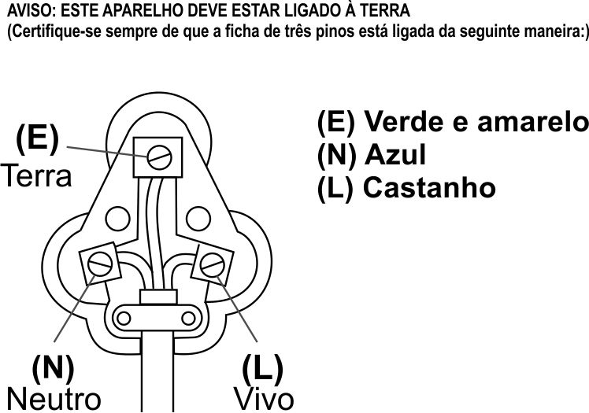

NO CASO DE RECLAMAÇÃO SOB GARANTIA, DEVE-SE TER ESTE RECIBO.

GARANTIA

- Tedelex Trading (Pty) Limited (“Tedelex”) garante ao comprador original deste produto (“o cliente”) que o produto está sem defeitos de qualidade e manufatura que sob uso normal pessoal, familiar ou domiciliar e propósito pode manifestar dentro do período de 1 (um) ano da data de compra (“período da garantia”).
- Se o cliente tiver comprador um produto e ele quebrar, estiver com defeito ou não funcionar adequadamente pelo período devido, o cliente deve notificar o fornecedor de quem comprou o produto (‘’o fornecedor”) dentro do período de garantia. Qualquer reclamação nos termos desta garantia devem ser acompanhadas pelo recibo de compra. Se não possuir o recibo, então a cobrança do conserto, e/ou do serviço deverá ser pago pelo cliente ao fornecedor.
- O produto defeituoso deve ser levado ao centro de serviço do fornecedor representante para ter direito à garantia.
- O fornecedor reembolsará, consertará ou trocará o produto nos termos desta garantia sujeita a requerimentos legislativos. Esta garantia será válida somente se o cliente não tiver quebrado ele mesmo o produto, ou usado de modo inapropriado. A garantia não inclui e não será usada para cobrir produtos danificados por causa de desastre, mau uso, falsificação, abuso ou modificação não autorizada ou conserto do produto.
- Esta garantia somente será estendida ao produto fornecido na data da compra e não valerá para nenhuma das extensões anexadas ou instaladas pelo cliente.
- Se o cliente solicitar que o fornecedor conserte o produto e o produto quebrar ou não funcionar apropriadamente dentro de 3 (três) meses do conserto e não devido ao uso errado, falsificação ou modificação por ou da parte do cliente, então o fornecedor pode substituir o produto ou reembolsar o cliente.
- O cliente poderá ser responsabilizado por certos custos se os produtos devolvidos não estiverem na embalagem original ou se a embalagem estiver danificada. Isso será deduzido de qualquer reembolso pago ao cliente.
TEDELEX TRADING (PTY) LTD

JOANESBURGO N.º TEL. +2711 490-9600
CIDADE DO CABO N.º TEL. +2721 552-5161
DURBAN N.º TEL. +2731 792-6000

www.amap.co.za
www.russellhobbs.co.za
www.facebook.com/RussellHobbsSA

Félicitations pour l'achat de notre Friteuse Digitale de 3.0L Russell Hobbs. Chaque unité est produite pour garantir un maximum de sécurité et de fiabilité. Avant d'utiliser cet ustensile pour la première fois, veuillez lire attentivement le manuel d'utilisation et le conserver pour toute référence future.

CARACTERISTIQUES DE LA FRITEUSE DIGITALE DE 3.0L RUSSELL HOBBS

- Capacité d’Huile de 3.0 Litres
- Affichage Digital LCD
- Panier de cuisson lavable au lave-vaisselle et casserole de cuisson en email
- Finition en acier inoxydable noire élégante
- Fenêtre de vision XL
- Complètement programmable (température et temps)
- Température peut être réglée entre 110ºC e 190ºC
- Filtre en aluminium remplaçable
- Se démonte complètement pour un nettoyage facile
- Technologie de protection contre la surchauffe
- Emmagasinage commode du cordon
- Élément du chauffage à immersion entre en contact direct avec l’huile pour un chauffage ultra rapide
- Guide de cuisson sur le panneau avant
- 2000W
- Seulement pour usage domestique

CARACTERISTIQUES TECHNIQUES

Tension Nominale: 220-240V~Fréquence Nominale: 50/60Hz Puissance Nominale: 1830-2180W

MESURES DE PROTECTION IMPORTANTES

Lorsqu'on utilise un appareil électrique, il est toujours important de suivre les consignes de sécurité y compris ce qui suit :

- Avant d'utiliser un appareil électrique lire attentivement les instructions.
- S'assurer que le voltage indiqué sur l'étiquette corresponde au voltage de la maison.
- Une utilisation incorrecte ou non appropriée peut endommager l'appareil et provoquer des blessures à l'usager.
- Cet appareil est conçu uniquement pour l'utilisation domestique. L'utilisation à des fins commerciales de cet appareil annule la garantie et le fournisseur ne pourra être tenu responsable de tout dommage ou accident causé par l'appareil lorsque son usage diffère de celui prévu.
- Eviter tout contact avec les parties en mouvement.
- Cet appareil ne doit pas être utilisé par des personnes (y compris les enfants) à mobilité réduite, dont les capacités sensorielles ou mentales sont amoindries, ou manquant de l'expérience ou des connaissances nécessaires, à moins qu'elles ne soient sous la surveillance d'une personne responsable de leur sécurité ou qu'elle aient reçu de cette dernière des instructions d'utilisation de l'appareil.
- Les enfants devraient être toujours surveillés afin qu'ils ne jouent pas avec l'appareil.
- Inspecter et brancher régulièrement le fil électrique pour vérifier qu'il ne soit pas endommagé. Si le fil ou la prise sont endommagés, leur substitution sera faite par le producteur ou par une personne qualifiée afin d'éviter tout risque d'accident électrique.
- Faites attention que l'appareil en fonction ne soit pas en contact avec rideau, revêtements muraux, vêtements, torchons de cuisine ou autres matériels inflammables. Lorsque vous travaillez sur des surfaces qui craignent la chaleur, il est conseillé d'utiliser un tapis isolant. Lorsque l'unité est en fonction ne pas la déposer sur des surfaces en plastique, en tissu ou sur du tapis.
- L'appareil n'est pas conçu pour être utilisé avec un minuteur externe ou par un système de commande à distance.
- Ne pas toucher les surfaces chaudes, utiliser les poignées.
- Soulever toujours le couvercle en l'éloignant du visage, la vapeur ou huile qui ressort pourrait causer des brûlures ou des blessures.
- Éloigner les mains, les bras, le visage, etc. des sources de vapeur ou huile lors de l'ouverture du couvercle.
- NE PAS positionner le produit près de matériaux inflammable.
- Avant de nettoyer ou de ranger la friteuse s'assurer qu'elle soit complètement froide.
- Déplacer le poêlon contenant des liquides chauds avec une attention extrême. Il est recommandé de ne pas déplacer l'unité lorsqu'elle est complètement pleine, lorsqu'elle est en fonction ou avant qu'elle ne soit refroidie.
- Ne pas utiliser l'appareil s'il a été endommagé d'une manière quelconque ou en cas de chute. En cas de dommage, faire examiner et/ou réparer l'unité par un agent agréé.
- Ne pas utiliser des agents abrasifs agressifs, des produits de nettoyage caustiques ou des produits pour four.
- Afin de réduire les risques d'électrocution, ne pas immerger ou exposer à l'eau ou à tout autre liquide l'appareil, le fil ou la prise.
- Ne pas immerger l'unité dans l'eau ou dans tout autre liquide pour la nettoyer.
- L'unité ne peut pas être immergée dans l'eau complètement ou partiellement.
- Pour enlever la prise la tenir fermement. Ne pas tirer le fil pour déconnecter l'appareil de la prise de courant. Déconnecter l'unité lorsqu'elle n'est pas en fonction ou lors du nettoyage ou du démontage.
- L'utilisation d'accessoires qui ne sont pas recommandés ou fournis par le producteur pourrait provoquer des accidents, des incendies ou des électrocutions.
- Le fil fourni est court afin d'éviter tout risque de suffocation ou de blessure suite au trébuchement sur un fil plus long.
- Ne pas laisser le fil pendre d'une table ou d'un plan de travail. S'assurer que le fil ne soit pas en une position où il pourrait être tiré par mégarde.
- Ne pas laisser le fil en contact avec des surfaces chaudes et ne pas placer sur ou près d'un réchaud au gaz ou électrique ou dans un four chaud.
- Ne pas utiliser l'appareil sur une taque ou gaz ou près d'une flamme libre.
- L'utilisation d'une rallonge électrique n'est pas recommandée. Cependant si l'utilisation d'une rallonge s'avère nécessaire, s'assurer qu'elle soit adaptée à la consommation de courant de l'appareil afin d'éviter tout risque de surchauffe de la rallonge, de l'appareil ou de la prise. Ne pas placer la rallonge dans un endroit où elle peut facilement être tirée par un enfant ou un animal ou où elle peut provoquer des trébuchements.
- Cet appareil ne convient pas à l'utilisation à l'extérieur. Uniquement pour usage domestique. Ne pas utiliser cet appareil pour tout autre but sauf celui pour lequel il a été conçu.
- NE PAS transporter l'appareil en le soulevant par le fil d'alimentation.
- Pendant l'utilisation ne pas laisser l'appareil sans surveillance. Débrancher toujours l'appareil lorsqu'il n'est pas en fonction ou avant le nettoyage.
- Poser toujours l'appareil sur une surface lisse, égale et stable. Ne pas placer l'unité sur une surface chaude.
- S’assurer que l’interrupteur est sur la position ‘Off’ ou ‘O’ après chaque utilisation.
- Ne pas laisser la friteuse chauffer sans huile à l’intérieur, ou avec l’huile en dessous du niveau minimum. Ceci causera l’arrêt de l’unité par l’arrêt thermal, et peut endommager l’unité.
- Ne pas connecter la friteuse à l’alimentation électrique sans huile dans l’unité. Le fabricant n’accepte aucune responsabilité pour tout dommage ou blessure causés par une utilisation impropre ou incorrecte, ou pour des réparations réalisées par du personnel non autorisé.
- En cas de problèmes techniques, éteindre la machine et ne pas essayer de la réparer soi-même. Rapporter l'appareil à un agent agréé pour qu'il soit examiné, réglé ou réparé. Insister pour que les pièces utilisées soient des originaux. Le manque de respect de ces précautions et instructions pourrait compromettre le fonctionnement de la machine.

SCHEMA DES ELEMENTS
Poignée du Couvercle
Fenêtre de Vision

Couvercle

Poignée du Panier

Boîtier Extérieur
Touche ON/OFF

Touche Mode
Touche Température
Touche Temps
Écran LED
Lumière de Puissance
Lumière de Chauffage
Lumière indiquant complet
Cordon d’Alimentation

Chauffage
Boîtier de Régulation
Marmite Interne
Poignée Latérale

Guide de l’Affichage

1. Mode ‘Standby’:
La friteuse émettra un seul “beep” pendant 1s. Alors la lumière verte de puissance s’allumera et l’affichage indiquera “-1-”.

2. Modes de Sélection:
Note: Chaque mode a un temps et température préréglés assortis, s’il vous plait voir la section “Temps et Température Préréglés”.
Appuyer sur le bouton “Mode” en mode ‘standby’ pour faire une sélection de mode. L’affichage indiquera “-1- à -5-“. Appuyer à nouveau et l’affichage indiquera “-1-“.
Appuyer sur le bouton “Temp” en mode ‘standby’. Alors l’affichage indiquera la température préréglée et l’indicateur lumineux rouge de température correspondant s’allumera. Appuyer sur le bouton “Temp“ une fois pour augmenter la température de 5ºC. Utiliser le bouton “Temp“ pour ajuster la température entre 110ºC et 190ºC. Quand la température sélectionnée atteint 190ºC, appuyer sur le bouton “Temp“ à nouveau et la température retournera à 110ºC.
Appuyer sur le bouton “Time” en mode ‘standby’ et l’affichage indiquera le temps préréglé. Alors l’indicateur lumineux rouge de temps correspondant s’allumera. Appuyer sur le bouton “Time“ une fois pour augmenter le temps de 1min. Utiliser le bouton “Time“ pour ajuster le temps entre 1min et 99min. Quand le temps sélectionné atteint 99min, appuyer sur le bouton “Time“ à nouveau et le temps retournera à 1min.
Format d’affichage : NNX (N se réfère aux minutes, X se réfère à aucun affichage). Par exemple, 10X signifie 10 minutes. Si vous appuyez sur le bouton “Time” pendant plus longtemps vous remarquerez que le temps sélectionné augmentera rapidement.
Pendant le processus, l’affichage digital indiquera 0.5s ce qui signifie que l’appareil est en fonctionnement. 0.5s clignotera sur l’affichage indiquant que le fonctionnement a été arrêté.

3. Mode de Chauffage
Après avoir choisi et sélectionné votre mode, appuyer sur le bouton ON/OFF et l’affichage indiquera la température actuelle de l’huile. Alors la lumière de puissance verte et l’indicateur lumineux de CHAUFFAGE jaune s’allumeront. La friteuse commence maintenant le processus de chauffage.

Pendant le processus de chauffage, appuyer sur le bouton “Mode”. Remarquer qu’il n’y a pas de changement sur l’affichage ou la sélection. Appuyer sur le bouton “Time” et l’affichage indiquera le temps préréglé. Appuyer sur le bouton “Temp” pour indiquer la température préréglée. Note : l’affichage indiquera la température actuelle pendant 5s sans que vous ayez à appuyer sur un bouton.
Pendant ce processus, la lumière de puissance verte et la lumière de chauffage jaune continueront à briller et l’affichage ne clignotera pas.

4. Mode d’Attente
Une fois que l’huile a atteint la température préréglée la friteuse fera un son “beep” (0.3s, stop 0.3s). L’affichage indiquera maintenant la température actuelle.
Si la friteuse est laissée sans sélection pendant 1min alors elle passera automatiquement en mode ‘standby’.

5. Mode de Friture
Après avoir sélectionné le mode d’attente, appuyer sur le bouton “ON/OFF”. La friteuse arrêtera son “beeping”. Pendant ce temps, l’affichage indiquera le temps préréglé. La lumière rouge OK brillera. Le format d’affichage du temps : NNX ou Nnn (N se réfère aux minutes restantes, N se réfère aux secondes restantes, X se réfère à aucun affichage). Exigences de précision temporelle ±3%.
Pendant le processus de friture, appuyer sur le bouton “Time” et l’affichage indiquera le temps préréglé. Alors la lumière rouge du temps brillera. Appuyer sur le bouton “Temp” et l’affichage indiquera la température préréglée. Si la friteuse est laissée sans sélection pendant 1min alors elle passera automatiquement à la température actuelle.
Une fois que la friteuse a atteint la température préréglée requise, l’élément de chauffage s’éteindra. Si la température de l’huile diminue, l’élément s’allumera à nouveau automatiquement pour atteindre la température préréglée requise. Par exemple Ceci peut avoir lieu en additionnant des aliments préparés à l’huile de cuisson. À ce moment, l’affichage indiquera le compte à rebours.
Une fois que la friteuse a atteint la fin de son temps préréglé, elle émettra dix beeps” (beep 2s, stop 1s). Elle arrêtera de chauffer et la lumière rouge OK s’éteindra. L’affichage indiquera le dernier préréglage et passera au mode de sélection.
Appuyer sur le bouton “ON/OFF” quand la friteuse fonctionne et la friteuse arrêtera le processus de chauffage. L’affichage indiquera le code défaut et passera au mode de sélection.

Mode Température et Temps Préréglés
MODE | TEMP（°C） | TEMPS（min）
1 | 150 | 5
2 | 160 | 6
3 | 170 | 10
4 | 180 | 4
5 | 190 | 6

INSTRUCTIONS D'UTILISATION

NOTE: Ne pas utiliser ce produit pour chauffer de l’eau. Ne jamais connecter le panneau de commandes à une prise de courant s’il n’est pas installé sur le boitier extérieur.

- Nettoyer l’unité avec soin avant la première utilisation.
- Placer la friteuse sur une surface sèche et stable.
- Retirer le couvercle de la friteuse et retirer les accessoires.
- Remplir la friteuse avec le montant requis d’huile ou de graisse. Le niveau d’huile ou de graisse doit être au dessus de la marque miminum et en dessous de la marque maximum. Ne pas mélanger différents types d’huile et/ou de graisse.
- Sélectionner la température, en accord avec les aliments que vous cuisinez. Le guide de température de cuisson sur le panneau de commandes et le tableau ci-dessous peut être utilisé comme directives. Attendre que la température sélectionnée soit atteinte, la lumière ‘Chauffage’ s’éteindra quand la température est atteinte.
- Placer les aliments à frire dans le panier, et descendre lentement le panier dans la friteuse. Il vaut mieux utiliser des aliments secs, car les aliments humides feront l’huile éclabousser hors de la friteuse ce qui est dangereux.
- Placer le panier dans la friteuse en utilisant seulement la poignée. La friteuse maintiendra la température sélectionnée et donc la lumière ‘Chauffage’ s’allumera et s’éteindra à mesure que le produit réchauffe l’huile.
- Quand le temps de friture correct est passé, soulever lentement le panier hors de la friteuse, permettant que l’excès d’huile coule des aliments.

GUIDE DE TEMPÉRATURE DE FRITURE

TYPE D’ALIMENT | TEMPÉRATURE DE FRITURE (ºC)
Croquettes au fromage | 170
Beignets au fromage | 180
Poulet | 160
Beignes | 190
Poisson | 170
Tranches de poisson | 180
Fondue parmesan | 170
Croquettes à la viande | 190
Croquettes à la viande/poisson/pomme de terre | 190
Pommes frites | 190
Pommes de terre pré-frites | 170
Beignets aux crevettes | 180

CONSEILS DE FRITURE
- Utiliser un maximum de 200 grammes d’aliments par litre d’huile.
- Pour les produits congelés, utiliser seulement 100 grammes d’aliments par litre d’huile, car les aliments refroidiront l’huile. Retirer toujours l’excès de glace des produits congelés avant la friture.
- L’huile ou la graisse peut être réutilisée après la friture. Drainer l’huile pour retirer toutes particules d’aliments et garder dans un récipient hermétique. Quand l’huile commence à perdre sa couleur et devient brune, il est temps de le jeter et d’utiliser de l’huile fraîche. L’huile peut durer jusqu’à 10 utilisations, dépendant du type et de la qualité de l’huile.
- Ne pas mélanger de l’huile ancienne et de l’huile nouvelle.

NETTOYAGE ET ENTRETIEN
- Retirer la prise électrique de la prise de courant.
- S’assurer que la sélection de température est réglée sur “0ff”, et que toute l’huile a été versée hors de l’unité.
- Soulever doucement le panier, bol intérieur en émail et élément hors du bol en acier inoxydable. Le bol intérieur en émail, panier et bol en acier inoxydable peuvent être lavés dans de l’eau tiède et savonneuse. L’élément peut être nettoyé avec un chiffon tiède et humide, mais ne pas plonger le derrière de l’élément dans de l’eau ou tout autre liquide, ou le tenir sous un robinet ouvert pour le nettoyer.
- Ne pas utiliser eau de javel ou autre substances abrasive ou solvants pour nettoyer l'appareil, ces produits pourraient endommager la finition.
- Pour retirer des marques/tâches difficiles, nettoyer les surfaces avec un chiffon légèrement humidifié avec de l’eau savonneuse ou un produit de nettoyage non abrasif. Rincer et sécher avec un chiffon propre, sec et doux.
- Permettre à l’unité de sécher complètement avant de la garder. Il est conseillé de ne laisser aucune huile ou graisse dans la friteuse pendant l’emmagasinage.

RANGEMENT DE L'APPAREIL

- Débrancher l'appareil de la prise de courant et nettoyer tous les éléments suivant les indications plus haut. Avant de ranger l'appareil s'assurer que toutes ses parties soient bien sèches.
- Ranger l'appareil dans sa boîte ou dans un endroit propre et sec.
- Ne jamais ranger l'appareil quand il est encore mouillé ou sale.
- Ne jamais enrouler le câble d'alimentation autour de l'appareil.

ENTRETIEN DE L'APPAREIL

Aucun élément de cet appareil ne peut être entretenu par l'usager. Si l'unité ne fonctionne pas correctement vérifier ce qui suit :
- Les instructions ont été suivies correctement
- L'unité a été branchée correctement et la prise de courant est bien allumée.
- L'alimentation générale de courant est ALLUMEE.
- La prise est bien insérée.

Si l'appareil ne marche toujours pas après ces vérifications :
- Consulter le revendeur pour qu'il répare ou remplace l'appareil. Si le revendeur ne parvient pas à résoudre le problème et le retour de l'appareil s'avère nécessaire, s'assurer que :
- L'unité soit emballée avec soin dans son emballage d'origine.
- La preuve d'achat soit jointe.
- Il y ait une explication des raisons du retour.

Si le câble d'alimentation est endommagé il doit être remplacé par le producteur ou par un agent agréé afin d'éviter tout accident. Si pendant la période couverte par la garantie il est nécessaire d'effectuer un entretien, l'appareil devrait être apporté chez un centre d'entretien approuvé par Tedelex Trading (Pty) Limited. En dehors de la période couverte par la garantie il est possible d'effectuer les entretiens mais au frais du client.

CHANGER LA PRISE

Au cas où le changement de prise s'avérait nécessaire, suivre les instructions ci-dessous.
Cette unité est conçue pour fonctionner uniquement au courant établi. La connexion à d'autres sources de courant pourrait endommager l'appareil. Connecter une prise à trois broches de la manière suivante :
Les files de ce câble sont colorés selon le code suivant :

Vert/jaune = Terre
Bleu = Neutre
Brun = Conducteur

DANS LE CAS D'UTILISATION DE LA GARANTIE CE RECU DOIT ÊTRE FOURNI.

G A R A N T I E

- Tedelex Trading (Pty) Limited ("Tedelex") garantit à l'acheteur original de ce produit ("le client") que ce produit n'a aucun défaut de qualité et de manufacture qui pourrait apparaître en 1 (un) an d'utilisation ordinaire, personnelle, familiale ou domestique du produit, à partir de la date d'achat ("période de garantie").
- Si le client a acheté un produit et ce dernier se casse, est défectueux ou ne fonctionne pas correctement par rapport à son usage prévu, le client doit le communiquer au fournisseur aurpès duquel il a effectué son achat ("le fournisseur") dans les délais imposés par la période de garantie. Toute déclaration selon les termes de la garantie doit être supportée par la preuve d'achat. Si cette preuve n'est pas disponible, la réparation et/ou les frais d'entretien seront à charge du client et payable au fournisseur.
- Le produit défectueux doit être remis au centre d'entretien du fournisseur afin de pouvoir utiliser la garantie.
- Le fournisseur va rembourser, réparer ou échanger le produit selon les termes de la garantie assujettie aux provisions de loi. Cette garantie est valable uniquement si le client n'a pas cassé le produit lui-même ou n'a pas utilisé le produit à des fins non prévues. Cette garantie n'inclut pas et ne couvrira pas les dommages provoqués par des calamités, mauvaise utilisation, manipulation, abus ou modification non autorisée ou réparation du produit.
- Cette garantie s'applique uniquement au produit fourni à la date d'achat et pas aux matériels consommables joints ou installés par le client.
- Si le client demande au fournisseur de réparer le produit et le produit se casse ou ne fonctionne pas correctement endeans les 3 (trois) mois de la réparation sans pour autant avoir fait l'objet d'une mauvaise utilisation, de manipulation ou de modification par ou pour compte du client, alors le fournisseur pourra remplacer le produit ou rembourser le client.
- Le client pourra devoir prendre en charge certains coûts lorsque les produits retournés ne sont pas dans leur emballage d'origine, ou si l'emballage est endommagé. Ceci sera déduit de tout remboursement fait au client.

TEDELEX TRADING (PTY) LTD
www.amap.co.za
+27 11 490-9600 (Jhb)
+27 31 792-6000 (Dbn)
+27 21 552-5161 (CT)
www.russellhobbs.co.za
www.facebook.com/RussellHobbsSA

