

INSTRUCTIONS AND WARRANTY

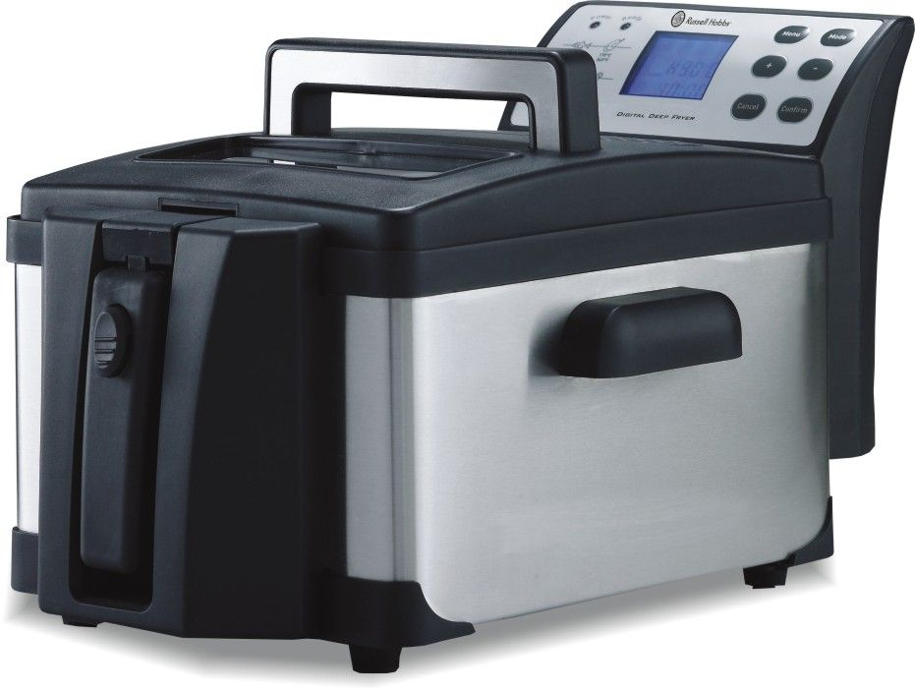

MODEL NO. RDF360

RUSSELL HOBBS DIGITAL DEEP FRYER

Congratulations on purchasing our Russell Hobbs Digital Deep Fryer. Each unit is manufactured to ensure safety and reliability. Before using this appliance for the first time, please read the instruction manual carefully and keep it for future reference.

FEATURES OF THE RUSSELL HOBBS DIGITAL DEEP FRYER
- The Russell Hobbs Digital Deep Fryer has a fully programmable micro-computer, which allows you to program the deep fryer to cook to your specific requirements.
- The digital LCD screen allows you to monitor the deep fryer’s temperature and programming better.
- The Russell Hobbs Digital Deep Fryer lid has a handy viewing window and a replaceable filter, to ensure perfect cooking every time.
- The enamel cooking pot and cooking basket are dishwasher safe, and the unit disassembles fully for easy cleaning
- The deep fryer has a 3.0L oil capacity to allow cooking for a larger family
- The adjustable basket height position ensures safe and convenient cooking.
- The cooking guide on the front panel makes deep frying easy, without having to refer to a recipe.

IMPORTANT SAFEGUARDS
When using any electrical appliance, basic safety precautions should always be followed including the following:
- Please read the instructions carefully before using any appliance.
- Always ensure that the voltage on the rating label corresponds to the mains voltage in your home.
- Incorrect operation and improper use can damage the appliance and cause injury to the user.
- The appliance is intended for household use only. Commercial use invalids the warranty and the supplier can not be held responsible for injury or damage caused when using the appliance for any other purpose than that intended.
- Avoid any contact with moving parts.
- Close supervision is required when any appliance is used near or by children or invalids.
- Check the power cord and plug regularly for any damage. If the cord or the plug is damaged, it must be replaced by the manufacturer or a qualified person in order to avoid an electrical hazard.
- Do not use the appliance if it has been dropped or damaged in any way. In case of damage, take the unit in for examination and/or repair by an authorised service agent
- To reduce the risk of electric shock, do not immerse or expose the motor assembly, plug or the power cord to water or any other liquid.
- Never immerse the unit in water or any other liquid for cleaning purposes.
- Remove the plug from the socket by gripping the plug. Do not pull on the cord to disconnect the appliance from the mains. Always unplug the unit when not in use, before cleaning or when adding or removing parts.
- The use of accessory attachments that are not recommended or supplied by the manufacturer may result in injuries, fire or electric shock.
- A short cord is provided to reduce the hazards resulting from becoming entangled in or tripping over a longer cord.
- Do not let the cord hang over the edge of a table or counter. Ensure that the cord is not in a position where it can be pulled on inadvertently.
- Do not allow the cord to touch hot surfaces and do not place on or near a hot gas or electric burner or in a heated oven.
- Do not use the appliance on a gas or electric cooking top or over or near an open flame.
- Use of an extension cord with this appliance is not recommended. However, if it is necessary to use an extension lead, ensure that the lead is suited to the power consumption of the appliance to avoid overheating of the extension cord, appliance or plug point. Do not place the extension cord in a position where it can be pulled on by children or animals or tripped over.
- This appliance is not suitable for outdoor use. Do not use this appliance for anything other than its intended use.
- DO NOT carry the appliance by the power cord.
- Do not leave this appliance unattended during use. Always unplug the unit when not in use or before cleaning.
- Always operate the appliance on a smooth, even, stable surface. Do not place the unit on a hot surface.
- Ensure that the unit is unplugged from the power socket after each use.
- The manufacturer does not accept responsibility for any damage or injury caused by improper or incorrect use, or for repairs carried out by unauthorised personnel.
- In case of technical problems, switch off the machine and do not attempt to repair it yourself. Return the appliance to an authorised service facility for examination, adjustment or repair. Always insist on the use of original spare parts. Failure to comply with the above mentioned pre-cautions and instructions, could affect the safe operation of this machine.
- Note: The surface becomes hot during use. Only use the handles or knob when touching the unit.
- Do not let the deep fryer heat without oil in it, or with the oil below the Min level. This will cause the thermal cut-off to switch the unit off, and may damage the unit.
- Do not connect the deep fryer to the power supply without oil in the unit.

PARTS DIAGRAM

OPERATING INSTRUCTIONS
NOTE: Do not use this product to heat water. Never plug the control panel into a wall socket if it is not installed in the outer housing.
- Clean the unit thoroughly before using for the first time.
- Place the deep fryer on a stable flat surface. Fill the enamel bowl (oil pot) with fresh cooking oil. Ensure the oil is above the Min mark and below the Max mark, seen on the inside of the bowl.
- Plug the heater into the wall socket and switch on the wall socket. The digital panel will light up and emit a beep.

To use the pre-set menu’s:
- The digital panel will show the temperature, time and default menu setting. The Power light will flash, but the unit will not start heating.
- Press the Menu button on the control unit to select the menu required. The menu options are as follows:
FOOD | COOKING TIME | TEMPERATURE
French Fries (Potato chips) | 7 minutes | 190˚C
Chicken | 11 minutes | 170˚C
Onions | 4 minutes | 190˚C
Fish | 6 minutes | 160˚C

- Press the confirm button. The deep fryer element will start heating and the Power light will show permanently. The buttons will now not work unless the programme is cancelled, by pressing the Cancel button.
- When the oil has heated to the selected temperature, the Ready light will go on and the unit will emit a beep.
- Now press the confirm button to start the countdown timer.
- The timer will start counting down. Place the food in the frying basket, and lower the basket into the oil. Place the lid onto the unit, and lower the basket handle by pulling on the handle latch.
- When the timer reaches 0:00, the unit will return to the Ready stage, the element will stop heating, and the unit will emit a beep.
- When the food is finished cooking, lift the basket handle to the horizontal position and lift the basket out of the oil to drain. Serve as desired.

To programme the unit to a specific cooking temperature and time:
- Press the Mode button once. The Temperature line will flash. Use the + or – buttons to change the temperature to the desired level. The temperature can be changed 1˚C at a time.
- Press the Mode button again. The Timer line will flash. Use the + or – buttons to change the time to the desired minutes. The time will change 30 seconds at a time.
- If the time is set to 0:00, then the unit will work until the Cancel button is pressed.
- Press the confirm button to confirm the programming. The deep fryer element will start heating and the Power light will show permanently. The buttons will now not work unless the programme is cancelled, by pressing the Cancel button.
- When the oil has heated to the selected temperature, the Ready light will go on and the unit will emit a beep. Press the confirm button again and the timer will start counting down. Place the food in the frying basket, and lower the basket into the oil. Place the lid onto the unit, and lower the basket handle by pulling on the handle latch.
- When the timer reaches 0:00, the unit will return to the Ready stage, the element will stop heating, and the unit will emit a beep.
- When the food is finished cooking, lift the basket handle to the horizontal position and lift the basket out of the oil to drain. Serve as desired.

To re-cook food:
- Raise the basket to keep the food out of the oil. Reselect the temperature as above and press the Confirm button.
- When the Ready light goes on, lower the food into the oil and close the unit with the lid.
- The timer will start counting down. Place the food in the frying basket, and lower the basket into the oil. Place the lid onto the unit, and lower the basket handle by pulling on the handle latch.
- When the timer reaches 0:00, the unit will return to the Ready stage, the element will stop heating, and the unit will emit a beep.
- When the food is finished cooking, lift the basket handle to the horizontal position and lift the basket out of the oil to drain. Serve as desired.

Tips when deep frying food:
- Frozen food will lower the temperature of the oil, so do not put too much in at once. Frozen food will thus also take a little longer to cook.
- It is advised to coat low-starch foods before cooking. This ensures tasty results and prevents the food from drying out during cooking.
- The following is a time guide for common foods. This is a guide only.
FOOD | TEMPERATURE | TIME
Ring Doughnuts | 190˚C | 2 minutes
Croutons (diced bread) | 190˚C | 1 minute
Fish cakes (fresh) | 190˚C | 3-4 minutes
Fish cakes (frozen) | 190˚C | 4-5 minutes
Chops (small – large) | 170˚C | 10 – 15 minutes
Chicken drum sticks | 170˚C | 14-15 minutes
Mushrooms (10 pieces) | 170˚C | 2 – 3 minutes
Meatballs (6 – 8 pieces) | 180˚C | 3 – 4 minutes
Chips: First cycle | 160˚C | 4 – 6 minutes
Chips: Second cycle | 190˚C | 3 – 4 minutes
Frozen chips (450g) | 190˚C | 5 – 6 minutes

CLEANING AND MAINTENANCE
- This appliance is for household use only and is not user-serviceable.
- Do not open or change any parts by yourself. Please refer to a qualified electrical service department or return to the supplier if servicing is necessary.
- Always remember to unplug the unit from the electrical outlet when not in use and before cleaning.
- Always ensure the unit has cooled down completely before cleaning.
- Lift the basket and the element out of the enamel bowl. Empty the oil out of the bowl.
- Wash the basket and enamel bowl in warm, soapy water, rinse and dry well, or place them in the dishwasher. Wash the element carefully, letting only the element get wet, and making sure the electric unit does not have any contact with water.
- The body of the appliance should be cleaned with a damp cloth. Do not let water enter the appliance.
- Do not use bleach or other abrasive substance or solvents to clean your appliance as it can be damaging to the finish.
- Do not immerse the unit in water or any other liquid, or hold it under a running tap to clean.
- To remove stubborn spots/marks, wipe the surfaces with a cloth slightly dampened in soapy water or mild non-abrasive cleaner. Rinse and dry a clean, dry, soft cloth.

STORING THE APPLIANCE
- Unplug the unit from the wall outlet and clean all the parts as instructed above. Ensure that all parts are dry before storing. Roll the cord into the gap in the back of the unit.
- Store the appliance in its box or in a clean, dry place.
- Never store the appliance while it is still wet or dirty.
- Never wrap the power cord around the appliance.

SERVICING THE APPLIANCE
There are no user serviceable parts in this appliance. If the unit is not operating correctly, please check the following:
- You have followed the instructions correctly
- That the unit has been wired correctly and that the wall socket is switched on.
- That the mains power supply is ON.
- That the plug is firmly in the mains socket.

If the appliance still does not work after checking the above:
- Consult the retailer for possible repair or replacement. If the retailer fails to resolve the problem and you need to return the appliance, make sure that:
- The unit is packed carefully back into its original packaging.
- Proof of purchase is attached.
- A reason is provided for why it is being returned.

If the supply cord is damaged, it must be replaced by the manufacturer or an authorised service agent, in order to avoid any hazard. If service becomes necessary within the warranty period, the appliance should be returned to an approved Amalgamated Appliance (Pty) Ltd service centre. Servicing outside the warranty period is still available, but will, however, be chargeable.

CHANGING THE PLUG
The unit is supplied with a 3pin plug, and is not earthed.
If you wish to change the plug, please connect as follows:
The wires in this mains lead are coloured in accordance with the following code:
No earth wire Blue = Neutral Brown = Live
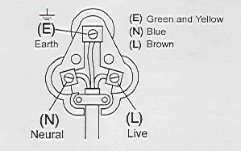

PLEASE NOTE: THIS IS A CLASS II PRODUCT AND DOES NOT NEED TO BE EARTHED

PLEASE AFFIX YOUR PROOF OF PURCHASE/RECEIPT HERE
IN THE EVENT OF A CLAIM UNDER WARRANTY THIS RECEIPT MUST BE PRODUCED.

W A R R A N T Y
Amalgamated Appliances (Pty) Limited (“the Supplier”) warrants to the original purchaser of this product (“the Customer”) that this product will be free of defects in material and workmanship which under normal, personal, family or household purpose manifest themselves within a period of 365 days from the date of purchase or in respect of commercial or professional purposes, manifest themselves within a period of 90 days from the date of purchase. Any claim in terms of the warranty must be supported by a proof of purchase. If such proof is not available, then notwithstanding anything to the contrary herein, the Supplier’s normal charge for service and/or spares will be payable by the Customer upon collection of the repaired product. If a claim is made in terms of the aforesaid warranty within the first 7 days from the date of purchase, the faulty product will be exchanged (provided that the product is in its original packaging with all accessories). Failing return of the product within 7 days, the Supplier’s liability shall be limited on return to the Supplier of the product or parts thereof, to the replacement or repair (in the sole discretion of the Supplier, or its duly authorised service dealer) of the product to eliminate any defect in workmanship or materials found to be due exclusively to any acts or omissions on the parts of the Suppliers, of which defects the Supplier shall have been notified in writing by the Customer within the aforesaid warranty period. The warranty provided herein and the obligations of the Supplier as aforesaid are in lieu of, and the Customer waives, all other warranties, guarantees, conditions or liabilities, express or implied, arising by law or otherwise, including without limitation, any obligation of the Supplier in respect of any injury, loss or damage (direct, indirect or consequential) arising out of the use of, or inability to use, this product and whether or not occasioned by the Supplier’s negligence (gross or otherwise) or any act or omission on its part. The warranty does not include and will not be construed to cover products damaged as a result of disaster, misuse, abuse or any non-authorised modification of the product. The warranty does not include replacement of light bulbs, heater bars, paper bags or any glass, plastic bowl or jug or other expendables. During the warranty period the product should be taken to a service centre of the Supplier or one of its duly authorised service agents. The Supplier neither assumes nor authorises any other person to assume for it, any additional liability in connection with the sale or servicing of its products.

AMALGAMATED APPLIANCES (PTY) LTD

JOHANNESBURG TEL NO. (011) 490-9000
29 HERONMERE ROAD
P O BOX 39186
BOOYSENS, JOHANNESBURG, 2016

CAPE TOWN TEL NO. (021) 535-0600

DURBAN TEL NO. (031) 792-6000

WIN PRIZES ONLINE – www.salton.co.za

