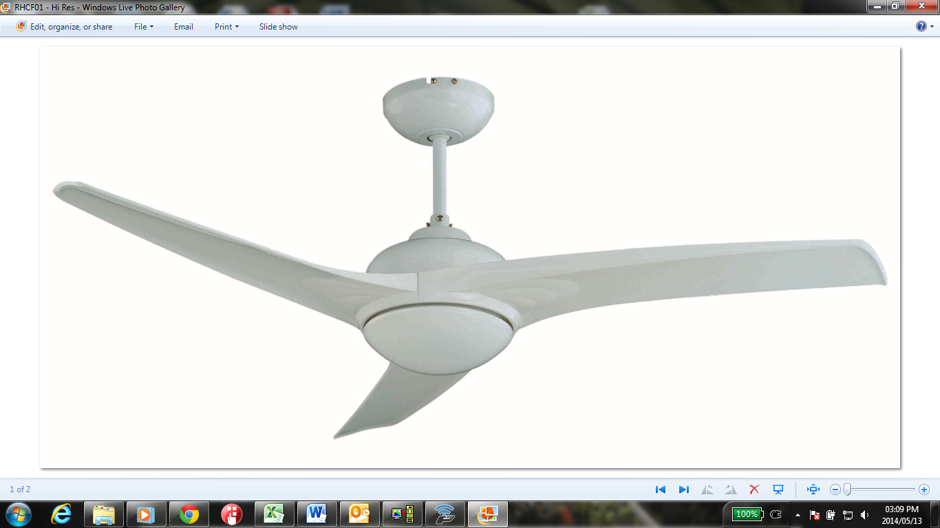

INSTRUCTIONS & WARRANTY

RHCF01
Ceiling Fan

INTRODUCTION
Congratulations on purchasing our Russell Hobbs Ceiling Fan. Each unit is manufactured to ensure safety and reliability. Before using this appliance for the first time, please read the instruction manual carefully and keep it for future reference.

IMPORTANT SAFEGUARDS
When using any electrical appliance, basic safety precautions should always be followed including the following:
- Please read the instructions carefully before using any appliance.
- Always ensure that the voltage on the rating label corresponds to the main voltage in your home.
- Incorrect operation and improper use can damage the fan and cause injury to the user.
- The fan is intended for household use only. Commercial use invalids the warranty and the supplier cannot be held responsible for injury or damage caused when using the appliance for any other purpose than that intended.
- This fan is not intended for use by persons (including children) with reduced physical, sensory or mental capabilities, or lack of experience and knowledge, unless they have been given supervision or instruction concerning use of the appliance by a person responsible for their safety.
- Do not use the fan if it has been dropped or damaged in any way. In case of damage, take the unit in for examination and/or repair by an authorized service agent.
- The use of accessory attachments that are not recommended or supplied by the manufacturer may result in injuries, fire or electric shock.
- This fan is not suitable for outdoor use. Do not use this appliance for anything other than its intended use.
- DO NOT COVER the fan under any circumstances.
- The manufacturer does not accept responsibility for any damage or injury caused by improper or incorrect use, or for repairs carried out by unauthorised personnel.
- In case of technical problems, switch off the unit and do not attempt to repair it yourself. Return the appliance to an authorized service facility for examination, adjustment or repair. Always insist on the use of original spare parts. Failure to comply with the above mentioned pre-cautions and instructions, could affect the safe operation of this machine.

INSTALLATION INSTRUCTIONS

Read these instructions carefully before mounting the fan

KEEP THE ORIGINAL CARTON AND STYROFOAM AS WARRANTY REPAIR AND SERVICE WILL NOT BE CARRIED OUT UNLESS THE FAN IS RETURNED IN COMPLETE ORIGINAL PACKING.

SAFETY PRECAUTIONS
- Never attach the fan to a power point, but to the ceiling itself.
- The minimum distance between the blades of the fan and the floor must be 2.3m. The minimum carrying capacity of the hook from which the fan is hung must be 100kg.
- Make sure to install all poles disconnection switch having a contact separation of at least 3mm between poles in the supply wiring to the ceiling fan.
- Install only bulbs of the type intended for your fan.
- Switch off the power before connecting or repairing the fan.
- The electrical wiring must be in accordance with the local regulation.
- The fan must be properly grounded to avoid the risk of electric shocks.
- Never mount the fan in a moist or wet room.
- Be careful when working near the rotating blades.

CAUTION
Always have your fan installed by someone who is knowledgeable about electrical wiring.
This appliance is not intended for use by persons (including children) with reduced physical. Sensory or mental capabilities, or lack of experience and knowledge, unless they have been given supervision or instruction concerning use of the appliance by a person responsible for their safety.
Children should be supervised to ensure that they do not play with the appliance.

FAN INSTALLATION ILLUSTRATION

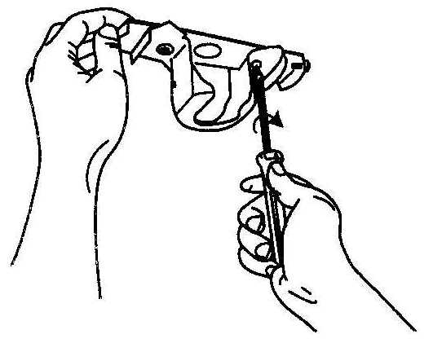  1. Secure the mounting plate to a ceiling joist with two screws, spring washers and flat washers provided. Ensure the support for the mounting plate must be capable of safely and securely holding the moving weight of the fan. | 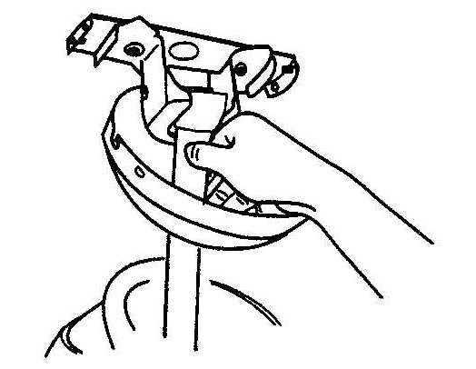  2. Hang the fan assembly onto the mounting plate. The mounting plate has a lug on it; this should be lined up with the corresponding groove on the fan assembly ball joint. | 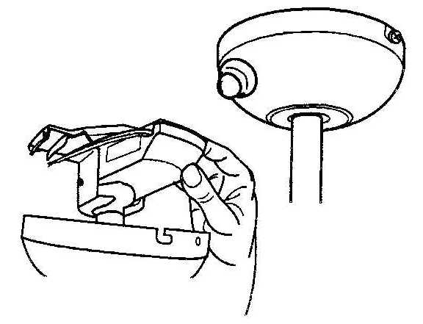  3. Insert the remote control receiver between the bracket and the ball joint, and the sensor as shown.
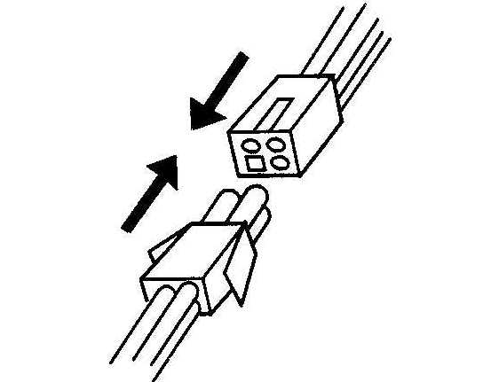  4. Insert the male connector into the female connector (from the remote control receiver to the fan, and from the remote control to the terminal block. | 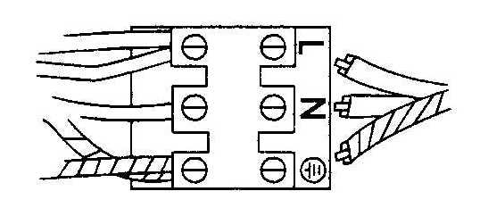  5. Connect the wires from the earthed mains supply to the terminal block. | 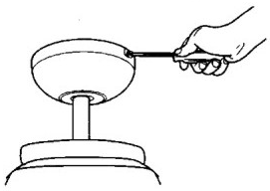  6. Lift up the canopy into place over the mounting plate. Ensure that you do not trap any wires.
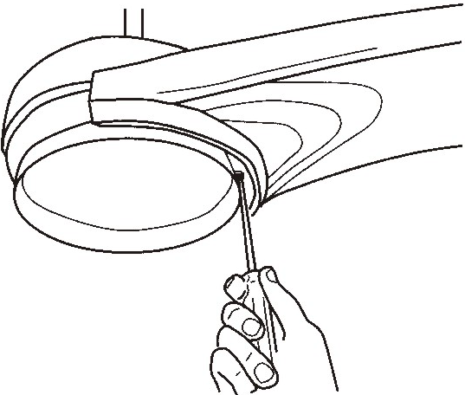  7. Fasten the blade assembly to the motor with the screws and spring washers already attached to the motor. | 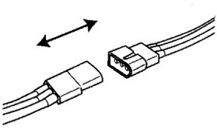  8. Connect the light kit by clipping together the two plastic male/female connectors. | 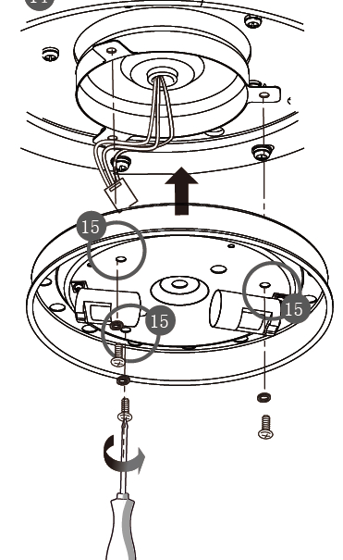  9. Fit the light kit to the switch housing by using the three light kit-fixing screws and star washers. Ensure that you do not trap any wires.
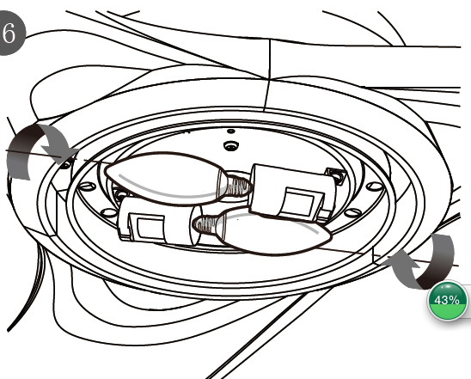  10. Install the light bulb. (E14 Max 42W, not supplied) | 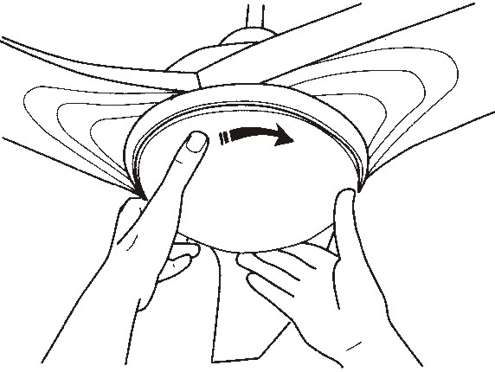  11. Install the lampshade onto the lamp gallery by rotating the lampshade clockwise.

OPERATING YOUR FAN
- Select the fan speed by pressing the speed control button on the remote control transmitter:
HI: High Speed MED: Medium Speed LOW: Low Speed OFF: Off
- The switch on motor housing for controlling the fan blades rotating direction controls the direction of air movement.
Caution: Before using this rotating direction switch, turn OFF the fan and ensure the fan stops rotating to prevent injury to yourself and damage to the motor.
Cold weather: Push the switch “UP” so that the blades will bring the warm air trapped near the ceiling fan to move downwards throughout the room.
Hot weather: Push switch “DOWN” so that the blades will create a breeze and circulate the air to the room.
- Pressing the “ON/OFF” light button on the remote control transmitter can control the turning on or off of the light.
- Pressing and holding the “DIMMER” button on the remote controller transmitter can adjust the level of light brightness.

REMOTE CONTROL
- Use the remote control transmitter to change the speed of the fan and to switch the light and fan on or off.
- Replace the batteries by sliding the battery compartment cover on the remote control transmitter in the direction of the arrow, fit 2 x “AAA” batteries, and ensure the polarity of the batteries match with the figures shown in the battery compartment. (Note: Batteries NOT included). Re-assemble the battery compartment cover.
- ALWAYS ensure the battery compartment cover is closed properly.
- DON”T expose the remote control to direct sunlight.
- DON”T attempt to recharge expired batteries. There are special rechargeable batteries, which are clearly marked with.
- DON”T dispose of batteries in fire to avoid explosion.

PLEASE AFFIX YOUR PROOF OF PURCHASE/RECEIPT HERE,
IN THE EVENT OF A CLAIM UNDER WARRANTY THIS RECEIPT MUST BE PRODUCED.

WARRANTY
- Home of Living Brands (Pty) Limited warrants to the original purchaser of this product (“the customer”) that this product will be free of defects in quality and workmanship which under normal personal, family or household use and purpose may manifest within a period of 1 (one) year from the date of purchase (“warranty period”).
- Where the customer has purchased a product and it breaks, is defective or does not work properly for the intended purpose, the customer must notify the supplier from whom the customer bought the product (“the supplier”) thereof within the warranty period. Any claim in terms of this warranty must be supported by a proof of purchase. If proof of purchase is not available, then repair, and/or service charges may be payable by the customer to the supplier.
- The faulty product must be taken to the supplier's service centre to exercise the warranty.
- The supplier will refund, repair or exchange the product in terms of this warranty subject to legislative requirements. This warranty shall be valid only where the customer has not broken the product himself, or used the product for something that it is not supposed to be used for. The warranty does not include and will not be construed to cover products damaged as a result of disaster, misuse, tamper, abuse or any unauthorised modification or repair of the product.
- This warranty will extend only to the product provided at the date of the purchase and not to any expendables attached or installed by the customer.
- If the customer requests that the supplier repairs the product and the product breaks or fails to work properly within 3 (three) months of the repair and not as a result of misuse, tampering or modification by or on behalf of the customer, then the supplier may replace the product or pay a refund to the customer.
- The customer may be responsible for certain costs where products returned are not in the original packaging, or if the packaging is damaged. This will be deducted from any refund paid to the customer.
HOME OF LIVING BRANDS (PTY) LTD (JOHANNESBURG)

JOHANNESBURG TEL NO. (011) 490-9000

CAPE TOWN TEL NO. (021) 552-5161

DURBAN TEL NO. (031) 792-6000

www.homeoflivingbrands.co.za
www.russellhobbs.co.za

