

INSTRUCTIONS AND WARRANTY

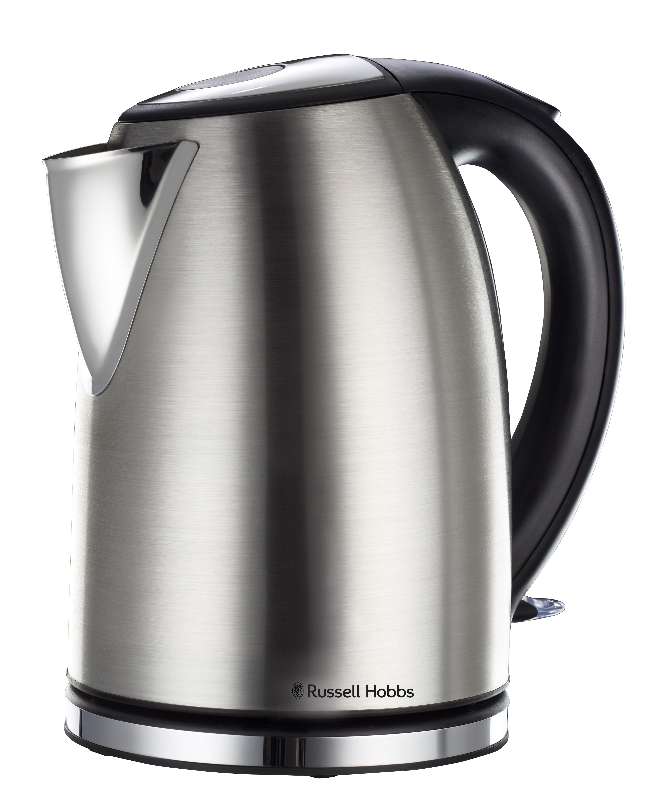

MODEL NO. RHCK07

RUSSELL HOBBS 1.8L STAINLESS STEEL CORDLESS KETTLE

Congratulations on purchasing our Russell Hobbs 1.8L Stainless Steel Cordless Kettle. Each unit is manufactured to ensure safety and reliability. Before using this appliance for the first time, please read the instruction manual carefully and keep it for future reference.

FEATURES OF THE RUSSELL HOBBS 1.8L STAINLESS STEEL CORDLESS KETTLE

- 1850-2200W
- Safety locking lid
- Automatic shut-off
- Boil-dry/over heat protection
- 360 degree base
- For domestic use only
- 1 year warranty

IMPORTANT SAFEGUARDS
When using any electrical appliance, basic safety precautions should always be followed including the following:
- Please read the instructions carefully before using any appliance.
- Always ensure that the voltage on the rating label corresponds to the mains voltage in your home.
- Incorrect operation and improper use can damage the appliance and cause injury to the user.
- The appliance is intended for household use only. Commercial use invalidates the warranty and the supplier can not be held responsible for injury or damage caused when using the appliance for any other purpose than that intended.
- This appliance is intended to be used in household and similar applications such as:
- Staff kitchen areas in shops, offices and other working environments
- Farm houses
- By clients in hotels, motels and other residential type environments
- Bed and breakfast type environments
- Avoid any contact with moving parts.
- This appliance is not intended for use by persons (including children) with reduced physical, sensory or mental capabilities, or lack of experience and knowledge, unless they have been given supervision or instruction concerning use of the appliance by a person responsible for their safety.
- Children should be supervised to ensure that they do not play with the appliance.
- Check the power cord and plug regularly for any damage. If the cord or the plug is damaged, it must be replaced by the manufacturer or a qualified person in order to avoid an electrical hazard.
- Do not use the appliance if it has been dropped or damaged in any way. In case of damage, take the unit in for examination and/or repair by an authorised service agent.
- Do not open the lid while the kettle is in use.
- Only fill the kettle with cold water. Do not fill the kettle above the MAX level (1.8L). Boiling water may splash out if overfilled.
- Unplug from outlet when not in use and before cleaning. Allow it to cool down completely before cleaning the appliance.
- Do not insert any objects into holes or slots in this appliance.
- To reduce the risk of electric shock, do not immerse or expose the motor assembly, plug or the power cord to water or any other liquid.
- Never immerse the unit in water or any other liquid for cleaning purposes. Do not allow liquid to penetrate into the electrical parts of this kettle.
- Remove the plug from the socket by gripping the plug. Do not pull on the cord to disconnect the appliance from the mains. Always unplug the unit when not in use, before cleaning or when adding or removing parts.
- The use of accessory attachments that are not recommended or supplied by the manufacturer may result in injuries, fire or electric shock. The kettle is only to be used with the base provided.
- A short cord is provided to reduce the hazards resulting from becoming entangled in or tripping over a longer cord.
- Do not let the cord hang over the edge of a table or counter. Ensure that the cord is not in a position where it can be pulled on inadvertently.
- Do not allow the cord to touch hot surfaces and do not place on or near a hot gas or electric burner or in a heated oven.
- Cleaning and user maintenance shall not be made by children unless they are older than 8 years and supervised. Keep the appliance and its cord away from reach of children aged less than 8 years old.
- Keep the device and the cable away from heat, direct sunlight, moisture, sharp edges and the like.
- Do not use the appliance on a gas or electric cooking top or over or near an open flame.
- Use of an extension cord with this appliance is not recommended. However, if it is necessary to use an extension lead, ensure that the lead is suited to the power consumption of the appliance to avoid overheating of the extension cord, appliance or plug point. Remember to not place the extension cord in a position where it can be pulled on by children or animals or tripped over.
- This appliance is not suitable for outdoor use. Do not use this appliance for anything other than its intended use.
- DO NOT carry the appliance by the power cord.
- Do not leave the appliance unattended during use. Always unplug the unit when not in use or before cleaning, and allow it to cool down completely before cleaning.
- Always operate the appliance on a smooth, even, stable surface. Do not place the unit on a hot surface.
- Ensure that the switch is in the “Off” position after each use.
- The manufacturer does not accept responsibility for any damage or injury caused by improper or incorrect use, or for repairs carried out by unauthorised personnel.
- In case of technical problems, switch off the machine and do not attempt to repair it yourself. Return the appliance to an authorised service facility for examination, adjustment or repair. Always insist on the use of original spare parts. Failure to comply with the above mentioned pre-cautions and instructions, could affect the safe operation of this machine.
- Do not touch hot surfaces. Use the handle and lid knob.
- Take care when pouring – pour slowly, and don’t over-tilt the kettle.
- Check that the lid is fully closed before switching the kettle on - otherwise it may not switch off.
- Check the kettle is properly located on the base before switching on.
- Do not switch on unless the kettle contains at least 2 cups of water.
- Remove the kettle from its base before filling or pouring.
- This appliance must not be operated by an external timer or remote control system.

PARTS DIAGRAM

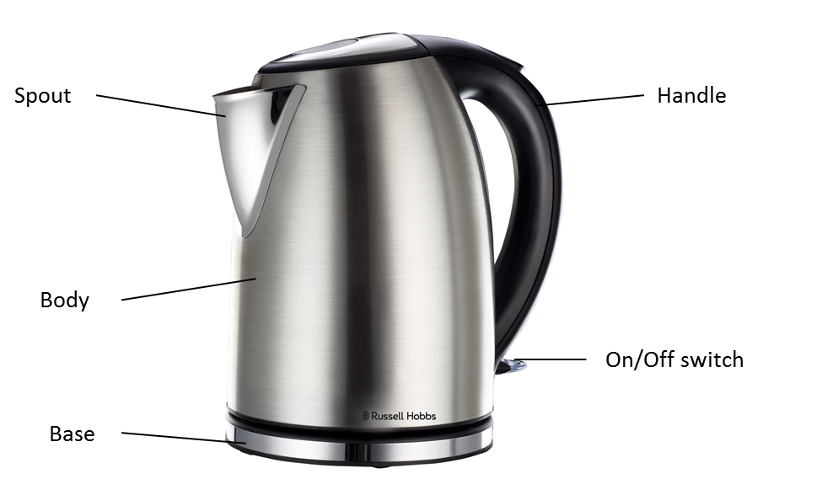

BEFORE USING THE KETTLE FOR THE FIRST TIME
Carefully remove your kettle from the box. You may wish to retain the packaging for further use.
Before first use, fill the kettle with cold water to the MAX water level mark, bring to boil and discard the boiling water – do this twice. This will ensure that any residues left over from the manufacturing process are completely removed.

POSITIONING THE KETTLE
- Position the power base on a dry flat surface away from any potential heat source.
- Unwind the length of the mains cable required to reach the mains socket.
- Ensure the mains cable does not hang over the work surface edge.

FILLING THE KETTLE
- Remove the kettle from the power base.
- Open the lid.
- Fill the kettle between the MIN and MAX markings on the water level indicator with cold water.
- Close the lid and place the kettle back on the power base. Make sure the lid is securely closed before boiling.
- Always remove the kettle from the power base before filling. Do not fill the kettle above the MAX mark or below the MIN mark on the water gauge.

SWITCHING ON
- Position the kettle on the power base.
- Plug the kettle into a mains supply socket.
- To start boiling the kettle, press the on/off switch.
- The power indicator light will illuminate and the kettle will start to boil.
- Never open the lid or touch the stainless steel surface during boiling.

Please beware of escaping steam from the lid of the kettle when in use.
SWITCHING OFF
- When the water has boiled, the kettle will switch off automatically. You can stop the boiling process at any time by lifting the on/off switch to the “0” (off) position or lifting the kettle off the base.

BOIL-DRY PROTECTION
- Should you accidentally switch on an empty kettle - the boil-dry protection will automatically switch off the power. If this occurs, allow the kettle to cool down before filling with cold water.
GENERAL
- Always remove the kettle from the base before pouring.
- To avoid the risk of splashing, pour slowly and do not over-tilt the kettle.
- Do not tilt the kettle backwards - water might get on to the control area. If this happens, let the kettle dry thoroughly before use – place it somewhere warm for 12 hours.
- When you lift the kettle, you may see moisture on the base. Do not worry – it’s the steam used to switch the kettle off automatically, which then condenses and escapes via vents under the kettle.
- You may see some discolouration on the floor of the kettle. Again, do not worry – it is due to the bonding of the element to the kettle floor.

CLEANING AND MAINTENANCE
- This appliance is for household use only and is not user-serviceable.
- Do not open or change any parts by yourself. Please refer to a qualified electrical service department or return to the supplier if servicing is necessary.
- Always remember to unplug the unit from the electrical outlet when not in use and before cleaning.
- Do not immerse the appliance in water or any other liquid, or hold it under a running tap to clean.
- To remove stubborn spots/marks, wipe the surfaces with a cloth slightly dampened in soapy water or mild non-abrasive cleaner. Rinse and dry with a clean, dry, soft cloth.
- Unplug the base from the wall socket, and let the kettle cool down before cleaning.
- Wipe the kettle, inside and out, with a damp cloth. You may use a little household detergent, but if you do, rinse well to avoid tainting the water.
- Wipe the base with a damp cloth.
- Keep all connectors and sockets dry.
- Do not immerse the kettle or kettle stand in liquid.
- Do not use harsh or abrasive cleaning agents or solvents.

We recommend that you descale your kettle regularly, even in soft water areas. Lime scale may be white, coloured, or even rusty-looking, but it is normally visible. Phosphate scale is not generally visible, but there is always a build-up, even in soft water areas. Any build-up of scale causes overheating, which reduces the life of the element, and may trigger the boil-dry cut-out to engage. So, even in a soft water area, descale at least monthly, to help keep your kettle in working order.

To descale your kettle:
- Use a descaler suitable for plastic products (all kettles have plastic parts). Follow the instructions on the descaler, then rinse several times, fill, boil and discard the water, to remove all chemical residues.
- Products returned under guarantee with faults related to scale will be subject to a repair charge.
- If you notice your kettle getting noisier – descale it.
- Do not rely on visible scale, as phosphate scale is not visible. Rather descale the kettle for preventative purposes.
- Do not try to move or remove the diffuser – you will break it.

Removing mineral deposits
- Decalcification refers to removing the calcium deposits which may form on the interior metal parts of the kettle.
- To get the best performance from your kettle, descale your kettle from time to time. Frequency depends on the hardness of your tap water and how often you use the kettle.
- We suggest use of a kettle descaler in order to dissolve chalky deposits or scale.
- Follow the directions on the descaler package. If a commercial descaler is not available, fill the kettle with enough white vinegar to cover the bottom by about 1.5cm. Bring the vinegar to a boil. You may need to repeat this several times with cooled vinegar to remove the calcium build-up completely. When the descaling process is complete, empty the kettle and rinse out several times with clean water.

STORING THE APPLIANCE
- Unplug the unit from the electrical outlet and clean all the parts as instructed above. Ensure that all parts are dry before storing.
- Store the appliance in its box or in a clean, dry place.
- Never store the appliance while it is still wet or dirty.
- Never wrap the power cord around the appliance.

SERVICING THE APPLIANCE
There are no user serviceable parts in this appliance. If the unit is not operating correctly, please check the following:
- You have followed the instructions correctly
- That the unit has been wired correctly and that the wall socket is switched on.
- That the mains power supply is ON.
- That the plug is firmly in the mains socket.

If the appliance still does not work after checking the above:
- Consult the retailer for possible repair or replacement. If the retailer fails to resolve the problem and you need to return the appliance, make sure that:
- The unit is packed carefully back into its original packaging.
- Proof of purchase is attached.
- A reason is provided for why it is being returned.

If the supply cord is damaged, it must be replaced by the manufacturer or an authorised service agent, in order to avoid any hazard. If service becomes necessary within the warranty period, the appliance should be returned to an approved Home of Living Brands (Pty) Limited service centre. Servicing outside the warranty period is still available, but will, however, be chargeable.

CHANGING THE PLUG

Should the need arise to change the fitted plug, follow the instructions below.
This unit is designed to operate on the stated current only. Connecting to other power sources may damage the appliance. Connect a three-pin plug as follows:
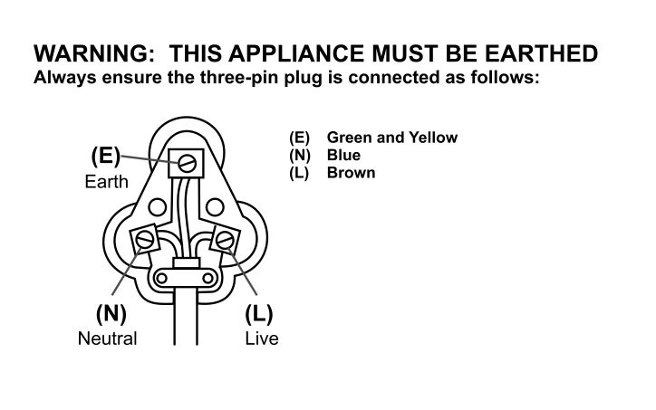
The wires in this mains lead are coloured in accordance with the following code:

PLEASE AFFIX YOUR PROOF OF PURCHASE/RECEIPT HERE
IN THE EVENT OF A CLAIM UNDER WARRANTY THIS RECEIPT MUST BE PRODUCED.

W A R R A N T Y

- Home of Living Brands (Pty) Limited (“Home of Living Brands”) warrants to the original purchaser of this product (“the customer”) that this product will be free of defects in quality and workmanship which under normal personal, family or household use and purpose may manifest within a period of 1 (one) year from the date of purchase (“warranty period”).
- Where the customer has purchased a product and it breaks, is defective or does not work properly for the intended purpose, the customer must notify the supplier from whom the customer bought the product (“the supplier”) thereof within the warranty period. Any claim in terms of this warranty must be supported by a proof of purchase. If proof of purchase is not available, then repair, and/or service charges may be payable by the customer to the supplier.
- The faulty product must be taken to the supplier's service centre to exercise the warranty.
- The supplier will refund, repair or exchange the product in terms of this warranty subject to legislative requirements. This warranty shall be valid only where the customer has not broken the product himself, or used the product for something that it is not supposed to be used for. The warranty does not include and will not be construed to cover products damaged as a result of disaster, misuse, tamper, abuse or any unauthorised modification or repair of the product.
- This warranty will extend only to the product provided at the date of the purchase and not to any expendables attached or installed by the customer.
- If the customer requests that the supplier repairs the product and the product breaks or fails to work properly within 3 (three) months of the repair and not as a result of misuse, tampering or modification by or on behalf of the customer, then the supplier may replace the product or pay a refund to the customer.
- The customer may be responsible for certain costs where products returned are not in the original packaging, or if the packaging is damaged. This will be deducted from any refund paid to the customer.

HOME OF LIVING BRANDS (PTY) LTD (JOHANNESBURG)

JOHANNESBURG TEL NO. (011) 490-9600

CAPE TOWN TEL NO. (021) 552-5161

DURBAN TEL NO. (031) 792-6000

www.russellhobbs.co.za
www.homeoflivingbrands.com
www.facebook.com/RussellHobbsSA

Félicitations pour l'achat de notre bouilloire sans fil 1,7 L en acier inoxydable Russell Hobbs. Chaque unité est fabriquée afin de d’assurer la sécurité et la fiabilité. Avant d’utiliser cet appareil pour la première fois, merci de lire le manuel avec soin et de le garder à titre de référence.

CARACTÉRISTIQUES DE LA BOUILLOIRE SANS FIL 1,8 L EN ACIER INOXYDABLE RUSSELL HOBBS

- 1850 - 2200 W
- Dispositif de verrouillage de sécurité du couvercle
- Arrêt automatique
- Protection anti-chauffage à sec / contre le surchauffement
- Base à 360°
- Réservé uniquement à un usage domestique
- 1 an de garantie

GARANTIES IMPORTANTES
Lors de l’utilisation de n’importe quel appareil électrique, des précautions de sécurité élémentaires devraient toujours être suivies, ainsi que les points suivants :
- Merci de lire les instructions avec attention avant d’utiliser tout appareil quel qu’il soit.
- Toujours vous assurer que le voltage indiqué sur la plaque signalétique correspond aux voltages principaux dans votre maison.
- Une opération incorrecte et une utilisation inappropriée peuvent endommager l’appareil et entraîner des blessures pour l’utilisateur.
- L’appareil est destiné à uniquement à un usage domestique. Une utilisation commerciale annule la garantie et le fournisseur ne peut pas être tenu pour responsable des blessures ou des dommages causent lors de l’utilisation de l’appareil pour tout autre usage que celui auquel il est destiné.
- Cet appareil est conçu pour une utilisation domestique ou dans des applications comparables, comme :
- la cuisine du personnel dans les boutiques, dans les bureaux ou dans d’autres environnements professionnels ;
- maisons de champagne ;
- par les clients des hôtels, motels et d’autres environnements de type résidentiels ;
- environnements de type chambres d’hôtes.
- Éviter tout contact avec les parties mobiles.
- Cet appareil n’est pas destiné aux personnes (y compris les enfants) dont les capacités physiques, sensorielles et intellectuelles sont limitées, ou qui ont un manque d’expérience et de connaissances à moins qu’elles n’aient été supervisées ou qu’elles aient reçu des instructions sur l’utilisation de l'appareil par une responsable de leur sécurité.
- Les enfants devraient être surveillés pour s’assurer qu’ils ne jouent pas avec l’appareil.
- Vérifier le cordon d’alimentation et brancher régulièrement pour éviter que le cordon ne soit endommagé. Si le cordon ou la prise sont endommagés, ils doivent être remplacés par le fabricant ou par une personne qualifiée afin d’éviter un danger électrique.
- Ne pas utiliser l’appareil s’il est tombé ou s’il a été endommagé de quelque manière que ce soit. En cas de dommage, rapporter l’unité pour un examen et / ou une réparation par un agent de maintenance agréé.
- N'ouvrez pas le couvercle pendant que la bouilloire fonctionne.
- Remplissez la bouilloire uniquement avec de l'eau froide. Ne remplissez pas la bouilloire au-delà du niveau MAX (1,7 L). De l'eau bouillante peut éclabousser, si la bouilloire est trop remplie.
- Débranchez-la de la prise lorsqu'elle ne fonctionne pas et avant de la nettoyer. Laissez refroidir complètement avant de nettoyer l'appareil.
- N'insérez aucuns objets dans les trous et les fentes de cet appareil.
- Pour éviter le risque de choc électrique, ne pas immerger ou exposer l’ensemble du moteur, la prise, ou le cordon d’alimentation dans l’eau ou bien dans tout autre liquide.
- Ne jamais immerger l’unité dans l’eau ou dans tout autre liquide pour le nettoyer. Ne laissez pas de liquide s'infiltrer dans les pièces électriques de cette bouilloire.
- Retirer la fiche de la prise en tenant la fiche. Ne pas tirer sur le cordon pour déconnecter l’appareil du secteur. Toujours débrancher l’unité lorsqu’elle n’est pas utilisée, avant le nettoyage ou lors de l’ajout ou du retrait de parties.
- L’utilisation d’accessoires se fixant à l’unité qui ne sont ni recommandés ou fournis par le fabricant pourrait entraîner des blessures, un incendie ou un choc électrique. La bouilloire ne doit être utilisée qu’avec le socle qui est fourni.
- Un cordon court est fourni pour réduire les risques résultant d’un entremêlement, ou de trébuchement sur ce dernier.
- Ne pas laisser le cordon dépasser du bord de la table ou du comptoir. S’assurer que le cordon n’est pas dans une position ou il peut être tire par inadvertance.
- Ne pas laisser le cordon de toucher des surfaces chaudes et ne pas le placer sur ou près d’un réchaud à gaz ou électrique ou d’un four chaud.
- Le nettoyage et l'entretien de la part d l'utilisateur ne doivent pas être faits par des enfants, à moins qu'ils n'aient plus de 8 ans et qu'ils soient supervisés. Gardez l'appareil et son cordon hors de la portée des enfants âgés de moins de 8 ans.
- Gardez le dispositif et le câble à l'écart de la chaleur, de la lumière directe du soleil, de l'humidité, de bords tranchants, etc.
- Ne pas utiliser l’appareil sur une plaque à gaz ou électrique ou au-dessus d’une flamme.
- L’utilisation d’un cordon d’extension avec cet appareil n’est pas recommandée. Cependant, s’il s’avère nécessaire d’utiliser une rallonge électrique qui est adaptée à la consommation d’énergie de l’appareil, afin d’éviter le surchauffement du cordon d’extension, de l’appareil ou de la prise de courant. Rappelez-vous de ne pas placer la rallonge du cordon dans une position où elle peut être tirée par les enfants ou les animaux ou bien où l'on risque de trébucher dessus.
- Cet appareil n’est pas recommandé pour un usage extérieur. Ne pas utiliser cet appareil pour quoique ce soit d’autre que l’utilisation à laquelle il est destiné.
- NE PAS porter l’appareil en le prenant par le cordon d’alimentation.
- Ne pas laisser cet appareil sans surveillance pendant son utilisation. Débranchez toujours l'appareil, lorsqu'il ne fonctionne pas ou avant le nettoyage, et laissez-le refroidir complètement avant de le nettoyer.
- Faire toujours fonctionner l’appareil sur une surface régulière et stable. Ne pas placer l’unité sur une surface chaude.
- S’assurer que l’interrupteur est en position « ARRÊT » après chaque utilisation.
- Le fabricant n’accepte de prendre aucune responsabilité pour tout dommage ou blessure que ce soit, qui seraient dues à une utilisation incorrecte ou inappropriée, ou celle de réparations exécutées par un personnel non-agréé.
- En cas de problèmes techniques, éteindre la machine et ne pas essayer de la réparer vous-même. Renvoyer l’appareil à un service de maintenance habileté pour un examen, un ajustement ou pour une réparation. Insister toujours pour que les pièces détachées d’origines soient utilisées. Le non-respect avec les précautions et les instructions mentionnées ci-dessus pourrait empêcher le bon fonctionnement de cette machine.
- Ne touchez pas les surfaces chaudes. Utilisez la poignée et le bouton du couvercle.
- Faites attention lorsque vous versez – versez lentement et n’inclinez pas trop la bouilloire.
- Vérifiez que le couvercle soit totalement fermé avant d’allumer la bouilloire, sinon elle pourrait d’éteindre.
- Vérifiez que la bouilloire soit bien installée sur le socle avant de l’allumer.
- N’allumez pas, à moins que la bouilloire ne contienne au moins 2 tasses d’eau.
- Retirez la bouilloire de son socle avant de la remplir ou de verser de l’eau.
- Cet appareil ne doit pas être utilisé avec une minuterie externe ou avec un système de contrôle à distance.

SCHÉMA DES PIÈCES
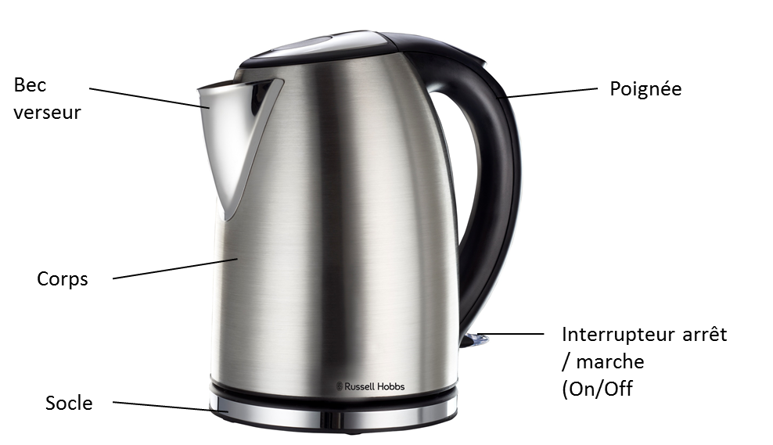

AVANT D’UTILISER LA BOUILLOIRE POUR LA PREMIÈRE FOIS
Retirez soigneusement votre bouilloire de la boîte. Vous pouvez souhaiter de garder l'emballage pour un usage ultérieur.
Avant la première l'utilisation, remplissez la bouilloire avec de l'eau froide jusqu'au niveau MAX, portez-la à ébullition et jetez l'eau bouillante – faites cela à deux reprises. Ceci assurera que tous les résidus restant, qui proviennent du processus de fabrication, sont complètement enlevés.

POSITIONNEMENT
POSITIONNEMENT DE LA BOUILLOIRE
- Positionnez le socle d'alimentation sur une surface plane, sèche, à l'écart de toute source de chaleur potentielle.
- Déroulez la longueur du câble d'alimentation requise pour atteindre la prise d'alimentation.
- Assurez-vous que le câble d'alimentation ne pende pas au-dessus du bord de la surface de travail.

LE REMPLISSAGE DE LA BOUILLOIRE
- Retirez la bouilloire du socle d'alimentation.
- Ouvrez le couvercle.
- Remplissez la bouilloire avec de l'eau froide, entre les marques MIN et MAX se trouvant sur l'indicateur du niveau d'eau.
- Fermez le couvercle et remettez la bouilloire sur le socle d'alimentation. Assurez-vous que le couvercle soit bien fermé avant de faire bouillir.
- Retirez toujours la bouilloire du socle d'alimentation, avant de la remplir. Ne remplissez pas la bouilloire au-delà de la marque MAX, ou en-deçà de la marque MIN qui se trouvent sur la jauge d'eau.

ALLUMER
- Placez la bouilloire sur le socle d'alimentation.
- Branchez la bouilloire dans une prise de courant.
- Pour que la bouilloire commence à chauffer, appuyez sur vers le bas sur l'interrupteur on/of (marche / arrêt).
- Le témoin lumineux de mise sous tension s'allumera et la bouilloire commencera à bouillir.
- N'ouvrez jamais le couvercle ou ne touchez jamais la surface en acier inoxydable pendant que la bouilloire chauffe.
- Ne faites pas fonctionner la bouilloire sans que le filtre ne soit installé.

Faites attention à la vapeur qui s’échappe du couvercle de la bouilloire lorsqu’elle fonctionne.
ÉTEINDRE
- La bouilloire s’éteindra automatiquement lorsque l’eau est bouillie. Vous pouvez interrompre le processus d'ébullition à tout instant en soulevant l'interrupteur on/off (marche / arrêt) sur la position « 0 » ou en soulevant la bouilloire du socle.

DISPOSITIF D'ANTI-ÉBULLITION À SEC
- Au cas où vous mettriez, par accident, une bouilloire vide en marche, le dispositif d'anti-ébullition à sec coupera automatiquement l'alimentation. Si cela arrive, laissez la bouilloire refroidir avant de la remplir d'eau froide.

GÉNÉRAL
- Retirez toujours la bouilloire du socle d'alimentation, avant de verser.
- Pour éviter les risques d’éclaboussures, évitez de trop incliner la bouilloire.
- N’inclinez pas la bouilloire vers l’arrière – l’eau pourrait gicler sur la zone de contrôle. Si cela arrive, laissez la bouilloire sécher avant de l’utiliser – placez-la dans un endroit chaud pendant 12 heures.
- Lorsque vous soulevez la bouilloire, vous verrez peut-être de l’humidité sur le socle. Ne vous inquiétez pas – il s’agit de la vapeur qui sert à éteindre la bouilloire automatiquement, qui a condensé et qui s’est échappée des trous d’aération situés sous la bouilloire.
- Vous pourriez observer certaines décolorations au fond de la bouilloire. Encore une fois, ne vous inquiétez pas – ceci est dû des éléments qui collent au fond de la bouilloire.

NETTOYAGE ET MAINTENANCE
- Cet appareil est destiné uniquement à un à usage domestique et il ne peut pas être réparé par l’utilisateur.
- Ne pas ouvrir ou changer aucune des parties vous-même. Veuillez-vous référer auprès d’un service électrique qualifié ou renvoyer le batteur manuel au fournisseur si cela s’avère nécessaire pour son entretien.
- Souvenez-vous de toujours débrancher l’unité de la prise électrique lorsqu’elle n’est pas utilisée et avant de la nettoyer.
- Ne pas immerger l'appareil dans de l’eau ou dans tout autre liquide, et le maintenir sous un robinet pour le nettoyer.
- Pour enlever les tâches / marques résistantes, essuyer la surface avec un chiffon légèrement humidifié dans de l’eau savonneuse ou avec un nettoyant non abrasif doux. Rincer et nettoyer avec un chiffon propre, sec et doux.
- Débranchez le socle de la prise murale et laissez la bouilloire refroidir avant de la nettoyer.
- Essuyez l’intérieur et l’extérieur de la bouilloire avec un chiffon humide. Vous pouvez utiliser un peu de liquide vaisselle, mais dans ce cas, rincez bien pour éviter de teinter l’eau.
- Essuyez le socle avec un chiffon humide.
- Gardez tous les connecteurs et toutes les prises au sec.
- N’immergez pas la bouilloire ou le socle dans du liquide.
- N’utilisez pas de produits de nettoyage agressifs ou abrasifs, ainsi que des solvants.

Nous recommandons que vous détartriez régulièrement votre bouilloire, cela même dans les zones d’eau douce. Le dépôt de calcaire peut être blanc, coloré où il peut même avoir une couleur de rouille, mais normalement il est visible. Le dépôt de phosphate est généralement invisible, mais il est présent même dans les zones où l‘eau est douce. Tout dépôt de tarte peut provoquer une surchauffe, qui réduit la durée de vie de la résistance électrique et qui peut déclencher la fonction de coupure lorsque l’appareil bouille à sec. Donc, même dans les zones où l’eau est douce, détartrez au moins une fois par mois, afin de conserver votre bouilloire en état de marche.

Pour détartrer votre bouilloire :
- Utilisez un détartrant compatible avec les produits en plastiques (toutes les bouilloires ont des parties en plastique). Suivez les instructions indiquées sur le détartrant, puis rincez plusieurs fois, remplissez, faites bouillir et jetez l’eau afin d’enlever tous les résidus chimiques.
- Les produits sous garantie, qui auront été renvoyés avec des défauts causés par le tartre seront sujets à des frais de réparation.
- Si vous constatez que votre bouilloire devient plus bruyante – détartrez-la.
- Ne vous fiez pas au tartre qui est visible, car le tartre de phosphate est invisible. Il vaut mieux en action préventive détartrer votre bouilloire.
- N’essayez pas de déplacer ou d’enlever le diffuseur – vous le casseriez.

Filtre à eau :
- Les particules de calcaire en suspension dans l’eau, pourrait lui donner une apparence trouble ou grisâtre.
- Le filtre évitera que ces particules n’arrivent dans vos boissons. Si vous voyez des dépôts sur le filtre, nettoyez-le, sinon la performance de votre bouilloire diminuera, vos boissons pourraient alors contenir du calcaire et l’eau à l’intérieur pourrait être trouble.

Le nettoyage du filtre :
- Le filtre se trouve à l'intérieur de la bouilloire derrière le bec.
- Avec le couvercle ouvert, retirez doucement le filtre de sa fente de maintien.
- Retirez le filtre de la bouilloire.
- Rincez le filtre dans de l'eau chaude et retirez soigneusement tout le calcaire avec une brosse douce.
- Pour replacer le filtre, faites-le glisser vers le bas dans sa fente, jusqu'à ce qu'il s'enclenche en place.

Retirer les dépôts minéraux
- La décalcification se rapporte au retrait des dépôts de calcium qui peuvent se former à l'intérieur des pièces métallique de la bouilloire.
- Afin d'obtenir la meilleure performance de la part de votre bouilloire, détartrez-la de temps en temps. La fréquence dépend de la dureté de votre eau du robinet et de la fréquence avec laquelle vous utilisez votre bouilloire.
- Nous suggérons l'utilisation d'un détartrant pour bouilloire, afin de dissoudre les dépôts calciques ou de calcaire.
- Suivez les indications sur le paquet du détartrant. Dans le cas où un détartrant commercial n'est pas disponible, remplissez la bouilloire avec suffisamment de vinaigre blanc pour couvrir la base sur environ 1,5 cm. Portez le vinaigre à ébullition. Vous aurez peut-être besoin de répéter cela plusieurs fois avec un vinaigre refroidit afin de retirer complètement l'accumulation de calcaire. Lorsque le processus de détartrage est terminé, videz la bouilloire et rincez-la plusieurs fois avec de l'eau propre.

RANGEMENT DE L'APPAREIL
- Assurez-vous que l’appareil est en position d’ARRÊT. Débranchez la cafetière de la prise d’alimentation.
- Nettoyer les pièces comme il l’a été recommandé ci-dessus. S’assurer que toutes les pièces sont sèches avant de les ranger.
- Ranger l'appareil dans un endroit propre et sec.
- Ne jamais ranger l'appareil s’il est encore humide ou sale.
- Ne jamais enrouler le cordon d’alimentation autour du appareil.

MAINTENANCE DE L’APPAREIL
Il n’existe pas de pièces dans cet appareil, dont la maintenance puisse être faite par l’utilisateur. Si l’unité ne fonctionne pas correctement, veuillez vérifier les points suivants :
- Vous avez correctement suivi les instructions.
- Que l’unité a été correctement connectée et que toutes les prises murales sont allumées.
- Que l’alimentation secteur est sur MARCHE.
- Que la fiche est solidement ancrée dans la prise de courant.

Si cet appareil ne fonctionne toujours pas après avoir vérifié les points énoncés ci-dessus :
Consulter un détaillant pour la possibilité d’une réparation ou bien d’un replacement. Si le détaillant ne réussit pas à résoudre le problème est que vous devez renvoyer l’appareil, assurez-vous que :
- L’unité est emballée avec soin dans son emballage d’origine.
- La preuve d’achat est jointe.
- La raison pour laquelle l’appareil est renvoyé.

Si le cordon d’alimentation est endommagé, il doit être remplacé par le fabriquant ou par un agent de maintenance agréé, afin d’éviter tout danger. Si la maintenance devient nécessaire pendant la durée de la garantie, l’appareil devrait être renvoyé à un centre de maintenance agréé par Home of Living Brands (Pty) Ltd. La maintenance au-delà de la garantie est toutefois possible, mais elle sera cependant facturée.

LE CHANGEMENT DE LA PRISE
Si la prise intégrée devait être change, suivez les instructions ci-dessous.
Cette unité est uniquement conçue pour fonctionner au courant indiqué. La connexion à d’autres sources d’alimentation pourrait endommager le appareil. Connecter la prise à trois chiffes de la manière suivante :
Les fils de ce réseau sont colorés selon le code suivant :
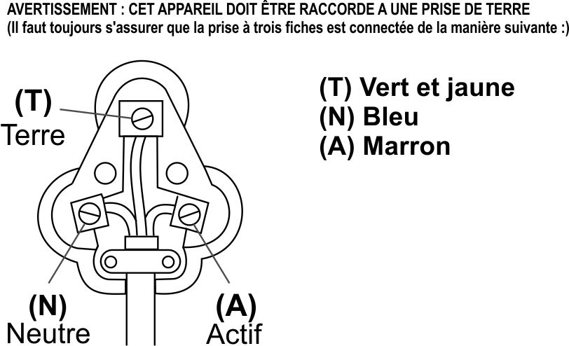
Vert/jaune = Terre
Bleu = Neutre
Marron = Actif

VEUILLEZ APPOSER VOTRE PREUVE D’ACHAT / RECU ICI EN CAS DE RECLAMATION PENDANT LA PERIODE DE GARANTIE CE RECUS DOIT ETRE PRESENTE.

GARANTIE

- Home of Living Brands (Pty) Limited garantie à l’acheteur d’origine de ce produit (« le client »), que ce dernier ne présentera pas de défauts de qualité, ni de fabrication qui dans le cadre d’une utilisation normale, familiale ou domestique pourrait apparaître en l’espace d’1 (d’une) année suivant la date d’achat (« période de garantie »).
- Lorsque le client a acheté un produit qui se casse, présente des défauts ou qui ne fonctionne pas correctement pour l’utilisation pour laquelle il était destiné, le client doit signaler cela au fournisseur auprès duquel il a acheté le produit (« le fournisseur ») durant la période de garantie. Toute réclamation selon les conditions de la garantie doit être accompagnée d’une preuve d’achat. Si la preuve d’achat, n’est pas disponible, à ce moment-là, les frais de réparation et / ou d’entretien peuvent être à la charge du client vis-à-vis du fournisseur.
- Un produit défectueux doit être rapporté au centre d’entretien du fournisseur pour faire jouer la garantie.
- Le fournisseur remboursera, réparera ou échangera le produit selon les termes de cette garantie qui est assujettie aux exigences légales. Cette garantie devrait être valable uniquement quand le client n’a pas cassé lui-même l’appareil, ou utilisé ce dernier pour faire quelque chose pour lequel il n’était pas destiné. La garantie ne comprend pas et ne peut pas être saurait être considérée comme couvrant les dommages affectant l’appareil, qui seraient le résultat d’un accident, d’une mauvaise utilisation, d’une modification, d’un abus ou de toute modification ou réparation non-autorisée de l’appareil.
- La garantie couvrira uniquement le produit fournit à la date d’achat et elle ne s’appliquera pas à toute pièces ajoutée ou installée par le client.
- Si le client demande au fournisseur de réparer le produit et si le produit casse ou ne fonctionne pas correctement dans les 3 (trois) mois de la réparation, et si ceci n’est pas le résultat d’une mauvaise utilisation, à ce moment-là le fournisseur pourrait remplacer le produit ou rembourser le client.
- Le client pourrait être tenu pour responsable de certains frais lorsque les produits ne sont pas renvoyés dans leur emballage d’origine, ou si l’emballage est endommagé. Ceci sera déduit de tout remboursement fait au client.
HOME OF LIVING BRANDS (PTY) LTD
www.homeoflivingbrands.com
011 490-9600 (Johannesburg)
031 792-6000 (Durban)
021 552-5161 (Cape Town)
www.russellhobbs.co.za
www.facebook.com/RussellhobbsSA

Parabéns por ter comprado a nossa chaleira sem fios de 1,7 L de aço inoxidável da Russell Hobbs. Cada unidade é fabricada de forma a garantir segurança e fiabilidade. Antes de utilizar este aparelho pela primeira vez, leia o manual de instruções atentamente e guarde-o para futura referência.

CARACTERÍSTICAS DA CHALEIRA SEM FIOS DE 1,8 L DE AÇO INOXIDÁVEL DA RUSSELL HOBBS

- 1850 - 2200 W
- Tampa de bloqueio de segurança
- Desligamento automático
- Protecção contra funcionamento a seco/sobreaquecimento
- Base de 360 graus
- Apenas para utilização doméstica
- 1 ano de garantia

SALVAGUARDAS IMPORTANTES
Quando utilizar qualquer aparelho elétrico, deve seguir sempre as precauções de segurança básicas, incluindo o seguinte:
- Leia atentamente as instruções antes de utilizar qualquer aparelho.
- Certifique-se sempre de que a tensão na etiqueta de classificação corresponde à tensão da corrente elétrica na sua residência.
- A operação incorreta e utilização imprópria podem danificar o aparelho e causar lesões no utilizador.
- O aparelho destina-se apenas a utilização doméstica. A utilização comercial invalida a garantia e o fornecedor não pode ser responsabilizado por lesões ou danos causados quando o aparelho for utilizado para qualquer outra finalidade diferente da prevista.
- Este aparelho destina-se a ser utilizado em ambientes domésticos e aplicações semelhantes, como:
- Áreas da cozinha do pessoal em lojas, escritórios e outros ambientes de trabalho;
- Quintas;
- Por clientes nos hotéis, motéis e outros ambientes semelhantes a residenciais;
- Ambientes do tipo Bed and breakfast;
- Evite qualquer contacto com as peças em movimento.
- Este aparelho não se destina a ser utilizado por pessoas (incluindo crianças) com capacidades físicas, sensoriais ou mentais reduzidas, ou com falta de experiência e conhecimentos, a não ser que tenham sido supervisionados ou ensinados a utilizar o aparelho por uma pessoa responsável pela sua segurança.
- As crianças devem ser supervisionadas para garantir que não brincam com o aparelho.
- Verifique o cabo de alimentação e a ficha regularmente para verificar a existência de quaisquer danos. Se o cabo ou a ficha estiverem danificados, devem ser substituídos pelo fabricante ou por uma pessoa qualificada de forma a evitar um perigo elétrico.
- Não utilize o aparelho se este tiver sido deixado cair ou estiver danificado de qualquer forma. Em caso de danos, devolva a unidade para verificação e/ou reparação por parte de um agente de assistência autorizado.
- Não abra a tampa enquanto a chaleira estiver a ser utilizada.
- Encha a chaleira apenas com água fria. Não encha a chaleira acima do nível MÁX (1,7 L). A água a ferver pode salpicar para fora caso encha em demasia.
- Desligue da tomada quando não estiver a ser utilizada e antes de limpar. Deixe arrefecer completamente antes de limpar o aparelho.
- Não insira quaisquer objectos nos orifícios ou ranhuras neste aparelho.
- Para reduzir o risco de choque elétrico, não mergulhe ou exponha o conjunto do motor, ficha ou cabo de alimentação em água ou em qualquer outro líquido.
- Nunca coloque a unidade dentro de água ou qualquer outro líquido para fins de limpeza. Não permita a entrada de líquidos nas peças eléctricas desta chaleira.
- Remova a ficha da tomada ao agarrar na ficha. Não puxe pelo cabo para desligar o aparelho da corrente elétrica. Desligue sempre a unidade quando esta não estiver a ser utilizada, antes de limpar ou quando adicionar ou remover peças.
- A utilização de acessórios não recomendados ou fornecidos pelo fabricante pode resultar em lesões, incêndios ou choque elétrico. A chaleira destina-se a ser utilizada apenas com a base fornecida.
- É fornecido um cabo pequeno para reduzir os riscos resultantes de ficar preso ou de tropeçar num cabo maior.
- Não deixe o cabo suspenso pela extremidade de uma mesa ou balcão. Certifique-se de que o cabo não se encontra numa posição em que possa ser puxado inadvertidamente.
- Não permita que o cabo toque em superfícies quentes e não o coloque sobre ou perto de uma caldeira elétrica ou a gás quente ou num forno aquecido.
- A limpeza e a manutenção do utilizador não devem ser efectuadas por crianças, a não ser que tenham mais de 8 anos e estejam sob supervisão. Mantenha o aparelho e o seu cabo de alimentação fora do alcance das crianças com idade inferior a 8 anos.
- Mantenha o dispositivo e o cabo afastados do calor, luz solar directa, humidade, extremidades afiadas e semelhantes.
- Não utilize o aparelho sobre uma superfície de cozimento a gás ou elétrica ou sobre ou perto de uma chama.
- A utilização de uma extensão com este aparelho não é recomendada. No entanto, caso seja necessário utilizar uma ficha de extensão, certifique-se de que a ficha é adequada para o consumo de energia do aparelho para evitar o sobreaquecimento do cabo da extensão, aparelho ou tomada. Lembre-se de não colocar o cabo de extensão numa posição onde possa ser puxado por crianças ou animais ou que possa provocar quedas.
- Este aparelho não é adequado para ser utilizado no exterior. Não utilize este aparelho para outra finalidade diferente da prevista.
- NÃO transporte o aparelho pelo cabo de alimentação.
- Não deixe o aparelho não supervisionado durante a utilização. Desligue sempre a unidade da tomada quando não está a ser utilizada ou antes de a limpar e deixe-a arrefecer completamente antes de a limpar.
- Utilize sempre o aparelho numa superfície suave, uniforme e estável. Não coloque a unidade numa superfície quente.
- Certifique-se de que o interruptor está na posição "Off" (desligado) após cada utilização.
- O fabricante não aceita responsabilidade por qualquer dano ou lesão causados devido a uma utilização imprópria ou incorreta ou a reparações realizadas por pessoal não autorizado.
- Em caso de problemas técnicos, desligue a máquina e não tente repará-la você próprio. Devolva o aparelho a um agente de assistência autorizado para verificação, ajuste ou reparação. Insista sempre em utilizar peças sobresselentes originais. O não cumprimento das precauções e instruções acima poderá afetar o funcionamento seguro desta máquina.
- Não toque nas superfícies quentes. Utilize a pega e o puxador da tampa.
- Tenha cuidado quando verter a água – verta lentamente e não incline demasiado a chaleira.
- Verifique se a tampa está totalmente fechada antes de ligar a chaleira, caso contrário poderá não se desligar.
- Verifique se a chaleira está devidamente localizada na base antes de a ligar.
- Não ligue o aparelho a não ser que a chaleira contenha, pelo menos, 2 copos de água.
- Retire a chaleira da sua base antes de encher ou verter.
- Este aparelho não deve ser operado por um temporizador externo ou sistema de controlo remoto.

DIAGRAMA DE PEÇAS

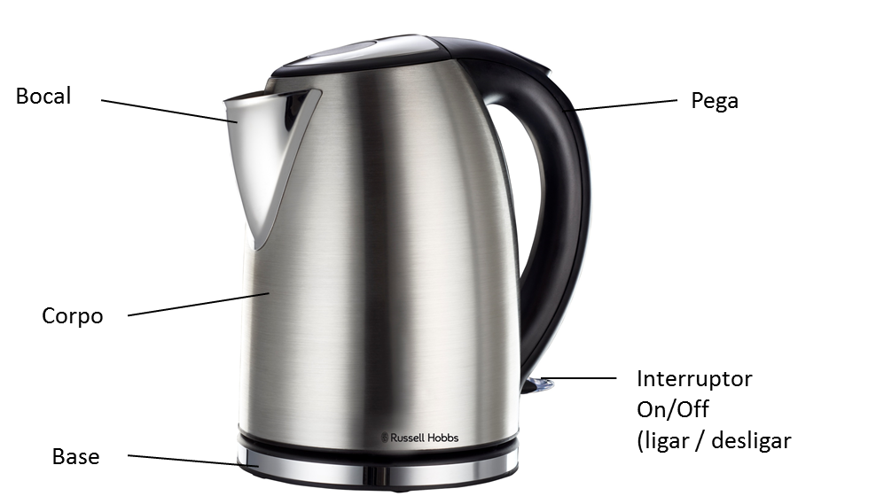

ANTES DE UTILIZAR A CHALEIRA PELA PRIMEIRA VEZ
Remova cuidadosamente a sua chaleira da embalagem. Pode guardar a embalagem para futura utilização.
Antes de a utilização pela primeira vez, encha a chaleira com água fria até à marca de nível de água MÁX., deixe ferver e deite fora a água a ferver - efectue este processo duas vezes. Isto irá garantir que quaisquer resíduos do processo de fabrico são completamente removidos.

POSICIONAMENTO
POSICIONAMENTO DA CHALEIRA
- Posicione a base de alimentação numa superfície seca e plana afastada de qualquer fonte de potencial calor.
- Desenrole o comprimento do cabo de alimentação necessário para alcançar a tomada eléctrica.
- Certifique-se de que o cabo de alimentação não pende sobre a extremidade da superfície de trabalho.

ENCHER A CHALEIRA
- Retire a chaleira da base de alimentação.
- Abra a tampa.
- Encha a chaleira entre as marcas de MÍN. e MÁX. no indicador de nível de água com água fria.
- Feche a tampa e coloque a chaleira novamente na base de alimentação. Certifique-se de que a tampa está bem fechada antes de ferver.
- Remova sempre a chaleira da base de alimentação antes de encher. Não encha a chaleira acima da marca de MÁX. ou abaixo da marca de MÍN. no medidor de água.

LIGAR
- Posicione delicadamente a chaleira no suporte
- Ligue a chaleira a uma tomada de alimentação.
- Para ligar a chaleira para ferver a água, pressione o interruptor de on/off.
- A luz indicadora de alimentação acende-se e a chaleira começa a ferver.
- Nunca abra a tampa ou toque na superfície de aço inoxidável durante o processo de fervura.
- Não opere esta chaleira sem o filtro integrado.

Tenha cuidado com o vapor que sai pela tampa da chaleira quando em uso.
DESLIGAR
- A chaleira desliga-se automaticamente quando a água estiver fervida. Pode interromper o processo de fervura a qualquer altura ao colocar o interruptor de on/off na posição "0" (off [desligar] ou ao levantar a chaleira extraindo-a da base.

PROTECÇÃO DE FUNCIONAMENTO A SECO
- Caso ligue acidentalmente uma chaleira vazia, a protecção contra o funcionamento a seco desliga automaticamente a alimentação. Se isto ocorrer, deixe a chaleira arrefecer antes de encher com água fria.

GERAL
- Retire sempre a chaleira da base antes de verter.
- Para evitar o risco de salpicos, verta lentamente e nunca incline demasiados a chaleira.
- Não incline a chaleira para trás; a água pode entrar na área de controlo. Se isto ocorrer, deixe a chaleira a secar bem antes de utilizar – coloque-a em qualquer local quente durante 12 horas.
- Quando levanta a chaleira, pode ver humidade na base. Não se preocupe – é o vapor utilizado para desligar a chaleira automaticamente, que depois se condensa e escapa através das aberturas por baixo da chaleira.
- Pode ver alguma descoloração na base da chaleira. Uma vez mais, não se preocupe - deve-se à ligação do elemento à base da chaleira.

LIMPEZA E MANUTENÇÃO
- Este aparelho destina-se apenas a utilização doméstica e não é reparável pelo utilizador.
- Não abra nem substitua quaisquer peças. Consulte um departamento de apoio elétrico qualificado ou devolva o aparelho ao fornecedor, caso seja necessário repará-lo.
- Nunca se esqueça de desligar a unidade da tomada elétrica quando não está a ser utilizado e antes de limpar.
- Nunca mergulhe o aparelho em água ou em qualquer outro líquido nem o coloque debaixo de água a correr para o limpar.
- Para remover manchas/marcas persistentes, limpe a superfície com um pano ligeiramente humedecido em água com detergente ou agente de limpeza suave não abrasivo. Enxague e seque completamente com um pano macio.
- Desligue a base da tomada da parede, e deixe a chaleira arrefecer antes de a limpar.
- Limpe a parte interna e externa da chaleira com um pano humedecido. Pode utilizar um pouco de detergente doméstico, mas se o fizer, enxagúe bem para evitar manchar a água.
- Limpe a base com um pano humedecido.
- Mantenha os conectores e as tomadas secas.
- Nunca mergulhe a chaleira ou o suporte em líquidos.
- Não utilize agentes de limpeza agressivos ou abrasivos ou solventes.

Recomendamos que remova o depósito de calcário na chaleira regularmente, mesmo em áreas de água macia. O calcário pode ser branco, colorido, até mesmo enferrujado, mas normalmente é visível. O calcário de fosfato geralmente não é visível, mas existe sempre uma acumulação, mesmo em áreas de água mole. Todo o tipo de calcário causa o sobreaquecimento, o que reduz a vida útil do elemento e pode desencadear o dispositivo de bloqueio de segurança de funcionamento a seco a engatar-se. Assim, mesmo numa área de água mole, deve descalcificar pelo menos mensalmente, para ajudar a manter a sua chaleira em boas condições de funcionamento.

Para descalcificar a chaleira:
- Utilize um descalcificante adequado para produtos de plástico. Siga as instruções no descalcificador, enxagúe várias vezes, depois encha, ferva e elimine a água, para garantir que não são deixados quaisquer resíduos químicos.
- Os produtos devolvidos ao abrigo da garantia com avarias devido ao calcário estarão sujeitos a um custo de reparação.
- Se observar que a sua chaleira se torna mais ruidosa, descalcifique-a.
- Não se regule apenas por depósitos de calcário visíveis, visto que o depósito de fosfatos não é visível. Remova os depósitos de calcário da chaleira como prevenção.
- Não tente mover ou remover o difusor, irá parti-lo.

Filtro de água:
- As partículas de calcário na água podem dar um aspecto turbo ou oleoso.
- O filtro irá evitar que estas partículas entrem na sua bebida. Se visualizar depósitos no filtro, limpe-o, caso contrário, o desempenho da sua chaleira irá diminuir, as suas bebidas podem conter calcário e a água no interior da chaleira pode parecer turva.
Limpar o filtro:
- O filtro está localizado dentro da chaleira por trás do bocal.
- Com a tampa aberta, puxe delicadamente o filtro para fora da sua ranhura de retenção.
- Levante o filtro extraindo-o da chaleira.
- Enxagúe o filtro em água quente e remova delicadamente qualquer calcário com uma escova macia.
- Para substituir o filtro, deslize-o pela sua ranhura até encaixar no devido lugar.

Remover depósitos minerais
- A descalcificação refere-se à remoção dos depósitos de cálcio que se podem formar dentro das peças metálicas da chaleira.
- Para obter o melhor desempenho da sua chaleira, descalcifique a chaleira ocasionalmente. A frequência depende da dureza da sua água da torneira e da frequência com que utiliza a chaleira.
- Recomendamos a utilização de um produto descalcificante de chaleiras para dissolver os depósitos de calcário.
- Siga as instruções na embalagem do produto descalcificante. Se não estiver disponível um produto descalcificante comercial, encha a chaleira com vinagre branco suficiente para cobrir o fundo em cerca de 1,5 cm. Deixe o vinagre ferver. Poderá ser necessário repetir este procedimento várias vezes com vinagre arrefecido para remover completamente a acumulação de calcário. Quando o processo de descalcificação estiver concluído, esvazie a chaleira e enxagúe várias vezes com água limpa.

GUARDAR O APARELHO
- Certifique-se de que a unidade é colocada na posição OFF (Desligada). Retire o cabo da máquina de café da tomada de alimentação.
- Limpe todas as peças conforme instruído acima. Certifique-se de que todas as peças estão secas antes de guardar.
- Guarde o aparelho num local limpo e seco.
- Nunca guarde o aparelho enquanto estiver molhado ou sujo.

Nunca enrole o cabo de alimentação à volta do aparelho.

REPARAÇÃO DO APARELHO
O aparelho não contém componentes que possam ser reparados pelo utilizador. Se a unidade não estiver a funcionar corretamente, verifique o seguinte:
- Se seguiu as instruções corretamente.
- Se a unidade foi devidamente ligada e se a tomada de parede está ligada.
- Se a fonte de alimentação elétrica está ligada.
- Se a ficha está firmemente encaixada na tomada elétrica.

Se o aparelho continuar sem funcionar depois de verificar os itens acima:
- Consulte o revendedor para uma possível reparação ou substituição. Se o revendedor não for capaz de resolver o problema e necessitar de devolver o aparelho, certifique-se de que:
- A unidade está devidamente embalada na sua embalagem original.
- Apresenta uma prova de compra.
- É fornecida uma razão para a devolução.

Se o cabo de alimentação estiver danificado, deve ser substituído pelo fabricante ou por um agente de assistência autorizado de forma a evitar qualquer perigo. Caso seja necessário reparar o aparelho dentro do período de garantia, o aparelho deve ser devolvido a um centro de assistência da Home of Living Brands (Pty) Limited aprovado. A reparação fora do período de garantia continua a ser possível, mas, contudo, será cobrada.

SUBSTITUIÇÃO DA FICHA
Cumpra com as instruções seguintes caso seja necessário substituir a ficha.
Esta unidade destina-se a operar apenas na corrente indicada. A ligação a outras fontes de alimentação poderá danificar o aparelho. Ligue uma ficha de três pinos da seguinte maneira:
Os fios neste terminal de alimentação estão coloridos de acordo com o seguinte:
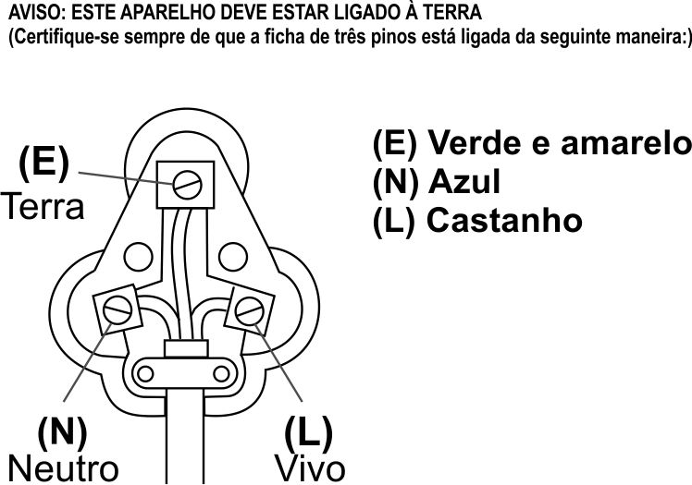
Verde/Amarelo = Terra
Azul = Neutro
Castanho = Vivo

ANEXE A SUA PROVA DE COMPRA/RECIBO AQUI
EM CASO DE RECLAMAÇÃO AO ABRIGO DE GARANTIA, É NECESSÁRIO PRODUZIR ESTE RECIBO.

GARANTIA
- Home of Living Brands (Pty) Limited garante ao comprador original deste produto (“o cliente") que este produto não apresenta defeitos de material e fabrico que se manifestam na utilização normal pessoal, familiar ou doméstica num período de 1 (um) ano desde a data de compra (“período de garantia”).
- No caso de um cliente comprar um produto e este se quebrar, apresentar defeitos ou não funcionar corretamente para a finalidade prevista, o cliente tem de notificar o fornecedor ao qual comprou o produto ("o fornecedor") desse fato dentro do período de garantia. Qualquer reclamação nos termos da garantia deve ser acompanhada por uma prova de compra. Caso não esteja disponível uma prova de compra, então as despesas da reparação e/ou manutenção poderão ter de ser pagas pelo cliente ao fornecedor.
- O produto avariado tem de ser devolvido ao centro de assistência do fornecedor para aplicar a garantia.
- O fornecedor irá reembolsar, reparar ou trocar o produto nos termos desta garantia, sujeito aos requisites legislativos. Esta garantia será válida apenas quando o cliente não tiver quebrado ele próprio o produto ou utilizado o produto para outro fim que não o previsto. A garantia não inclui e não será interpretada como abrangendo produtos danificados como resultado de um desastre, utilização imprópria, manipulação, abuso ou qualquer modificação não autorizada ou reparação do produto.
- Esta garantia aplicar-se-á apenas ao produto fornecido na data de compra e não a quaisquer acessórios incluídos ou instalados pelo cliente.
- Se o cliente solicitar que o fornecedor repare o produto e o produto se quebrar ou não funcionar corretamente nos 3 (três) meses após a reparação, considerando que não seja resultado de utilização imprópria, manipulação ou modificação por ou em nome do cliente, então o fornecedor poderá substituir o produto ou pagar um reembolso ao cliente.
- O cliente poderá ser responsável por certos custos quando os produtos devolvidos não estiverem na embalagem original, ou caso a embalagem esteja danificada. Este custo será deduzido de qualquer reembolso pago ao cliente.
HOME OF LIVING BRANDS (PTY) LTD
www.homeoflivingbrands.com
011 490-9600 (Joanesburgo)
031 792-6000 (Durban)
021 552-5161 (Cidade do Cabo)
www.russellhobbs.co.za
www.facebook.com/RussellhobbsSA

