

INSTRUCTIONS AND WARRANTY

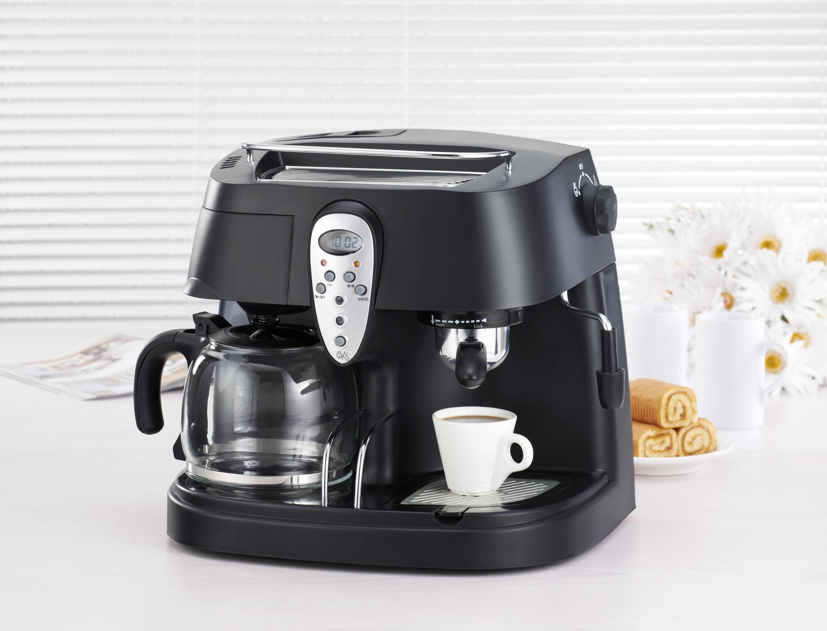

RHCM3

Russell Hobbs 5 in 1 coffee maker

Congratulations on purchasing our Russell Hobbs 5 in 1 coffee maker. Each unit is manufactured to ensure safety and reliability. Before using this appliance for the first time, please read the instruction manual carefully and keep it for future reference.

FEATURES OF THE RUSSELL HOBBS 5-IN-1 COFFEE MAKER
- 5 in 1 coffee maker (filter coffee, espresso, latte, mocha and cappuccino)
- 1.5 litre water tank
- 15 bar pressure pump
- 10 cup filter capacity
- 4 cup espresso capacity
- Permanent filter
- Steam nozzle for frothing milk
- 2 independent thermostats
- Warming plate for keeping coffee warm for longer

IMPORTANT SAFEGUARDS
When using any electrical appliance, basic safety precautions should always be followed including the following:
- Please read the instructions carefully before using any appliance.
- Always ensure that the voltage on the rating label corresponds to the mains voltage in your home.
- Incorrect operation and improper use can damage the appliance and cause injury to the user.
- The appliance is intended for household use only. Commercial use invalids the warranty and the supplier can not be held responsible for injury or damage caused when using the appliance for any other purpose than that intended.
- Avoid any contact with moving parts.
- This appliance is not intended for use by persons (including children) with reduced physical, sensory or mental capabilities, or lack of experience and knowledge, unless they have been given supervision or instruction concerning use of the appliance by a person responsible for their safety.
- Children should be supervised to ensure that they do not play with the appliance.
- Check the power cord and plug regularly for any damage. If the cord or the plug is damaged, it must be replaced by the manufacturer or a qualified person in order to avoid an electrical hazard.
- Do not use the appliance if it has been dropped or damaged in any way. In case of damage, take the unit in for examination and/or repair by an authorised service agent.
- To reduce the risk of electric shock, do not immerse or expose the motor assembly, plug or the power cord to water or any other liquid.
- Never immerse the unit in water or any other liquid for cleaning purposes.
- Remove the plug from the socket by gripping the plug. Do not pull on the cord to disconnect the appliance from the mains. Always unplug the unit when not in use, before cleaning or when adding or removing parts.
- The use of accessory attachments that are not recommended or supplied by the manufacturer may result in injuries, fire or electric shock.
- A short cord is provided to reduce the hazards resulting from becoming entangled in or tripping over a longer cord.
- Do not let the cord hang over the edge of a table or counter. Ensure that the cord is not in a position where it can be pulled on inadvertently.
- Do not allow the cord to touch hot surfaces and do not place on or near a hot gas or electric burner or in a heated oven.
- Do not use the appliance on a gas or electric cooking top or over or near an open flame.
- Use of an extension cord with this appliance is not recommended. However, if it is necessary to use an extension lead, ensure that the lead is suited to the power consumption of the appliance to avoid overheating of the extension cord, appliance or plug point. Do not place the extension cord in a position where it can be pulled on by children or animals or tripped over.
- This appliance is not suitable for outdoor use. Do not use this appliance for anything other than its intended use.
- DO NOT carry the appliance by the power cord.
- Do not leave this appliance unattended during use. Always unplug the unit when not in use or before cleaning.
- Always operate the appliance on a smooth, even, stable surface. Do not place the unit on a hot surface.
- Ensure that the switch is in the “Off” position after each use.
- The manufacturer does not accept responsibility for any damage or injury caused by improper or incorrect use, or for repairs carried out by unauthorised personnel.
- In case of technical problems, switch off the machine and do not attempt to repair it yourself. Return the appliance to an authorised service facility for examination, adjustment or repair. Always insist on the use of original spare parts. Failure to comply with the above mentioned pre-cautions and instructions, could affect the safe operation of this machine.

ADDITIONAL SAFEGUARDS

PARTS DIAGRAM
A. water tank cover B. water tank C. warming jug facility
D. nylon filter E. removable brew basket F. drip carafe
G. removable shelf H. drip tray I. measuring spoon and tamper
J. Metal funnel (for Espresso)
K. press bar（press steel filter with it when pour coffee residue to avoid its slipping out）
L. Espresso jug M. steel mesh N. adjustable steam outlet
O. steam wand P. Control panel (See Fig.1) Q. Transition knob

YELLOW INDICATOR: Pre-set function is on.
Press continuously to adjust the minutes.
Press once to switch the drip coffee function ON/OFF
GREEN INDICATOR: Espresso Coffee/Steam power is switched on.
Press continuously to adjust the hours.
RED INDICATOR: Indicates that drip coffee has been made.
YELLOW INDICATOR: Indicates that the unit is pre-heating. You can turn the transition switch to froth or espresso when it goes off.
Press button continuously to set the timer, whether it is to the present time or pre-set time.

OPERATING INSTRUCTIONS
BEFORE FIRST USE:
- Please rinse the coffee maker with warm water as follows:
- Pour the water into the water tank according to the gauge, then replace its cover.
- Set nylon filter in removable brew basket (add NO coffee ground), then fix removable brew basket in the coffee maker.
- Set steel mesh into the metal funnel (no coffee in the metal filter mesh) then place them upwards into the snap and you can fix them into coffee maker firmly, turn it anticlockwise until it is at the lock position.
- Place drip carafe on keeping warm plate and espresso jug or the coffee jug on removable shelf.
- CAUTION: there is a tube outlet under the removable shelf, this is the overpressure release outlet. In the event of pressure being over-generated inside the appliance, the pressure release device inside the appliance will operate to discharge the over steam pressure to normal level to prevent the risk of explosion. The steam will then be released from the tube. NEVER block the tube outlet. Empty the Drip tray frequently.
- Connect to power source, 12:00 will show on display.
- Press ON/OFF button once, the red indicator light will be illuminated, and hot water will come out of the removable brew basket bottom.
- After a few seconds, press the ON/OFF button twice again, the red indicator light will go out and the coffee maker will stop working.
- Press down / button, both the yellow and green indicator will be illuminated and the internal heating element starts working, the coffee maker begins to pre-heat. When the yellow is extinguished, you can turn the transition knob to left “”position (see Fig.2) ，the yellow indicator will illuminate again and water will run out of the metal funnel.
Fig. 2
- After the water has stopped dripping, you can pour out the water from each container then clean them thoroughly, now you can start brewing!
- NOTE: There may be noise when the machine pumps the water out for the first time, it is normal; the appliance is just releasing air that is in the appliance. After about 20s, the noise will stop.

MAKE DRIP COFFEE:
- Take off the water tank cover, pour water into the water tank according to the water level mark in the tank.
- Replace the water tank cover, only then must you connect the appliance to the power supply source, the display will show 12:00.
- Add ground coffee to the removable nylon filter with measuring spoon, a spoon of ground coffee power can make one cup of top-grade coffee, but you can adjust the taste accordingly ( the max capacity of coffee powder cannot exceed 10 spoons）
- Set nylon filter into the removable brew basket and place brew basket into the coffee maker.
- Push drip carafe on the keeping warm plate, make sure that the centre line of the carafe aligns with that of the brew basket.
- Press down the ON/OFF button once, the red indicator will illuminate and coffee will drip out automatically after a while. NOTE: you can take out the carafe at any time to serve but the time cannot exceed 20 seconds, otherwise the coffee may overflow from the edge of brew basket.
- The coffee maker will turn to the keep warm function if brewing coffee is finished. You can switch the power off, otherwise the coffee maker will do automatically after two hours.
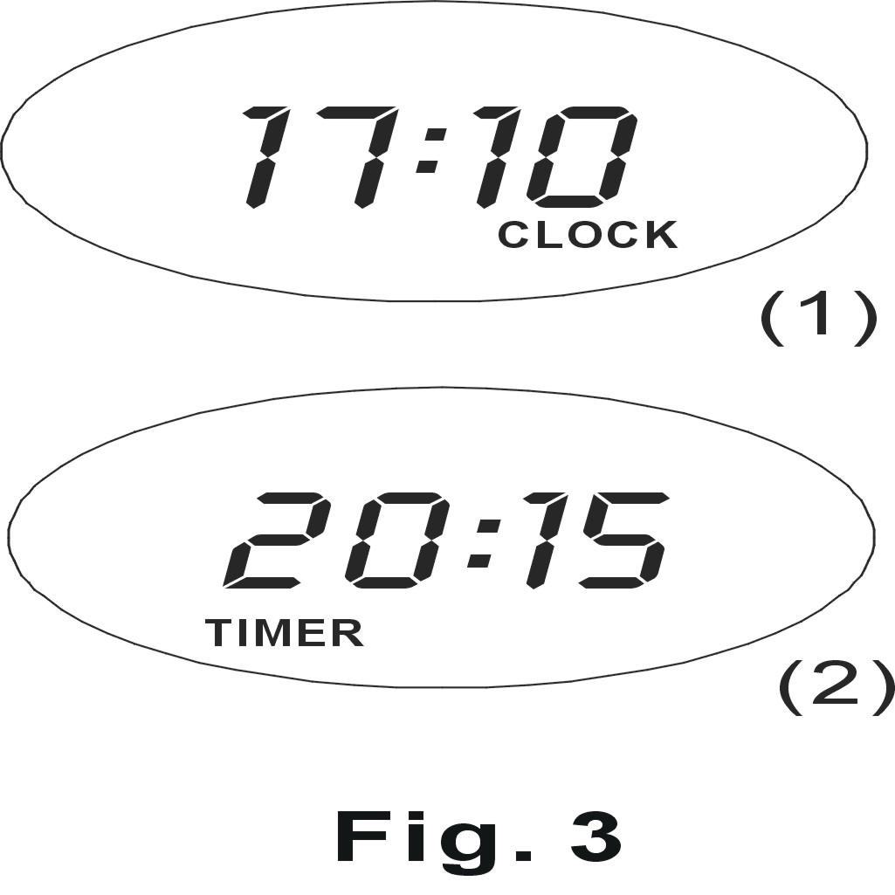
SET THE CLOCK AND PROGRAM AUTOMATIC START-UP (only fit for making drip coffee)
- The appliance has a pre-set function which can be set as follows:
- Press PROG button once, the word CLOCK will appear at the top-right corner of the display.
- Press the HR and MIN button continuously to set the present time (See fig. 3(1)). NOTE: if you keep pressing down HR or MIN button more than two seconds, the hour or minute number on display will increase rapidly.
- Press PROG button once again and the word TIMER shows on the bottom left corner of the display.
- You can set the pre-setting time in the same way by pressing HR button and MIN button continuously, that is 20:15 (see Fig. 3. Note: the word on display will disappear automatically and enter normal state if no button is touched for more than 10 seconds at setting state.
- Press ON/OFF button two times, the yellow indicator turn on.
- The yellow indicator will go off automatically, at the same time the red indicator will turn on when the time is 20:15 and the unit will start brewing. NOTE：If no one there, the appliance will cut off power automatically after two hours.
PRE-HEATING FUNCTION:
- To make a cup of good hot Espresso coffee, we recommend you pre-heat the appliance before making coffee, including the funnel, filter and cup, so that the coffee flavour cannot be influenced by the cold parts.
- Take down water tank cover, add water into the water tank. Then replace the water tank cover.
- Set steel mesh into metal filter (WITHOUT coffee powder ), then place them upwards into the snap and you can fix them into coffee maker firmly by turning it anticlockwise until it is at the lock position.(See fig. 4).
- Place espresso jug on the removable shelf.
- Connect the appliance to the power supply. Make sure the transition knob is on the OFF position.
- Press down / button, the yellow and green indicators will both illuminate, the internal heat element begins to preheat. After about 3 minutes, the yellow indicator goes out, you can turn the transition knob to now and the yellow will illuminate again, the coffee will drip down after a few seconds.
- After making a jug hot water, you must turn the transition knob to “OFF” position. The preheating process is finished.
FFig
MAKE ESPRESSO COFFEE:
- Remove the funnel by turning it in clockwise, add ground coffee to steel mesh with measuring spoon, a spoon of ground coffee power can make one cup of coffee, then press the ground coffee powder tightly with the tamper.
- Set the steel mesh into metal filter, then place them upwards into the snap and you can fix them into coffee maker firmly, turn it anticlockwise until it is on the lock position.
- Pour out the hot water in the jug. Place espresso jug on removable shelf. Make sure that the transition knob is at the OFF position.
- At the time, the yellow indicator will go out, you can turn the transition knob to now and the yellow light will illuminate again, the coffee will start to drip down after a few seconds. When the jug is filled with coffee, you must turn the transition knob to “OFF” position.
- NOTE: during operating, do not touch the warming jug facility. When moving the appliance, never carry the handle on the warming jug. The handle is ONLY to prevent the warming jug from slipping.
- If you want to make more coffee, wait for a moment, once the yellow indicator is extinguished, turn the transition to position and make coffee. You should press down / button manually when desired coffee is obtained or the colour of coffee changes, the yellow and green indicator will switch off and the coffee maker will stop working, at any time, make sure to turn transition knob to the OFF position, your coffee is ready now!
- WARNING: Do not leave the coffee maker unattended while making coffee, as you may need to operate the machine manually at times!
- After making the coffee, you can take the metal funnel out by turning it clockwise, and then pour the coffee residue out with the steel mesh by pressing the press bar.
- Let the machine cool down completely, before rinsing the parts under running water.
GENERATE STEAM/ MAKE CAPPUCCINO:
- NOTE: Steam function can be used to froth milk(make cappuccino, hot chocolate and so on) or heat water(make tea and other hot drinks)
- Prepare espresso first with espresso jug, make sure that the transition knob is at the OFF position.
- Press down power button / for Espresso coffee, both the yellow and green indicators below will be illuminated, the internal heat element starts working to preheat the appliance.
- Fill espresso jug/cup with about 100 grams of milk for each cappuccino to be prepared, you are recommended to use fresh cream milk at refrigerator temperature (do not heat up the milk)
- When the yellow indicator is off, rotate the transition knob on the right side of unit clockwise to position and the yellow indicator will illuminate again, steam will come out from the adjustable steam outlet.
- Insert the steam outlet into the milk about two centimetre, froth milk by moving the vessel up and down.
- When the required temperature is reached, you can turn the Transition knob to OFF position to stop the steam generating. NOTE: Clean steam outlet with wet the sponge immediately after steam stops generating, be very careful when doing this as the steam may scald you.
- Pour the frothed milk into the espresso prepared; now the cappuccino is ready. Sweeten to taste and if desired, sprinkle the froth with a little cocoa powder.
- Press the button/ once to cut the power source off.
- NOTE: we recommend you allow the coffee maker to cool down for at least 5 minutes otherwise burnt odour may arise in your Espresso coffee and please DO NOT make drip coffee, espresso coffee or cappuccino at the same time.

CLEANING AND MAINTENANCE
- This appliance is for household use only and is not user-serviceable.
- Do not open or change any parts by yourself. Please refer to a qualified electrical service department or return to the supplier if servicing is necessary.
- Always remember to unplug the unit from the electrical outlet when not in use and before cleaning. Ensure that the speed control is set to “0”.
- It is much easier to clean the accessories directly after they have been used. Wash them in warm, soapy water, rinse and dry well.
- The body of the appliance and the stand should be cleaned with a damp cloth. Do not let water enter the appliance or the stand.
- Do not use bleach or other abrasive substance or solvents to clean your appliance as it can be damaging to the finish.
- Do not immerse the appliance in water or any other liquid, or hold it under a running tap to clean.
- To remove stubborn spots/marks, wipe the surfaces with a cloth slightly dampened in soapy water or mild non-abrasive cleaner. Rinse and dry a clean, dry, soft cloth.

STORING THE APPLIANCE
- Unplug the unit from the wall outlet and clean all the parts as instructed above. Ensure that all parts are dry before storing.
- Store the appliance in its box or in a clean, dry place.
- Never store the appliance while it is still wet or dirty.
- Never wrap the power cord around the appliance.

SERVICING THE APPLIANCE
There are no user serviceable parts in this appliance. If the unit is not operating correctly, please check the following:
- You have followed the instructions correctly
- That the unit has been wired correctly and that the wall socket is switched on.
- That the mains power supply is ON.
- That the plug is firmly in the mains socket.

If the appliance still does not work after checking the above:
- Consult the retailer for possible repair or replacement. If the retailer fails to resolve the problem and you need to return the appliance, make sure that:
- The unit is packed carefully back into its original packaging.
- Proof of purchase is attached.
- A reason is provided for why it is being returned.

If the supply cord is damaged, it must be replaced by the manufacturer or an authorised service agent, in order to avoid any hazard. If service becomes necessary within the warranty period, the appliance should be returned to an approved Tedelex Trading (Pty) Limited service centre. Servicing outside the warranty period is still available, but will, however, be chargeable.

CHANGING THE PLUG

Should the need arise to change the fitted plug, follow the instructions below.
This unit is designed to operate on the stated current only. Connecting to other power sources may damage the appliance. Connect a three-pin plug as follows:
The wires in this mains lead are coloured in accordance with the following code:
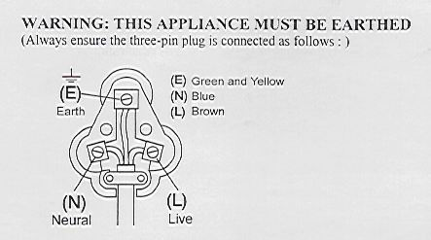
Green/Yellow = Earth
Blue = Neutral
Brown = Live

PLEASE AFFIX YOUR PROOF OF PURCHASE/RECEIPT HERE
IN THE EVENT OF A CLAIM UNDER WARRANTY THIS RECEIPT MUST BE PRODUCED.

W A R R A N T Y

- Home of Living Brands (Pty) Limited (“Home of Living Brands”) warrants to the original purchaser of this product (“the customer”) that this product will be free of defects in quality and workmanship which under normal personal, family or household use and purpose may manifest within a period of 1 (one) year from the date of purchase (“warranty period”).
- Where the customer has purchased a product and it breaks, is defective or does not work properly for the intended purpose, the customer must notify the supplier from whom the customer bought the product (“the supplier”) thereof within the warranty period. Any claim in terms of this warranty must be supported by a proof of purchase. If proof of purchase is not available, then repair, and/or service charges may be payable by the customer to the supplier.
- The faulty product must be taken to the supplier's service centre to exercise the warranty.
- The supplier will refund, repair or exchange the product in terms of this warranty subject to legislative requirements. This warranty shall be valid only where the customer has not broken the product himself, or used the product for something that it is not supposed to be used for. The warranty does not include and will not be construed to cover products damaged as a result of disaster, misuse, tamper, abuse or any unauthorised modification or repair of the product.
- This warranty will extend only to the product provided at the date of the purchase and not to any expendables attached or installed by the customer.
- If the customer requests that the supplier repairs the product and the product breaks or fails to work properly within 3 (three) months of the repair and not as a result of misuse, tampering or modification by or on behalf of the customer, then the supplier may replace the product or pay a refund to the customer.
- The customer may be responsible for certain costs where products returned are not in the original packaging, or if the packaging is damaged. This will be deducted from any refund paid to the customer.

TEDELEX TRADING (PTY) LTD (JOHANNESBURG)

JOHANNESBURG TEL NO. (011) 490-9600

CAPE TOWN TEL NO. (021) 552-5161

DURBAN TEL NO. (031) 792-6000

www.amap.co.za

