

BREW STATION FILTER COFFEE MAKER

MODEL: RHCMB5
Rating: 220-240V ~ 50/60Hz, 870-1030W

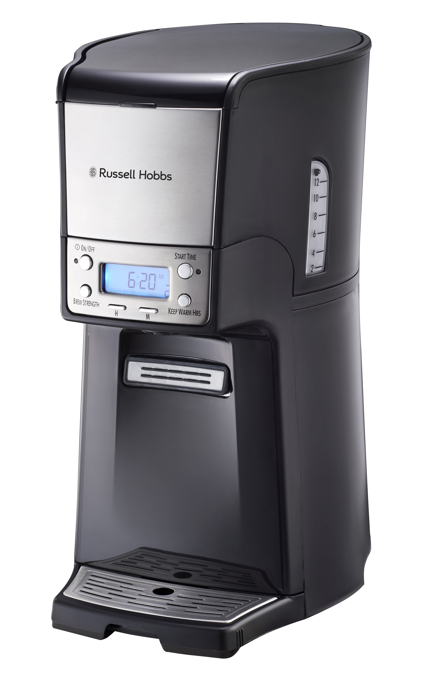

Congratulations on purchasing our Russell Hobbs Brew Station Filter Coffee Maker. Each unit is manufactured to ensure safety and reliability. Before using this appliance for the first time, please read the instruction manual carefully and keep it for future reference.

FEATURES OF THE RUSSELL HOBBS BREW STATION FILTER COFFEE MAKER
- Brews multiple cups of coffee
- Dispenses one fresh cup or travel mug at a time
- Large 1.8L water tank capacity
- Convenient one hand dispensing saves you time
- Water tank with transparent coffee level indicator
- Removable coffee tank for easy cleaning
- Includes permanent removable coffee filter
- 24 hour preset/delay function
- LCD display for easy visibility
- PTC heating technology heats water faster and allows for safer and longer lasting machine use
- Fixed drip tray and detachable drip tray cover.
- Auto Shut Off after 4 hours for safety
- Suitable for ground coffee
- 870-1030W
- For domestic use only
- 1 year warranty

IMPORTANT SAFEGUARDS

When using electrical appliances, basic safety precautions should always be followed to reduce the risk of fire, electric shock, and/or injury to persons, including the following:

1. Read all instructions.
2. Do not touch hot surfaces. Use handles or knobs. Care must be taken, as burns can occur from touching hot parts or from spilled, hot liquid.
3. To protect against electric shock, do not place cord, plug, or appliance in water or other liquid.
4. Close supervision is necessary when any appliance is used by or near children.
5. Unplug from outlet when either the appliance or clock is not in use and before cleaning. Allow to cool before putting on or taking off parts and before cleaning the appliance.
6. Scalding may occur if the lid is lifted during the brewing cycle. Do not open lid until coffeemaker has cooled completely.
7. The appliance must be operated on a flat surface away from the edge of counter to prevent accidental tipping.
8. Do not operate any appliance with a damaged cord or plug, or after the appliance malfunctions or is dropped or damaged in any manner.
9. The use of accessory attachments not recommended by the appliance manufacturer may cause injuries.
10. Do not use outdoors.
11. Do not let cord hang over edge of table or counter or touch hot surfaces, including stove.
12. The coffee tank is designed for use with this appliance only. It must never be used on a range top or in a microwave oven.

13. Do not place the appliance on or near a hot gas or electric burner or in a heated oven.
14. To disconnect the appliance, turn controls to OFF; then remove plug from wall outlet.
15. WARNING! To reduce the risk of fire or electric shock, do not remove the bottom cover. No user-serviceable parts are inside. Repair should be done by authorized service personnel only.
16. Do not use appliance for other than intended use.

***SAVE THESE INSTRUCTIONS

OTHER CONSUMER SAFETY INFORMATION

This appliance is intended for household use only.

WARNING! Shock Hazard:
Do not defeat the safety purpose of the plug by modifying the plug in any way or by using an adapter. If the plug does not fit fully into the outlet, reverse the plug. If it still does not fit, have an electrician replace the outlet.

The length of the cord used on this appliance was selected to reduce the hazards of becoming tangled in or tripping over a longer cord. If a longer cord is necessary, an approved extension cord may be used. The electrical rating of the extension cord must be equal to or greater than the rating of the appliance. Care must be taken to arrange the extension cord so that it will not drape over the countertop or tabletop where it can be pulled on by children or accidentally tripped over.

To avoid an electrical circuit overload, do not use another high-wattage appliance on the same circuit with this appliance.

IMPORTANT: Never use coffee tank to pour hot coffee or carry hot coffee. Handle coffee tank when it holds only cold water.
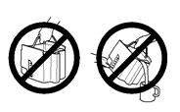

ADDITIONAL INFORMATION

- If overflow occurs: Let unit, coffee, and grounds cool completely before attempting any cleaning.
- Use only brand-name, high-quality filters.
- Use only 1 Tablespoon of ground coffee for each cup of water.
- Use coffeemaker cleaner to prevent hard water deposits that affect coffeemaker performance. Clean monthly.
- Do not clean coffee tank in dishwasher.
- Read instructions before using.
- The coffee-maker shall not be placed in a cabinet when in use.
- Cleaning and user maintenance shall not be made by children without supervision.

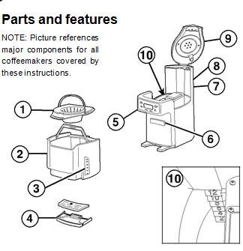


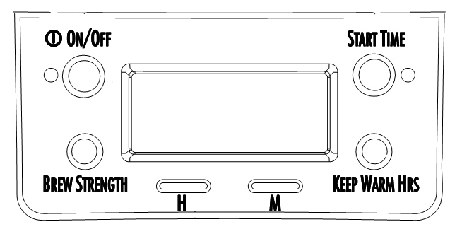

1. Filter Basket 6. Coffee Dispenser Bar
2. Coffee Tank 7. Water Reservoir
3. Coffee Level Guide 8. Keep Warm Plate
4. Drip Tray 9. Lid
5. Control Panel and 10. Water Level Guide
Display

HOW TO MAKE COFFEE

WARNING Burn Hazard.

• Never use coffee tank to pour or carry hot coffee.
• Handle coffee tank only when holding cold water for filling water reservoir and to clean tank.
• If the appliance overflows, unplug unit. Allow unit, coffee, and grounds to cool before cleaning unit, coffee, or grounds.

BEFORE FIRST USE:

Wash coffee tank, filter basket, and drip tray in hot, soapy water.
NEVER put the coffee tank in the dishwasher.
The appliance can be programmed to automatically shut off in 0 (for Iced Coffee), 1, 2, 3, or 4 hours as desired. Default is 4 hours for automatic shutoff.

1. Place a paper filter in filter basket. A permanent filter may also be used.
2. For each cup of coffee being made, place one level Tablespoon of coffee into filter. Avoid getting coffee grounds in any other areas of the appliance.
3. Fill coffee tank with the desired amount of cold tap water.
4. Lift lid and pour water from coffee tank into water reservoir.
5. Set KEEP WARM HOURS to 1, 2, 3, or 4. The 0 setting is for iced coffee.
6. Press ON/OFF or button to start. An illuminated red light on the ON/OFF or button indicates coffeemaker is on.
7. Coffeemaker will beep one time when brewing is complete. Press coffee dispensing bar with mug to dispense coffee.
BOLD: For enhanced full/strong-flavored coffee, press BREW STRENGTH button until BOLD is displayed.
1–4 CUPS: When brewing 1–4 cups of coffee, press BREW STRENGTH button until 1–4 CUPS is displayed.

NOTE: BOLD and 1–4 CUPS modes will require additional time to complete a brewing cycle. A BREW STRENGTH must be selected prior to pressing the ON/OFF button. The setting cannot be changed during/in brew mode. If a BREW STRENGTH is not selected, the coffeemaker will automatically brew on the regular/default setting.

TO REHEAT COFFEE

Press and hold ON/OFF button for 3 seconds. This will reset the timer and keep coffee warm for selected number of hours (1, 2, 3, or 4).

HOW TO MAKE ICED COFFEE

1. Follow Steps 1 through 4 in “How to make coffee” section. Do not fill coffee tank beyond the 6-cup line when making iced coffee. NOTE: Brew double-strength coffee for iced coffee. Add 2 scoops (optional accessory) or 2 level Tablespoons of ground coffee per cup (up to 12 scoops).
2. Fill coffee tank with ice to the 10 CUP marking line.
3. Set KEEP WARM HOURS to 0. Press ON/OFF.
4. Press coffee dispensing bar with glass full of ice to dispense coffee.

PROGRAMMING

1. To set clock: Press H and then M. NOTE: Clock time must be set for programming function to work.
2. To program auto brew: Press and hold START TIME until clock flashes. START TIME will appear in display.
3. Continue holding START TIME， then press H and M until the desired brewing start time is reached.
4. Press and release START TIME to activate automatic brewing. A green light will signal that the unit is in program mode.

CARE AND CLEANING

WARNING Burn Hazard.

Do not immerse cord, plug, or coffeemaker in any liquid.

Clean the appliance at least once a month (once a week for areas with hard water).

Inside of coffeemaker:

1. Remove optional water filter.

2. Pour 2 cups/500 ml vinegar into water reservoir.

3. Press ON button. Turn OFF or after 20 seconds and wait 30 minutes. Press ON button. Turn OFF when finished. When cool, dispense several cups before emptying and rinsing reservoir.

NOTE: Coffeemaker will remind you it is time for cleaning in two ways:

• Built-in cycle timer—every 30 cycles, CLEAN will flash in display and stay illuminated for 2 cycles.
• Built-in residue sensor—CLEAN will appear in display when unit senses residue build-up and remain illuminated until the unit has been cleaned.

4. Run 2–3 more brew cycles with CLEAN WATER only. Allow to cool between cycles.

Filter basket and coffee tank: Remove the filter basket and coffee tank and wash by hand with warm, soapy water. Filter basket may also be cleaned in top rack of dishwasher. Clean filter basket often.

Outside of coffeemaker:

Wipe outside with a soft cloth and warm, soapy water. Do not use abrasive cleaners, since they will scratch the finish of the product.

SERVICING THE APPLIANCE

There are no user serviceable parts in this appliance. If the unit is not operating correctly, please check the following:

• You have followed the instructions correctly
• That the unit has been wired correctly and that the wall socket is switched on.
• That the mains power supply is ON.
• That the plug is firmly in the mains socket.

If the appliance still does not work after checking the above:
Consult the retailer for possible repair or replacement. If the retailer fails to resolve the problem and you need to return the appliance, make sure that:
• The unit is packed carefully back into its original packaging.
• Proof of purchase is attached.
• A reason is provided for why it is being returned.

If the supply cord is damaged, it must be replaced by the manufacturer or an authorised service agent, in order to avoid any hazard. If service becomes necessary within the warranty period, the appliance should be returned to an approved Home of Living Brands (Pty) Limited service centre. Servicing outside the warranty period is still available, but will, however, be chargeable.

CHANGING THE PLUG

Should the need arise to change the fitted plug, follow the instructions below.
This unit is designed to operate on the stated current only. Connecting to other power sources may damage the appliance. Connect a three-pin plug as follows:
The wires in this mains lead are coloured in accordance with the following code:

Green/Yellow = Earth
Blue = Neutral
Brown = Live

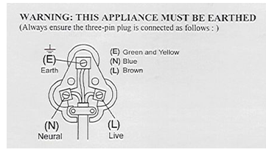

TROUBLESHOOTING
PROBLEM | POSSIBLE CAUSES | SOLUTIONS
Coffee leaks from the dispenser. | Coffee grounds trapped in coffee tank dispensing mechanism under seal in coffee tank. | See “Care and cleaning: Inside of coffeemaker.”
CLEAN appears in display. | This is a reminder to clean coffeemaker. | See “Care and cleaning: Inside of coffeemaker.”
Coffee tastes bad. | - Coffeemaker needs cleaning.  - Coffee ground too coarsely or too finely.  - Coffee-to-water ratio unbalanced.  - Poor water quality. | - See “Care and cleaning: Inside of coffeemaker.”  - Set coffee grinder to automatic drip grind.  - Adjust for personal preference.  - Use filter water or bottled water to make coffee.
Coffee not brewing or stops brewing/unit will not turn on. | - Mineral deposits have built up.  - Water reservoir is empty.  - Unit is unplugged.  - Power outage or power surge. | - Clean the Coffee Maker following “Care and cleaning: Inside of coffeemaker.”  - Fill the tank; not exceeding max level.  - Plug the appliance into the power source.  - In case of a surge, unplug the unit; then plug back in.
Coffee brews slowly. | - Coffeemaker needs cleaning.  - Coffeemaker is in the 1–4 CUPS or BOLD modes. | - Clean at least every 30 days to maintain proper performance.  - Press BREW STRENGTH button until no lights appear.

Coffee overflows the basket. | - Excessive amounts of coffee grounds.  - Coffee ground too finely.  - More than one paper filter in filter basket.  - Poor quality paper filter or wrong size paper filter. | - Remove some coffee grounds.  - Set coffee grinder to automatic drip grind.  - Check and remove the additional filters.  - Check and replace with correct filter.
Unit beeps continuously/will not brew and/or POUR WATER appears in display. | No water in reservoir. | Transfer water from coffee tank to reservoir.
Coffee is cold when dispensed. | Selected Keep Warm Hours have elapsed and coffeemaker has automatically shut off. | See “TO REHEAT COFFEE” instructions, or brew new cycle.

IN THE EVENT OF A CLAIM UNDER WARRANTY THIS RECEIPT MUST BE PRODUCED.

W A R R A N T Y

Home of Living Brands (Pty) Limited warrants to the original purchaser of this product (“the customer”) that this product will be free of defects in quality and workmanship which under normal personal, family or household use and purpose may manifest within a period of 1 (one) year from the date of purchase (“warranty period”).

Where the customer has purchased a product and it breaks, is defective or does not work properly for the intended purpose, the customer must notify the supplier from whom the customer bought the product (“the supplier”) thereof within the warranty period. Any claim in terms of this warranty must be supported by a proof of purchase. If proof of purchase is not available, then repair, and/or service charges may be payable by the customer to the supplier.

The faulty product must be taken to the supplier's service centre to exercise the warranty.

The supplier will refund, repair or exchange the product in terms of this warranty subject to legislative requirements. This warranty shall be valid only where the customer has not broken the product himself, or used the product for something that it is not supposed to be used for. The warranty does not include and will not be construed to cover products damaged as a result of disaster, misuse, tamper, abuse or any unauthorised modification or repair of the product.

This warranty will extend only to the product provided at the date of the purchase and not to any expendables attached or installed by the customer.

If the customer requests that the supplier repairs the product and the product breaks or fails to work properly within 3 (three) months of the repair and not as a result of misuse, tampering or modification by or on behalf of the customer, then the supplier may replace the product or pay a refund to the customer.

The customer may be responsible for certain costs where products returned are not in the original packaging, or if the packaging is damaged. This will be deducted from any refund paid to the customer.

HOME OF LIVING BRANDS (PTY) LTD
www.homeoflivingbrands.co.za
011 493 6204 (Jhb)
031 792-6000 (Dbn)
021 552-5161 (CT)
www.russellhobbs.co.za
www.facebook.com/RussellhobbsSA

