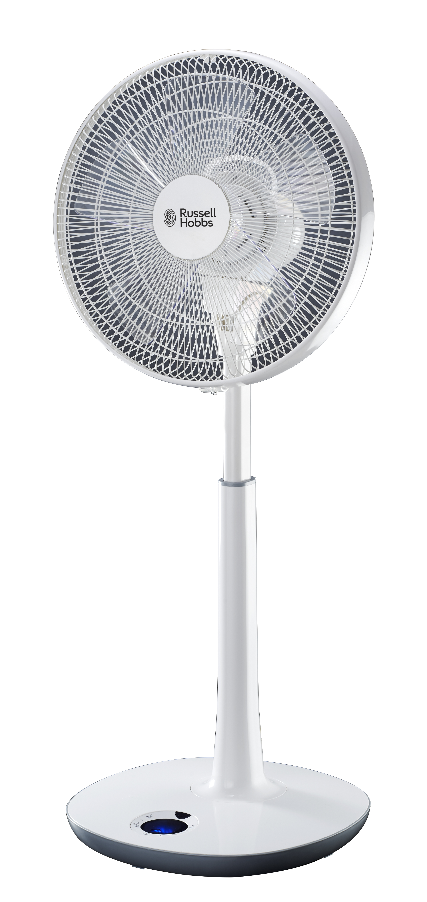

MODEL NO.: RHDC40
RUSSELL HOBBS DC PEDESTAL FAN



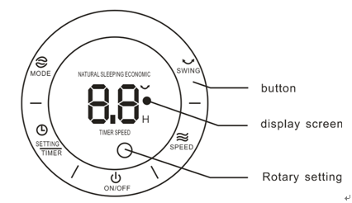


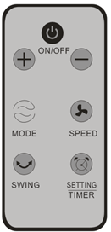

- Front guard cover
- Fan blade fastener
- Fan blade
- Screw of guard clip
- Guard clip
- Shroud ring
- Back guard cover fastener
- Back guard cover
- Motor shaft
- Thumb latch of motor shaft
- Handle
- Motor house
- Back cover of motor house
- Extension tube
- Footstool
- Control panel
- Top base
- Below base
- Power cord
- Footstool fastener



Assemble footstool
Insert footstool into base, then assemble footstool fastener.

Assemble back guard
Take out fan blade fastener in clockwise direction
Take out back guard cover fastener in counterclockwise direction.
Assemble back guard cover and motor house.
Assemble back guard cover fastener in clockwise direction.

Assemble fan blade
Insert fan blade into motor shaft,
Fan blade indentation aim motor shaft, ensure they can fit each other.
Fix fan blade fastener in counterclockwise direction.

Assemble front guard
Assemble back guard cover and shroud ring ensure hanger on back guard and fit each other.
Assemble front guard cover.
Lock guard clip, then tighten by screw of guard clip.

Disassembly method
Disassemble screw of guard clip, release guard clip.
Disassemble shroud ring and guard.


ON/OFF 
After connect to DC power supply, press this button turn on fan, press again turn off fan.
Under fan working, if not any operation within 30 seconds, screen display will stop. Press any button recover screen display.
SPEED 
Press “SPEED” button, begin to set wind speed.
Rotate “rotary setting” in clockwise direction or press”+” on remote control increase wind speed.

Rotate “rotary setting” in counterclockwise direction, or press “-” on remote control decrease wind speed.
If haven’t any operation for long time, “rotary setting” and “+” “-” on remote control it stay wind speed function.
SETTING TIMER
After turn on, press button “setting timer”, display screen “timer” begin blink. Begin to set time within 5 seconds.
Rotate “rotary setting” in clockwise direction, or press “+” on remote control increase time, screen display time
Figure.
Rotate “rotary setting” in counterclockwise direction, or press “-” on remote control decrease time, screen display time figure.
If haven’t any operation within 5 seconds or operate another button, finish timer setting. Then screen display time and speed by turns.


Remote control
Assemble battery steps:
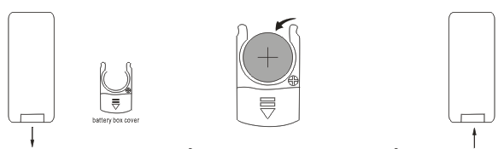
Open battery box cover put battery into battery box (caution + -) close battery box cover

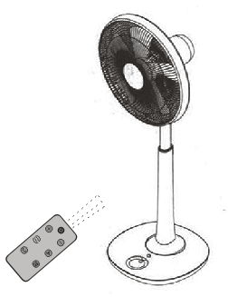
Caution
Remote control must point towards fan.
Remote control available distance within 5 meters away from fan.
Remote control can’t work, if fan install beside big power machine.
Don’t place any substance between fan and remote control.
Please keep this remote control and don’t lose.
Transparent plastic insulation sheet must be pulled out before use.

MODEL | VOLTAGE | FREQUENCY | POWER | NOISE
RHDC40 | 220V~ | 50Hz | 25W | <57db(A)

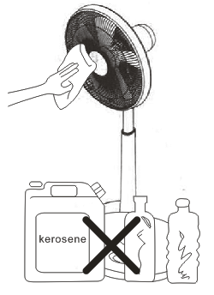

This appliance only needs common external cleaning and wiping.
Pull out plug before cleaning. Ensure to switch off the power supply.
Don’t place in a moisture environment.
Don’t wash directly; ensure not splash water to fan.
Use kitchen detergent to clean fan, don’t use thinner, toluene, acidic
detergent, kerosene, alcohol, chemistry clothes to clean.
Place into case and store in dry place if long time don’t use this
Appliance.


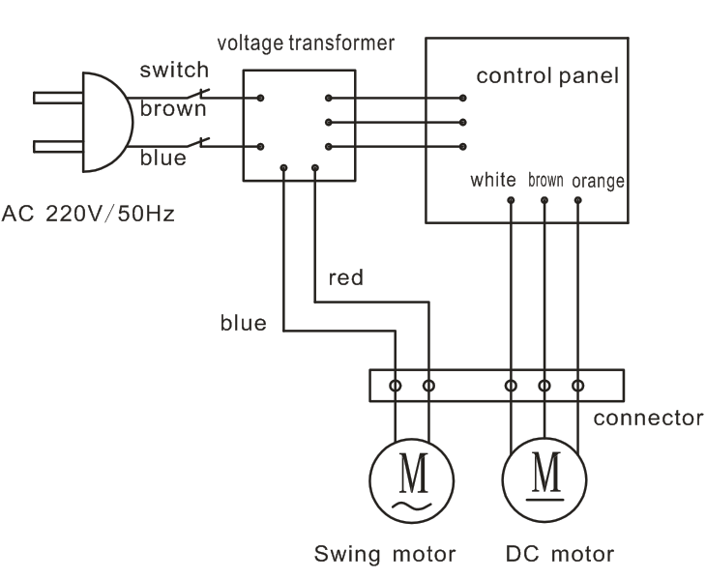


Don’t pull out the power supply plug by pulling power supply cord. Which may lead to electrical shock or
generating electrical shock.

Turn off all switches and pull out power supply plug when you go out for long time.

If the supply cord is damaged. It must be repaired by manufacture or its service agent or a similarly qualified in order to avoid a hazard.

Before sending for maintaining, if the unit doesn’t work please check the plug of power supply has been inserted into socket with electricity.


Please check voltage before use, ensure voltage fit fan voltage.

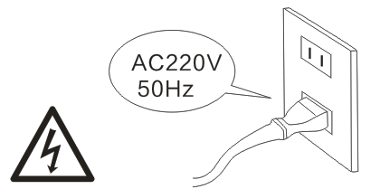

Please check power cord and plug before use, ensure no damage.
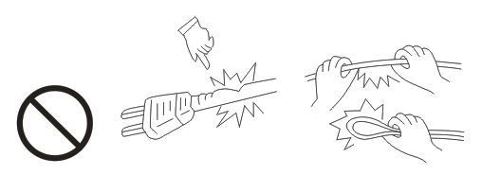

Firstly turn off fan before unplug. Don’t unplug by hand with water avoid electric shock hazards.

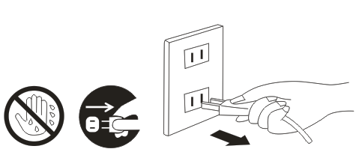

Prohibit use before finishing assembly avoids any hazard in case.
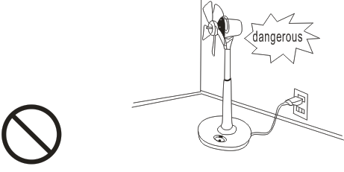

Keep away from curtain, cloth or other something may affect fan’s work.
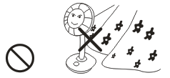

Don’t hang clothes on guard.
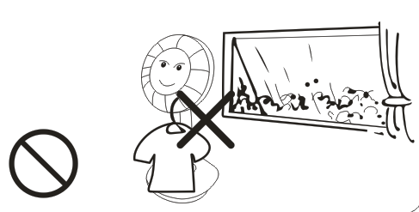


When the fan works, prohibit put finger and other substances into guard avoid cause harm, especially children and baby.
Children and baby should be supervised to ensure they don’t play with the appliance.
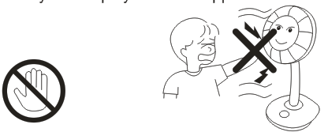

Baby, old peoples, patient don’t blow the fan directly onto them for too long.
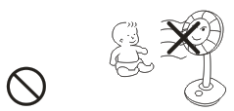

Don’t wash fan directly. Don’t use fan in rain.
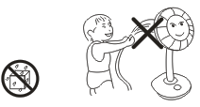

Don’t spray insecticide on the fan.
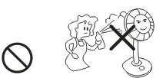

Don’t use fan under high temperature (more than 40°C) ，moisture, rain, dust, chemical articles and oil place.
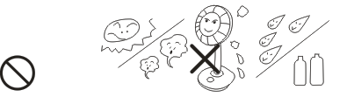

SERVICING THE APPLIANCE
There are no user serviceable parts in this appliance. If the unit is not operating correctly, please check the following:
- You have followed the instructions correctly
- That the unit has been wired correctly and that the wall socket is switched on.
- That the mains power supply is ON.
- That the plug is firmly in the mains socket.
If the appliance still does not work after checking the above:
Consult the retailer for possible repair or replacement. If the retailer fails to resolve
the problem and you need to return the appliance, make sure that:
- The unit is packed carefully back into its original packaging.
- Proof of purchase is attached.
- A reason is provided for why it is being returned.
If the supply cord is damaged, it must be replaced by the manufacturer or an authorised service agent, in order to avoid any hazard. If service becomes necessary within the warranty period, the appliance should be returned to an approved Home of Living Brands (Pty) Ltd service center. Servicing outside the warranty period is still available, but will, however, be chargeable.

CHANGING THE PLUG
Should the need arise to change the fitted plug, follow the instructions below.
This unit is designed to operate on 220V- 240V current only. Connecting to other power sources may damage the appliance. Connect a three-pin plug as follows:
The wires in this mains lead are coloured in accordance with the following code:
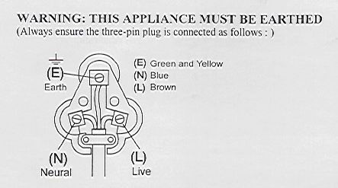
Green/Yellow = Earth
Blue = Neutral
Brown = Live
PLEASE AFFIX YOUR PROOF OF PURCHASE/RECEIPT HERE
IN THE EVENT OF A CLAIM UNDER WARRANTY THIS RECEIPT MUST BE PRODUCED.

W A R R A N T Y
- Home of Living Brands (Pty) Limited warrants to the original purchaser of this product (“the customer”) that this product will be free of defects in quality and workmanship which under normal personal, family or household use and purpose may manifest within a period of 1 (one) year from the date of purchase (“warranty period”).
- Where the customer has purchased a product and it breaks, is defective or does not work properly for the intended purpose, the customer must notify the supplier from whom the customer bought the product (“the supplier”) thereof within the warranty period. Any claim in terms of this warranty must be supported by a proof of purchase. If proof of purchase is not available, then repair, and/or service charges may be payable by the customer to the supplier.
- The faulty product must be taken to the supplier's service center to exercise the warranty.
- The supplier will refund, repair or exchange the product in terms of this warranty subject to legislative requirements. This warranty shall be valid only where the customer has not broken the product himself, or used the product for something that it is not supposed to be used for. The warranty does not include and will not be construed to cover products damaged as a result of disaster, misuse, tamper, abuse or any unauthorised modification or repair of the product.
- This warranty will extend only to the product provided at the date of the purchase and not to any expendables attached or installed by the customer.
- If the customer requests that the supplier repairs the product and the product breaks or fails to work properly within 3 (three) months of the repair and not as a result of misuse, tampering or modification by or on behalf of the customer, then the supplier may replace the product or pay a refund to the customer.
- The customer may be responsible for certain costs where products returned are not in the original packaging, or if the packaging is damaged. This will be deducted from any refund paid to the customer.
HOME OF LIVING BRANDS (PTY) LTD (JOHANNESBURG)

JOHANNESBURG TEL NO. (011) 490-9600

CAPE TOWN TEL NO. (021) 552-5161

DURBAN TEL NO. (031) 792-6000

