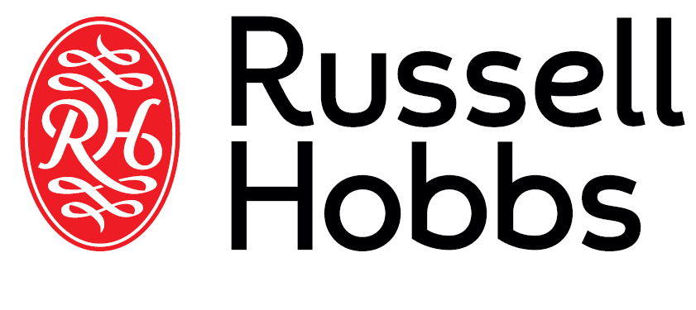

INSTRUCTIONS AND WARRANTY

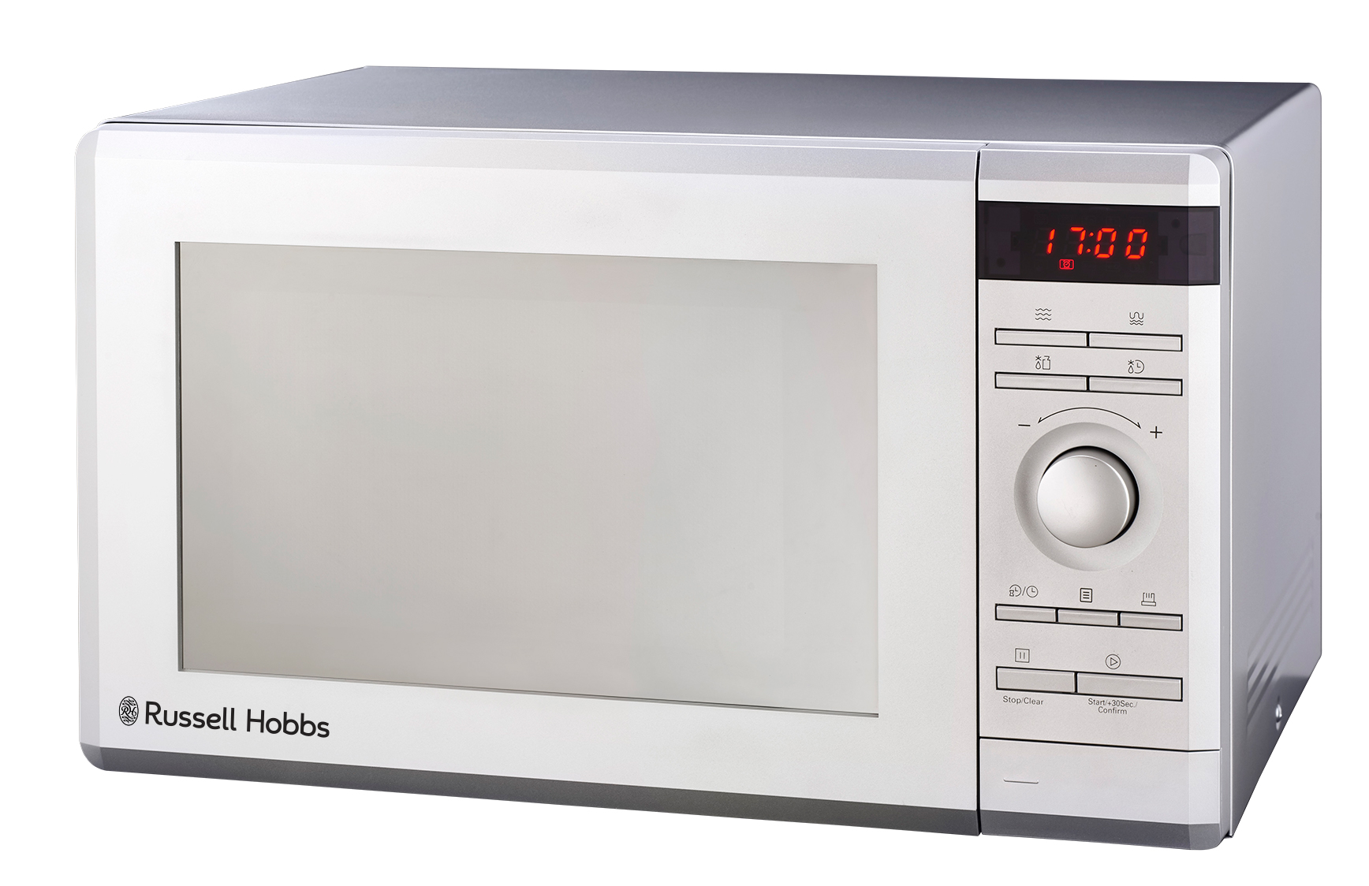

MODEL NO. RHEM36G
RUSSELL HOBBS 36L ELECTRONIC MICROWAVE OVEN WITH GRILL

Congratulations on purchasing our Russell Hobbs 36L Electronic Microwave Oven with Grill. Each unit is manufactured to ensure safety and reliability. Before using this appliance for the first time, please read the instruction manual carefully and keep it for future reference.

FEATURES OF THE RUSSELL HOBBS 36L ELECTRONIC MICROWAVE OVEN

- 36L Capacity
- Digital LED display with Clock
- Power output: 1000W
- 5 power levels
- Programmable multi-stage cooking
- 8 Auto menus: cook, defrost, popcorn, potato, frozen vegetable, beverage, dinner plate, pizza
- 95 minute cooking timer with end signal
- Grill/Combi cooking function
- With quick start and kitchen timer functions
- Smart Info function
- Elegant mirror finish front
- 315mm glass turntable diameter
- User friendly control panel
- Easy to use push button door
- Grey interior for easy cleaning
- With child lock safety feature
- Grill/Combi cooking function
- For domestic use only
- 1 year warranty

IMPORTANT SAFEGUARDS

When using any electrical appliance, basic safety precautions should always be followed including the following:
- Please read the instructions carefully before using any appliance.
- Always ensure that the voltage on the rating label corresponds to the mains voltage in your home.
- Incorrect operation and improper use can damage the appliance and cause injury to the user.
- The appliance is intended for household use only. Commercial use invalids the warranty and the supplier can not be held responsible for injury or damage caused when using the appliance for any other purpose than that intended.
- Avoid any contact with moving parts.
- Close supervision is required when any appliance is used near or by children or invalids.
- Check the power cord and plug regularly for any damage. If the cord or the plug is damaged, it must be replaced by the manufacturer or a qualified person in order to avoid an electrical hazard.
- Do not use the appliance if it has been dropped or damaged in any way. In case of damage, take the unit in for examination and/or repair by an authorised service agent
- Do not operate the oven when empty.
- Do not operate this appliance if it has a damaged cord or plug, if it is not working properly or if it has been damaged or dropped. If the supply cord is damaged, it must be replaced by the manufacturer or its service agent or a similarly qualified person in order to avoid a hazard.
- This appliance is not intended for use by persons (including children) with reduced physical, sensory or mental capabilities, or lack of experience and knowledge, unless they have been given supervision or instruction concerning use of the appliance by a person responsible for their safety.
- WARNING: Only allow children to use the oven without supervision when adequate instructions have been given so that the child is able to use the oven in a safe way and understands the hazards of improper use.
- Do not operate the microwave unit without any food contents inside the cavity.

- To reduce the risk of fire in the oven cavity:
- When heating food in a plastic or paper container, check the oven frequently in terms of the possibility of ignition.
- Remove wire twist-ties from paper or plastic bags before placing the bag in oven.
- If smoke is observed, switch off or unplug the appliance and keep the door closed in order to stifle any flames.
- Do not use the cavity for storage purposes. Do not leave paper products, cooking utensils or food in the cavity when not in use.
WARNING: Liquid or other food must not be heated in sealed containers since they are able to explode.
15. Microwave heating of beverages can result in delayed eruptive boiling, therefore care has to be taken when handling the container.
16. Do not fry food in the oven. Hot oil can damage oven parts and utensils and even result in burns.
17. Eggs in their shell and whole hard-boiled eggs should not be heated in microwave ovens since they may explode even after microwave heating has ended.
18. Pierce foods with heavy skins such as potatoes, whole squashes, apples and chestnuts before cooking.
19. The contents of feeding bottles and baby jars should be stirred or shaken and the temperature should be checked before serving in order to avoid burns or scalding.
20. Cooking utensils may become hot because of heat transferred from the heated food. Potholders/ oven gloves may be needed to handle the utensil.
21. Utensils should be checked to ensure that they are suitable for use in microwave oven.
22. WARNING: It is hazardous for anyone other than a trained person to carry out any service or repair operation which involves the removal of any cover which gives protection against exposure to microwave energy.
- This product is Group 2 Class B ISM equipment. The definition of Group 2 which contains all ISM (Industrial, Scientific and Medical) equipment in which radio-frequency energy is intentionally generated and/or used in the form of electromagnetic radiation for the treatment of material, and spark erosion equipment. For Class B equipment is equipment suitable for use in domestic establishments and in establishments directly connected to a low voltage power supply network which supplies buildings used for domestic purpose.
- Never immerse the unit in water or any other liquid for cleaning purposes.
- Remove the plug from the socket by gripping the plug. Do not pull on the cord to disconnect the appliance from the mains. Always unplug the unit when not in use, before cleaning or when adding or removing parts.
- The use of accessory attachments that are not recommended or supplied by the manufacturer may result in injuries, fire or electric shock.
- A short cord is provided to reduce the hazards resulting from becoming entangled in or tripping over a longer cord.
- Do not let the cord hang over the edge of a table or counter. Ensure that the cord is not in a position where it can be pulled on inadvertently.
- Do not allow the cord to touch hot surfaces and do not place on or near a hot gas or electric burner or in a heated oven.
- Do not use the appliance on a gas or electric cooking top or over or near an open flame.
- Use of an extension cord with this appliance is not recommended. However, if it is necessary to use an extension lead, ensure that the lead is suited to the power consumption of the appliance to avoid overheating of the extension cord, appliance or plug point. Do not place the extension cord in a position where it can be pulled on by children or animals or tripped over.
- This appliance is not suitable for outdoor use. Do not use this appliance for anything other than its intended use.
- DO NOT carry the appliance by the power cord.
- Do not leave this appliance unattended during use. Always unplug the unit when not in use or before cleaning.
- Always operate the appliance on a smooth, even, stable surface. Do not place the unit on a hot surface.
- Ensure that the switch is in the “Off” or “0” position after each use.
- The manufacturer does not accept responsibility for any damage or injury caused by improper or incorrect use, or for repairs carried out by unauthorised personnel.
- In case of technical problems, switch off the machine and do not attempt to repair it yourself. Return the appliance to an authorised service facility for examination, adjustment or repair. Always insist on the use of original spare parts. Failure to comply with the above mentioned pre-cautions and instructions, could affect the safe operation of this machine.
- The microwave oven should not be placed in a cabinet unless it has been tested in a cabinet.
- Appliances are not intended to be operated by means of an external timer or separate remote-control system.
- The door or the outer surface may get hot when the appliance is in operation.
- The rear surface of the appliance should be placed against a wall.

SPECIFICATIONS

Model: | RHEM36G
Rated Voltage: | 230V~50Hz
Rated Input Power(Microwave): | 1500W
Rated Output Power(Microwave): | 1000W
Rated Input Power(Grill): | 1100W
Oven Capacity: | 36L
Turntable Diameter: | 315mm
External Dimensions: | 519 423 315mm

PRECAUTIONS TO AVOID POSSIBLE EXPOSURE TO EXCESSIVE MICROWAVE ENERGY
- Do not attempt to operate this oven with the door open since open door operation can result in harmful exposure to microwave energy. It is important not to break or tamper with the safety interlocks.
- Do not place any object between the oven front face and the door or allow soil or cleaner residue to accumulate on sealing surfaces.
- Do not operate the oven if it is damaged. It is particularly important that the oven door close properly and that there is no damage to the
    - Door (bent),
    - Hinges and latches (broken or loosened),
    - Door seals and sealing surfaces.
- The oven should not be adjusted or repaired by anyone except properly qualified service personnel.
- If the microwave appliance is not maintained in a good state of cleanliness, its surface could become degraded, its lifespan affected and could result in a possibly hazardous situation.

INSTALLATION
- Make sure that all the packing materials are removed from the inside of the door.
- WARNING: Check the oven for any damage, such as misaligned or bent door, damaged door seals and sealing surface, broken or loose door hinges and latches and dents inside the cavity or on the door. If there is any damage, do not operate the oven and contact qualified service personnel.
- This microwave oven must be placed on a flat, stable surface to hold its weight and the heaviest food likely to be cooked in the oven.
- Do not place the oven where heat, moisture, or high humidity are generated, or near combustible materials.
- For correct operation, the oven must have sufficient airflow. Allow 20cm of space above the oven, 20cm at back and 20cm at both sides. Do not cover or block any openings on the appliance. Do not remove feet.
- Do not operate the oven without a glass tray, roller support, and shaft in their proper positions.
- Make sure that the power supply cord is undamaged and does not run under the oven or over any hot or sharp surface.
- The socket must be readily accessible so that it can be easily unplugged in an emergency.
- Blocking the intake and/or outlet openings can damage the oven.
- Remove any protective film found on the microwave cabinet surface. Do not remove the light brown Mica cover that is attached to the oven cavity to protect the magnetron.
- Never place the glass tray upside down. The glass tray should never be restricted.
- Both glass tray and turntable ring assembly must always be used during cooking.
- All food and containers are always to be placed on the glass tray for cooking.
- If the glass tray or turntable ring assembly cracks or breaks, contact your nearest authorized service center.

RADIO INTERFERENCE

Operation of the microwave oven can cause interference to your radio, TV, or similar equipment. When there is interference, it may be reduced or eliminated by taking the following measures:

- Clean the door and sealing surface of the oven.
- Reposition the receiving antenna of the radio or television.
- Relocate the microwave oven with respect to the receiver.
- Plug the microwave oven into a different outlet so that microwave oven and receiver are on different branch circuits.

MICROWAVE COOKING PRINCIPLES

- Arrange food carefully. Place thickest areas towards outside of dish.
- Watch cooking time. Cook for the shortest amount of time indicated and add more as needed. Food severely overcooked can smoke or ignite.
- Cover foods while cooking. Covers prevent spattering and help foods to cook evenly.
- Turn foods over once during microwave cooking to speed cooking of such foods as chicken and hamburgers. Large items like roasts must be turned over at least once.
- Rearrange foods such as meatballs halfway through cooking both from top to bottom and from the center of the dish to the outside.

UTENSILS GUIDE

  - The ideal material for a microwave utensil is material which is transparent. This allows energy to pass through the container and heat the food.
  - A microwave cannot penetrate metal, so metal utensils or dishes with metallic trim should not be used.
  - Do not use recycled paper products when microwave cooking, as they may contain small metal fragments which may cause sparks and/or fires.
  - Round /oval dishes rather than square/oblong ones are recommend, as food in corners tends to overcook.
  - Narrow strips of aluminium foil may be used to prevent overcooking of exposed areas. But be careful don’t use too much and keep a distance of 1 inch.
  - The list below is a general guide to help you select the correct utensils:

COOKWARE | MICROWAVE
Heat–Resistant Glass | Yes
Non Heat–Resistant Glass | No
Heat–Resistant Ceramics | Yes
Microwave–Safe Plastic Dish | Yes
Paper Kitchen Towels | Yes
Metal Tray | No
Metal Rack | No
Aluminium Foil & Foil Containers | No
Parchment Paper | Yes
Plastic Wrap | Yes
Wax Paper | Yes
Containers containing metal parts | Yes
Metal Twist-ties | No
Paper Bags | No
Plastic Foam | No
Wood | No

PARTS DIAGRAM
A

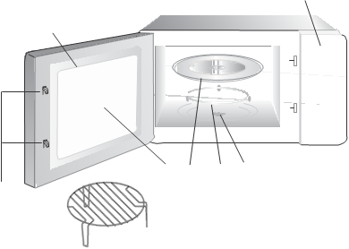
B
C
D
E
D
H
G
- Control Panel
- Turntable Shaft
- Turntable ring assembly
- Glass Tray
- Observation window
- Door Assembly
- Safety Interlock System
- Grill Rack

TURNTABLE INSTALLATION
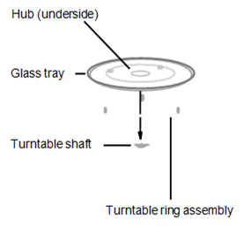

- Never place the glass tray upside down. The glass tray should not be restricted.
- Both glass tray and turntable ring should always be used during cooking.
- All food and containers of food should always be placed on the glass tray for cooking.
- If glass tray or turntable ring assembly cracks or breaks, contact your nearest authorized service centre.
CONTROL PANEL

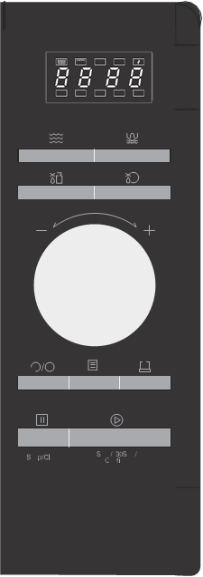
Microwave
Time Defrost
Weight Defrost
 Kitchen Timer/ Clock
Menu
Memory
Stop/Clear
Start/+30 Sec/ Confirm
Grill/ Combi

OPERATION INSTRUCTIONS

Level | 1 | 2 | 3 | 4 | 5
Microwave Power | 100% | 80% | 50% | 30% | 10%
Display | P100 | P80 | P50 | P30 | P10

1. Clock Setting
When the microwave oven is electrified, the screen will display "0:00", buzzer will ring once.

1) Press " " twice to select clock function, the hour figures will flash.

2) Turn " " to adjust the hour figures, the input time should be within 0--23.

3) Press " ", the minute figures will flash.

4) Turn " " to adjust the minute figures, the input time should be within 0--59.

5) Press " “to finish clock setting. ":" will flash, and the time will light.

Note: 1) If the clock is not set, it would not function when powered.
2) During the process of clock setting, if you press” ", the oven will go back to the previous status automatically.

2. Microwave Cooking

Press " " once , the screen will display "P100".Press " " repeatedly or turn

" "to choose the power you want, and "P100", "P80" "P50", "P30" or "P10" will

display for each added press. Then press" " to

confirm, and turn " " to

set cooking time from 0:05 to 95:00. Press " " again to start cooking.

set cooking time from 0:05 to 95:00. Press " " again to start cooking.

Example: If you want to use 80% microwave power to cook for 20 minutes, you can operate the oven as the following steps.
1) Press " " once, the screen display "P100".

2) Press " " once again or turn" " to choose 80% microwave power.

3) Press " " to confirm, and the screen displays "P 80".

4) Turn " " to adjust the cooking time until the oven displays "20:00”.
5) Press " " to start cooking .
Note: the step quantities for the adjustment time of the coding switch are as follow:
0---1 min : 5 seconds
1---5 min : 10 seconds
5---10 min : 30 seconds
10---30 min : 1 minute
30---95 min : 5 minutes
3. Grill or Combi Cooking

Press “” once, the screen will display “G” and press “” repeatedly or turn the

" " to choose the power you want, and "G","C-1" or "C-2" will display for each

added press. Then press " "to confirm,and turn"
0:05 to 95:00. Press " " again to start cooking.
to “set cooking time from

Example: If you want to use 55% microwave power and 45% grill power(C-1) to cook for
10 minutes, you can operate the oven as the following steps.

1) Press " " once, the screen display "G".

2) Press " " once again or turn " " to choose combi. 1 mode.

3) Press " " to confirm, and the screen displays "C-1".

4) Turn " " to adjust the cooking time until the oven displays "10:00".

5) Press " " to start cooking .

"Grill/ Combi. "Pad Instructions
Order | Display | Microwave Power | Grill Power
1 | G | 0% | 100%
2 | C-1 | 55% | 45%
3 | C-2 | 36% | 64%

Note: If half the grill time passes, the oven sounds twice, and this is normal. In order to have a better effect of grilling food, you should turn the food over,
close the door, and then press" " to continue cooking. If no operation, the oven will continue working.

4. Quick Start
1) In waiting state, Press " " to start cooking with 100% power for 30 seconds , each added press will increase 30 seconds cooking time up to 95 minutes.
2) In microwave, grill ,combination cooking or time defrost state, each press of " "
can increase 30 seconds of cooking time .
3) In waiting state, turn " " left to set cooking with 100% microwave power.

After choosing the cooking time , press " " to start cooking.

5. Defrost By Weight
1) Press " " , and the oven will display "dEF1".

2) Turn " " to select the weight of food from 100 to 2000 g.

3) Press " " to start defrosting.

6. Defrost By Time
1) Press " " , and the oven will display "dEF2".

2) Turn " " to select the defrost time. The MAX time is 95 minutes.

3) Press " " to start defrosting.The defrost power is P30 , and it will not be
Changed
.
7. Kitchen Timer

(1) Press " " once, the screen will display 00:00, clock indicator will light.

(2) Turn " " to enter the correct time.(The maximum cooking time is 95 minutes.)
(3) Press " " to confirm setting, clock indicator will be lighted.
(4) When the kitchen time is reached, clock indicator will go out. The buzzer will ring 5 times. If the clock be set (24-hour system), the screen will display the current time.

Note: The kitchen Time differs from 24-hour system, Kitchen Timer is a only used as a timer.
8. Auto Menu
1) Press " " to start Auto cooking. Turn " " right to choose the menu, and "A-1" to "A-8" will display, which means pizza, meat, vegetable, pasta, potato, fish, beverage and popcorn.

2) Press " " to confirm.

3) Turn " " to choose the default weight as the menu chart.

4) Press " " to start cooking.
Example: If you want to use "Auto Menu" to cook fish for 350g.

1) Press " ",then turn " " clockwise till "A-6" display.

2) Press " " to confirm.

3) Turn " " to select the weight of fish till "350" display.

4) Press " " to start cooking.

The menu chart:

Menu | Weight | Display
A-1 Pizza | 200 g | 200
A-1 Pizza | 400 g | 400
A-2 Meat | 250 g | 250
A-2 Meat | 350 g | 350
A-2 Meat | 450 g | 450
A-3 Vegetable | 200 g | 200
A-3 Vegetable | 300 g | 300
A-3 Vegetable | 400 g | 400
A-4 Pasta | 50g(with 450 ml cold water) | 50
A-4 Pasta | 100g(with 800 ml cold water) | 100
A-5 Potato | 200 g | 200
A-5 Potato | 400 g | 400
A-5 Potato | 600 g | 600
A-6 Fish | 250 g | 250
A-6 Fish | 350 g | 350
A-6 Fish | 450 g | 450
A-7 Beverage | 1 cup(120 ml) | 1
A-7 Beverage | 2 cups(240 ml) | 2
A-7 Beverage | 3 cups(360ml) | 3
A-8 Popcorn | 50 g | 50
A-8 Popcorn | 85 g | 85
A-8 Popcorn | 100 g | 100

9. Multi-section cooking
At most 2 sections can be set for cooking. In multi-section cooking, if one section is defrosting, then defrosting will be placed in the first section automatically.
Example: If you want to defrost food for 5 minutes and then cook with 80% microwave power for 7 minutes, operate it as the following:
1) Press " " once, and the oven will display "dEF2".

2) Turn " " to select the defrost time till "5:00" display.

3) Press " " once, the screen display "P100".

4) Press " " once again or turn " " to choose 80% microwave power.

5) Press " " to confirm, and the screen displays "P 80".

6) Turn " " to adjust the cooking time till the oven displays "7:00".

7) Press " " to start cooking, and buzzer will sound once for the first section, defrosting time counts down; buzzer will sound once again entering the second cooking. when cooking finish, buzzer sounds five times.
Note: Auto menu cannot be set as one of the multi-stage.

10 Memory Function
If the procedure has been set, press “ " to use it.

If not, continue to set the procedure. Only one or two stages can be set.
Then press " " to finish setting.

11. Inquiring Function
(1) In states of microwave,grill and combination cooking, press " " or " ", the current power will be displayed for 3 seconds. After 3 seconds, the oven will turn back
to the former state;
(2) In cooking.state, press " " to inquire the time and the time will display for
3 seconds .

12. Lock-out Function for Children
Lock: In waiting state, press " " for 3 seconds, there will be a long beep denoting entering the children-lock state and current time will diplay if the time has
been set, otherwise, the screen will display " ".

Lock quitting: In locked state, press " " for 3 seconds, there will be a long denoting that the lock is released.
"beep"

13. Specification
1) The buzzer will sound once when turning the knob at the beginning;
2) " " must be pressed to continue cooking if the door is opened during cooking;
3) Once the cooking programme has been set , " " is not pressed in 1 minute.
The current time will be displayed. The setting will be cancelled.
4) The buzzer sounds once by efficient press, inefficient press will be no response.
5) The buzzer will sound five times to remind you cooking is finished.

Trouble shooting

 | 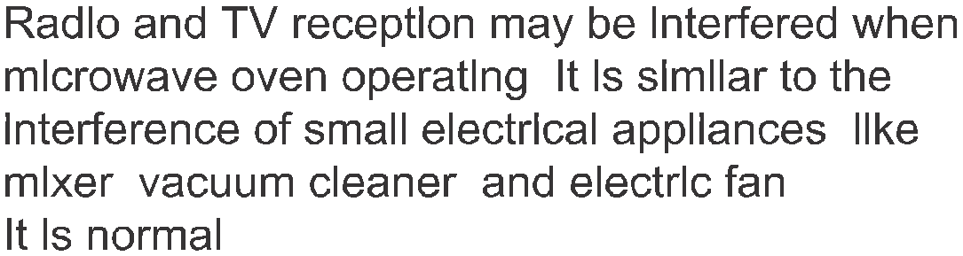
 | 
 | 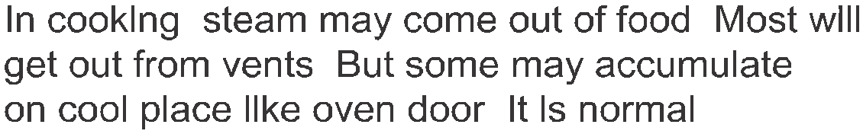
 | It is forbidden to run the unit without any food inside. It is very dangerous.

 |  | 
 | 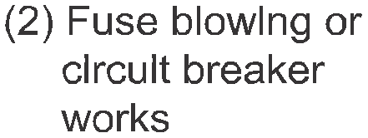 | 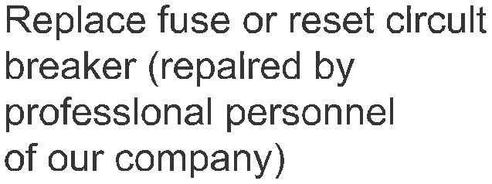
 |  | 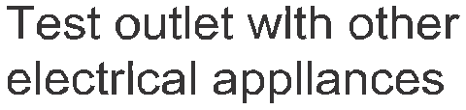
 |  | 
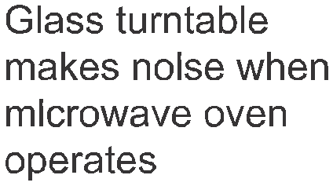 | 
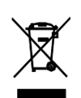

According to the Waste of Electrical and Electronic Equipment (WEEE) directive, WEEE should be separately collected and treated. If at any time you need to dispose of this product, please do NOT dispose of this product with household waste. Please send this product to WEEE collecting points where available.

CLEANING AND MAINTENANCE

- This appliance is for household use only and is not user-serviceable.
- Do not open or change any parts by yourself. Please refer to a qualified electrical service department or return to the supplier if servicing is necessary.
- Turn off the oven and remove the power plug from the wall socket before cleaning.
- Keep the inside of the oven clean. When food splatters or spilled liquids adhere to oven walls, wipe with a damp cloth. Mild detergent may be used if the oven gets very dirty. Avoid the use of spray and other harsh cleaners as they may stain, streak or dull the door surface.
- The outside surfaces should be cleaned with a damp cloth. To prevent damage to the operating parts inside the oven, water should not be allowed to seep into the ventilation openings.
- Wipe the door and window on both sides, the door seals and adjacent parts frequently with a damp cloth to remove any spills or spatters. Do not use abrasive cleaner.
- Do not allow the control panel to become wet. Clean with a soft, damp cloth. When cleaning the control panel, leave oven door open to prevent oven from accidentally turning on.
- If steam accumulates inside or around the outside of the oven door, wipe with a soft cloth. This may occur when the microwave oven is operated under high humidity condition. And it is normal.
- It is occasionally necessary to remove the glass tray for cleaning. Wash the tray in warm sudsy water or in a dishwasher.
- The roller ring and oven floor should be cleaned regularly to avoid excessive noise. Simply wipe the bottom surface of the oven with mild detergent. The roller ring may be washed in mild sudsy water or dishwasher. When removing the roller ring from cavity floor for cleaning, be sure to replace in the proper position.
- Remove odors from your oven by combining a cup of water with the juice and rind of one lemon in a deep microwaveable bowl, microwave for 5 minutes. Wipe thoroughly and dry with a soft cloth.
- When it becomes necessary to replace the oven light, please consult a dealer to have it replaced.
- The oven should be cleaned regularly and any food deposits removed. Failure to maintain the oven in a clean condition could lead to deterioration of the surface that could adversely affect the life of the appliance and possibly result in a hazardous situation.
- Please do not dispose this appliance into the domestic rubbish bin; it should be disposed to the particular disposal center provided by the municipalities.
- Do not use bleach or other abrasive substance or solvents to clean your appliance as it can be damaging to the finish.

STORING THE APPLIANCE

- Unplug the unit from the wall outlet and clean all the parts as instructed above. Ensure that all parts are dry before storing.
- Store the appliance in its box or in a clean, dry place.
- Never store the appliance while it is still wet or dirty.
- Never wrap the power cord around the appliance.

SERVICING THE APPLIANCE

There are no user serviceable parts in this appliance. If the unit is not operating correctly, please check the following:
- You have followed the instructions correctly
- That the unit has been wired correctly and that the wall socket is switched on.
- That the mains power supply is ON.
- That the plug is firmly in the mains socket.

If the appliance still does not work after checking the above:
- Consult the retailer for possible repair or replacement. If the retailer fails to resolve the problem and you need to return the appliance, make sure that:
- The unit is packed carefully back into its original packaging.
- Proof of purchase is attached.
- A reason is provided for why it is being returned.

If the supply cord is damaged, it must be replaced by the manufacturer or an authorised service agent, in order to avoid any hazard. If service becomes necessary within the warranty period, the appliance should be returned to an approved Amalgamated Appliance (Pty) Ltd service centre. Servicing outside the warranty period is still available, but will, however, be chargeable.

CHANGING THE PLUG

Should the need arise to change the fitted plug, follow the instructions below.
This unit is designed to operate on 230V~240V current only. Connecting to other power sources may damage the appliance. Connect a three-pin plug as follows:
The wires in this mains lead are coloured in accordance with the following code:
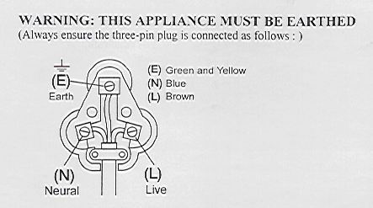
Green/Yellow = Earth
Blue = Neutral
Brown = Live

PLEASE AFFIX YOUR PROOF OF PURCHASE/RECEIPT HERE
IN THE EVENT OF A CLAIM UNDER WARRANTY THIS RECEIPT MUST BE PRODUCED.

2 YEAR WARRANTY
1 year retail ⵏ 1 year extended warranty upon registration*
visit www.russellhobbs.co.za

W A R R A N T Y AND EXTENDED WARRANTY

- Home of Living Brands (Pty) Limited ("Home of Living Brands") warrants to the original purchaser of this product ("the customer") that this product will be free of defects in quality and workmanship which under normal personal, family or household use and purpose may manifest within a period of 1 (one) year from the date of purchase ("warranty period").
- Home of Living Brands shall extend the warranty period for a further period of 1(one) year (“extended warranty period*”), on condition that the purchaser registers the product on the website, within 12 months from the date of purchase of the product. The website address for registration is as follows: http://russellhobbs.co.za/info-pages/warranty-info.aspx. The extended warranty period only applies to products purchased on or after 1 October 2017.
- Where the customer has purchased a product and it breaks, is defective or does not work properly for the intended purpose, the customer must notify the supplier from whom the customer bought the product ("the supplier") thereof within the warranty period or if applicable, the extended warranty period. Any claim in terms of this warranty must be supported by a proof of purchase. If proof of purchase is not available, then repair, and/or service charges may be payable by the customer to the supplier.
- The faulty product must be taken to the supplier's service centre to exercise the warranty.
- The supplier will refund, repair or exchange the product in terms of this warranty subject to legislative requirements. This warranty shall be valid only where the customer has not broken the product themselves, or used the product for something that it is not supposed to be used for. The warranty does not include and will not be construed to cover products damaged as a result of disaster, misuse, tamper, abuse or any unauthorised modification or repair of the product.
- This warranty will extend only to the product provided at the date of the purchase and not to any expendables attached or installed by the customer.
- If the customer requests that the supplier repairs the product and the product breaks or fails to work properly within 3 (three) months of the repair and not as a result of misuse, tampering or modification by or on behalf of the customer, then the supplier may replace the product or pay a refund to the customer, subject to the supplier’s discretion.
- The customer may be responsible for certain costs where products returned are not in the original packaging, or if the packaging is damaged. This will be deducted from any refund paid to the customer.

HOME OF LIVING BRANDS (PTY) LTD (JOHANNESBURG)
JOHANNESBURG TEL NO. (011) 490-9600
CAPE TOWN TEL NO. (021) 552-5161
DURBAN TEL NO. (031) 303-1163
www.homeoflivingbrands.com
www.russellhobbs.co.za
www.facebook.com/RussellHobbsSA

