Instructions of Milk Foamer

- Model: F280
- Electricity Range: 230-240V~ 50 Hz
- Power: 600-650W
- Heating element: flat heating disc
- Capacity: 100-250 ml cold milk
- Main wire: 0,75 metres
- Size: 158mm long, 126mm width, 164 mm height
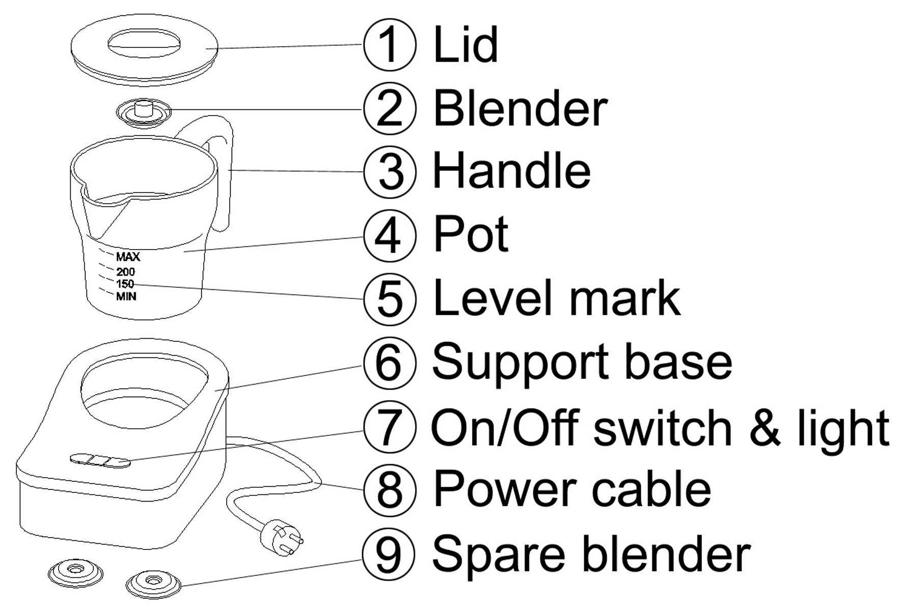
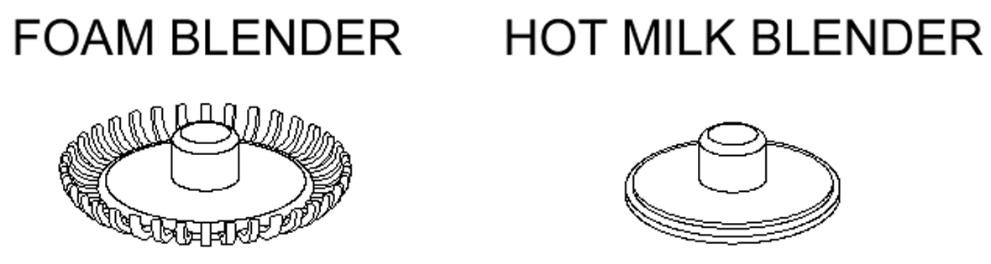
Safety warnings
- After having the packaging removed, check that the appliance is intact. If in doubt do not use the appliance and contact your sales agent.
- The parts of the packaging, plastic bags etc. must not be left within the reach of children as they are potential sources of danger.
- This appliance has been manufactured to make milk foam and chocolate only.
- This appliance is designed for and must only be used for house hold purposes. All other use is considered improper and as a result dangerous and voids the warranty.
- The manufacturer declines all liability for any damage deriving from improper, incorrect and unreasonable use of the appliance.
- In the event of faults or malfunctioning of the appliance, do not tamper with it. For any repairs, only contact service centres that are authorised by the manufacturer. Failure to observe the above warnings may compromise the safety of the appliance.
- The appliance is not intended for use by persons (including children) with reduced physical, sensory or mental capabilities, or lack of experience and knowledge, unless they have been given supervision or instruction.
- Children should be supervised to ensure that they do not play with the appliance.
- Keep out of reach from children when in use, the milk is very hot.
- During cleaning, never immerse the support base in water, this is an electrical appliance.
- When using the appliance do not touch the hot surface of pot and heating element.

Important
When using the appliance, please prepare everything first (cleaning the pot, filling with milk) before placing it on the base station.
If the appliance has already heated up, allow it to cool down completely, before using it.
Please keep the heating disc clean. Don’t leave anything on the surface of heating element and the bottom of the pot..

.

Operation---milk foam
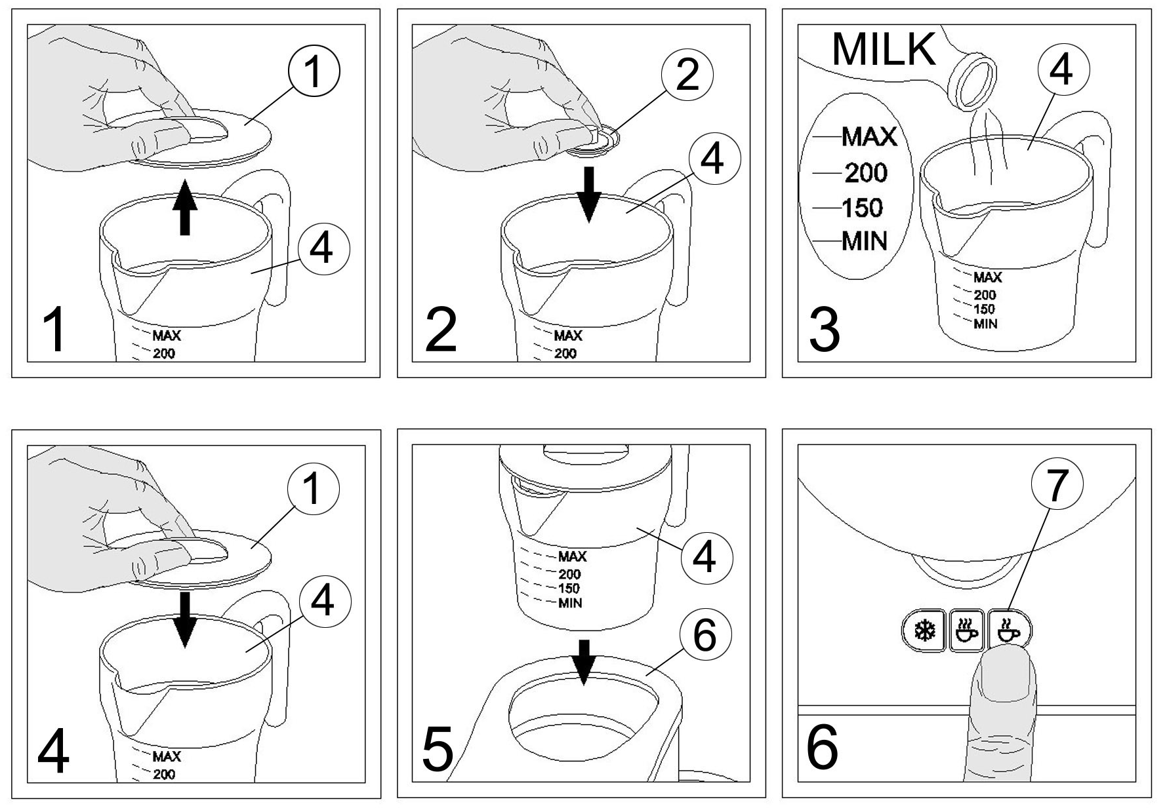
Fig 1 Open the lid of the appliance .
Fig 2 Press the blender into the pot.
Fig 3 Pour milk into the pot, at a maximum of 250 ml, which is the level marked with –Max. If more milk is poured into the pot you risk an overflow of warm milk!
Fig 4 Close the lid of the appliance.
Fig 5 Put the pot onto the support base. Check that the electrical plug is inserted into the mains socket.
When you need to speed up to work the appliance, please wet the bottom of the pot with little tap water. See the Fig.
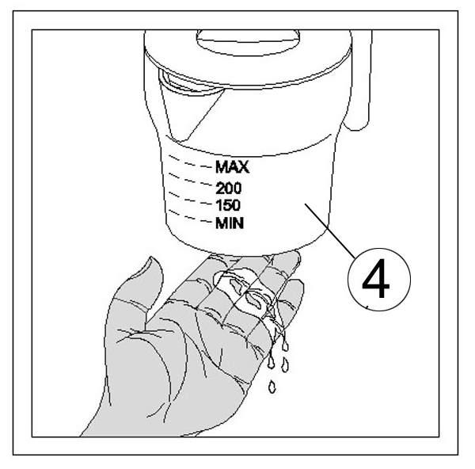
Fig 6 On the support base,the sign  is the heating switch and the sign  is the non-heating switch.When you firstly start the appliance, the indicator light will be on and the blender start to rotate the milk. In about 90 – 240 seconds, the appliance will stop automatically and the light will be off. The pot is now filled with hot luscious milk foam that can be poured in your coffee cup. When you need to stop the appliance to work on halfway, you can repeat to press the switch and it will stop immediately.
Operation---hot chocolate
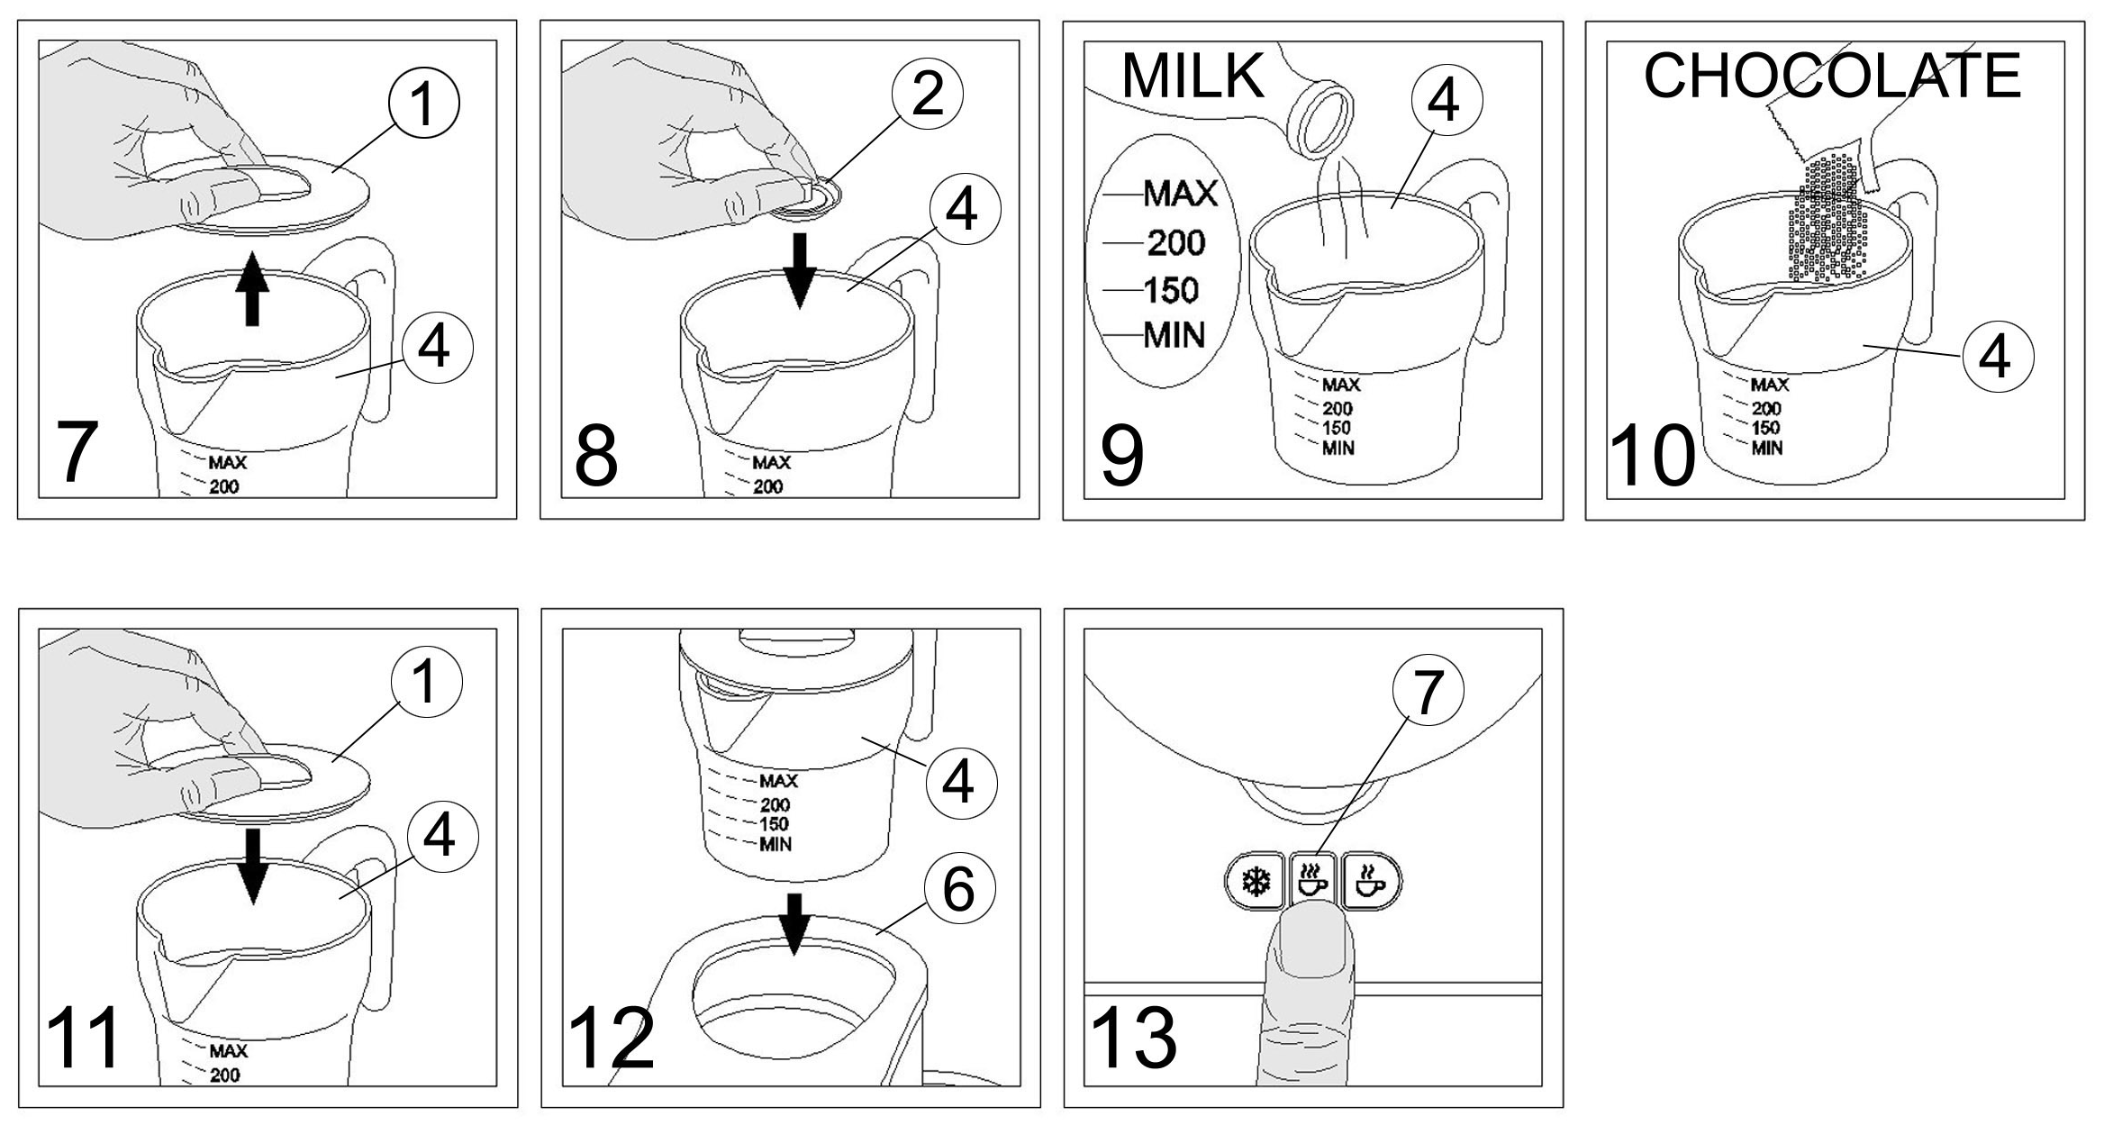
Fig 7 Open the lid of the appliance.
Fig 8 Press the blender into the pot.
Fig 9 Pour milk into the pot, at a maximum of 250 ml, which is the level marked with –Max. If more milk is poured into the pot you risk an overflow of warm milk!
Fig 10 Pour the chocolate into the pot.
Fig 11 Close the lid of the appliance.
Fig 12 Put the pot onto the support base . Check that the electrical plug is inserted into the mains socket.
When you need to speed up to work the appliance, please wet the bottom of the pot with little tap water. See the Fig.
Fig 13 On the support base, the sign  is the heating switch. When you firstly start the appliance, the indicator light will be on and the blender start to rotate the milk. In about 90 – 240 seconds, the appliance will stop automatically and the light will be off. The pot is now filled with hot chocolate that can be poured in your cup. When you need to stop the appliance to work on halfway, you can repeat to press the switch and it will stop immediately.

Cleaning & Maintenance
Before clean the inside after use, wait for the appliance to cool down.
When cleaning the inside, use a sponge or a soft brush together with normal washing up liquid. Do not use any solvents or abrasive detergents. Sharp or hard instruments or steel wool is strictly forbidden.
Take care! The heating element must not be scratched.
When cleaning outside of the appliance, just use a damp cloth. Keep attention not to wet any electrical parts. Do not wash the appliance in the dishwasher.
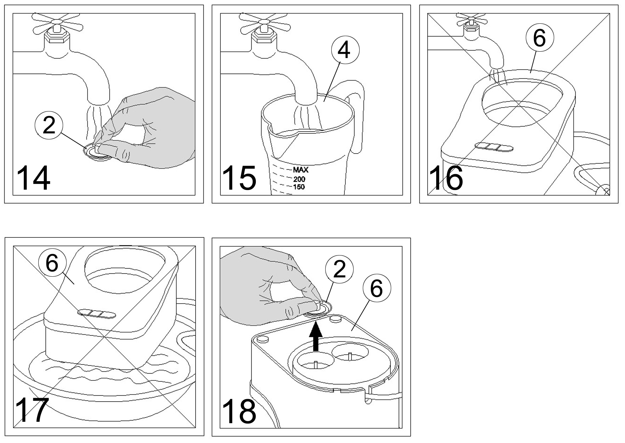
Fig 14 You can take out the blender and wash it under tap water.
Fig 15 You can pour the tap water into the pot to clean it.
Fig 16 Do NOT put the support base of the heater into water.
Fig 17 The support base of the heater can NOT be washed in water nor rinsed under tap water.
Fig 18 You can use the spare blender under the support base if you need it.

Problem solving
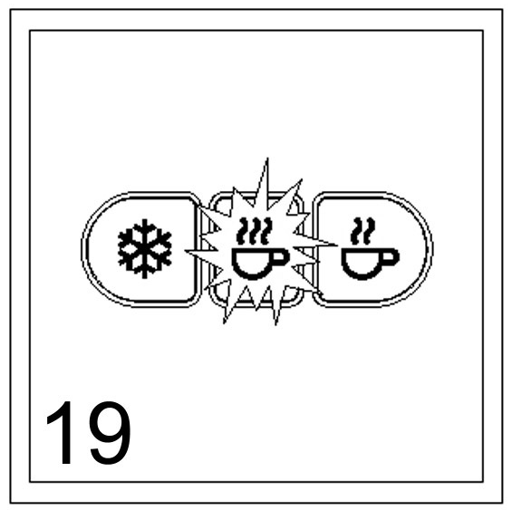
Fig 19 When the switch is twinkling, that means the thermostat system of the appliance was been malfunction. At this time, you should cut off the electricity power and informed service dealer.
When the ON switch is pressed down, there is no light and it fails to work.
If the supply cord is damaged, it must be replaced by the manufacturer, its service agent or similarly qualified persons in order to avoid a hazard.
Check the power input: It is connected to the main socket in the wall and that there is electricity.
If it still fails to work. Contact a qualified service dealer.
The milk is not becoming a foam.

Check that the blender is correctly placed on the centre shaft.
Check that the blender is not broken.
Check that the blender is not jammed by other things or old clogged residues.
New blenders are available as a spare part.

