RHFF56

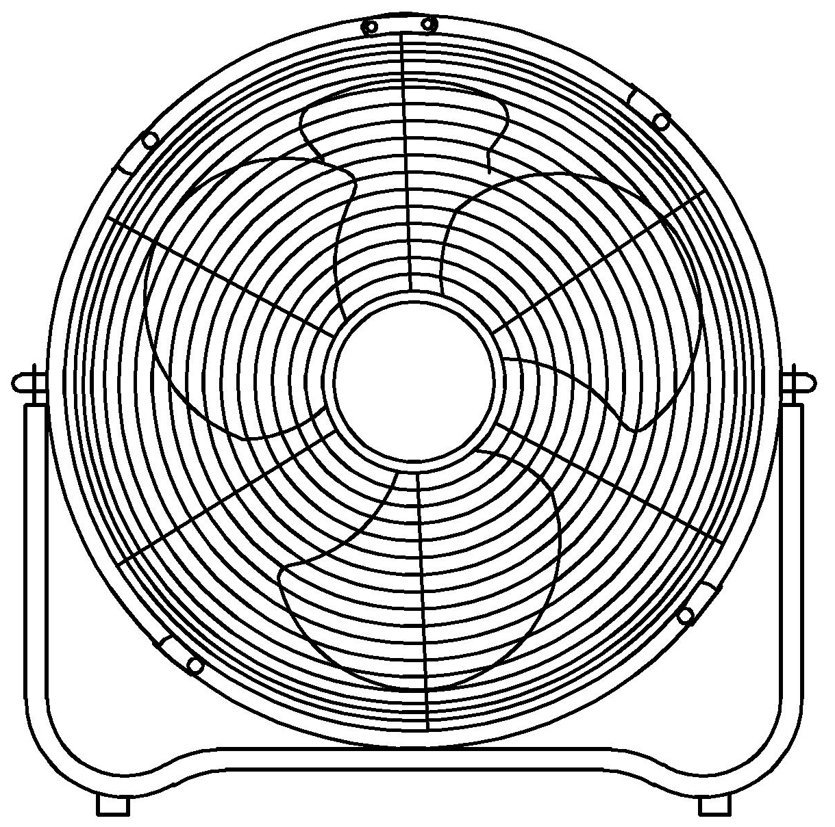

INTRODUCTION
Congratulations on purchasing our Russell Hobbs High Velocity Floor Fan. Each unit is manufactured to ensure safety and reliability. Before using this appliance for the first time, please read the instruction manual carefully and keep it for future reference.

IMPORTANT SAFEGUARDS
When using any electrical appliance, basic safety precautions should always be followed including the following:
- Please read the instructions carefully before using any appliance.
- Always ensure that the voltage on the rating label corresponds to the main voltage in your home.
- Incorrect operation and improper use can damage the fan and cause injury to the user.
- The fan is intended for household use only. Commercial use invalidates the warranty and the supplier cannot be held responsible for injury or damage caused when using the appliance for any other purpose than that intended.
- This fan is not intended for use by persons (including children) with reduced physical, sensory or mental capabilities, or lack of experience and knowledge, unless they have been given supervision or instruction concerning use of the appliance by a person responsible for their safety.
- Check the power cord and plug regularly for any damage. If the cord or the plug is damaged, the manufacturer or a qualified person must replace it in order to avoid an electrical hazard.
- Do not use the fan if it has been dropped or damaged in any way. In case of damage, take the unit in for examination and/or repair by an authorised service agent.
- To reduce the risk of electric shock, do not immerse or expose assembly, plug or the power cord to water or any other liquid.
- Never immerse the unit in water or any other liquid for cleaning purposes.
- Remove the plug from the socket by gripping the plug. Do not pull on the cord to disconnect the fan from the mains. Always unplug the unit when not in use, before cleaning or when adding or removing parts.
- The use of accessory attachments that are not recommended or supplied by the manufacturer may result in injuries, fire or electric shock.
- A short cord is provided to reduce the hazards resulting from becoming entangled in or tripping over a longer cord.
- Ensure that the cord is not in a position where it can be pulled on inadvertently.
- Do not allow the cord to touch hot surfaces and do not place on or near a hot gas or electric burner or in a heated oven.
- Use of an extension cord with the fan is not recommended.
- This fan is not suitable for outdoor use. Do not use this appliance for anything other than its intended use.
- DO NOT carry the appliance by the power cord.
- DO NOT COVER the fan under any circumstances.
- Do not leave the appliance unattended during use. Always unplug the unit when not in use or before cleaning.
- Always operate the appliance on a smooth, even, stable surface. Do not place the unit on a hot surface.
- Ensure that the switch is in the “Off” position after each use.
- The manufacturer does not accept responsibility for any damage or injury caused by improper or incorrect use, or for repairs carried out by unauthorized personnel.
- In case of technical problems, switch off the unit and do not attempt to repair it yourself. Return the appliance to an authorised service facility for examination, adjustment or repair. Always insist on the use of original spare parts. Failure to comply with the above mentioned pre-cautions and instructions, could affect the safe operation of this machine.

Fan Diagram

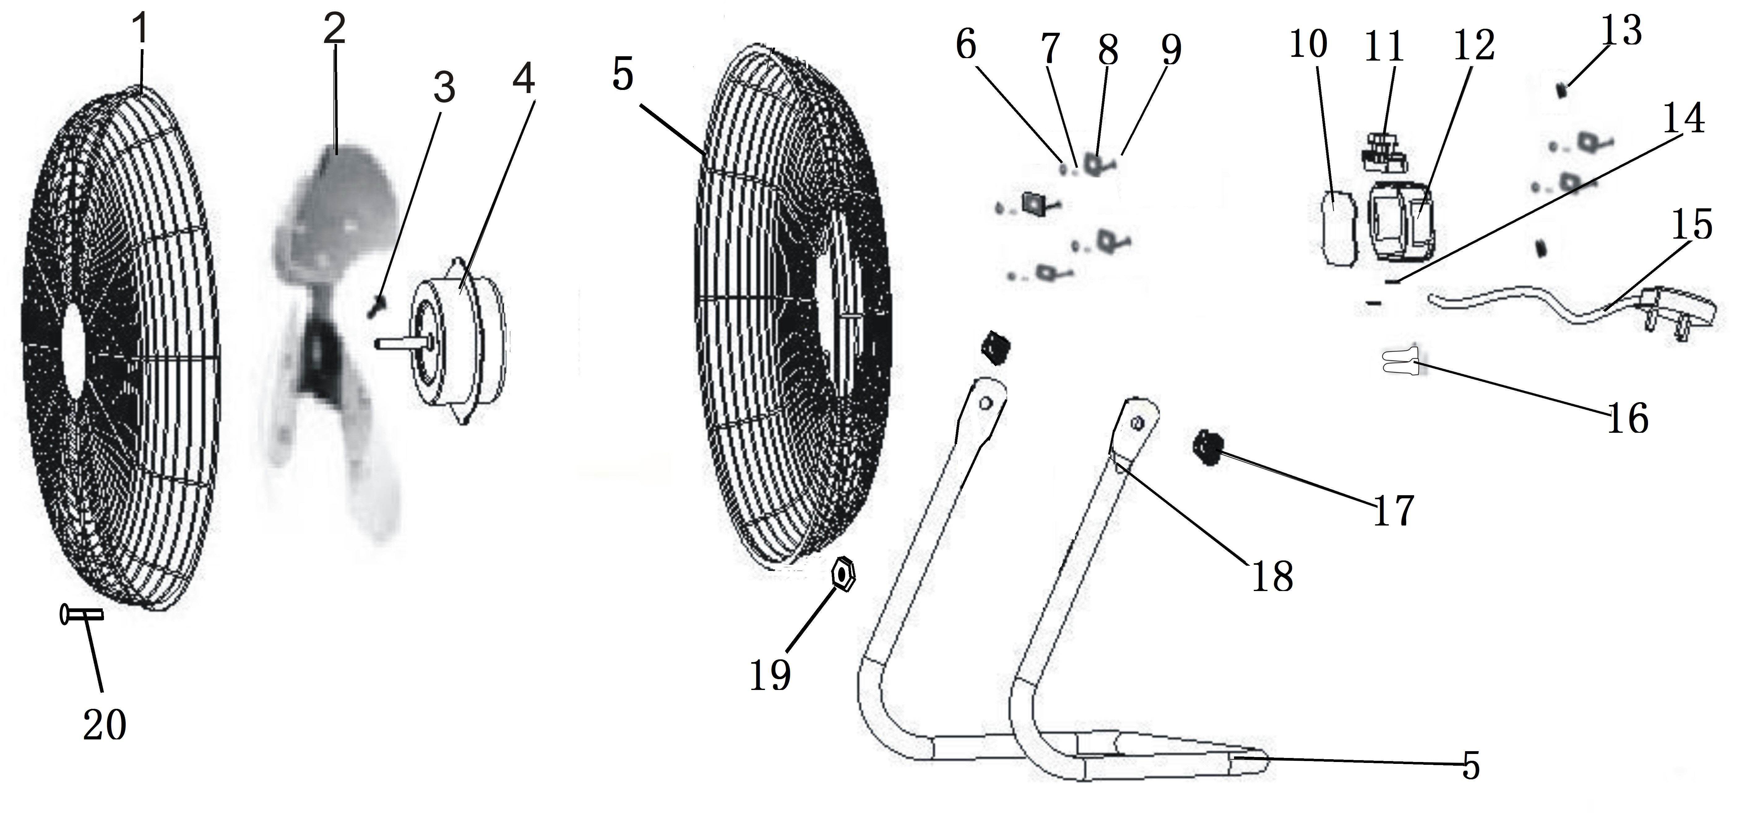

- FRONT GUARD
- BLADE
- BLADE SCREW
- MOTOR
- REAR GUARD
- NUT
- WASHER
- WASHER
- SCREW
- CONTROL BOX
- SWITCH
- CONTROL BOX
- PROTECTS THE COIL
- CORD HOLDER
- POWER CORD
- CLOSE-END CONNECTOR
- PARTICLE
- TUBE BASE
- LOCK NUT
- SCREW

Operating Instructions:

1) Ensure voltage used corresponds with the voltage indicated.
2) Turn the speed control to select desired speed
3) By pushing the tilt-guard, you can adjust the fan to any elevation preferred.
4) Never touch the blades with hand or any object!
5) Do not pull the cord too hard.
6) To clean: Disconnect the power cord from the mains. Remove the guard and the blades carefully. Do not drop the blades! First use soft cloth with light soap to clean off oil stains. Then wipe and polish with dry cloth. Never use polish or any corrosive liquid that will damage the paint, metal or plastic! Put back the blades and lock the guard securely before use.
7) This appliance is not intended for use by persons (including children) with reduced physical, sensory or mental capabilities, or lack of experience and knowledge, unless they have been given supervision or instruction concerning use of the appliance by a person responsible for their safety.
8) Children should be supervised to ensure that they do not play with the appliance.
9) If the supply cord is damaged, it must be replaced by the manufacturer, its service agent or similarly qualified persons in order to avoid a hazard.

Technical Specification:

Voltage: 220-240V

Frequency: 50Hz

Input power: 110W

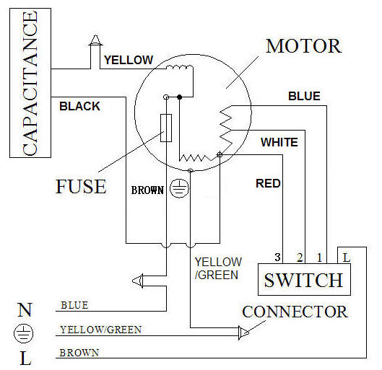

PLEASE AFFIX YOUR PROOF OF PURCHASE/RECEIPT HERE
IN THE EVENT OF A CLAIM UNDER WARRANTY THIS RECEIPT MUST BE PRODUCED.

2 YEAR WARRANTY

1 year retail ⵏ 1 year extended

Warranty upon registration*

visit www.russellhobbs.co.za

W A R R A N T Y AND EXTENDED WARRANTY
- Home of Living Brands (Pty) Limited ("Home of Living Brands") warrants to the original purchaser of this product ("the customer") that this product will be free of defects in quality and workmanship which under normal personal, family or household use and purpose may manifest within a period of 1 (one) year from the date of purchase ("warranty period").
- Home of Living Brands shall extend the warranty period for a further period of 1(one) year (“extended warranty period*”), on condition that the purchaser registers the product on the website, within 12 months from the date of purchase of the product. The website address for registration is as follows: http://russellhobbs.co.za/info-pages/warranty-info.aspx. The extended warranty period only applies to products purchased on or after 1 October 2017.
- Where the customer has purchased a product and it breaks, is defective or does not work properly for the intended purpose, the customer must notify the supplier from whom the customer bought the product ("the supplier") thereof within the warranty period or if applicable, the extended warranty period. Any claim in terms of this warranty must be supported by a proof of purchase. If proof of purchase is not available, then repair, and/or service charges may be payable by the customer to the supplier.
- The faulty product must be taken to the supplier's service centre to exercise the warranty.

- The supplier will refund, repair or exchange the product in terms of this warranty subject to legislative requirements. This warranty shall be valid only where the customer has not broken the product themselves, or used the product for something that it is not supposed to be used for. The warranty does not include and will not be construed to cover products damaged as a result of disaster, misuse, tamper, abuse or any unauthorised modification or repair of the product.
- This warranty will extend only to the product provided at the date of the purchase and not to any expendables attached or installed by the customer.
- If the customer requests that the supplier repairs the product and the product breaks or fails to work properly within 3 (three) months of the repair and not as a result of misuse, tampering or modification by or on behalf of the customer, then the supplier may replace the product or pay a refund to the customer, subject to the supplier’s discretion.
- The customer may be responsible for certain costs where products returned are not in the original packaging, or if the packaging is damaged. This will be deducted from any refund paid to the customer.

HOME OF LIVING BRANDS (PTY) LTD (JOHANNESBURG)

JOHANNESBURG TEL NO. (011) 490-9600

CAPE TOWN TEL NO. (021) 552-5161

DURBAN TEL NO. (031) 303-1163

www.homeoflivingbrands.com

www.russellhobbs.co.za

www.facebook.com/RussellHobbsSA

