

INSTRUCTIONS AND WARRANTY

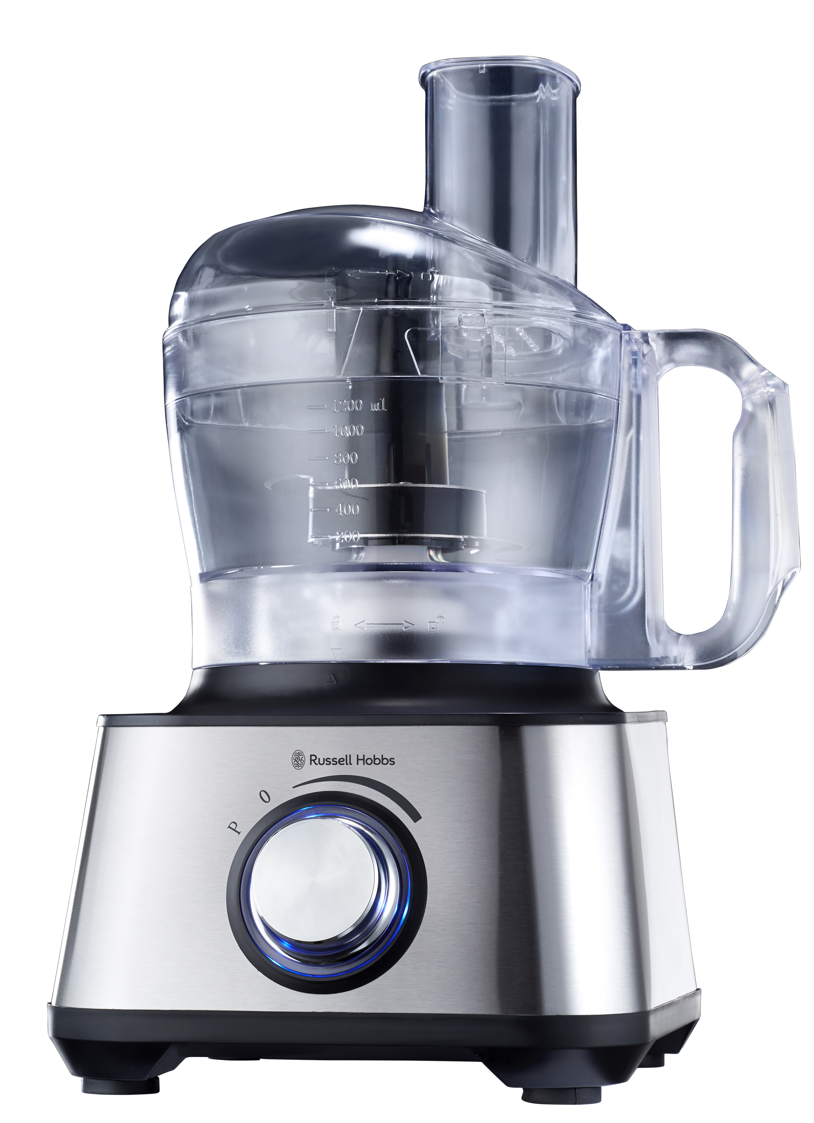

MODEL NO. RHFP001

RUSSELL HOBBS PRO ELITE 8-IN-1 FOOD PROCESSOR

Congratulations on purchasing your Russell Hobbs Pro Elite 8-in-1 Food Processor. Each unit is manufactured to ensure safety and reliability. Before using this appliance for the first time, please read the instruction manual carefully and keep it for future reference.

FEATURES OF THE RUSSELL HOBBS Pro Elite 8-in-1 FOOD PROCESSOR

- 1000W
- 2 speed control plus pulse for precise start and stop control
- Stylish silver aluminium and black design
- Extra-large 75mm feed chute
- Non-slip rubber feet for stability
- The Pro Elite Food Processor includes the following accessories:
- dough tool
- stainless steel slicing/chopping/mixing blade
- stainless steel reversible thin slicing and fine shredding disc
- stainless steel rasping/grating disc
- stainless steel chip slicing disc
- citrus juicing attachment
- 1.5L glass blender jug
- 1.2L plastic food processing bowl with maxi blend canopy
- Double safety lock system
- Blue illuminated control panel
- For domestic use only
- 2 year warranty (1 year retail • 1 year extended upon online registration of product • visit www.russellhobbs.co.za)

IMPORTANT SAFEGUARDS
When using any electrical appliance, basic safety precautions should always be followed including the following:

- Please read the instructions carefully before using any appliance.
- Always ensure that the voltage on the rating label corresponds to the mains voltage in your home.
- Incorrect operation and improper use can damage the food processor and cause injury to the user.
- This food processor is intended for household use only. Commercial use invalidates the warranty and the supplier can not be held responsible for injury or damage caused when using the appliance for any other purpose than that intended.
- Avoid any contact with moving parts.
- This food processor is not intended for use by persons (including children) with reduced physical, sensory or mental capabilities, or lack of experience and knowledge, unless they have been given supervision or instruction concerning use of the appliance by a person responsible for their safety.
- Children should be supervised to ensure that they do not play with the food processor.
- Check the power cord and plug regularly for any damage. If the cord or the plug is damaged, it must be replaced by the manufacturer or a qualified person in order to avoid an electrical hazard.
- Do not use the food processor if it has been dropped or damaged in any way. In case of damage, take the unit in for examination and/or repair by an authorised service agent.
- To reduce the risk of electric shock, do not immerse or expose the motor assembly, plug or the power cord to water or any other liquid.
- Never immerse the unit in water or any other liquid for cleaning purposes.
- Remove the plug from the socket by gripping the plug. Do not pull on the cord to disconnect the appliance from the mains. Always unplug the unit when not in use, before cleaning or when adding or removing parts.
- The use of accessory attachments that are not recommended or supplied by the manufacturer may result in injuries, fire or electric shock.
- Care must be taken when dismantling and assembling the blender as the blades and discs are very sharp.
- Never reach with your fingers into the feed chute.
- Never place hard objects into the processor, the blades could become blunt. This process may also result in injury.
- The maxi blend should only be removed when the tools/blades /discs/ are stationary.
- Do not fill the processing bowl with hot liquids (only cold or room temperature liquids).
- The food processor can be used for up to 1 minute without stopping (this is one cycle). Ensure the appliance is cooled down for at least 2 minutes after each cycle. After the 3rd cycle the food processor should be switched off for 5 minutes.
- Always remove the tools/blades/discs and spindles before removing the contents of the bowl.
- Do not exceed the maximum filling volume.
- Please be careful with the metal blade, it is extremely sharp, store it with the blade protector fitted.
- A short cord is provided to reduce the hazards resulting from becoming entangled in or tripping over a longer cord.
- Do not let the cord hang over the edge of a table or counter. Ensure that the cord is not in a position where it can be pulled on inadvertently.
- Do not allow the cord to touch hot surfaces and do not place on or near a hot gas or electric burner or in a heated oven.
- Do not use the food processor on a gas or electric cooking top or over or near an open flame.
- Use of an extension cord with this food processor is not recommended. However, if it is necessary to use an extension cord, ensure that the cord is suited to the power consumption of the appliance to avoid overheating of the extension cord, appliance or plug point. Do not place the extension cord in a position where it can be pulled on by children or animals or tripped over.
- This food processor is not suitable for outdoor use. Do not use this appliance for anything other than its intended use.
- DO NOT carry the food processor by the power cord.
- Do not leave this food processor unattended during use. Always unplug the unit when not in use or before cleaning.
- Always operate the food processor on a smooth, even, stable surface. Do not place the unit on a hot surface.
- Ensure that the switch is in the “Off” position after each use.
- The manufacturer does not accept responsibility for any damage or injury caused by improper or incorrect use, or for repairs carried out by unauthorised personnel.
- In case of technical problems, switch off the machine and do not attempt to repair it yourself. Return the appliance to an authorised service facility for examination, adjustment or repair. Always insist on the use of original spare parts. Failure to comply with the above mentioned pre-cautions and instructions, could affect the safe operation of this machine.
- The appliance is fitted with a safety switch to prevent the motor operating unless the food processor bowl or blender jug is in place. Do not use this to switch the appliance on and off.
- Do not use the food processor without first locking the lid in place.
- Do not put your hand into the bowl or jug, even when it has been removed for cleaning – the blades are very sharp.
- Do not put any other object (spoon, spatula, etc.) into the bowl or jug while the blender is plugged in.
- Do not let the bowl or jug overflow. If liquid gets under the motor unit, it may be sucked into the motor, damaging it.
- Do not fill the bowl or jug above the MAX. mark. If you do, the contents may force the lid off when you start the motor.
- Do not use the food processor for any purpose other than those described in these instructions.
- Do not run the food processor empty, as it may overheat.
- This food processor is designed for processing household quantities; it is not suitable for commercial purposes. Use the appliance only for the purpose it was designed for.
- Do not run this food processor with an external timer or remote control system.
- To avoid the danger of fire and/or explosion, do not use this food processor to stir/mix paints or solvents.

Safety System
The processor will only operate once the maxi blend cover is fitted correctly.

PARTS DIAGRAM

(1) Safety pusher (11) Stainless steel reversible thin slicing/fine shredding disc
(2) Feed chute (12) Stainless steel chip slicing disc
(3) Maxi blend canopy (13) Stainless steel rasping/grating disc
(4) Removable drive attachment (14) Citrus press juicing cone
(5) Plastic food processor bowl (15) Citrus press attachment plastic strainer
(6) Motor shaft attachment (16) Blender measuring cap
(7) Rotor (17) Blender lid
(8) Motor body (18) Blending jug
(9) Dough tool (19) Sealing ring
(10) Stainless steel chopping/mixing/slicing blade (20) Blender base

PLEASE NOTE: When opening the box for the first time, the removable drive attachment (4) comes as one attachment joined with the dough tool (9). You would then have to detach it when you need to use it with the stainless-steel chopping blade (10). To achieve this, remove the dough tool by pressing on the drive attachment at the far end (close to the tool) then slide up the dough tool to detach it from the drive attachment.
OPERATING INSTRUCTIONS

Locking the bowl/jug

Align the base and jug/bowl as illustrated. Turn the jug/bowl clockwise until it locks into place. The jug/bowl will lock onto the base in 3 different positions for user convenience.
NOTE: The food processor will not work unless the jug/bowl is locked into position.

Assembling the lid

Align the lid as illustrated by placing your thumb on the lid tab and twisting the lid clockwise. Four visual alignment markers are provided, one on the bowl, one on the handle and two on bowl lid. NOTE: The food processor will not work unless the lid is locked into position.

Operating the controls

The control dial is conveniently located on the front of the base. Rotate the dial clockwise to speed up. Rotate counter clockwise to slow down. For more precise start/stop control, turn the dial counter clockwise to the (P) PULSE setting. To turn off the machine, rotate the dial to the OFF (O) position.

Processing tips and techniques

- The food processor is excellent for chopping, mixing, slicing and shredding most foods. However, to maintain peak performance, do not use your food processor for the following: grinding grain, coffee beans or spices or slicing frozen meat.
- To process the maximum capacity, use the stainless steel chopping/ slicing/ mixing blade and add food no higher than the maximum fill line on the plastic food processor bowl.
- Operating time will depend on the quantity of the food being processed. Most foods can be sliced, chopped, or shredded in seconds.
- Do not puree or mash starchy vegetables like potatoes. They will be over processed in a matter of seconds and turn gummy.

Processing using the stainless steel slicing/chopping/mixing blade
Removable drive attachment
Chopping/mixing blade

Motor shaft attachment

- For a more uniform consistency, start with pieces of food that are similar in size. Do not process 10cm pieces together with 1cm pieces for example.
- The stainless steel slicing/chopping/mixing blade can be used to coarsely chop, finely mince, mix, or puree food to a smooth consistency.
- Make sure the control dial is turned to OFF (0) and the unit is unplugged.
- Place the motor shaft attachment onto the motor body.
- Lock the food processor bowl onto the motor body. (See “Locking the bowl”)
- Place the removable drive attachment into the food processor bowl
- Place the slicing/chopping/mixing blade onto the removable drive attachment of the food processor in centre of the bowl. Turn slowly until the blade drops into place. Handle carefully as the blade is sharp.
- Lock the lid onto the bowl.
- Plug in the food processor and switch it on to process the ingredients.
- Process the ingredients by pushing it through the feed chute with the safety pusher.
- When you have finished processing, turn the dial to the OFF (0) position or release from the PULSE position. Wait until the blade has stopped rotating before removing the lid.
- Unplug the food processor.

Processing using the stainless steel reversible thin slicing and fine shredding disc
Slicer/shredder disc

Removable drive attachment

Motor shaft attachment

- The reversible thin slicing/fine shredding disc has a slicing blade on one side and shredding teeth on the other. The disc side facing up, is the function selected.
- Place the disc on the motor shaft attachment with the desired cutting edge facing up.
- Make sure the control dial is turned to OFF (0) and the unit is unplugged.
- Lock the bowl onto the base. (See “Locking the bowl”.)
- Place the thin slicing/fine shredding disc on the motor shaft attachment with the desired side facing up for either slicing or shredding. Lock lid onto bowl (See “Assembling the lid”).
- Plug in the food processor and switch it on to process the ingredients.
- Process the ingredients by pushing it through the feed chute with the safety pusher.

Tips
- To slice or shred cheese, make use of firm cheese like, Cheddar, Monterey Jack, or Swiss. Place the cheese in the freezer for 30 minutes before processing for best results.
- To slice/shred longer shaped thin foods (such as pepperoni, carrots, and celery) lock the lid. These foods can be inserted into the feed chute opening and processed as long as the feed chute lid is closed. Always use the safety pusher to feed food into the chute. NEVER PUSH FOOD THROUGH THE FEED CHUTE WITH HANDS, FINGERS, UTENSILS OR ANY OTHER OBJECTS.

Processing using the citrus juicer
Citrus press juicing cone

Citrus press plastic strainer

Motor shaft attachment

- Make sure the control dial is turned to the OFF (0) position and the unit is unplugged.
- Attach the motor shaft attachment to the blending base.
- Lock the plastic food processor bowl onto the base (See “Locking the bowl”).
- Place citrus press plastic strainer on the removable drive attachment, then place the citrus press juicing cone on the removable drive attachment on top of the citrus press plastic strainer
- The large cone is suitable for juicing large citrus fruit, such as grapefruit, oranges etc. The small cone is suitable for juicing small citrus fruit, such as lemons, limes etc.
- Cut a citrus fruit in half and press the cut end of one half of the fruit onto the cone. Turn on the machine and choose the speed. Please select a low speed before juicing and gradually increase it throughout the juicing process.
- The cone scrapes the pulp out and squeezes the juice from the fruit.
- To maximize the quantity of juice extracted from a fruit, press a fruit onto the cone several times.

Processing using the blending jug

Blender lid

Blending jug

Blender base

- First check the position of the safety switch.
- Put the sealing ring into blender base slot then screw and fasten the blending jug into the blending base (clockwise for fastening and counterclockwise for loosening).
- Screw the blender base clockwise into the main machine motor body (counter clockwise for loosening).
- Add desired ingredients and put the blender lid and the blender cap on.
- Select the appropriate speed for blending the ingredients.

TROUBLESHOOTING GUIDE

POTENTIAL PROBLEM | PROBABLE CAUSE/SOLUTION
Unit does not operate on any speed or Pulse mode. | - Is the unit plugged in? Does the power outlet work?  - Is the bowl and bowl lid all locked in place? See “Operating instructions”
Food is not chopped, sliced or shredded uniformly. | - Packing too much food in the feed chute, or pushing too hard on the safety pusher may cause the processed food to be irregularly sliced or shredded.
Unit stops and will not switch back on. | - Are the bowl and bowl lid all locked in place? They may have moved slightly during processing. See “Operating instructions.”  - Is the power outlet still working? Check this, by plugging in any other working appliance. You may have overloaded the circuit and blown a fuse or tripped the circuit breaker.  - Turn the unit OFF, allow the food processor to rest for 3 to 4 minutes, and then turn the appliance back ON. If none of these suggestions correct the problem, DO NOT attempt to repair the unit. Call the Customer Service number to get the name of your nearest Authorized Service Centre.
Unit has a burning smell. | - There may be residue left on the motor from the manufacturing process, causing a slight odour during initial use. This will go away. If a strong odour or any visible smoke appears, unplug the unit IMMEDIATELY and call the Customer Service number.
Motor seems weak. | - Are you using the correct speed for the item you are processing?  - Do the food items need to be diced into pieces before processing?

RELEASING THE SUCTION CUP FEET AFTER USE

The suction cup feet on the bottom of the food processor are designed to keep the unit stationary during use. To maximize the life of the unit please review the following instructions:
- Lift the fully assembled food processor from the counter by placing hands underneath the unit as shown and lift it to one side.

- Alternatively lift it from the counter by grabbing the food processor bowl handle as shown below and lifting from the same side as the bowl handle.

- If the bowl and lid have been removed from the food processor: Lift it from the counter by placing your hands underneath the unit as shown below and lift it towards one side.

CLEANING AND MAINTENANCE

- Wash the bowl, lids, blades, discs, removable drive attachment and safety pusher in warm, soapy water.
- Rinse and dry thoroughly. To clean food thoroughly from the bowl and the bowl lid/feed chute, immerse in warm, soapy water. NOTE: Do not store the unit with lid in locked position; this may put strain on the interlock tab.
- Wipe base, control panel, and cord with a damp cloth or sponge. To remove stubborn foods, use a mild non-abrasive cleanser.
- To store, place bowl on base. Then place chopping/slicing/mixing blade on motor shaft attachment and the thin slicing/fine shredding disc on chopping/slicing/mixing blade. The removable drive attachment may be stored in the bowl. Place lid on bowl but do not lock.
- Place a drop of vegetable oil on the blades of the food processor on a monthly basis.

SMOOTHIE MAKER RECIPES

Banana Smoothie
Ingredients:
1Banana Peeled & Sliced
¼ Cup Oats
1Tbsp Honey
1 Tbsp Peanut Butter
100g flax seeds
150ml Yogurt
1 Cup Ice

Method:
- Add all ingredients into the blender.
- Pulse it at first to break the ice.
- Blend for about 2 minutes until smooth.

Tip
- This smoothie is great for sustained energy throughout the day.
- The banana has high levels of potassium, helping you to quickly replenish electrolytes. (The riper a banana, the higher sugar content), the peanut butter is high in protein and the raw oats is a Low GI filler.
- Flax seed is a great source of fibre and Omega 3 fatty acids, and yoghurt contains protein, calcium, riboflavin, vitamin B₆ and vitamin B₁₂.

Berry smoothie
Ingredients:
1 Cup Strawberry, blueberry & Raspberry
150ml low fat ice cream/frozen yogurt
1 Banana
1 Cup Ice

Method:
- Add all ingredients into the blender.
- Pulse it at first to break the ice.
- Blend for about 2 minutes until smooth.

Tip.
- Strawberries are high in vitamin C and antioxidants.
- Blueberries also contain a high level of antioxidants and may be considered the most nutritional berry.
- Raspberries have a sweeter taste and contain vitamin C, vitamin E, and is also a good weight loss supplement.
- Bananas are high in dietary fibre and potassium.

Coconut Smoothie
Ingredients:
1 Tin coconut milk
1 tablespoon sesame oil
1 tablespoon flax seeds
1 teaspoon vanilla extract
1 Tbsp Honey
1 Cup ice
Method:
- Add all ingredients into the blender.
- Pulse it at first to break the ice.
- Blend for about 2 minutes until smooth.
Tip
- Sesame oil is a source of vitamin E which is an anti-oxidant and has been correlated with lowering cholesterol levels.
- Flax seed is a great source of fibre and Omega 3 fatty acids.

Fruit & Muesli smoothie
Ingredients:
1½ cups low-fat milk
2 tablespoons low-fat natural or vanilla yoghurt
1 ripe banana
¼ cup chopped berries: strawberries, raspberries, blueberries
1-2 tablespoons muesli
½ Cup Rolled Oats
1 cup ice

Method:
- Add all ingredients into the blender.
- Pulse it at first to break the ice.
- Blend for about 2 minutes until smooth.

Tip:
This delicious smoothie is a meal in itself. Rich in protein, complex carbohydrates, dietary fibre, vitamin C and antioxidants. Sweetened naturally with berries and banana.

Green tea Smoothie
Ingredients:
250ml Green Tea
1Tbsp Honey
1 Tsp Chopped Mint
100ml Vanilla flavoured low fat ice cream/frozen yoghurt

Method
- Brew a cup of green tea using 2 tea bags and chill.
- Once the tea has cooled down, add all ingredients into the blender.
- Blend for about 2 minutes until smooth.

Tip:
- Green tea has tons of antioxidants, helps boost metabolism, and stabilizes Cholesterol.
- Fresh mint works as a decongestant for illness such as the common cold.

High Fiber/Low GI Smoothie
Ingredients:
½ Papino
1Tbsp Flax Seeds
2Tbsp Digestive Bran
1/2Cup 100% Orange juice
1/2Cup Low Fat Cultured Yogurt
1 Tbsp Honey
1 Cup Ice

Method:
- Add all ingredients into the blender.
- Pulse it at first to break the ice.
- Blend for about 2 minutes until smooth.

Tip:
- Papaya fruit is an excellent source of dietary fiber, folate, vitamin A, C and E. It also contains small amount of calcium, iron, riboflavin, thiamine and niacin. It is also very rich in antioxidant nutrients flavonoids and carotenes, very high in vitamin C plus A, and low in calories and sodium.
- Flax seed is a great source of fibre and Omega 3 fatty acids, and yogurt contains protein, calcium, riboflavin, vitamin B₆ and vitamin B₁₂.

Low fat Chocolate Crunch Smoothie
Ingredients:
1 Cup 2% milk
1 Tbsp Cocoa Powder
½ Cup peanuts/ cashews
1 Tbsp Honey
¼ tsp Vanilla essence
1 Cup Ice

Method
- Add all ingredients into the blender.
- Pulse it at first to break the ice.
- Blend for about 2 minutes until smooth.

Tip:
- This smoothie is low fat and delicious.
- For an iced coffee, replace the cocoa powder with instant coffee powder or a chilled espresso.

Spiced Mango lassi
Ingredients:
1 Large Mango, peeled & Chopped
1 Cup Plain Low Fat Yogurt
1 Tbsp Honey
¼ Tsp Ground Cinnamon
1/8 Tsp Ground Cardamom
½ Tsp vanilla Extract
1 Cup Ice

Method:
- Add all ingredients into the blender.
- Pulse it at first to break the ice.
- Blend for about 2 minutes until smooth.

Tip:
- This rendition of India's popular yogurt shake makes a cooling counterpoint to any spicy dish
- For a great cocktail, add 50 ml dark rum.

Sweet Melon Smoothie
(Serves 4)
Ingredients:
½ Honey Melon
Thumb size Ginger, peeled
1 medium Cucumber
1 Tbsp Honey
150 ml Yogurt
1 Cup Ice

Method:
- Add all ingredients into the blender.
- Pulse it at first to break the ice.
- Blend for about 2 minutes until smooth.

Tip:
- Cucumbers are rich in Vitamin C and dietary fibre.
- Ginger is a great source of anti-oxidants, making this smoothie a delightfully fresh way to strengthen your immune system.

Tomato Smoothie
Ingredients:
2 tomatoes (chopped then frozen)
1 small tin of tomato juice
¼ Cup Chopped Celery juice and rind of 1/2 lemon
1 Tbsp Chopped basil leaves
Tabasco to taste
Salt & Pepper to taste
1 Cup Ice

Method:
- Add all ingredients into the blender.
- Pulse it at first to break the ice.
- Blend for about 2 minutes until smooth.

Tip:
- This smoothie is great for sustained energy throughout the day.
- The banana has high levels of potassium, helping you to quickly replenish electrolytes. The riper a banana, the higher sugar content.
- The peanut butter is high in protein and the raw oats is a Low GI filler.
- Flax seed is a great source of fibre and Omega 3 fatty acids, and yoghurt contains protein, calcium, riboflavin, vitamin B₆ and vitamin B₁₂.

STORING THE APPLIANCE
- Unplug the unit from the wall outlet and clean all the parts as instructed above. Ensure that all parts are dry before storing.
- Store the appliance in its box or in a clean, dry place.
- Never store the appliance while it is still dirty.
- Never wrap the power cord around the appliance.

SERVICING THE APPLIANCE
There are no user serviceable parts in this appliance. If the unit is not operating correctly, please check the following:
- You have followed the instructions correctly.
- That the wall socket is switched on.
- That the mains power supply is ON.
- That the plug is firmly in the mains socket.

If the appliance still does not work after checking the above:
- Consult the retailer for possible repair or replacement. If the retailer fails to resolve the problem and you need to return the appliance, make sure that:
- The unit is packed carefully back into its original packaging.
- Proof of purchase is attached.
- A reason is provided for why it is being returned.
If the supply cord is damaged, it must be replaced by the manufacturer or an authorised service agent, in order to avoid any hazard. If service becomes necessary within the warranty period, the appliance should be returned to an approved Home of Living Brands (Pty) Ltd service centre. Servicing outside the warranty period is still available, but will, however, be chargeable.

CHANGING THE PLUG
Should the need arise to change the fitted plug, follow the instructions below.
This unit is designed to operate on the stated current only. Connecting to other power sources may damage the appliance.

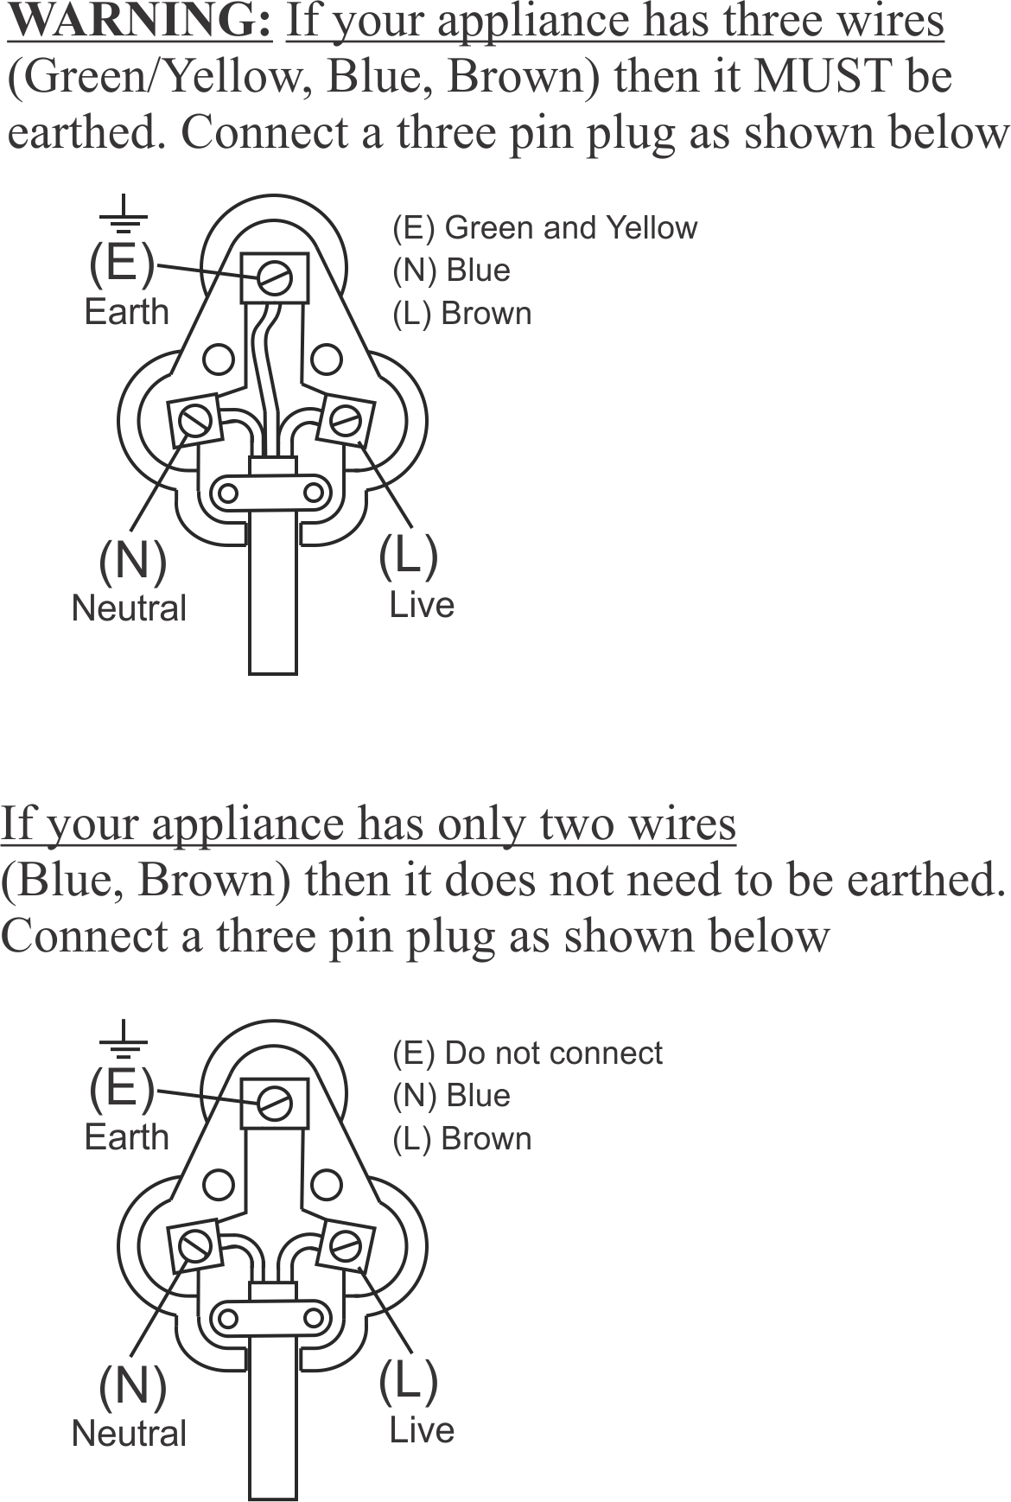
PLEASE AFFIX YOUR PROOF OF PURCHASE/RECEIPT HERE
IN THE EVENT OF A CLAIM UNDER WARRANTY THIS RECEIPT MUST BE PRODUCED.

2 YEAR WARRANTY
1 year retail ⵏ 1 year extended warranty upon registration*
visit www.russellhobbs.co.za

W A R R A N T Y AND EXTENDED WARRANTY

- Home of Living Brands (Pty) Limited ("Home of Living Brands") warrants to the original purchaser of this product ("the customer") that this product will be free of defects in quality and workmanship which under normal personal, family or household use and purpose may manifest within a period of 1 (one) year from the date of purchase ("warranty period").
- Home of Living Brands shall extend the warranty period for a further period of 1(one) year (“extended warranty period*”), on condition that the purchaser registers the product on the website, within 12 months from the date of purchase of the product. The website address for registration is as follows: http://russellhobbs.co.za/info-pages/warranty-info.aspx. The extended warranty period only applies to products purchased on or after 1 October 2017.
- Where the customer has purchased a product and it breaks, is defective or does not work properly for the intended purpose, the customer must notify the supplier from whom the customer bought the product ("the supplier") thereof within the warranty period or if applicable, the extended warranty period. Any claim in terms of this warranty must be supported by a proof of purchase. If proof of purchase is not available, then repair, and/or service charges may be payable by the customer to the supplier.
- The faulty product must be taken to the supplier's service centre to exercise the warranty.
- The supplier will refund, repair or exchange the product in terms of this warranty subject to legislative requirements. This warranty shall be valid only where (a) the customer is not the cause of the product breaking, and (b) the product has been used for the intended purpose stipulated in the product manual. The warranty does not include and will not be construed to cover products damaged as a result of disaster, misuse, tamper, abuse or any unauthorised modification or repair of the product.
- This warranty will extend only to the product provided at the date of the purchase and not to any expendables attached or installed by the customer. In this regard any accessories supplied with the product by the supplier, may be excluded in this warranty or extended warranty (see Exclusions to Warranty and Extended Warranty document).
- If the customer requests that the supplier repairs the product and the product breaks or fails to work properly within 3 (three) months of the repair and not as a result of misuse, tampering or modification by or on behalf of the customer, then the supplier may replace the product or pay a refund to the customer, subject to the supplier’s discretion.
- The customer may be responsible for certain costs where products returned are not in the original packaging, or if the packaging is damaged. This will be deducted from any refund paid to the customer.
HOME OF LIVING BRANDS (PTY) LTD (JOHANNESBURG)

JOHANNESBURG TEL NO. (011) 490-9600
CAPE TOWN TEL NO. (021) 552-5161
DURBAN TEL NO. (031) 303-1163
www.homeoflivingbrands.com
www.russellhobbs.co.za
www.facebook.com/RussellHobbsSA

EXCLUSIONS TO W A R R A N T Y AND EXTENDED WARRANTY

- Any accessories supplied with the product, including but not limited to, bowls, jugs, mills or carafes made either of glass or plastic and supplied with this appliance (hereinafter referred to as “the accessory or accessories”), is warranted to be free from material and workmanship defects for the duration of the appliance warranty.
- The accessories should give trouble free service when used in accordance with the directions described in the instruction manual. However, the accessories will be damaged if subjected to impact, and this damage is not covered by the warranty. Such impact damage can occur either from the outside (if for example it is dropped or knocked against a hard surface), or from within (if for example foreign objects are placed within the accessories and the power is switched on).
- Should you need to replace an accessory during the warranty period; a claim for a free replacement will only be considered if the item (including all shards and broken parts) is returned to the nearest HOLB service centre for examination.
- The remains of the accessory will be carefully examined by the relevant professionals and if it is determined (at the sole discretion of HOLB) that the damage was caused by impact, then the claim will be refused and will not be covered by the warranty or any extended warranty.
- Any replacement part provided in terms of clause 4 above will become a chargeable item payable by the customer.

