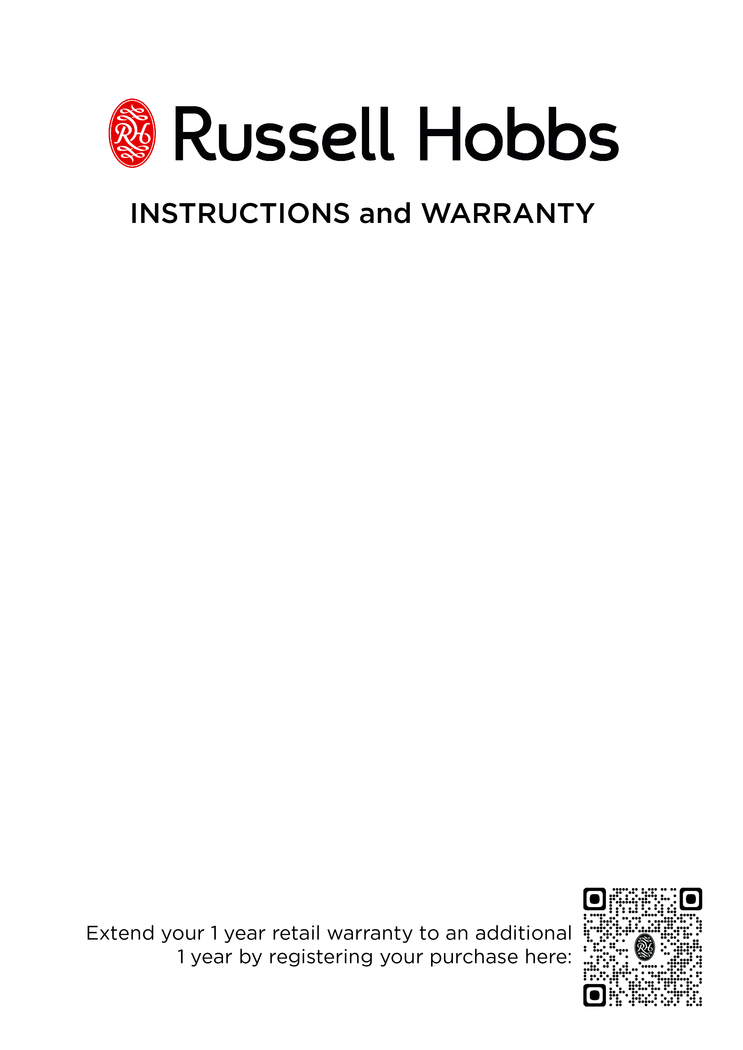

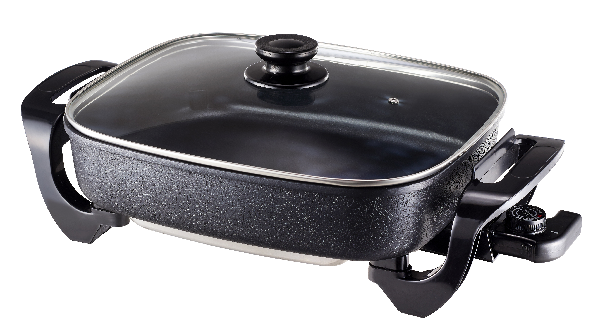

MODEL No. RHFP1000
Russell Hobbs Frying Pan

Congratulations on purchasing your Russell Hobbs Frying Pan. Each unit is manufactured to ensure safety and reliability. Before using this appliance for the first time, please read the instruction manual carefully and keep it for future reference.

FEATURES OF THE RUSSELL HOBBS CASSEROLE FRYING PAN
- 1500W
- 6.8L capacity
- ULTRA deep 8cm interior for cooking, roasting, grilling, frying and steaming, poaching, defrosting and keeping food warm
- Pan dimensions: 31 x 38cm
- Die-cast aluminium construction – 4mm thick pan
- Cooks from simmer (110-220ºC)
- Easy-to-read, adjustable thermostat control with 5 heat settings for precision cooking
- Convenient for serving - select the first setting to serve directly from the pan
- With power indicator light for that perfect temperature convenience
- Stylish and ergonomic design
- Tempered glass lid with steam vent
- Cool-touch handles
- Non-stick coated aluminum pan for hassle-free cooking and easy cleaning
- Dishwasher safe lid
- Includes recipes
- For domestic use only
- 1 year standard warranty. Warranty will be extended for another year if you register your product online within 12 months of purchase (visit https://russellhobbswarranty.co.za/)

IMPORTANT SAFEGUARDS

When using any electrical appliance, basic safety precautions should always be followed including the following:

- Please read the instructions carefully before using any appliance.
- Always ensure that the voltage on the rating label corresponds to the mains voltage in your home.
- Incorrect operation and improper use can damage the appliance and cause injury to the user.
- The appliance is intended for household use only. Commercial use invalidates the warranty and the supplier can not be held responsible for any injury or damage caused when using the appliance for any other purpose than is intended.
- Avoid any contact with moving parts.
- Close supervision is required when any appliance is used in the vicinity of children or invalids.
- Check the power cord and plug regularly for any damage. If the cord or the plug is damaged, it must be replaced by the manufacturer or a qualified person in order to avoid an electrical hazard.
- Do not use the appliance if it has been dropped or damaged in any way. In case of damage, take the unit in for examination and/or repair by an approved home of living brands service centre.
- To reduce the risk of electric shock, do not immerse or expose the element, thermostat control/ probe, plug or the power cord to water or any other liquid.
- Never immerse the unit in water or any other liquid for cleaning purposes.
- Remove the plug from the socket by gripping the plug. Do not pull on the cord to disconnect the appliance from the mains. Always unplug the unit when not in use, before cleaning or when adding or removing parts.
- The use of accessory attachments or thermostat control/ probes that are not recommended or supplied by the manufacturer may result in injuries, fire or electric shock.
- A short cord is provided to reduce the hazards resulting from becoming entangled in or tripping over a longer cord.
- Do not let the cord hang over the edge of a table or counter. Ensure that the cord is not in a position where it can be pulled on inadvertently.
- Do not allow the cord to touch hot surfaces and do not place on or near a hot gas or electric burner or in a heated oven.
- Do not use the appliance on a gas or electric cooking top or over or near an open flame.
- Use of an extension cord with this appliance is not recommended. However, if it is necessary to use an extension lead, ensure that the lead is suited to the power consumption of the appliance to avoid overheating of the extension cord, appliance or plug point. Do not place the extension cord in a position where it can be pulled on or tripped over by children or animals.
- This appliance is not suitable for outdoor use. Do not use this appliance for anything other than its intended use.
- DO NOT carry the appliance by the power cord.
- Do not leave this appliance unattended during use. Always unplug the unit when not in use or before cleaning.
- Always operate the appliance on a smooth, even, stable surface. Do not place the unit on a hot surface.
- Ensure that the switch is in the “Off” or “0” position after each use.
- The manufacturer does not accept responsibility for any damage or injury caused by improper or incorrect use, or for repairs carried out by unauthorised personnel.
- In case of technical problems, switch off the appliance and do not attempt to repair it yourself. Return the appliance to an authorised service facility for examination, adjustment or repair. Always insist on the use of original spare parts. Failure to comply with the above mentioned pre-cautions and instructions, could affect the safe operation of this appliance.
- Do not move the unit while in use.
- Always insert the thermostat control/ probe into the unit and ensure it is fully inserted before inserting the plug in the power socket.
- Do not use any sharp cooking utensils, as this will damage the non-stick finish on the unit. Only use wooden or plastic utensils.
- DO NOT use caustic cleaners, nylons or metal brushes on the non-stick surface. It may scratch or damage the surface.
- Do not touch hot surfaces. Use handles or knobs.
- Close supervision is necessary when any appliance is used by or near children.
- DO NOT place the thermostat control/ probe on the non-stick surface or store the thermostat control/ probe inside the pan. It may scratch or damage the surface.
- Do not operate any appliance with a damaged cord or plug or after the appliance malfunctions, or has been damaged in any manner. Return appliance to the nearest approved home of living brands service centre for examination, repair or adjustment.
- Extreme caution must be used when moving an appliance containing hot oil or other hot liquids.
- Do not operate this appliance by means of an external timer or separate remote control system.
- Always lift the lid away from your face as escaping steam may cause injury or scalding.
- Keep hands, arms, face etc clear from the escaping steam when opening the lid.

PARTS DIAGRAM

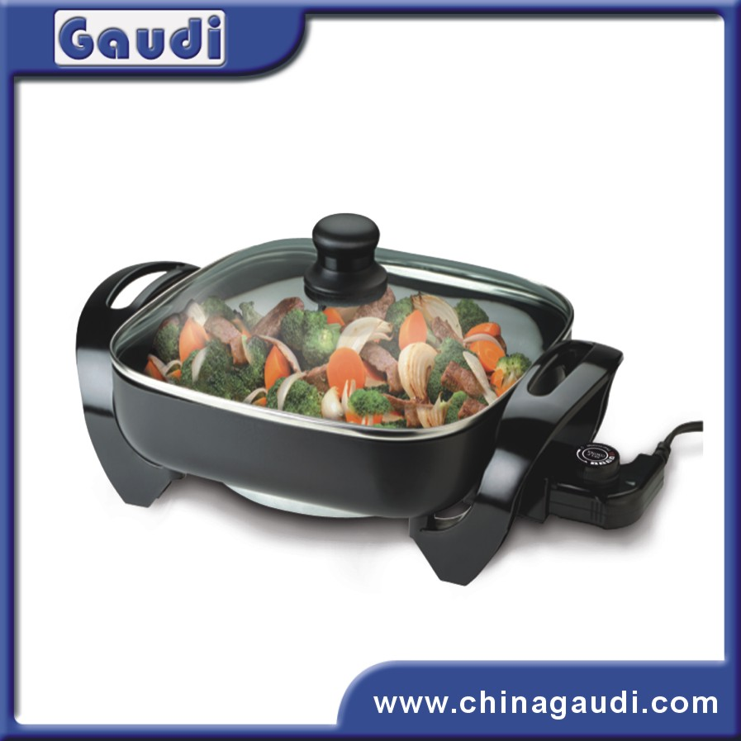
A
C
E
E
F
G
H
B
D
C
D
F
G
A. Glass lid
B. Lid knob
C. Frying pan
D. Handles
E. Thermostat control/ probe
F. Temperature dial
G. Indicator light
H. Inner pan with non-stick coating

BEFORE FIRST USE

Before using this appliance for the first time, unpack the frying pan and remove all protective packaging and wrappings. Please ensure to discard the protective packaging and wrappings immediately. It is important to keep these away from babies, infants, children and animals for safety purposes.

Wash the frying pan as per the cleaning instructions provided. The inner pan must be wiped with warm soapy water, rinsed and towel dried. DO NOT IMMERSE the UNIT in any liquid. DO NOT IMMERSE the thermostat control/ probe or let the control come in contact with any liquid.

OPERATING INSTRUCTIONS

- Place the unit on a firm, flat surface and place the lid on the unit.
- Turn the temperature dial of the thermostat control/probe to the “Off”, “0” or “Min” position. Plug the thermostat control/ probe into the unit and ensure that it is fully inserted. Note: If the thermostat control/ probe is not completely inserted, abnormal heating may occur, resulting in damage.
- Now insert the plug into the power socket and switch the power on.
- Turn the thermostat control’s dial in a clockwise direction to turn the unit ON, and turn it to the temperature required. The indicator light will turn on and the unit will start heating to the temperature required.
- The indicator light will turn off when the unit has reached desired temperature.
- Before first use: pour some cooking oil into the pan together with some water and bring it to the boil. Leave to boil for 5-7 minutes. Once complete, discard the oil and water mixture. Clean the inner pan and begin the cooking process. This quick measure will eliminate any manufacturing odours.
- To cook: Follow steps 1 to 5 above. Now lift the lid and place the food to be cooked into the pan. Be careful when inserting the food as the pan is hot and this may cause the food to splatter. During cooking, the indicator light may cycle on and off indicating that the desired temperature is being maintained.
- As a general tip: low settings are ideal for casseroles, stews, steaming and other slow cooking. High settings are used for browning, shallow frying and grilling. Should you wish to let the food simmer, turn the temperature to its lowest setting. NOTE: Never turn the unit on without any food and / or liquid in the pan.
- Once the food is cooked to your preference, turn the thermostat control’s dial to the “Off” or “0” position and unplug the unit from the power socket.
NOTE: Be careful when working with the frying pan during use, as the pan and lid will be hot. Only the handles will be cool enough to touch.

Following a few general tips can prolong the life of your frying pan:

- Always wash the pan and lid as soon as possible after each use.
- DO NOT pour cold water into a hot pan.
- Never scrape with hard or sharp utensils when cleaning.
- DO NOT place the thermostat control/ probe on the pan surface. It may scratch or damage the non-stick coating.
- DO NOT wash the pan with the thermostat control/ probe connected.
- Wash the frying pan after each use to avoid stains caused by a build-up of food or grease residues. Never leave food in the pan overnight.
- Hold the unit at a 45° angle, socket side facing upwards for washing. This will prevent or at-least minimize the likelihood of water getting into the socket.

COOKING TIPS

- Foods which overcook easily should be removed from the frying pan as soon as cooking has been completed.
- Try to dry meat, fish, poultry, etc. before adding to hot oil to prevent unnecessary splattering.
- Do not fry too much food at a time in order to prevent the oil temperature from dropping too much.

CLEANING AND MAINTENANCE

- This appliance is for household use only and is not user-serviceable.
- Do not open or change any parts by yourself. Please refer to a qualified electrical service department or return to the supplier if servicing is necessary.
- Always remember to unplug the unit from the electrical outlet when not in use and before cleaning. Ensure that the temperature dial is set to the “OFF” or “0” position.
- Always unplug the thermostat control/ probe from the unit before cleaning. Remove the thermostat control/ probe by gripping the control on either side firmly and pulling. Do not pull on the cord to remove the thermostat control/ probe from the pan.
Never allow the thermostat control/ probe to come into contact with any liquid. To clean the thermostat control/ probe, gently wipe it with a soft dry cloth or paper towel. Always ensure that the probe is completely dry before inserting it into the socket of the pan.
- Clean the body of the frying pan while it is still warm after use. Clean only when the frying pan is comfortable to the touch. The frying pan should be cleaned with a damp cloth. Do not let water enter the appliance. Clean the frying area of the unit with a damp sponge. Should food not come off immediately, pour some water into the pan and allow to soak for a few minutes, and then try again. Do not scrub the unit as this will damage the non-stick coating. Always ensure that the socket is completely dry before inserting the thermostat control/ probe.
- Do not use bleach or other abrasive substance or solvents to clean your appliance as it can be damaging to the finish.
- Do not immerse the unit in water or any other liquid, or hold it under a running tap.
- To remove stubborn spots/marks, wipe the surfaces with a cloth slightly dampened in soapy water or mild non-abrasive cleaner. Rinse and dry with a clean, dry, soft cloth.
- After cleaning, completely wipe the frying pan dry with a soft cloth. Clean the frying pan after each use.
- To maintain a longer life of the non-stick coated surface on the inside of the pan, apply a very light coat of cooking oil to the non-stick coating with a paper towel before storing. Repeat periodically.

STORING THE APPLIANCE

- Unplug the unit from the wall outlet and clean all the parts as instructed above. Ensure that all parts are dry before storing.
- Store the appliance in its box or in a clean, dry place.
- Never store the appliance while it is still wet or dirty.
- Never wrap the power cord around the appliance. Do not store the appliance with the thermostat control/ probe inserted in the unit, always unplug it. Ensure the thermostat control/ probe is stored in a safe place where it will not be dropped, bumped or damaged.

SERVICING THE APPLIANCE

There are no user serviceable parts in this appliance. If the unit is not operating correctly, please check the following:
- You have followed the instructions correctly
- The wall socket is switched on.
- The mains power supply is ON.
- The plug is firmly in the mains socket.

If the appliance still does not work after checking the above:
Consult the retailer for possible repair or replacement. If the retailer fails to resolve the problem and you need to return the appliance, make sure that:
- The unit is packed carefully back into its original packaging.
- Proof of purchase is attached.
- A reason is provided for why it is being returned.

If the supply cord is damaged, it must be replaced by the manufacturer or an approved home of living brands service agent, in order to avoid any hazard. If service becomes necessary within the warranty period, the appliance should be returned to an approved Home of Living Brands (Pty) Ltd service centre. Servicing outside the warranty period is still available, but will, however, be chargeable.

CHANGING THE PLUG

Should the need arise to change the fitted plug, follow the instructions below.
This unit is designed to operate on the stated current only. Connecting to other power sources may damage the appliance.

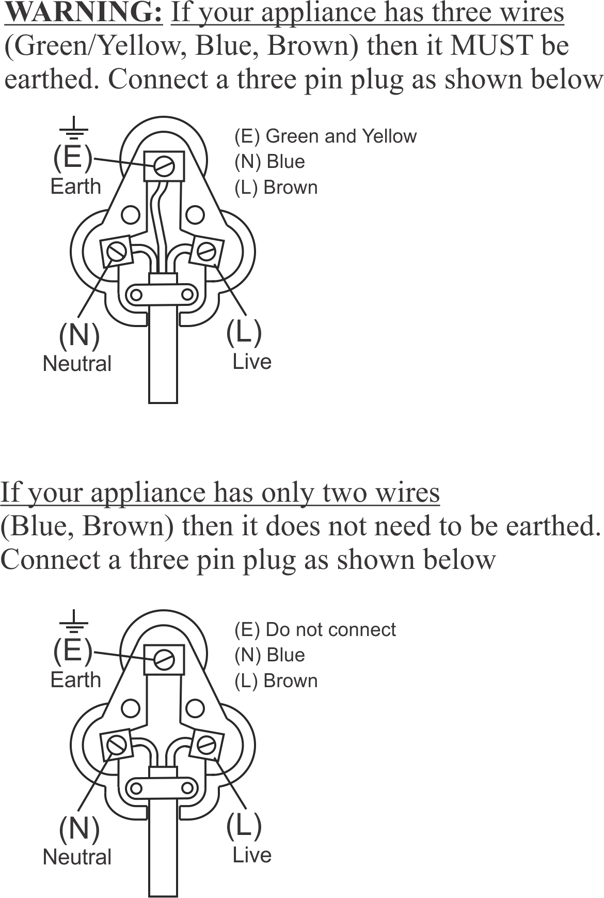

TASTY RECIPES AND MEAL IDEAS

Important: Temperature settings as given in recipes are approximate. Due to personal differences in taste, cooking times may vary. Therefore, heat settings may be increased, decreased or varied in any way to suit individual preference.

CHINESE MEAT BALLS

500g minced beef 2 tsp salt
250g cabbage 15ml soy sauce
2 onions 30ml shortening or cooking oil
½ tsp ground ginger

METHOD: Preheat the frying pan to about 150°C. Put meat, cabbage and onions through meat grinder using coarse cutter, or place in a food processor. Combine ginger, salt and soy sauce and add to meat mixture. Mix well. Shape into balls about 2.5 – 3 cm in diameter. Fry in melted shortening/cooking oil until done, browning well on all sides.

PORK CHOPS PAPRIKA

4 to 6 pork chops Pepper
Paprika 1tsp Sage
Salt to taste 300ml Milk

METHOD: Preheat the frying pan to setting 5.5. Sprinkle chops with paprika, salt, pepper and sage. Grease the frying pan lightly and brown the chops on both sides. Reduce the heat setting to 2.5. Add milk gradually as needed. Cover and braise until done.

ROAST CHICKEN WITH ROAST POTATOES

1 x 1.5kg chicken 60g butter
2½ tsp mixed dried herbs 6 medium sized potatoes, peeled
1 tsp tumeric Salt and pepper
1 large onion, quartered Flour
60ml oil

METHOD: Wash and dry chicken inside and out. Mix salt, pepper, herbs and tumeric and sprinkle over chicken. Place onion inside cavity of chicken and tie legs. Heat oil and butter in frying pan to about 180°C until butter begins to foam. Fry chicken until nicely browned all over. Turn heat down to approximately 120°C. Cover and roast chicken for about 1 hour, turning every 15 minutes. Season potatoes and sprinkle with flour. Add potatoes to frying pan for the last 30 minutes of cooking. Roast with the chicken, turning regularly.

SAVOURY LAMB STEW

750g lamb shoulder, cut in 2.5cm pieces
300ml water 2 tsp salt
30ml cooking oil 8 to 10 small whole onions
1 x 300ml can condensed tomato soup
300ml canned peas

METHOD: Preheat frying pan. Heat the cooking oil and brown the meat. Skim off the excess fat as it accumulates. Combine the tomato soup, water and salt and pour over the meat. Add the onions. Reduce the heat. Cover and cook for 1 hour or until the meat is tender. Add peas just before serving and reheat. Serve hot from the frying pan.

BEEF STROGANOFF

750g round steak cut into strips 300ml sour cream
Flour, salt and pepper 1 can tomato soup
30ml shortening/cooking oil 15ml Worcestershire sauce
150ml chopped onions 6 to 8 drops Tabasco sauce
1 clove garlic, minced 1 tsp salt
1 x 200g can mushrooms ½ tsp pepper

METHOD: Preheat the frying pan to 180°C. coat meat in seasoned flour. Melt shortening and brown meat well. Add onions, garlic and mushrooms and sauté lightly. Reduce heat to 100°C. Combine cream, tomato soup, Worcestershire sauce, tobasco sauce, salt and pepper and pour over meat. Cover and braise 1 ½ hours or until tender. Serve over hot spaghetti or rice. Sprinkle with parmesan cheese.

SCRAMBLED EGGS

6 Eggs slightly beaten 100ml cream or milk
Salt and pepper 30ml butter

METHOD: Preheat the frying pan. Combine the eggs, salt, pepper and milk. Melt the butter in the pan and add the eggs. Stir the eggs as they become firm. Serve when firm but not dry.
Variations:
• Curried – Add 5 to 10ml curry powder
• Dried Beef – Add 230ml shredded dried beef
• Ham or Bacon – Add sautéed cubed ham or bacon.
• Onion and Parsley – Add chopped onion and parsley
• Chives – Add chopped chives
• Mushrooms – Add sliced canned or fresh mushrooms
PLEASE AFFIX YOUR PROOF OF PURCHASE/RECEIPT HERE
IN THE EVENT OF A CLAIM UNDER WARRANTY THIS RECEIPT MUST BE PRODUCED.

1 YEAR STANDARD WARRANTY
Warranty will be extended for another year if you register your product online within 12 months of purchase (visit https://russellhobbswarranty.co.za/ )

W A R R A N T Y AND EXTENDED WARRANTY

- Home of Living Brands (Pty) Limited ("Home of Living Brands") warrants to the original purchaser of this product ("the customer") that this product will be free of defects in quality and workmanship which under normal personal, family or household use and purpose may manifest within a period of 1 (one) year from the date of purchase ("warranty period").
- Home of Living Brands shall extend the warranty period for a further period of 1(one) year (“extended warranty period*”), on condition that the purchaser registers the product on the website, within 12 months from the date of purchase of the product. The website address for registration is as follows: https://russellhobbswarranty.co.za/.
- Where the customer has purchased a product and it breaks, is defective or does not work properly for the intended purpose, the customer must notify the supplier from whom the customer bought the product ("the supplier") thereof within the warranty period or if applicable, the extended warranty period. Any claim in terms of this warranty must be supported by a proof of purchase. If proof of purchase is not available, then repair, and/or service charges may be payable by the customer to the supplier.
- The faulty product must be taken to the supplier's service centre to exercise the warranty.
- The supplier will refund, repair or exchange the product in terms of this warranty subject to legislative requirements. This warranty shall be valid only where (a) the customer is not the cause of the product breaking, and (b) the product has been used for the intended purpose stipulated in the product manual. The warranty does not include and will not be construed to cover products damaged as a result of disaster, misuse, tamper, abuse or any unauthorised modification or repair of the product.
- This warranty will extend only to the product provided at the date of the purchase and not to any expendables attached or installed by the customer. In this regard any accessories supplied with the product by the supplier, may be excluded in this warranty or extended warranty (see Exclusions to Warranty and Extended Warranty document).
- If the customer requests that the supplier repairs the product and the product breaks or fails to work properly within 3 (three) months of the repair and not as a result of misuse, tampering or modification by or on behalf of the customer, then the supplier may replace the product or pay a refund to the customer, subject to the supplier’s discretion.
- The customer may be responsible for certain costs where products returned are not in the original packaging, or if the packaging is damaged. This will be deducted from any refund paid to the customer.
HOME OF LIVING BRANDS (PTY) LTD (JOHANNESBURG)
JOHANNESBURG TEL NO. (011) 490-9600
CAPE TOWN TEL NO. (021) 552-5161
DURBAN TEL NO. (031) 303-1163
www.homeoflivingbrands.com
www.russellhobbs.co.za
www.facebook.com/RussellHobbsSA

EXCLUSIONS TO W A R R A N T Y AND EXTENDED WARRANTY
- Any accessories supplied with the product, including but not limited to, bowls, jugs, mills or carafes made either of glass or plastic and supplied with this appliance (hereinafter referred to as “the accessory or accessories”), is warranted to be free from material and workmanship defects for the duration of the appliance warranty.
- The accessories should give trouble free service when used in accordance with the directions described in the instruction manual. However, the accessories will be damaged if subjected to impact, and this damage is not covered by the warranty. Such impact damage can occur either from the outside (if for example it is dropped or knocked against a hard surface), or from within (if for example foreign objects are placed within the accessories and the power is switched on).
- Should you need to replace an accessory during the warranty period; a claim for a free replacement will only be considered if the item (including all shards and broken parts) is returned to the nearest HOLB service centre for examination.
- The remains of the accessory will be carefully examined by the relevant professionals and if it is determined (at the sole discretion of HOLB) that the damage was caused by impact, then the claim will be refused and will not be covered by the warranty or any extended warranty.
- Any replacement part provided in terms of clause 4 above will become a chargeable item payable by the customer.

POÊLE À FRIRE-CASSEROLE RUSSELL HOBBS

Félicitations pour l’achat de notre poêle à frire Russell Hobbs. Chaque unité est fabriquée afin de d’assurer la sécurité et la fiabilité. Avant d’utiliser cet appareil pour la première fois, merci de lire le manuel avec soin et de le garder à titre de référence.

CARACTÉRISTIQUES DE LA POÊLE À FRIRE-CASSEROLE RUSSELL HOBBS

1500 W

Capacité de 6,8 L

Intérieur ultra profond de 8 cm pour cuire, rôtir, griller, frire et cuire à la vapeur, pocher, décongeler et garder les aliments au chaud.

Dimensions du plat : 31 x 38 x 8 cm

Construction en fonte d’aluminium - poêle d’une épaisseur de 4 mm

Cuit en mijotant jusqu’à 220 °C

Contrôle thermostatique facile à lire, ajustable et dotée de 5 réglages de température pour une cuisson de précision

Pratique pour servir – sélectionnez le premier réglage pour servir directement depuis le plat

Avec un témoin lumineux pour une commodité parfaite au niveau de la température

Conception stylée et ergonomique

Couvercle en verre trempé avec évent à vapeur.

Poignées isolantes

Poêle non-adhésive en aluminium pour une cuisine et un nettoyage faciles

Couvercle passant au lave-vaisselle

Réservé uniquement à un usage domestique

Garantie de 2 ans (garantie commerciale de 1 an • garantie prolongée de 1 an sur enregistrement en ligne du produit • visitez www.russellhobbs.co.za)

GARANTIES IMPORTANTES

Lors de l’utilisation de n’importe quel appareil électrique, des précautions de sécurité élémentaires devraient toujours être suivies, ainsi que les points suivants :

- Merci de lire les instructions avec attention avant d’utiliser tout appareil quel qu’il soit.
- Toujours vous assurer que le voltage indiqué sur la plaque signalétique correspond à la tension du secteur dans votre maison.
- Une opération incorrecte et une utilisation inappropriée peuvent endommager l’appareil et entraîner des blessures pour l’utilisateur.
- L’appareil est destiné à uniquement à un usage domestique. Une utilisation commerciale annule la garantie et le fournisseur ne peut pas être tenu pour responsable des blessures ou des dommages causent lors de l’utilisation de l’appareil pour tout autre usage que celui auquel il est destiné.
- Éviter tout contact avec les parties mobiles.
- Une surveillance étroite est requise lorsque tout appareil est utilisé près d’enfants ou de personnes invalides.
- Vérifier le cordon d’alimentation et brancher régulièrement pour éviter que le cordon ne soit endommagé. Si le cordon ou la prise sont endommagés, ils doivent être remplacés par le fabricant ou par une personne qualifiée afin d’éviter un danger électrique.
- Ne pas utiliser l’appareil s’il est tombé ou s’il a été endommagé de quelque manière que ce soit. En cas de dommage, rapporter l’unité pour un examen et / ou une réparation par un agent de maintenance agréé.
- Pour éviter le risqué de choc électrique, ne pas immerger ou exposer l’élément, commande du thermostat / la sonde, prise, ou le cordon d’alimentation dans l’eau ou bien dans tout autre liquide.
- Ne jamais immerger l’unité dans l’eau ou dans tout autre liquide pour le nettoyer.
- Retirer la fiche de la prise en tenant la fiche. Ne pas tirer sur le cordon pour déconnecter l’appareil du secteur. Toujours débrancher l’unité lorsqu’elle n’est pas utilisée, avant le nettoyage ou lors de l’ajout ou du retrait de parties.
- L’utilisation d’accessoires se fixant à l'unité ou de la commandes de thermostat/des sondes qui ne sont ni recommandés ou fournis par le fabricant pourrait entraîner des blessures, un incendie ou un choc électrique.
- Un cordon court est fourni pour réduire les risques résultant d’un entremêlement, ou de trébuchement sur ce dernier.
- Ne pas laisser le cordon dépasser du bord de la table ou du comptoir. S’assurer que le cordon n’est pas dans une position où il peut être tiré par inadvertance.
- Ne pas laisser le cordon de toucher des surfaces chaudes et ne pas le placer sur ou près d’un réchaud à gaz ou électrique ou d’un four chaud.
- Ne pas utiliser l’appareil sur une plaque à gaz ou électrique ou au-dessus d’une flamme.
- L’utilisation d’une rallonge électrique avec cet appareil n’est pas recommandée. Cependant, s’il s’avère nécessaire d’utiliser une rallonge électrique qui est adaptée à la consommation d’énergie de l’appareil, afin d’éviter la surchauffe du cordon d’extension, de l’appareil ou de la prise de courant. Ne pas mettre la rallonge électrique dans une position où elle peut être tirée par des enfants, ou des animaux, ou bien où ils risquent de trébucher dessus.
- Cet appareil n’est pas recommandé pour un usage extérieur. Ne pas utiliser cet appareil pour quoique ce soit d’autre que l’utilisation à laquelle il est destiné.
- NE PAS porter l’appareil en le prenant par le cordon d’alimentation.
- Ne pas laisser cet appareil sans surveillance pendant son utilisation. Débrancher toujours l’unité lorsqu’elle n’est pas utilisée, ou avant de la nettoyer.
- Faire toujours fonctionner l’appareil sur une surface régulière et stable. Ne pas placer l’unité sur une surface chaude.
- S’assurer que l’interrupteur est en position « ARRÊT » ou « 0 » après chaque utilisation.
- Le fabricant n’accepte de prendre aucune responsabilité pour tout dommage ou toute blessure, qui seraient dûs à une utilisation incorrecte ou inappropriée, ou celle de réparations exécutées par un personnel non-agréé.
- En cas de problèmes techniques, éteindre l’appareil et ne pas essayer de la réparer vous-même. Renvoyer l’appareil à un service de maintenance habileté pour un examen, un ajustement ou pour une réparation. Insister toujours pour que les pièces détachées d’origines soient utilisées. Le non-respect des précautions et des instructions mentionnées ci-dessus pourrait empêcher le bon fonctionnement de cet appareil.
- Ne déplacez pas l’unité pendant qu’elle fonctionne.
- Insérez toujours la commande du thermostat/la sonde dans l’unité et assurez-vous qu’elle soit complètement insérée avant de brancher la fiche dans la prise d’alimentation.
- N’utilisez pas d’ustensiles de cuisine tranchants, car cela endommagerait le revêtement antiadhésif de l’appareil. Utilisez uniquement des ustensiles en bois ou en plastique.
- N’UTILISEZ PAS de nettoyants caustiques de brosses en nylon ou en métal sur la surface antiadhésive. Cela peut rayer ou endommager la surface.
- Ne touchez pas les surfaces chaudes. Utilisez les poignées ou les boutons.
- Une supervision rapprochée est nécessaire quand l’appareil est utilisé par ou près d’enfants.
- NE PLACEZ PAS la commande du thermostat / La sonde sur la surface antiadhésive ou ne rangez pas la commande du thermostat / la sonde, à l’intérieur de la poêle. Cela peut rayer ou endommager la surface.
- Ne faites pas fonctionner cet appareil avec un cordon ou une prise endommagés, ou après que l’appareil ait mal fonctionné, ou bien s’il est endommagé de quelque manière que ce soit. Renvoyez l’appareil au service d’entretien agréé le plus proche, pour une inspection, réparation ou pour un ajustement.
- Des précautions extrêmes doivent être prises lors du déplacement de l’appareil, lorsqu’il contient de l’huile chaude ou bien d’autres liquides chauds.
- Ne faites pas fonctionner cet appareil au moyen d’une prise minuterie ou un système de télécommande à distance séparée.
- Soulever le couvercle en le tenant toujours éloigné de votre visage, car la vapeur qui s’en échappe peut provoquer des blessures ou des brûlures.
- Tenir les mains, les bras, le visage etc. éloignés de la vapeur qui s’échappe lors de l’ouverture du couvercle.

SCHÉMA DES PIECES

H
G
F
E
D
D
C
B
A
G
F
E
C
A. Couvercle en verre
B. Bouton du couvercle
C. Poêle à frire
D. Poignées
E. Commande du thermostat / la sonde
F. Réglage de la température
G. Témoin lumineux
H. Partie intérieure avec une surface antiadhésive.

AVANT LA PREMIÈRE UTILISATION

Avant d’utiliser cet appareil pour la première fois, déballez la poêle à frire et retirez tous les emballages et les rembourrages de protection. Veuillez-vous assurer de jeter immédiatement les emballages et les rembourrages. Pour des questions de sécurité, il est important de les tenir à distance des bébés, nourrissons et enfants.

Nettoyez la poêle à frire selon les instructions fournies pour le nettoyage. L’intérieure de la poêle doit être essuyée avec de l’eau chaud et savonneuse, rincée et séchée avec un torchon. N’IMMERGEZ PAS l’UNITÉ dans tout liquide. N’IMMERGEZ PAS la commande du thermostat / la sonde ou ne laissez pas la commande en contact avec tout liquide.

INSTRUCTIONS DE FONCTIONNEMENT

- Mettez l’unité sur une surface stable et plate et mettez le couvercle sur l’unité.
- Tournez le sélecteur de température de la commande du thermostat/de la sonde sur la position « arrêt », « 0 » ou « Min ». Branchez la commande du thermostat / la sonde dans l’unité et assurez-vous qu’elle soit totalement insérée. Note : si le commande du thermostat / la sonde n’est pas totalement insérée, un réchauffement anormal peut avoir lieu, en provoquant un dommage.
- Maintenant insérez la fiche dans la prise d’alimentation et allumez l’électricité.
- Tournez le sélecteur du thermostat dans le sens des aiguilles d’une montre, afin d’allumer l’unité et tournez-le sur la température souhaitée. Le témoin lumineux s’allumera et l’unité commencera à chauffer à la température souhaitée.
- Le témoin lumineux s’éteindra lorsque l’unité a atteint la température souhaitée.
- Avant la première utilisation : versez un d’huile pour salade ou végétale dans le plat avec de l’eau et portez à ébullition. Laissez bouillir pendant 5-7 minutes. Une fois que c’est fait, jetez le mélange d’huile et d’eau. Nettoyez l’intérieur du plat et démarrez le processus de cuisson. Cette mesure rapide éliminera toutes les odeurs de fabrication.
- Pour cuire : suivez l’étape de 1 à 5 ci-dessus. Maintenant soulevez le couvercle et mettez les aliments à cuire dans le plat. Faites attention lorsque vous placez les aliments car le plat est chaude et cela peut provoquer des éclaboussures. Pendant la cuisson, le témoin lumineux peut s’allumer et s’éteindre en alternance en indiquant que la température souhaiter est maintenue.
- Un conseil général : les réglages faibles sont parfaits pour les cocottes, les ragoûts, la cuisson à la vapeur et pour d’autres types de cuisson lente. Les réglages élevés sont utilisés pour faire dorer, pour faire frire légèrement et pour griller. Si vous souhaitiez faire mijoter les aliments, tournez la température sur son réglage le plus faible. REMARQUE : n’allumez jamais l’unité, lorsqu’il n’y a pas d’aliments et/ou de liquide dans le plat.
- Une fois que les aliments sont à votre goût, tournez le sélecteur du thermostat sur la position « arrêt » ou « 0 » et débranchez l’unité de la prise électrique.
REMARQUE : faites attention lors de l’utilisation de la poêle à frire, car la poêle et le couvercle seront chauds. Seules les poignées seront assez froides pour être touchées.

En suivant quelques conseils d’ordre général, vous pouvez prolonger la durée de vie de votre poêle à frire :

- Nettoyez toujours la poêle et couvrez-la dès que possible après chaque utilisation.
- NE versez PAS d’eau froide dans un plat chaude.
- Ne la grattez jamais avec des ustensiles durs ou tranchants lorsque vous la nettoyez.
- NE PLACEZ PAS la commande du thermostat / la sonde sur la surface de la poêle. Cela pourrait érafler ou endommager le revêtement antiadhésif.
- NE NETTOYEZ PAS la poêle lorsque la commande du thermostat / la sonde sont connectées.
- Après chaque utilisation, nettoyez la poêle à frire pour éviter les tâches dues aux dépôts d’aliments, ou aux résidus de graisse. Ne laissez jamais de la nourriture dans la poêle toute une nuit.
- Pour la nettoyer, tenez l’unité à un angle de 45°, le côté de la prise dirigé vers le haut. Cela évitera, ou au moins réduira, le risque que de l’eau ne s’infiltre dans la prise.

NETTOYAGE ET MAINTENANCE

- Cet appareil est destiné uniquement à un à usage domestique et il ne peut pas être réparé par l’utilisateur.
- Ne pas ouvrir ou changer aucune des parties vous-même. Veuillez vous référer auprès d’un service électrique qualifié ou renvoyer le batteur manuel au fournisseur si cela s’avère nécessaire pour son entretien.
- Souvenez-vous de toujours débrancher l’unité de la prise électrique lorsqu’elle n’est pas utilisée et avant de la nettoyer. Assurez-vous que le sélecteur de température soit réglé sur la position « arrêt » ou « 0 ».
- Débranchez toujours la commande du thermostat / la sonde de l’unité avant de nettoyer celle-ci. Retirez la commande du thermostat / la sonde en saisissant fermement la commande de chaque côté et en tirant. Ne tirez pas sur le cordon pour retirer la commande du thermostat / la sonde du plat.
Ne laissez jamais commande du thermostat / la sonde en contact avec un liquide. Pour nettoyer la commande du thermostat / la sonde n essuyez-la doucement avec un tissu sec ou avec du papier. Assurez-vous toujours que la sonde est complètement sèche avant de l’insérer dans la prise du plat.
- Nettoyez le corps de la poêle à frire pendant qu’il est encore chaud, après utilisation. Faites attention, car il peut être encore chaud. Nettoyez, lorsqu’il est aisé de toucher la poêle à frire. La poêle à frire doit être nettoyée avec un chiffon humide. Ne pas laisser l’eau pénétrer dans l'appareil. Nettoyez la zone de friture de l’appareil avec une éponge humide. Si certains aliments ne s’enlèvent pas immédiatement, faites tremper l’appareil avec de l’eau tiède pendant quelques minutes, puis réessayez. Ne récurez pas l’appareil, car cela endommagerait son revêtement antiadhésif. Assurez-vous toujours, que la prise soit complètement sèche avant d’y insérer la commande du thermostat / la sonde.
- Ne pas utiliser d’eau de javel ou d’autres substances abrasives ou encore d’autres solvants pour nettoyer votre appareil, car cela peut endommager le revêtement.
- N’immergez pas l’appareil dans de l’eau ou dans tout autre liquide, ou ne la maintenez pas sous l’écoulement d’un robinet.
- Pour enlever les tâches / marques résistantes, essuyer la surface avec un chiffon légèrement humidifié dans de l’eau savonneuse ou avec un nettoyant non abrasif doux. Rincer et nettoyer avec un chiffon propre, sec et doux.
- Après le nettoyage, essuyez entièrement la poêle à frire avec un chiffon doux. Nettoyez la poêle à frire, après chaque utilisation.
- Pour assurer une vie plus longue à la surface antiadhésive à l’intérieur de la poêle, appliquez une légère couche d’huile de cuisson sur le revêtement antiadhésif à l’aide d’une serviette en papier, avant de la ranger. Répétez cela périodiquement.

RANGEMENT DE L'APPAREIL

- Débrancher l’unité de l’alimentation électrique et nettoyer les pièces comme il l’a été recommandé ci-dessus. S’assurer que toutes les pièces sont sèches avant de les ranger.
- Ranger l'appareil dans sa boîte ou bien dans un endroit propre et sec.
- Ne jamais ranger l'appareil s'il est encore humide ou sale.
- Ne jamais enrouler le cordon d’alimentation autour du appareil. Ne rangez pas l’appareil avec la commande du thermostat / la sonde insérées dans l’unité, toujours les débrancher. Assurez-vous que la commande du thermostat / la sonde est rangée dans un lieu sûr, où elle ne peut pas tomber, être cognée ou endommagée.

MAINTENANCE DE L’APPAREIL

Il n’existe pas de pièces dans cet appareil, dont la maintenance puisse être faite par l’utilisateur. Si l’unité ne fonctionne pas correctement, veuillez vérifier les points suivants :
- Vous avez correctement suivi les instructions.
- Que l’unité a été correctement connectée et que toutes les prises murales sont allumées.
- Que l’alimentation secteur est sur MARCHE.
- Que la fiche est solidement ancrée dans la prise de courant.

Si cet appareil ne fonctionne toujours pas après avoir vérifié les points énoncés ci-dessus :
Consulter un détaillant pour la possibilité d’une réparation ou bien d’un replacement. Si le détaillant ne réussit pas à résoudre le problème est que vous devez renvoyer l’appareil, assurez-vous que :
- L’unité est emballée avec soin dans son emballage d’origine.
- La preuve d’achat est jointe.
- La raison pour laquelle l’appareil est renvoyé.

Si le cordon d’alimentation est endommagé, il doit être remplacé par le fabriquant ou par un agent de maintenance agréé, afin d’éviter tout danger. Si la maintenance devient nécessaire pendant la durée de la garantie, l’appareil devrait être renvoyé à un centre de maintenance agréé par Home of Living Brands (Pty) Ltd. La maintenance au-delà de la garantie est toutefois possible, mais elle sera cependant facturée.

LE CHANGEMENT DE LA PRISE

Si la prise intégrée devait être change, suivez les instructions ci-dessous.
Cette unité est conçue pour fonctionner uniquement sur un courant continu de 230 V - 240 V. La connexion à d’autres sources d’alimentation pourrait endommager le appareil. Connecter la prise à trois chiffes de la manière suivante :

Les fils de ce réseau sont colorés selon le code suivant :
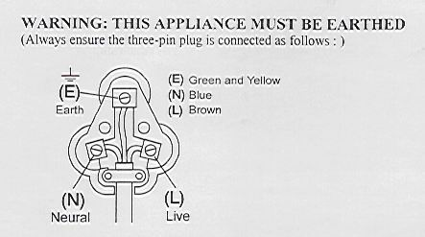
Vert/jaune = Terre
Bleu = Neutre
Marron = Actif

WARNING: THIS APPLIANCE MUST BE EARTHED | AVERTISSEMENT : CET APPAREIL DOIT ÊTRE BRANCHE A LA PRISE DE TERRE
(Always ensure the three-pin plug is connected as follows:) | (Assurez-vous aussi que la prise à trois fiches est connectée de la manière suivante :)
(E) Earth | (T) Terre
(E) Green and Yellow | (T) Vert et jaune
(N) Blue | (N) Bleu
(L) Brown | (A) Marron
(N) Neutral | (N) Neutre
(L) Live | (A) Actif

