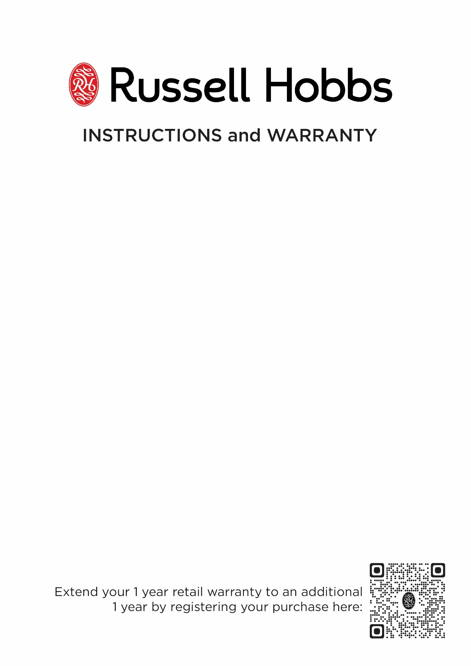

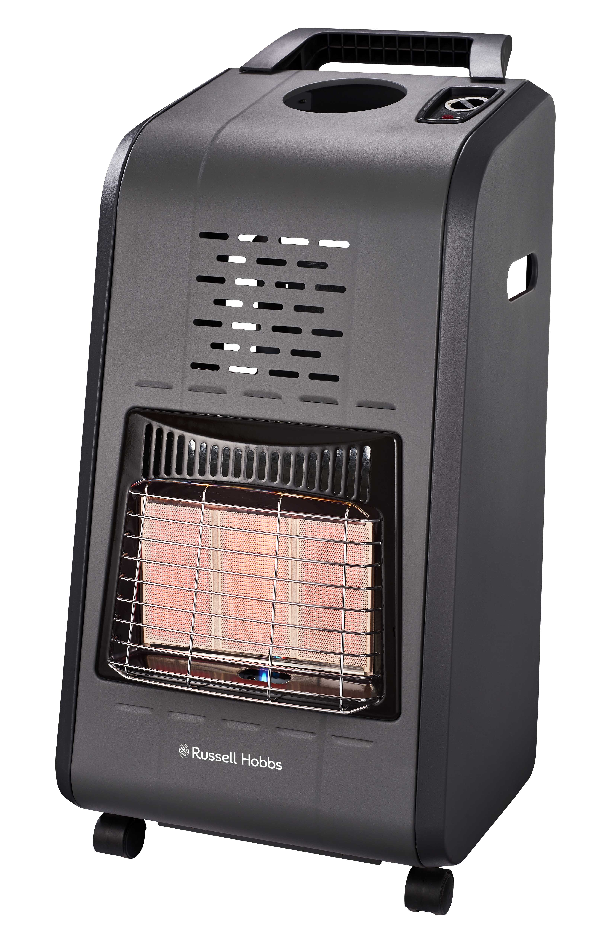

MODEL: RHGH02

RUSSELL HOBBS GAS HEATER

IMPORTANT: PLEASE READ BEFORE USE!

Thank you for purchasing the Russell Hobbs RHGH02 Gas Heater. Each unit is manufactured to ensure safety and reliability and has been approved by the LPGSASA.

IMPORTANT SAFEGUARDS
Read this instruction leaflet carefully as it has important information both for operational use and your safety. This appliance is a safe and efficient form of heating when used correctly and in accordance with these instructions. Save these instructions.

THIS APPLIANCE IS FOR HOUSEHOLD USE ONLY

- Use LPG (Liquid Petroleum Gas) only with this heater.
- The gas supply must be turned ON and OFF at the gas cylinder.
- Always ensure adequate ventilation for the effective performance of the appliance.
- Never attempt to open any part of the heater or dismantle the controls. The supplier cannot accept responsibility for any possible unit failure should this instruction be ignored.
- The appliance is intended for household use only. Commercial use invalidates the warranty and the supplier cannot be held responsible for injury or damage caused when using the appliance for any other purpose than that intended.
- This appliance is not intended for use by persons (including children) with reduced physical, sensory or mental capabilities, or lack of experience and knowledge, unless they have been given supervision or instruction concerning use of the appliance by a person responsible for their safety.
- Children should be supervised to ensure that they do not play with the appliance.
- Do not operate the heater if it is damaged, or after the appliance malfunctions. Return the unit to an authorised service agent for examination, repair, or adjustment.
- Never use a naked flame (matches, lighter, candle) to test for gas leaks.
- The gas cylinder must always be in an upright position. Do not turn the cylinder upside down in order to empty it completely.
- Always disconnect the appliance from the gas cylinder when not in use for long periods of time.
- The flexible gas hose must be checked periodically for signs of cracking.
- If the hose needs to be replaced, ensure that the replacement hose is suitable for LPG. Hoses should only be bought from certified gas dealers.
- Always use the heater in an upright position.
- Always face the heater to the centre of the room.
- Do not cover the heater with any type of cloth, clothing, foreign object or block the airflow in any way.
- Ensure that the appliance is not too close to curtains or fabric or any other flammable material.
- Do not move the heater while it is in operation. Ensure that the flame is properly extinguished before moving.
- If a gas leak is suspected (gas smell), turn the gas OFF at the cylinder immediately. Do not disconnect the regulator or hose from the heater. Replacement of the regulator must only be carried out by an authorised dealer and must be replaced with the same type and standard of regulator that complies with SABS 1237.
- Close supervision is required when any appliance is used near children
- Do not use the heater to cook or to heat food or fats.
- Do not leave the heater unattended when ON.
- Do not leave the heater ON overnight.
- The safety guard in front of the ceramic panels conforms to safety standard requirements and is to prevent risk of injury. No part of it should be removed or altered.
- Be aware that the appliance will remain hot for some time after use.
- In the event of BURN BACK (when the flame burns back into the jet), immediately turn the gas supply off at the cylinder. Ensure the flame is extinguished. Thereafter you may relight the heater as described below. Should the situation repeat itself, it is recommended that you contact the supplier or an approved service centre.
PARTS DIAGRAM
1
2
3
4

- Heat Level Selection Knob
- Infrared Burners
- Pilot Flame
- Castors

UNPACKING AND USING YOUR GAS HEATER FOR THE FIRST TIME

CAUTION! Always ensure that the gas cylinder valve is shut when the heater is not in use.

- Only a 9.0 kg gas cylinder is suitable for use with this heater.
- Unpack the heater and remove all protective wrapping.
- Install the handle as per the instructions provided.
- Un-tie the regulator from its shipping location and ensure that the hose is in perfect condition
- Unclip the gas cylinder retaining panel from the back of the heater body.

- Place the full LPG cylinder beside the rear of the heater. Ensure that the valve is clean and free of any obstructions or foreign matter and screw the regulator (anticlockwise ) onto the cylinder valve. Turn by hand and do not use a spanner.
- Turn the gas supply ON (anticlockwise ) one and half turns at the cylinder control valve.
- Before first use it is advisable to check the connection between the gas cylinder and the regulator for gas leaks as noted later in the instruction manual.
- If there are no gas leaks, insert the gas cylinder inside the heater. Ensure that the hose is not trapped in any way and the gas regulator is facing outside.
- Fit the rear retaining panel back onto the body ensuring that it is clipped on to both sides of the heater.
- The heater is controlled at the following 3 parts:
- Gas cylinder valve – controls gas supply to the heater.
- Heat level selection knob – controls the heat level by switching between the 3 marked settings.
- Piezo electric ignition button – generates a spark which ignites the gas when pressed.
.

INSTALLING THE HANDLE

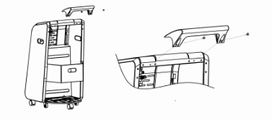
Handle Mounting Holes
Handle Mounting Points
Mounting Screws
Handle
Rear Retaining Panel

- Remove the Handle and Mounting Screws from the packaging.
- With the Rear Retaining Panel facing toward you, position the Handle with the Handle Mounting Holes lined up over the Handle Mounting Points.
- Insert the Mounting Screws into the Handle Mounting Holes.
- Using a star screwdriver tighten the Mounting Screws till the handle is secure. Take care not to over tighten the screws as this could cause damage to the Handel and Handle Mounting Holes.

LIGHTING THE HEATER

Note:
Ensure that the regulator is adequately fastened onto the gas cylinder. Please follow the installation instructions printed on the regulator tag.

The heat level selection knob has positive control, this prevents the knob’s position from being changed unintentionally. To change the heat level, press down the knob and turn.

- Turn the heat level selection knob to the first heat setting.
- Press the heat control knob and hold it down for 5 SECONDS.
- After 5 SECONDS (while still holding down the heat control knob) press the striker until the pilot flame lights up.
- You might need to press the striker 2 to 8 times before the pilot flame lights up.
- When pressing the striker, do it repeatedly (i.e. press the striker again as soon as you release it)
- Please note it is normal for blue rolling frames to appear for a short while during the striking procedure and heat level switching.
- Once the pilot flame lights up, keep holding down the control knob for at most 15 seconds and then let go, the pilot flame should keep on burning. If the pilot flame goes off, repeat the procedure.
- You can change the heat setting when the pilot flame is stable

N.B The heater has an oxygen depletion sensor which automatically shuts off the heater when the oxygen level is low. Ensure that windows are slightly opened when using the heater.
OFF
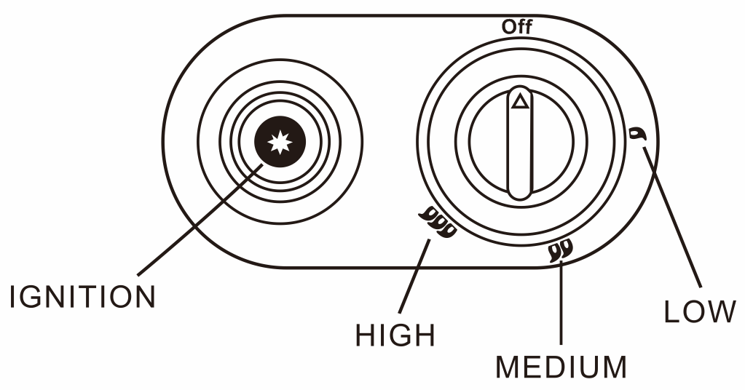

TURNING THE GAS HEATER “OFF”

Note:
When shutting off the heater, it is recommended to turn off the gas supply through the gas cylinder valve first.

- Turn OFF the gas supply to the heater by turning the gas cylinder valve clockwise.
- Turn the heat level selection valve to the off position.
- The pilot flame should automatically self-extinguish. Should it not, check if the gas cylinder valve is shut.

CHANGING THE GAS CYLINDER

- Take the heater outside and remove the rear panel.
- Remove the gas cylinder from the heater and place it on the floor next to the heater. MAKE SURE THAT THE CYLINDER VALVE IS CLOSED BEFORE ATTEMPTING TO DISCONNECT THE REGULATOR. Remove the regulator by turning clockwise.
- Before connecting the refilled cylinder, check that the nose seal on the regulator is not damaged and is still in good condition. If in doubt, take the regulator to an authorised dealer to be checked.
- Screw the regulator anticlockwise onto the new cylinder and fit the cylinder into the rear of the heater body. Ensure that the hose is not trapped, and the regulator is facing outwards.
- Fit the retaining panel back on to the body securing the clips on both sides.

MAINTENANCE AND SERVICING INSTRUCTIONS

There is minimum maintenance required on this appliance. Important points to remember are:
- Always check that the regulator seal is undamaged when changing the gas cylinder.
- Always check that the hose is in good condition before using, and that it is securely clamped on to the appliance and the regulator.
- It is recommended that the hose be replaced every two years whether it has been used or not. When replacing the hose, ensure that the replacement hose is suitable for LPG. Hoses should only be bought from certified gas dealers. Remember, when replacing the hose, to replace the hose clamps at the same time. These parts can be purchased from Home of Living Brands spares department
- With the exception of the hose and the regulator, there are no user fitted parts available for this heater. Should the heater not be functioning properly, an authorised service agent must check it, and if replacement parts are required, they will ensure that the correct parts are supplied and fitted correctly.
- It is recommended to perform a general inspection and a gas leakage test at the beginning of every season.

HOW TO TEST FOR GAS LEAKS

Note:
When performing a gas leakage test, ensure that there are no naked flames in the surrounding area. Do not smoke while performing the tests.

- Turn off the gas supply at the cylinder valve.
- Take the heater outside or to a well-ventilated area.
- Remove the regulator from the gas cylinder by turning clockwise.
- Visually inspect the hose connections and ensure that the regulator nose seal is in place.
- Re-connect the regulator to the gas cylinder and turn on the gas supply. Turn the cylinder valve one and a half turns.
- Apply soapy water on gas pipe connections. Formation of bubbles indicates leakage.
- If there is gas leakage, inform our nearest authorised service agent for rectification.
- Do not use the heater until an authorised service agent has inspected it.

CLEANING

- Wipe the exterior of the heater with a soft cloth moistened with a mild detergent.
- Do not use metal or furniture polish on the heater.
- If the elements appear dusty then clean them using a soft brush or dry cloth.
- Only clean the heater when it is cold and not in use.
- Do not use abrasive cleaners, as these will damage the paint surface.
- When not in use, store the heater by covering and placing it in a cool, dry and dust free area.

WARNING
- Never immerse the unit in water or let water come into contact with the burners.

IF YOU NEED TO RETURN THE PRODUCT PLEASE ENSURE THE FOLLOWING:

- The unit is packed carefully back into its original packaging.
- Proof of purchase is attached.

TROUBLE SHOOTING

Problem | Possible cause and solution
Heater will not light or runs poorly | Cylinder is empty. Replace with filled cylinder.
Heater will not light or runs poorly | If the cylinder is new, it may not have been purged of air properly.
Heater will not light or runs poorly | Check that the regulator is properly attached and that the cylinder valve is open (anticlockwise).
Heater will not light or runs poorly | Heater components may be dust contaminated or dirty. Have the heater serviced by an authorised service agent
Heater will not light or runs poorly | Russell Hobbs recommends using the following suppliers of LPG: Easigas (Shell), Totalgaz (Elf), and Handigas (Afrox).
Heater will not remain alight when the ignition button is released | Closely follow the ignition instructions, and if the problem persists, have the heater inspected by an authorised service agent.
The heater cuts off after a few minutes or hours of use | There is not enough ventilation in the room. Open the windows and doors to allow fresh air inside and then re-ignite the heater. The heater has an oxygen depletion sensor which shuts off the heater if the oxygen level is low. Ensure that windows are slightly opened when using the heater

PLEASE AFFIX YOUR PROOF OF PURCHASE/RECEIPT HERE
IN THE EVENT OF A CLAIM UNDER WARRANTY THIS RECEIPT MUST BE PRODUCED.

2 YEAR WARRANTY
1 year retail ⵏ 1 year extended warranty upon registration*
visit www.russellhobbs.co.za

W A R R A N T Y AND EXTENDED WARRANTY

- Home of Living Brands (Pty) Limited ("Home of Living Brands") warrants to the original purchaser of this product ("the customer") that this product will be free of defects in quality and workmanship which under normal personal, family or household use and purpose may manifest within a period of 1 (one) year from the date of purchase ("warranty period").
- Home of Living Brands shall extend the warranty period for a further period of 1(one) year (“extended warranty period*”), on condition that the purchaser registers the product on the website, within 12 months from the date of purchase of the product. The website address for registration is as follows: http://russellhobbs.co.za/info-pages/warranty-info.aspx. The extended warranty period only applies to products purchased on or after 1 October 2017.
- Where the customer has purchased a product and it breaks, is defective or does not work properly for the intended purpose, the customer must notify the supplier from whom the customer bought the product ("the supplier") thereof within the warranty period or if applicable, the extended warranty period. Any claim in terms of this warranty must be supported by a proof of purchase. If proof of purchase is not available, then repair, and/or service charges may be payable by the customer to the supplier.
- The faulty product must be taken to the supplier's service centre to exercise the warranty.
- The supplier will refund, repair or exchange the product in terms of this warranty subject to legislative requirements. This warranty shall be valid only where (a) the customer is not the cause of the product breaking, and (b) the product has been used for the intended purpose stipulated in the product manual. The warranty does not include and will not be construed to cover products damaged as a result of disaster, misuse, tamper, abuse or any unauthorised modification or repair of the product.
- This warranty will extend only to the product provided at the date of the purchase and not to any expendables attached or installed by the customer. In this regard any accessories supplied with the product by the supplier, may be excluded in this warranty or extended warranty (see Exclusions to Warranty and Extended Warranty document).
- If the customer requests that the supplier repairs the product and the product breaks or fails to work properly within 3 (three) months of the repair and not as a result of misuse, tampering or modification by or on behalf of the customer, then the supplier may replace the product or pay a refund to the customer, subject to the supplier’s discretion.
- The customer may be responsible for certain costs where products returned are not in the original packaging, or if the packaging is damaged. This will be deducted from any refund paid to the customer.
HOME OF LIVING BRANDS (PTY) LTD (JOHANNESBURG)
JOHANNESBURG TEL NO. (011) 490-9600
NATIONAL NUMBER TEL NO. (087) 245-0029
www.homeoflivingbrands.com
www.russellhobbs.co.za
www.facebook.com/RussellHobbsSA

EXCLUSIONS TO W A R R A N T Y AND EXTENDED WARRANTY

- Any accessories supplied with the product, including but not limited to, bowls, jugs, mills or carafes made either of glass or plastic and supplied with this appliance (hereinafter referred to as “the accessory or accessories”), is warranted to be free from material and workmanship defects for the duration of the appliance warranty.
- The accessories should give trouble free service when used in accordance with the directions described in the instruction manual. However, the accessories will be damaged if subjected to impact, and this damage is not covered by the warranty. Such impact damage can occur either from the outside (if for example it is dropped or knocked against a hard surface), or from within (if for example foreign objects are placed within the accessories and the power is switched on).
- Should you need to replace an accessory during the warranty period; a claim for a free replacement will only be considered if the item (including all shards and broken parts) is returned to the nearest HOLB service centre for examination.
- The remains of the accessory will be carefully examined by the relevant professionals and if it is determined (at the sole discretion of HOLB) that the damage was caused by impact, then the claim will be refused and will not be covered by the warranty or any extended warranty.
Any replacement part provided in terms of clause 4 above will become a chargeable item payable by the customer

