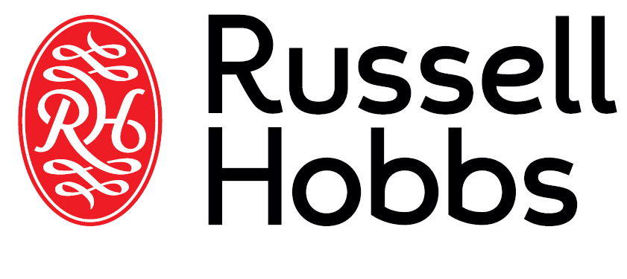

INSTRUCTIONS AND WARRANTY

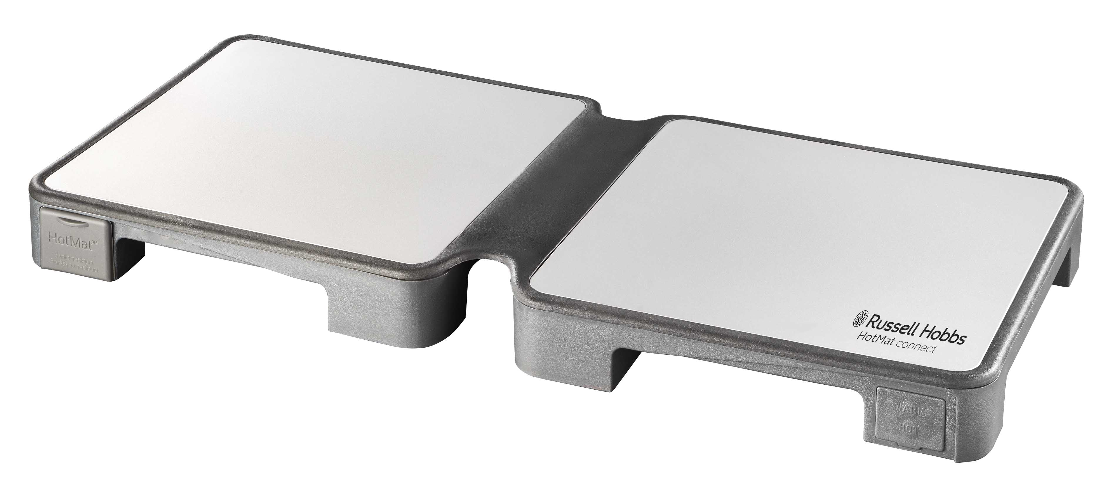

MODEL NO. RHHMC2

RUSSELL HOBBS 2 DISH HOTMAT CONNECT

Congratulations on purchasing our Russell Hobbs 2 Dish HotMat® connect. Each unit is manufactured to ensure safety and reliability. Before using this appliance for the first time, please read the instruction manual carefully and keep it for future reference.

FEATURES OF THE RUSSELL HOBBS 2 DISH HOTMAT CONNECT:

- 240W
- Used for evenly-distributed and energy-efficient heating
- A lightweight & easy to store foldable warming tray
- Two heat settings to keep food “warm” or “hot”
- Keeps different dishes warm to perfection for long periods of time
- Offers plenty of space for different sized pots & pans
- It is equivalent to a mid-size hotplate but uses 10% less space
- Provides the perfect storage solution when folded
- Uses MICA heating elements especially designed to give concentrated and even heating throughout the surface
- On and off switch
- Perfect hosting companion
- Connect up to 5 modular units
- For domestic use only
- 2 year warranty

INTRODUCTION
The Russell Hobbs HotMat® connect is designed to be your hosting and dining companion. Its features are especially designed to make your hosting experience fun and easy.
The Russell Hobbs HotMat® connect keeps your cooked food at just the right temperature for serving.
It allows you easy access to the food close to the dining table, simplifying the logistics of serving. When multi-course and multi-dish meals need to be kept warm, it acts as a modular system enabling the connection of up to 5 Russell Hobbs HotMat® connect units to warm up to 10 dishes using one electric socket!
Finally, after a great dinner, just store your Russell Hobbs HotMat® connect in any ordinary drawer. No need for "professional catering storage." Your kitchen drawer is just right!
Wishing you special dining moments and delicious food!

IMPORTANT SAFEGAURDS

When using electrical appliances, basic safety precautions should always be followed including the following:

- DO NOT touch the hot surfaces
- To protect against electrical hazards, DO NOT immerse cord, plugs, or the appliance in water or other liquid.
- Close supervision is necessary when any appliance is used by or near children.
- Unplug from outlet when not in use and before cleaning. Allow to cool before folding and before cleaning the appliance.
- DO NOT operate any appliance with a damaged cord or plug or after the appliance malfunctions or has been damaged in any manner. Return appliance to our service centre for examination, repair or adjustment.
- The use of accessories or attachments not recommended by us may cause hazards.
- DO NOT put food directly on the warming tray. Always use heat-proof dishes, containers and crockery.
- DO NOT use outdoors.
- DO NOT let cord hang over edge of table or counter or touch hot surfaces.
- DO NOT place on or near a hot gas or electric burner or in a heated oven.
- Extreme caution must be used when moving an appliance containing hot liquids.
- This appliance is for household use only. DO NOT use this appliance for other than its intended use.
- DO NOT leave unit unattended while in use.
- This appliance can be used by children aged from 8 years and above and persons with reduced physical, sensory or mental capabilities or lack of experience and knowledge if they have been given supervision or instruction concerning use of the appliance in a safe way and understand the hazards involved.
- Children should not play with the appliance.
- Cleaning and user maintenance shall not be made by children without supervision.

IMPORTANT NOTE: A short supply cord is provided to reduce the hazards of becoming entangled in or tripping over a long cord. Extension cords may be used if care is exercised in their use. If an extension cord is used, the marked electrical rating of the detachable power-supply cord or extension cord should be at least as great as the electrical rating of the appliance. If the appliance is of the grounded type, the extension cord should be of a grounded 3-wire cord. The extension cord should be arranged so that it will not drape over the counter top or table top, where it can be pulled on by children or tripped over.

GROUNDED PLUG
To reduce the risk of electric shock this appliance has a grounded plug. If the plug does not fit fully into the electrical outlet contact a qualified electrician. Do not modify the plug in any way or use an adaptor.

BEFORE FIRST USE
.
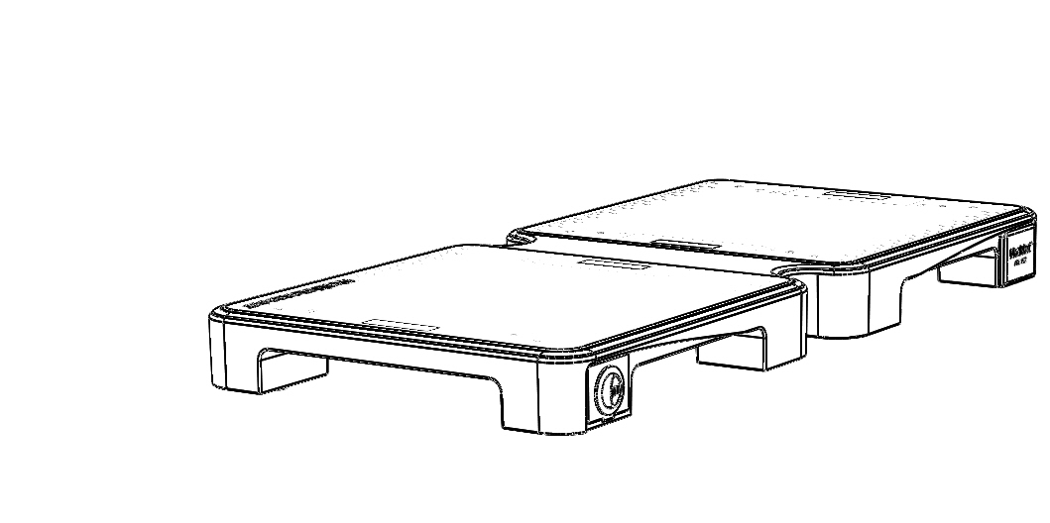
Wipe the aluminium and silicon surfaces of the Warming Tray with a damp cloth; dry thoroughly.

HOW TO USE

- Unfold the Russell Hobbs HotMat® connect. Always make sure your Russell Hobbs HotMat® connect is placed on a surface material that can withstand heat of 130 degrees Fahrenheit (55 degrees Celsius).
- Connect the power cord to the 3-pin insert in the Warming Tray and then plug into an A.C. outlet. Ensure that the voltage indicated on the rating plate of the appliance agrees with the mains voltage in your area.
- Connect the appliance only to a properly earthed power point. (Use of a residual current device (RCD) reduces the risk of electric shock, seek the advice of an electrician.) While the appliance is in use, the mains plug must be accessible in case of an emergency. To ensure continued protection against risk of electric shock, connect to properly grounded outlets only. If the power point is unsuitable for accommodating the plug of your appliance, have the power point changed by a licensed electrician
- Press the switch to your chosen heat setting: one line - warm, two lines - hot. The Warming Tray will take approximately 20 minutes to reach the maximum temperature chosen.
- The red ‘Power’ indicator light located opposite the switch will remain ‘On’ as long as the Warming Tray is plugged in.

Please note: that when the Russell Hobbs HotMat® connect is connected for the first time, it might produce a “plastic smell” for its first few hours of operation.

PARTS DIAGRAM

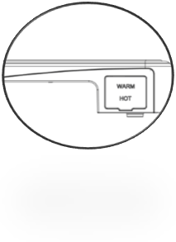

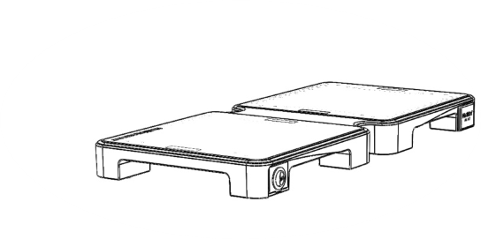
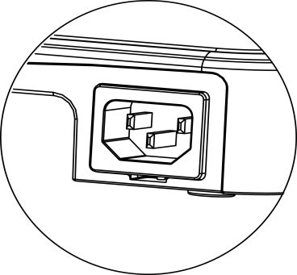
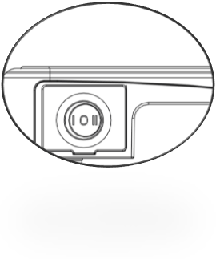
3 pin insert
Warm / off / Hot
Light Indicator

Power Switch
IMPORTANT NOTE: Porcelain and china dishes may cause scratches. Place dishes carefully on the aluminium Teflon-coated heating surface to prevent scratching.

HELPFUL HINTS
• Ensure that the Warming Tray is always placed on a flat and sturdy surface.
• Covered crockery dishes with a flat base and edges that are not too high keep food warmest.

CLEANING AND MAINTENANCE
- Always unplug the appliance and let it cool before cleaning.
- Clean the silicon and aluminium surfaces by wiping with a damp soapy cloth. Dry thoroughly.
- NEVER immerse the Warming Tray in water or any other liquid.
- NEVER use abrasive cleaning products, bleach or alcohol.

CONNECTING RUSSELL HOBBS HotMat® connect (up to 5 units)

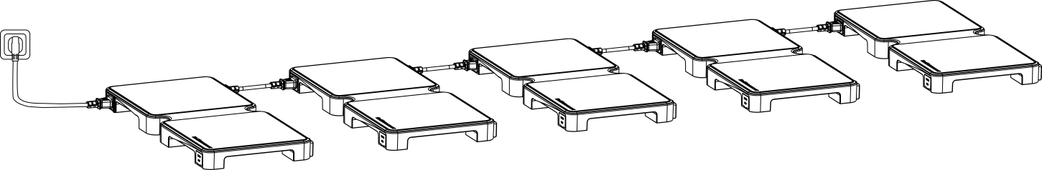

Your Russel Hobbs HotMat® connect can connect up to 5 identical units using only one socket connection. To connect an additional unit, use the dedicated connecting cable and attach it first to the 3-pin insert of the additional unit to be added. Then connect it to the opposite insert of the original unit. To connect more units (up to 5 units only), repeat this process and connect each additional unit it to the preceding unit.
After all units are connected, adjust each unit to your temperature of choice.
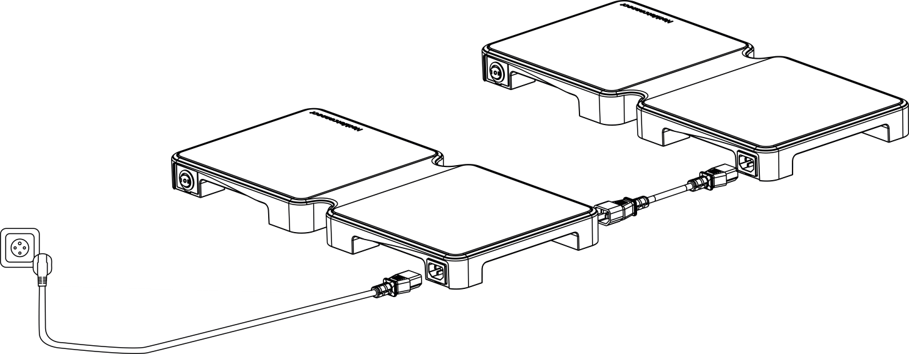
Additional Unit

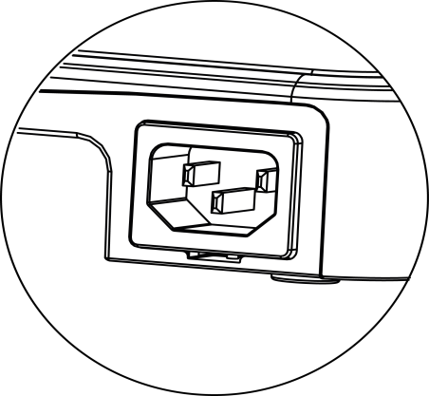
Original Unit
Connecting Plug
3 pin insert
TIPS FOR RUSSELL HOBBS HOTMAT® CONNECT LONGEVITY:

- Avoid covering your Russell Hobbs HotMat® connect heat surfaces with aluminium foil or similar materials.
- Choose cookware that conducts heat well, such as metal pots and trays, rather than ceramic dishes.

Correct disposal of this product
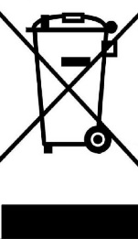 | This marking indicates that this product should not be disposed with other household wastes throughout the EU. To prevent possible harm to the environment or human health from uncontrolled waste disposal, recycle it responsibly to promote the sustainable reuse of material resources. To return your used device, please use the return and collection systems or contact the retailer where the product was purchased. They can take this product for environmental safe recycling.

STORING THE APPLIANCE

- Unplug the unit from the wall outlet and clean all the parts as instructed above. Ensure that all parts are dry before storing.
- Store the appliance in its box or in a clean, dry place.
- Never store the appliance while it is still wet or dirty.
- Never wrap the power cord around the appliance.

SERVICING THE APPLIANCE

There are no user serviceable parts in this appliance. If the unit is not operating correctly, please check the following:
- You have followed the instructions correctly
- That the unit has been wired correctly and that the wall socket is switched on.
- That the mains power supply is ON.
- That the plug is firmly in the mains socket.

If the appliance still does not work after checking the above:
Consult the retailer for possible repair or replacement. If the retailer fails to resolve the problem and you need to return the appliance, make sure that:
- The unit is packed carefully back into its original packaging.
- Proof of purchase is attached.
- A reason is provided for why it is being returned.

If the supply cord is damaged, it must be replaced by the manufacturer or an authorised service agent, in order to avoid any hazard. If service becomes necessary within the warranty period, the appliance should be returned to an approved Home of Living Brands (Pty) Ltd service centre. Servicing outside the warranty period is still available, but will, however, be chargeable.

CHANGING THE PLUG
Should the need arise to change the fitted plug, follow the instructions below.
This unit is designed to operate on 230V-240V current only. Connecting to other power sources may damage the appliance. Connect a three-pin plug as follows:
The wires in this mains lead are coloured in accordance with the following code:
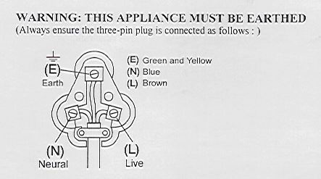
Green/Yellow = Earth
Blue = Neutral
Brown = Live

PLEASE AFFIX YOUR PROOF OF PURCHASE/RECEIPT HERE
IN THE EVENT OF A CLAIM UNDER WARRANTY THIS RECEIPT MUST BE PRODUCED.

2 YEAR WARRANTY
1 year retail ⵏ 1 year extended warranty upon registration*
visit www.russellhobbs.co.za

W A R R A N T Y AND EXTENDED WARRANTY

- Home of Living Brands (Pty) Limited ("Home of Living Brands") warrants to the original purchaser of this product ("the customer") that this product will be free of defects in quality and workmanship which under normal personal, family or household use and purpose may manifest within a period of 1 (one) year from the date of purchase ("warranty period").
- Home of Living Brands shall extend the warranty period for a further period of 1(one) year (“extended warranty period*”), on condition that the purchaser registers the product on the website, within 12 months from the date of purchase of the product. The website address for registration is as follows: http://russellhobbs.co.za/info-pages/warranty-info.aspx. The extended warranty period only applies to products purchased on or after 1 October 2017.
- Where the customer has purchased a product and it breaks, is defective or does not work properly for the intended purpose, the customer must notify the supplier from whom the customer bought the product ("the supplier") thereof within the warranty period or if applicable, the extended warranty period. Any claim in terms of this warranty must be supported by a proof of purchase. If proof of purchase is not available, then repair, and/or service charges may be payable by the customer to the supplier.
- The faulty product must be taken to the supplier's service centre to exercise the warranty.
- The supplier will refund, repair or exchange the product in terms of this warranty subject to legislative requirements. This warranty shall be valid only where the customer has not broken the product themselves, or used the product for something that it is not supposed to be used for. The warranty does not include and will not be construed to cover products damaged as a result of disaster, misuse, tamper, abuse or any unauthorised modification or repair of the product.
- This warranty will extend only to the product provided at the date of the purchase and not to any expendables attached or installed by the customer.
- If the customer requests that the supplier repairs the product and the product breaks or fails to work properly within 3 (three) months of the repair and not as a result of misuse, tampering or modification by or on behalf of the customer, then the supplier may replace the product or pay a refund to the customer, subject to the supplier’s discretion.
- The customer may be responsible for certain costs where products returned are not in the original packaging, or if the packaging is damaged. This will be deducted from any refund paid to the customer.

HOME OF LIVING BRANDS (PTY) LTD (JOHANNESBURG)
JOHANNESBURG TEL NO. (011) 490-9600
CAPE TOWN TEL NO. (021) 552-5161
DURBAN TEL NO. (031) 303-1163
www.homeoflivingbrands.com
www.russellhobbs.co.za
www.facebook.com/RussellHobbsSA

