

INSTRUCTIONS AND WARRANTY

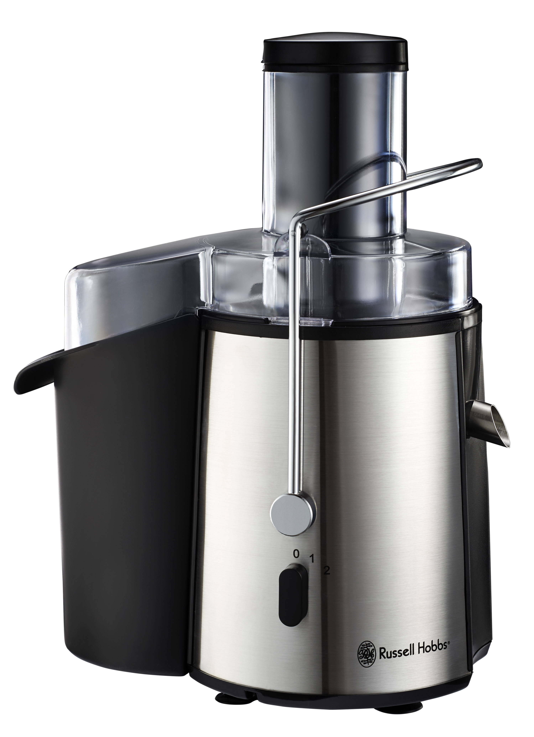

MODEL NO. RHJM01

RUSSELL HOBBS JUICE SENSATION

Congratulations on purchasing our Russell Hobbs Juice Sensation. Each unit is manufactured to ensure safety and reliability. Before using this appliance for the first time, please read the instruction manual carefully and keep it for future reference.

FEATURES OF THE RUSSELL HOBBS JUICE SENSATION
- The Russell Hobbs Juice Sensation has two speed settings using up to 700W of power for soft or hard fruit and vegetables.
- The extra large chute is designed to fit whole fruit and vegetables.
- The one piece stainless steel mesh strainer is easy to remove and clean.
- The Russell Hobbs Juice Sensation also has a 1.8L extra large pulp bin for longer use.
- The juicer is quick and easy to disassemble for cleaning, and all removable parts are dishwasher safe.
- The built-in auto shut-off motor protection ensures safe use of the unit, and the non-slip suction feet guarantee that the juicer will remain stable during use.
- 2 year warranty

IMPORTANT SAFEGUARDS
When using any electrical appliance, basic safety precautions should always be followed including the following:
- Please read the instructions carefully before using any appliance.
- Always ensure that the voltage on the rating label corresponds to the mains voltage in your home.
- Incorrect operation and improper use can damage the appliance and cause injury to the user.
- The appliance is intended for household use only. Commercial use invalids the warranty and the supplier can not be held responsible for injury or damage caused when using the appliance for any other purpose than that intended.
- Avoid any contact with moving parts, ensure the centrifuge has come to a complete stop before opening the lid.
- Close supervision is required when any appliance is used near or by children or invalids.
- Check the power cord and plug regularly for any damage. If the cord or the plug is damaged, it must be replaced by the manufacturer or a qualified person in order to avoid an electrical hazard.
- Do not use the appliance if it has been dropped or damaged in any way. In case of damage, take the unit in for examination and/or repair by an authorised service agent
- To reduce the risk of electric shock, do not immerse or expose the motor assembly, plug or the power cord to water or any other liquid.
- Never immerse the unit in water or any other liquid for cleaning purposes.
- Remove the plug from the socket by gripping the plug. Do not pull on the cord to disconnect the appliance from the mains. Always unplug the unit when not in use, before cleaning or when adding or removing parts.
- The use of accessory attachments that are not recommended or supplied by the manufacturer may result in injuries, fire or electric shock.
- A short cord is provided to reduce the hazards resulting from becoming entangled in or tripping over a longer cord.
- Do not let the cord hang over the edge of a table or counter. Ensure that the cord is not in a position where it can be pulled on inadvertently.
- Do not allow the cord to touch hot surfaces and do not place on or near a hot gas or electric burner or in a heated oven.
- Do not use the appliance on a gas or electric cooking top or over or near an open flame.
- Use of an extension cord with this appliance is not recommended. However, if it is necessary to use an extension lead, ensure that the lead is suited to the power consumption of the appliance to avoid overheating of the extension cord, appliance or plug point. Do not place the extension cord in a position where it can be pulled on by children or animals or tripped over.
- This appliance is not suitable for outdoor use. Do not use this appliance for anything other than its intended use.
- DO NOT carry the appliance by the power cord.
- Do not leave this appliance unattended during use. Always unplug the unit when not in use or before cleaning.
- Always operate the appliance on a smooth, even, stable surface. Do not place the unit on a hot surface.
- Ensure that the switch is in the Off position after each use.
- The manufacturer does not accept responsibility for any damage or injury caused by improper or incorrect use, or for repairs carried out by unauthorised personnel.
- In case of technical problems, switch off the machine and do not attempt to repair it yourself. Return the appliance to an authorised service facility for examination, adjustment or repair. Always insist on the use of original spare parts. Failure to comply with the above mentioned pre-cautions and instructions, could affect the safe operation of this machine.
- Do not use this appliance if the centrifuge is damaged.
PARTS DIAGRAM

ASSEMBLY OF THE UNIT
- Place motor unit on a flat and even surface, with the On/Off switch facing forward. Press the motor down firmly so that the suction cups on the feet of the unit get a good grip.
- Place the pulp holder on the holder on the left hand side of the unit. For easy cleaning, you can place a plastic bag into the pulp holder, and fold the bag over the sides of the holder.
- Place the centrifuge base onto the motor unit so that the discharge lip holds the pulp bin down.
- Carefully place he centrifuge with ribs into the base so that the inner wheel fits into the outer wheel and press down gently until the centrifuge clips into place. Carefully turn the centrifuge and check that it turns smoothly. NOTE: THE CENTRIFUGE WITH RIBS IS VERY SHARP, HANDLE IT VERY CAREFULLY.
- Position the lid onto the unit with the fill nozzle over the centrifuge. Press down firmly until the lid clips into place.
- Pull the clamp over the lid and snap it into place on either side of the unit.
- Place a container underneath the juice outflow pipe. The unit is now ready for use.

OPERATING INSTRUCTIONS
- Plug in the unit and switch on the electrical outlet.
- Prepare the fruit or vegetables to be used:
  - Wash the fruit and/or vegetables
  - Peels and seeds in the fruit and vegetables do not have to be removed before extracting their juice. It is advised that citrus peels be removed though, as these sometimes leave a slightly bitter taste in the juice.
  - Large pits should be removed before juicing, as these may damage the unit.
  - Fruits and vegetables that are too large should be cut into smaller pieces.
  - Conical fruit and vegetables (such as carrots) should be inserted tip first.
- Juicing:
- NOTE: The juicer cannot be used for a period longer than 3 minutes uninterrupted, as the motor will overheat. After 3 minutes of continuous use, allow the juicer to cool down for at least 20 minutes before it is used again.
- Turn on the unit using the rotary On/Off switch.
- Use level 1 to extract juice from soft fruits and vegetables.
- Use level 2 to extract juice from harder fruits and vegetables.
- Insert the fruit or vegetables into the fill nozzle. Insert the stopper into the fill nozzle and gently press down on the fruit or vegetables. Too much pressure will decrease the amount of juice obtained.
- Once the fruit has been juiced, turn the On/Off switch to 0.
- The juicer can be used until the pulp container is full. Do not overfill the pulp container, as this may damage the appliance.

HANDY RECIPES USING YOUR RUSSELL HOBBS JUICE SENSATION

HANDY RECIPES USING PULP FROM YOUR RUSSELL HOBBS JUICE SENSATION

HANDY HINTS WHEN USING YOUR RUSSELL HOBBS JUICE SENSATION
- Use fresh fruit and vegetable, as these will contain more juice.
- Peels and skins do not have to be removed, unless they are hard or thick, as they will damage the juicer.
- It is advised that citrus peels be removed though, as these sometimes leave a slightly bitter taste in the juice.
- Apple juice turns brown in fresh air very quickly. Serve apple juice as soon as possible after juicing, or add a little lemon juice to prevent the juice going brown.
- Fruits which are thick such as bananas, mangoes, papayas etc, should not be juiced. Rather use a blender for these fruits.
- Form balls out of leafy vegetables before juicing.
- Do not juice stringy or hard fruits and vegetables (such as sugar cane), as these will damage the unit.
- It is advised to drink the juice as soon as possible after extraction, as the juice tastes best then.

CLEANING AND MAINTENANCE
- This appliance is for household use only and is not user-serviceable.
- Do not open or change any parts by yourself. Please refer to a qualified electrical service department or return to the supplier if servicing is necessary.
- Always remember to unplug the unit from the electrical outlet when not in use and before cleaning. Ensure that the speed control is set to “0”.
- It is much easier to clean the accessories directly after they have been used. Wash them in warm, soapy water, rinse and dry well, or place them in the dishwasher.
- The body of the appliance and the stand should be cleaned with a damp cloth. Do not let water enter the appliance or the stand.
- Do not use bleach or other abrasive substance or solvents to clean your appliance as it can be damaging to the finish.
- Do not immerse the juicer in water or any other liquid, or hold it under a running tap to clean.
- To remove stubborn spots/marks, wipe the surfaces with a cloth slightly dampened in soapy water or mild non-abrasive cleaner. Rinse and dry a clean, dry, soft cloth.

STORING THE APPLIANCE
- Unplug the unit from the wall outlet and clean all the parts as instructed above. Ensure that all parts are dry before storing.
- Store the appliance in its box or in a clean, dry place.
- Never store the appliance while it is still wet or dirty.
- Never wrap the power cord around the appliance.

SERVICING THE APPLIANCE
There are no user serviceable parts in this appliance. If the unit is not operating correctly, please check the following:
- You have followed the instructions correctly
- That the unit has been wired correctly and that the wall socket is switched on.
- That the mains power supply is ON.
- That the plug is firmly in the mains socket.

If the appliance still does not work after checking the above:
- Consult the retailer for possible repair or replacement. If the retailer fails to resolve the problem and you need to return the appliance, make sure that:
- The unit is packed carefully back into its original packaging.
- Proof of purchase is attached.
- A reason is provided for why it is being returned.

If the supply cord is damaged, it must be replaced by the manufacturer or an authorised service agent, in order to avoid any hazard. If service becomes necessary within the warranty period, the appliance should be returned to an approved Home Of Living Brands (Pty) Limited service centre. Servicing outside the warranty period is still available, but will, however, be chargeable.

CHANGING THE PLUG
Should the need arise to change the fitted plug, follow the instructions below.
This unit is designed to operate on the stated current only. Connecting to other power sources may damage the appliance.

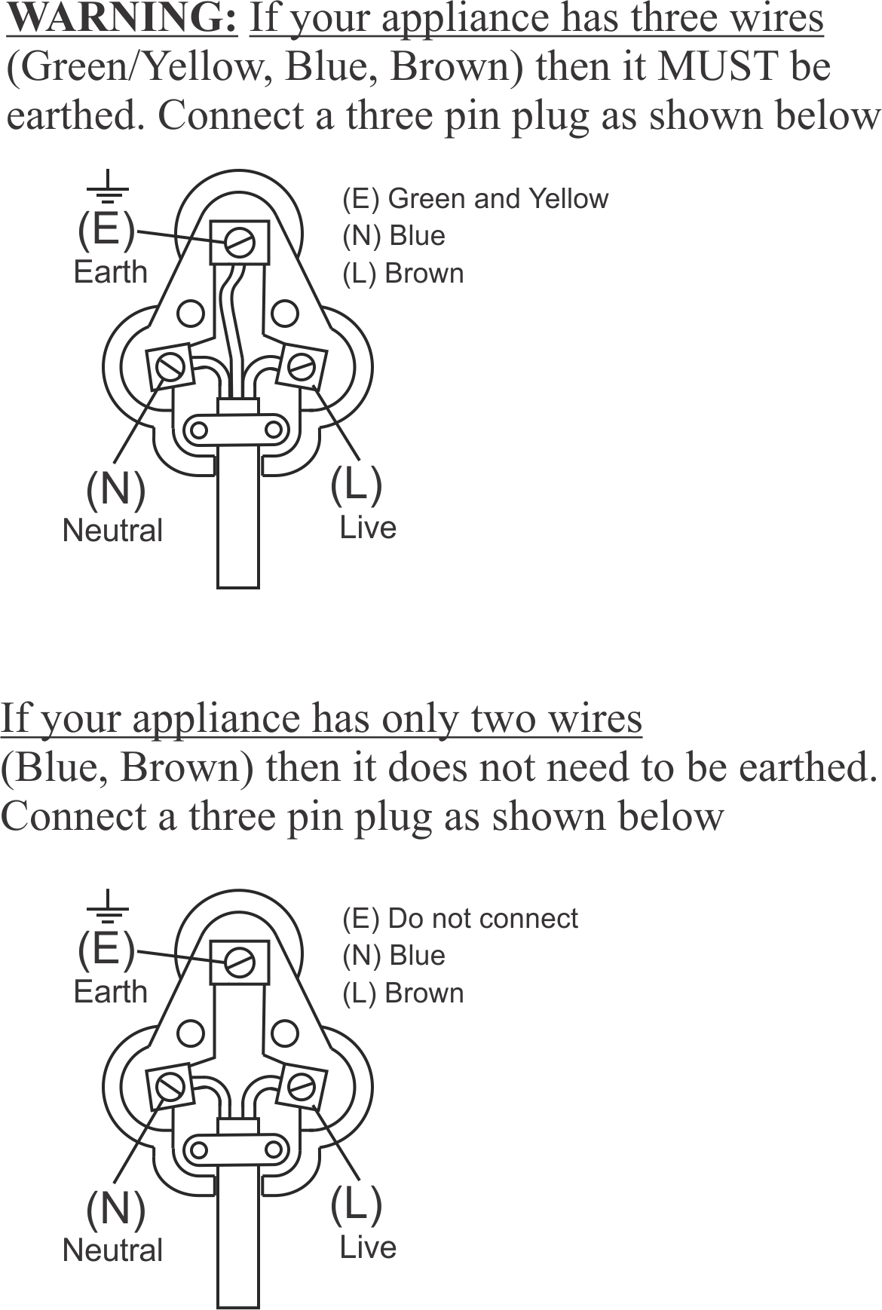

PLEASE AFFIX YOUR PROOF OF PURCHASE/RECEIPT HERE
IN THE EVENT OF A CLAIM UNDER WARRANTY THIS RECEIPT MUST BE PRODUCED.

2 YEAR WARRANTY
1 year retail ⵏ 1 year extended warranty upon registration*
visit www.russellhobbs.co.za

W A R R A N T Y AND EXTENDED WARRANTY

- Home of Living Brands (Pty) Limited ("Home of Living Brands") warrants to the original purchaser of this product ("the customer") that this product will be free of defects in quality and workmanship which under normal personal, family or household use and purpose may manifest within a period of 1 (one) year from the date of purchase ("warranty period").
- Home of Living Brands shall extend the warranty period for a further period of 1(one) year (“extended warranty period*”), on condition that the purchaser registers the product on the website, within 12 months from the date of purchase of the product. The website address for registration is as follows: http://russellhobbs.co.za/info-pages/warranty-info.aspx. The extended warranty period only applies to products purchased on or after 1 October 2017.
- Where the customer has purchased a product and it breaks, is defective or does not work properly for the intended purpose, the customer must notify the supplier from whom the customer bought the product ("the supplier") thereof within the warranty period or if applicable, the extended warranty period. Any claim in terms of this warranty must be supported by a proof of purchase. If proof of purchase is not available, then repair, and/or service charges may be payable by the customer to the supplier.
- The faulty product must be taken to the supplier's service centre to exercise the warranty.
- The supplier will refund, repair or exchange the product in terms of this warranty subject to legislative requirements. This warranty shall be valid only where (a) the customer is not the cause of the product breaking, and (b) the product has been used for the intended purpose stipulated in the product manual. The warranty does not include and will not be construed to cover products damaged as a result of disaster, misuse, tamper, abuse or any unauthorised modification or repair of the product.
- This warranty will extend only to the product provided at the date of the purchase and not to any expendables attached or installed by the customer. In this regard any accessories supplied with the product by the supplier, may be excluded in this warranty or extended warranty (see Exclusions to Warranty and Extended Warranty document).
- If the customer requests that the supplier repairs the product and the product breaks or fails to work properly within 3 (three) months of the repair and not as a result of misuse, tampering or modification by or on behalf of the customer, then the supplier may replace the product or pay a refund to the customer, subject to the supplier’s discretion.
- The customer may be responsible for certain costs where products returned are not in the original packaging, or if the packaging is damaged. This will be deducted from any refund paid to the customer.

HOME OF LIVING BRANDS (PTY) LTD (JOHANNESBURG)

JOHANNESBURG TEL NO. (011) 490-9600
CAPE TOWN TEL NO. (021) 552-5161
DURBAN TEL NO. (031) 303-1163
www.homeoflivingbrands.com
www.russellhobbs.co.za
www.facebook.com/RussellHobbsSA

EXCLUSIONS TO W A R R A N T Y AND EXTENDED WARRANTY

- Any accessories supplied with the product, including but not limited to, bowls, jugs, mills or carafes made either of glass or plastic and supplied with this appliance (hereinafter referred to as “the accessory or accessories”), is warranted to be free from material and workmanship defects for the duration of the appliance warranty.
- The accessories should give trouble free service when used in accordance with the directions described in the instruction manual. However, the accessories will be damaged if subjected to impact, and this damage is not covered by the warranty. Such impact damage can occur either from the outside (if for example it is dropped or knocked against a hard surface), or from within (if for example foreign objects are placed within the accessories and the power is switched on).
- Should you need to replace an accessory during the warranty period; a claim for a free replacement will only be considered if the item (including all shards and broken parts) is returned to the nearest HOLB service centre for examination.
- The remains of the accessory will be carefully examined by the relevant professionals and if it is determined (at the sole discretion of HOLB) that the damage was caused by impact, then the claim will be refused and will not be covered by the warranty or any extended warranty.
- Any replacement part provided in terms of clause 4 above will become a chargeable item payable by the customer.

