

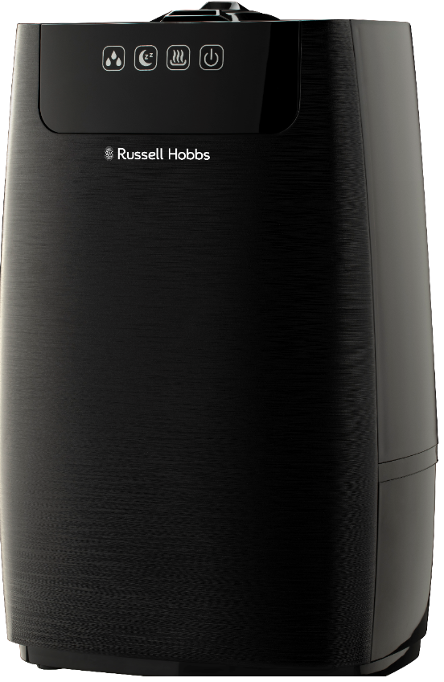

MODEL No. RHLBH5
Russell Hobbs Nevoa Warm Mist Humidifier
Congratulations on purchasing your Russell Hobbs Nevoa Warm Mist Humidifier. Each unit is manufactured to ensure safety and reliability. Before using this humidifier for the first time, please read the instruction manual carefully and keep it for future reference.

FEATURES OF THE RUSSELL HOBBS NEVOA WARM MIST HUMIDIFIER

The Russell Hobbs Nevoa Warm Mist Humidifier is the ultimate in style and efficiency when it comes to your humidifier needs. The cool and warm mist functions allow you to keep your living space at the optimum humidity for your comfort.

  - 5L Ultrasonic humidifier
  - One touch control
  - Adjustable mist capacity
  - Adjustable mist direction
  - Aroma diffuser
  - Large water tank opening for easy cleaning
  - Automatic shut-off protection - water level & water tank detachment
  - Silent operation
  - Usage time: 15hours
  - Cold and Warm mist
  - For domestic use only
  - 2 year warranty (1 year retail • 1 year extended upon online registration of product • visit www.russellhobbs.co.za)

IMPORTANT SAFEGUARDS

When using any electrical humidifier, basic safety precautions should always be followed including the following:

- Please read the instructions carefully before using any humidifier.
- Always ensure that the voltage on the rating label corresponds to the mains voltage in your home.
- Incorrect operation and improper use can damage the humidifier and cause injury to the user.
- This humidifier is intended for household use only. Commercial use invalidates the warranty and the supplier cannot be held responsible for injury or damage caused when using the humidifier for any other purpose than that intended.
- This humidifier is not intended for use by persons (including children) with reduced physical, sensory or mental capabilities, or lack of experience and knowledge, unless they have been given supervision or instruction concerning use of the humidifier by a person responsible for their safety.
- Children should be supervised to ensure that they do not play with the humidifier.
- Check the power cord and plug regularly for any damage. If the cord or the plug is damaged, the manufacturer or a qualified person must replace it in order to avoid an electrical hazard.
- Do not use the humidifier if it has been dropped or damaged in any way. In case of damage, take the unit in for examination and/or repair to an authorised service agent
- To reduce the risk of electric shock, do not immerse or expose the plug or the power cord to water or any other liquid. Do not use it with wet hands.
- Never immerse the unit in water or any other liquid for cleaning purposes.
- Remove the plug from the socket by gripping the plug. Do not pull on the cord to disconnect the humidifier from the mains. Allow the unit to cool and unplug it when not in use, before cleaning or when adding or removing parts.
- Insert and use only original parts.
- The use of accessory attachments that are not recommended or supplied by the manufacturer may result in injuries, fire or electric shock.
- A short cord is provided to reduce the hazards resulting from becoming entangled in or tripping over a longer cord.
- Do not let the cord hang over the edge of a table or counter. Ensure that the cord is not in a position where it can be pulled on inadvertently.
- Do not allow the cord to touch hot surfaces and do not place on or near a hot gas or electric burner or in a heated oven.
- Keep the humidifier and cord away from direct radiant heat from the sun, from sharp edges and other dangers.
- Do not use the humidifier on a gas or electric cooking top or over or near an open flame.
- Use on a hard, flat level surface only, to avoid interruption of airflow underneath the humidifier.
- Use of an extension cord with this humidifier is not recommended. However, if it is necessary to use an extension cord, ensure that the cord is suited to the power consumption of the humidifier to avoid overheating of the extension cord, the humidifier or plug point. Do not place the extension cord in a position where it can be pulled on by children or animals or tripped over.
- This humidifier is not suitable for outdoor use. Do not use this humidifier for anything other than its intended use.
- Do not operate this humidifier by means of an external timer or separate remote control system.
- Always be sure to place the water tank tightly back in the unit with its lid closed and filled with water at or above the minimum level marking before turning the humidifier ON.
- Switch OFF the humidifier before removing the water tank.
- DO NOT carry any humidifier by the power cord.
- Always unplug the unit when not in use or before cleaning.
- Do not place the unit on a hot surface.
- Ensure that the humidifier is switched off after each use.
- The manufacturer does not accept responsibility for any damage or injury caused by improper or incorrect use, or for repairs carried out by unauthorised personnel.
- In case of technical problems, switch off the humidifier and do not attempt to repair it yourself. Return the humidifier to an authorised service facility for examination, adjustment or repair. Always insist on the use of original spare parts. Failure to comply with the above-mentioned pre-cautions and instructions, could affect the safe operation of this humidifier.
- Only fill the water tank with clean and cold water. Never fill it with mineral water or other liquids.

PARTS DIAGRAM

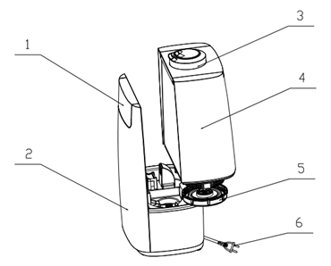
1.
3.

- Display screen
- Front panel
- Mist outlet
- Water tank
- Water tank cover
- Power cord
- Transducer
- Aroma pad

4.

2.
5.

6.

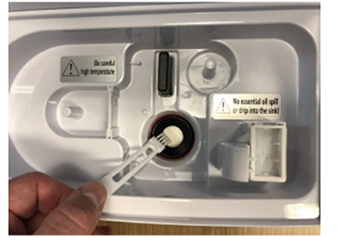

7.
8.

INTRODUCTION

- Before using your humidifier for the first time, take the humidifier out of the box and take off any protective wrappings. REMEMBER: DO NOT LEAVE PROTECTIVE PACKAGING LYING AROUND, AS IT COULD BE DANGEROUS AROUND INFANTS AND/OR ANIMALS.
- Place the humidifier on a dry, level surface.
- Please refer to the “PARTS DIAGRAM” section to familiarize yourself with the humidifier and identify all parts of the humidifier.
- Please make sure the unit is switched OFF by pressing the power button. Make sure that it is unplugged from the electrical outlet.
- Wipe down the humidifier with a damp cloth.
- Rinse the water tank.

OPERATING INSTRUCTIONS

NOTE:
- Do not fill the water tank with any liquid other than water as this will damage the humidifier.

Optimum operating conditions
- For the best results with a humidifier, it should be operated at a room temperature between 5-45 ̊C and a relative humidity of below 80%.
- When operating a humidifier at higher relative humidity levels (greater than 70%) or in an enclosed space. The humidifier should be used on the min mist setting.
- Use cool, clean water in the water tank.
- If the humidifier is being used after a long period of time, make sure to clean the water tank and mist outlet as directed in the cleaning and care instructions.

Display/Button instructions



-  The Power Button
  - Once the humidifier is plugged in and the main power supply is switched on, it will enter standby mode.
  - Press the power button once. The humidifier with switch on and mist will be emitted from the humidifier.
  - To switch the humidifier off, press the power button again.
- Night Mode Button
  - When this button is pressed the display lights will dim.
  - Press the night mode button again to illuminate the display lights.
- Mist Temperature Control Button
  - Press the mist temperature control button to change between warm and cool mist.
- Mist Level Button
  - This button controls the volume of mist emitted from the humidifier.
  - There are 2 levels: Low mist volume and High mist volume.

Using your humidifier
- Remove the water tank from the humidifier.
- Unscrew the lid at the bottom of the tank.
- Fill the water tank with cool, clean water.
- Screw the lid back onto the water tank. Ensure that the lid is securely fitted.
- Place the water tank back into the humidifier.
- Plug the humidifier into the mains socket. Switch the mains on. The humidifier will enter standby mode.
- Switch the humidifier on using the power button, as indicated above.
- The humidifier will begin emitting mist.

Using the aroma diffuser function
- Make sure the humidifier is switched off.
- Remove the water tank.
- In the base of the humidifier you will see a small rectangular sponge. This is the Aroma pad.
- Place a few drops of water-soluble aroma/essential oil on the aroma pad.
- Ensure that the oil DOES NOT fall into the water reservoir of the humidifier as this will damage the mechanics of the humidifier.
- Replace the water tank into the humidifier.
- When the humidifier is switched on, the aroma oil will automatically be diffused into the mist.
- Should you wish to stop the aroma diffuser function, remove the aroma pad from the humidifier.
- Make sure to clean/wash the sponge using a mild detergent to remove any aroma oils. This step is especially important when the humidifier is not going to be used for a long period of time.
- DO NOT use any harsh detergents as this will damage the aroma pad.

CLEANING AND CARE
NOTES:
- Before commencing the cleaning process, note the safety instructions and ensure that the humidifier is switched of and unplugged.
- Do not use any toxic, corrosive or abrasive cleaning agents or scouring sponges to clean the humidifier. These can damage the surface.

- Limescale may form on the surfaces that come in contact with water and mist, especially in areas where the water quality is hard.
- It is recommended that the humidifier be cleaned once a week, especially when used everyday.

Cleaning the transducer
- Place 5-10 drops of vinegar on the transducer.
- Wait for 2-5 minutes.
- Using a small, soft brush (such as a toothbrush), gently clean the limescale off the transducer.
- Rinse the transducer with clean water.
- DO NOT use any harsh, hard or abrasive objects to clean the transducer as this will cause damage to the transducer.

Cleaning the water tank
- Clean the inside of the water tank with a soft dry cloth.
- Should there be any stubborn marks or limescale, soak a soft cloth in a mixture of vinegar and water. Use this cloth to wipe the inside of the water tank.
- Rinse the cloth in clean water and wipe the inside of the water tank again.
- Lastly use a soft dry cloth and dry the inside of the water tank.

Cleaning the water reservoir
- Pour the remaining water out of the water reservoir.
- Using a small, soft brush (such as a toothbrush), gently clean the limescale from the inside of the reservoir.
- Rinse the reservoir with clean water.
- Should there be any stubborn marks or limescale, soak a soft cloth in a mixture of vinegar and water. Use this cloth to wipe the inside of the water reservoir.
- Rinse the cloth in clean water and wipe the inside of the water reservoir again.
- Lastly use a soft dry cloth and dry the inside of the water reservoir.

Cleaning the body of the humidifier
- Wipe the body of the humidifier using a soft damp cloth.
- Dry the humidifier using a soft dry cloth.
- DO NOT use any harsh abrasive detergents to clean the humidifier as this will cause damage to the finishing

STORAGE

Disconnect the humidifier from the mains power when it is not going to be used for a prolonged period. Clean the humidifier again if necessary (see Cleaning and Care) and let it dry completely.
Store the humidifier and all accessories in a dry and clean place that is protected from direct sunlight and cannot be accessed by children or animals.

TROUBLE SHOOTING

CHANGING THE PLUG

Should the need arise to change the fitted plug, follow the instructions below.
This unit is designed to operate on the stated current only. Connecting to other power sources may damage the humidifier.

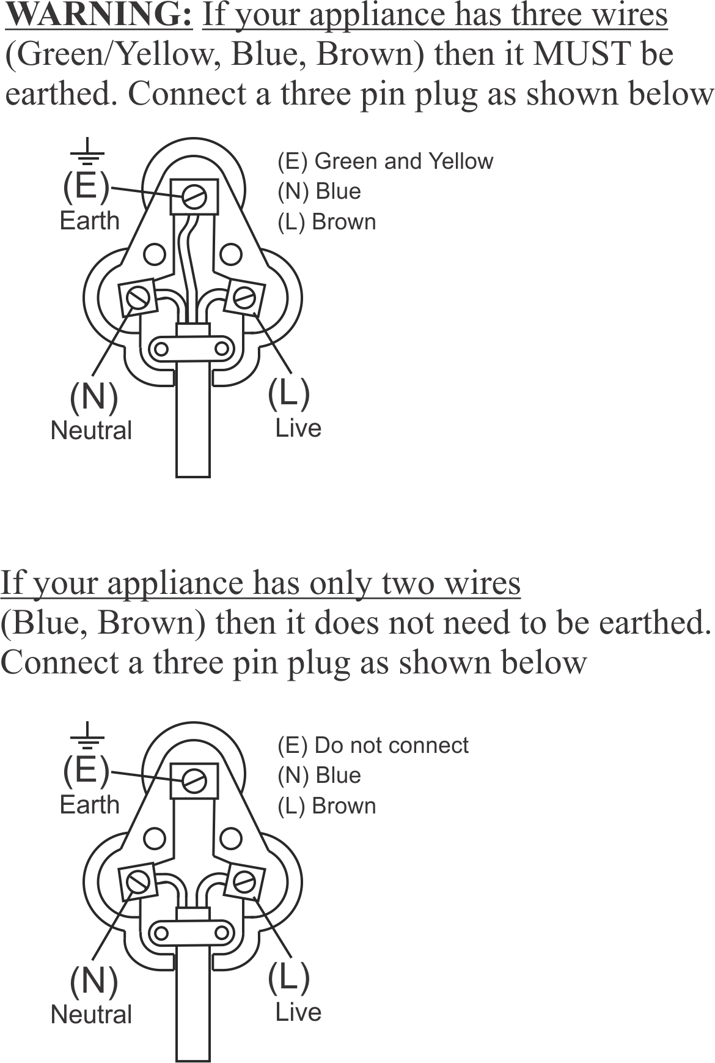

PLEASE AFFIX YOUR PROOF OF PURCHASE/RECEIPT HERE
IN THE EVENT OF A CLAIM UNDER WARRANTY THIS RECEIPT MUST BE PRODUCED.

1 YEAR STANDARD WARRANTY
Warranty will be extended for another year if you register your product online within 12 months of purchase (visit https://russellhobbswarranty.co.za/ )

W A R R A N T Y AND EXTENDED WARRANTY

- Home of Living Brands (Pty) Limited ("Home of Living Brands") warrants to the original purchaser of this product ("the customer") that this product will be free of defects in quality and workmanship which under normal personal, family or household use and purpose may manifest within a period of 1 (one) year from the date of purchase ("warranty period").
- Home of Living Brands shall extend the warranty period for a further period of 1(one) year (“extended warranty period*”), on condition that the purchaser registers the product on the website, within 12 months from the date of purchase of the product. The website address for registration is as follows: https://russellhobbswarranty.co.za/.
- Where the customer has purchased a product and it breaks, is defective or does not work properly for the intended purpose, the customer must notify the supplier from whom the customer bought the product ("the supplier") thereof within the warranty period or if applicable, the extended warranty period. Any claim in terms of this warranty must be supported by a proof of purchase. If proof of purchase is not available, then repair, and/or service charges may be payable by the customer to the supplier.
- The faulty product must be taken to the supplier's service centre to exercise the warranty.
- The supplier will refund, repair or exchange the product in terms of this warranty subject to legislative requirements. This warranty shall be valid only where (a) the customer is not the cause of the product breaking, and (b) the product has been used for the intended purpose stipulated in the product manual. The warranty does not include and will not be construed to cover products damaged as a result of disaster, misuse, tamper, abuse or any unauthorised modification or repair of the product.
- This warranty will extend only to the product provided at the date of the purchase and not to any expendables attached or installed by the customer. In this regard any accessories supplied with the product by the supplier, may be excluded in this warranty or extended warranty (see Exclusions to Warranty and Extended Warranty document).
- If the customer requests that the supplier repairs the product and the product breaks or fails to work properly within 3 (three) months of the repair and not as a result of misuse, tampering or modification by or on behalf of the customer, then the supplier may replace the product or pay a refund to the customer, subject to the supplier’s discretion.
- The customer may be responsible for certain costs where products returned are not in the original packaging, or if the packaging is damaged. This will be deducted from any refund paid to the customer.
HOME OF LIVING BRANDS (PTY) LTD (JOHANNESBURG)
JOHANNESBURG TEL NO. (011) 490-9600
CAPE TOWN TEL NO. (021) 552-5161
DURBAN TEL NO. (031) 303-1163
www.homeoflivingbrands.com
www.russellhobbs.co.za
www.facebook.com/RussellHobbsSA

EXCLUSIONS TO W A R R A N T Y AND EXTENDED WARRANTY
- Any accessories supplied with the product, including but not limited to, bowls, jugs, mills or carafes made either of glass or plastic and supplied with this appliance (hereinafter referred to as “the accessory or accessories”), is warranted to be free from material and workmanship defects for the duration of the appliance warranty.
- The accessories should give trouble free service when used in accordance with the directions described in the instruction manual. However, the accessories will be damaged if subjected to impact, and this damage is not covered by the warranty. Such impact damage can occur either from the outside (if for example it is dropped or knocked against a hard surface), or from within (if for example foreign objects are placed within the accessories and the power is switched on).
- Should you need to replace an accessory during the warranty period; a claim for a free replacement will only be considered if the item (including all shards and broken parts) is returned to the nearest HOLB service centre for examination.
- The remains of the accessory will be carefully examined by the relevant professionals and if it is determined (at the sole discretion of HOLB) that the damage was caused by impact, then the claim will be refused and will not be covered by the warranty or any extended warranty.
- Any replacement part provided in terms of clause 4 above will become a chargeable item payable by the customer.

