

INSTRUCTIONS AND WARRANTY

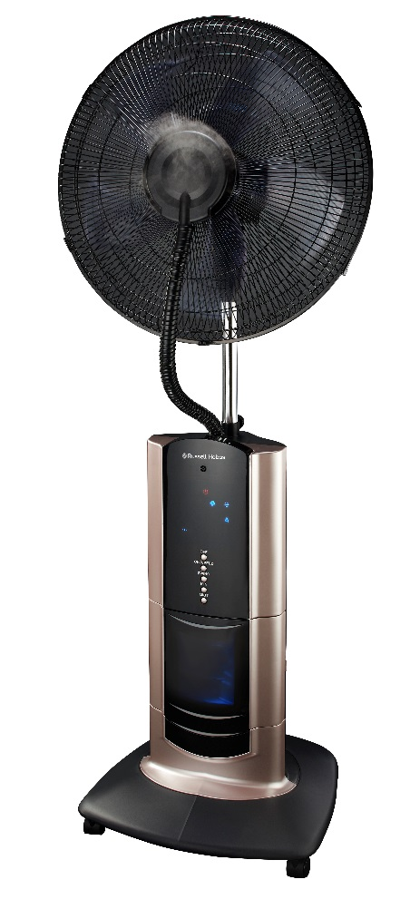

MODEL NO. RHMF10

RUSSELL HOBBS 18” MIST FAN

Introduction

Thank you for purchasing this product. Please read this instruction manual thoroughly before operating it in order to use the fan correctly and efficiently.

Working Elements
The Electric Mist Fan uses ultrasonic vibration elements, atomizes the water to 1-5 micro ultra-particles, and spreads the mist to the air through wind. This increases the cool humidity which makes you feel cool in a single room or entire home.
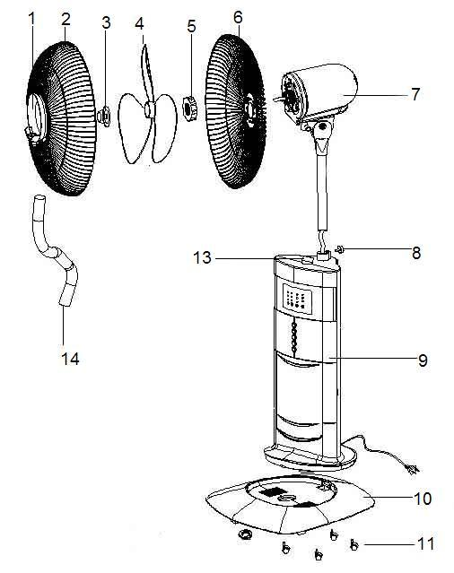
Assembly Chart and Technical Specifications
12
- Front guard ornament
- Front guard
- Blade cap
- Blade
- Guard mounting nut
- Rear guard
- Motor
- Adjust knob
- Fan body
- Base
- Wheel
- Base nut
- Mist tube fixer
- Mist tube

How to Assemble
Please reference the picture and assemble the fan following the below steps:
1) Fix the four wheels 11 into the base 10.
2) Install motor 7 on the fan body 9, and fasten the adjust knob 8.
3) Install fan buoy 9 on the base 10, and fasten the base nut 12.
4) Install rear guard 6 on the motor shaft 16, then fasten the guard mounting nut 5.
5) Install the blade 4 on the motor shaft 16, then fasten blade cap 3 in an anticlockwise direction.
6) Make the front guard 2 face to face rear guard 6, and push down the front guard 2 properly.
7) Set one side mist tube 14 into front guard ornament 1, the other side mist tube insert the mist tube fixer.

Assembling the Stand Fan Body to the Base
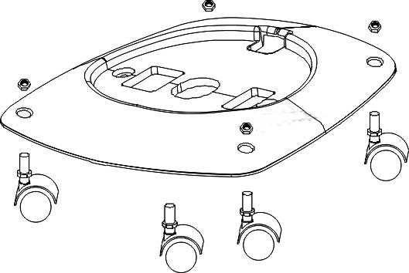
- Take out the base nut under the body.
- Use the base nut to assemble the body to the base (black base holes are in downward position).
- Place and fix the wheels into their holes on the base and press them firmly. The wheels have been supplemented with the feature of clips

Assembling the Rear Guard
- Take out the blade cap from the shaft turning it clockwise.
- Take out the rear guard mounting nut turning it anti-clockwise.
- Insert the rear guard into the motor matching 3 rods on the front side of the motor (the handle will direct upwards) to 3 holes of the rear guard.
- Fasten the rear guard tightly by turning the guard mounting nut clockwise.

Assembling the Fan Blade
- Insert the blade to the shaft and ensure the pin enters the blade slot.
- Tighten the blade using the blade cap turning anti-clockwise in the direction” TIGHT” arrow on it.
Note: Proper assembly of the blade is of great importance. Otherwise, the blade spins in the air and damages the appliance.

Assembling the Front Guard
- Fix the front guard with the logo in the upright position on the rear guard. Make sure that they are connected from the upper side.
- Take the front guard rim to set in the groove and fix it with screwdriver.
Note: Do not operate the fan without assembling the guards properly and tightly.

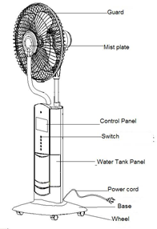
Technical Specifications

Rated Voltage: 230V~
Rated Frequency: 50Hz
General Power: 110W
Max Mist Capacity: 200ml/h
Blades Size: 450mm
Water Tank Capacity: 1500m

Operating the Water Tank
According to the six steps below, firmly place the mist fan on the ground and add water inside the water tank.

Note: Do not take out the water tank before unplugging the power cord, hot water (40℃ and above) is not allowed to be added in the water tank.
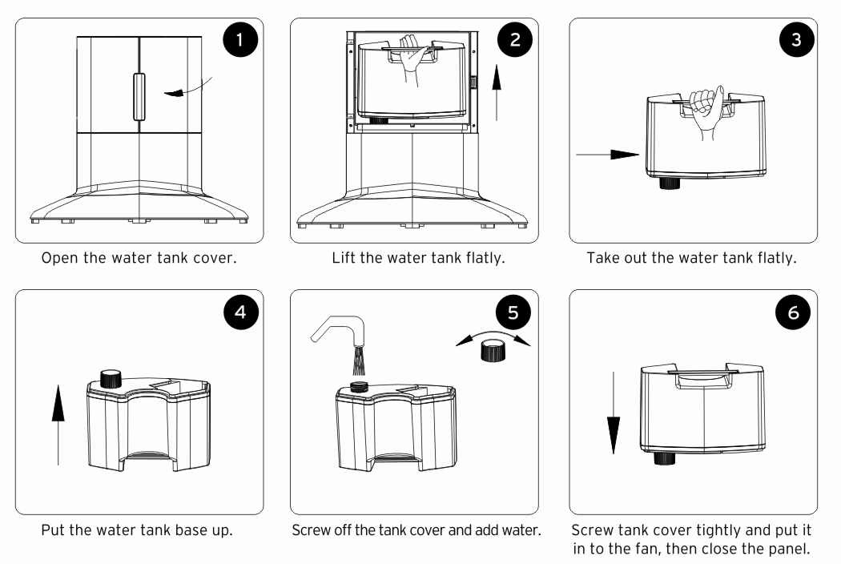

Note: Do not add dirty or chalky water in your tank, instead, add air-conditioned water or fresh water to ensure longer life for your fan.

Operating the Fan
- Insert plug to the electrical outlet, make sure that the indicator light is on as shown above.
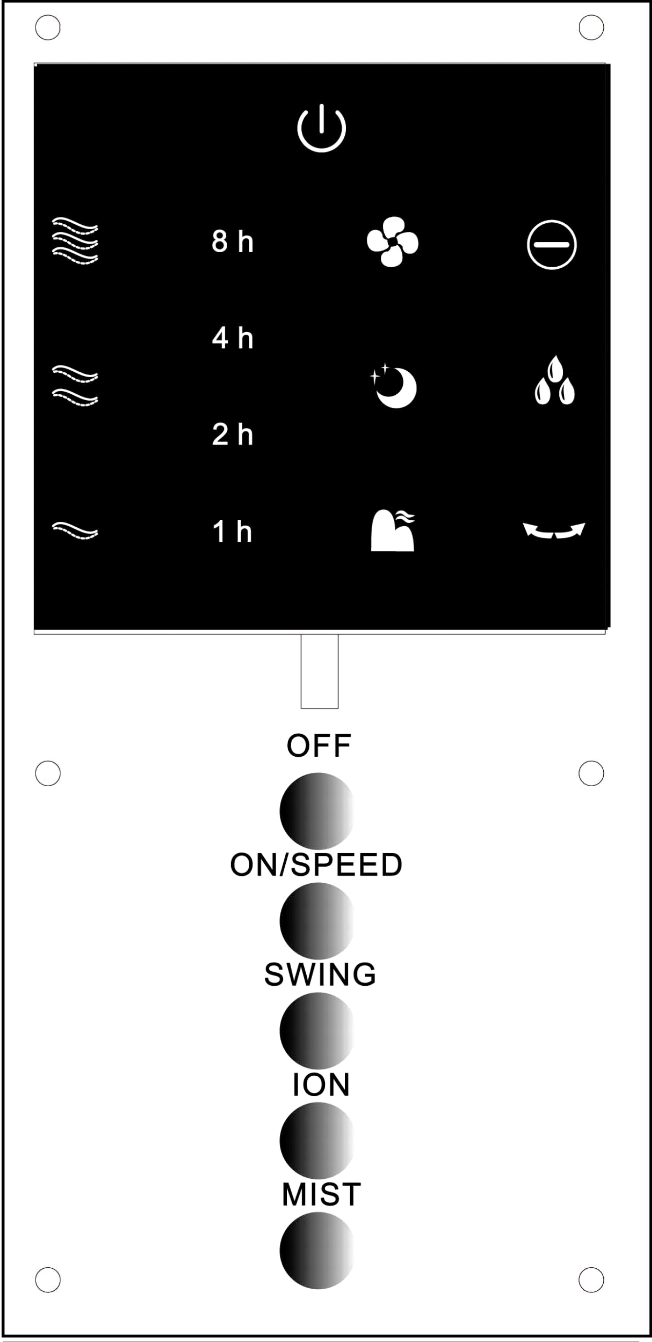
- Press “OFF” button, to turn off the fan.
- Press “ON/SPEED” button, to choose the wind speed-Low, Med, High that matches the light on the control panel.
- Press “SWING” button, to change the wind direction, meanwhile the corresponding light switches on. Press this button again to stop oscillation. The wind angle of upwards and downwards is done manually. Set the desired wind angle moving the guard and the motor of the fan up and down.
- Press “ION” button, to turn the Ionizer feature on/off (the fan must be operating for Ionizing to work). When the ionizer is turned on, it will assist in the purification of the room air.
- Press “MIST” button, the light is on, the mist will spread out of the front mist plate.
“MIST” button can be operated separately or worked together with the fan, this will result in a cool feel wind. If the mist function is used separately, it can increase humidity in the air.
Note: When the mist function is on, an apparent mist will be observed. Such an emission is quite normal and to should not change the settings of your appliance. 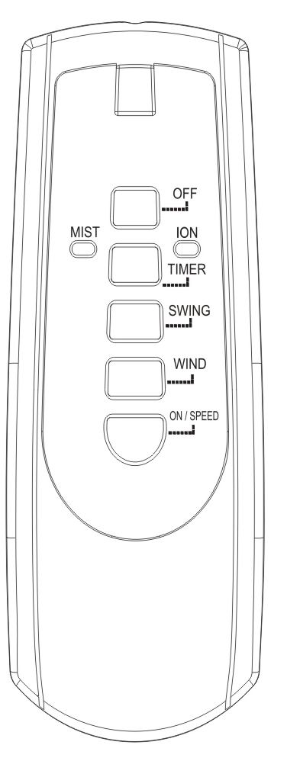

- Press “TIMER” button to set the time using the timer function. Sets the time between 1 to 15 hours and switches the fan off after the preset time. There are 4 indicator lights of automatic timing. To set a time of 1 hour you need to press the button once and to set 15 hours of running time you need to press 15 times and all the 4 indicator lights will light up.

WARNING
Do not take out the plastic tube on the front of your fan.

Remote Control: must be aimed at the infra-red port (as shown in the picture) when using it. If the remote control doesn’t work, please first check the inside battery and change to new batteries if needed.

Notes:
Change the batteries with new and same types, otherwise your remote control may not operate properly.
Remove the batteries out of the remote control if you won’t use the remote control for a long time. Old batteries may damage your remote control.

Safety Precautions
1. Make sure the fan and the power cord is not damaged before operating your fan. In case of damage, consult your authorized technical service provider.
2. Do not place the fan or any part close to flammable materials and heating appliances.
3. Do not install your fan onto wall or ceiling.
4. Avoid touching moving parts.
5. Never plug the power cord before the installation has been completed.
6. Ensure voltage used corresponds with the voltage indicated.
7. Place your fan in dry and stable surfaces. Do not use the fan in wet environments such as the bath-tub, swimming pool and bathrooms.
8. Unplug your fan from the electric outlet when not operating, moving it from one room to another, installing or uninstalling it’s parts and before cleaning.
9. Supervision is needed when this product is used anywhere near children. The appliance is not intended for use by children or other persons without assistance or supervision if their physical, sensory or mental capabilities prevent them from using it safely.
10. For safety reasons, please disconnect the plug from the electrical outlet. Do not pull the plug while the power is on. Always ensure that the plug is fully inserted into the electric outlet.
11. Never handle the power cord with wet hands as this could result in fire or electric shock.
12. Do not disassemble, repair or modify this product on your own. Warranty will be voided if repair is carried out by an unauthorized person/agency.
13. The water safety button will automatically switch off the fan when it runs out of water in the tank.
14. Never forget to add water for permanent operation of your fan.
15. Do not put any sundries into guard and mist-prayed hole to avoid destroying the fan.
16. Do not stick any finger or objects into the guard.
17. If the supply cord is damaged, it’s service agent or a similarly qualified person must replace it in order to avoid any hazard.
18. This appliance is not intended for use by persons (including children) with reduced physical, sensory or mental capabilities, or lack of experience and knowledge, unless they are under supervision or given instructions concerning use of the appliance by a person responsible for their safety.
19. Children should be supervised to ensure that they do not play with the appliance.

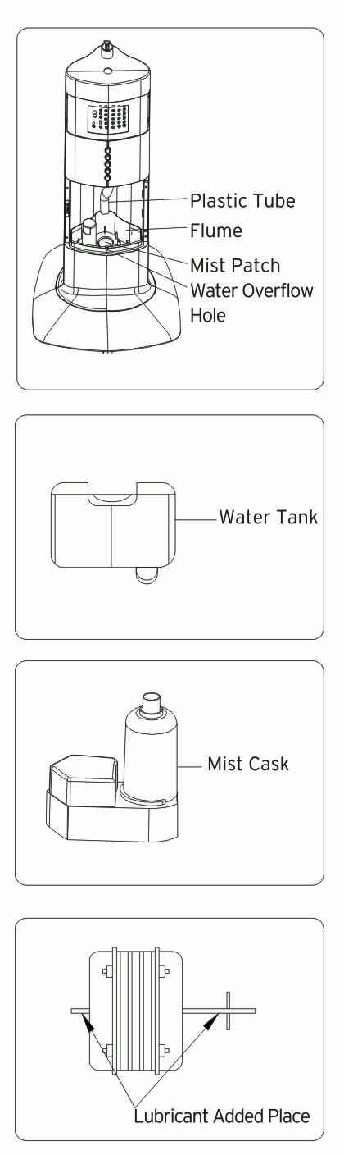
Cleaning and Maintenance
1. Pull out the power cord plug from the electrical outlet and make sure that your fan is not operating before cleaning it.
2. Please clean the water tank every two to three weeks, and clean the flume every week.
3. Take out the water tank when cleaning it, pull plastic tube out of the atomizing cup properly, then take out the atomizing cup and clean it.
4. Use a dry cloth to absorb water remaining when cleaning the ultrasonic atomizer, and dry it using a piece of soft cloth. Or use mild detergent to clean the ultrasonic atomizer if it is dirty.
5. Please add a few drops of lubricant to the motor shaft after cleaning to extend motor life every year.
6. Pack this appliance properly and store it in a cool dry place if you are not using it.

PLEASE AFFIX YOUR PROOF OF PURCHASE/RECEIPT HERE
IN THE EVENT OF A CLAIM UNDER WARRANTY THIS RECEIPT MUST BE PRODUCED.

2 YEAR WARRANTY
1 year retail ⵏ 1 year extended warranty upon registration*
visit www.russellhobbs.co.za

W A R R A N T Y AND EXTENDED WARRANTY

- Home of Living Brands (Pty) Limited ("Home of Living Brands") warrants to the original purchaser of this product ("the customer") that this product will be free of defects in quality and workmanship which under normal personal, family or household use and purpose may manifest within a period of 1 (one) year from the date of purchase ("warranty period").
- Home of Living Brands shall extend the warranty period for a further period of 1(one) year (“extended warranty period*”), on condition that the purchaser registers the product on the website, within 12 months from the date of purchase of the product. The website address for registration is as follows: http://russellhobbs.co.za/info-pages/warranty-info.aspx. The extended warranty period only applies to products purchased on or after 1 October 2017.
- Where the customer has purchased a product and it breaks, is defective or does not work properly for the intended purpose, the customer must notify the supplier from whom the customer bought the product ("the supplier") thereof within the warranty period or if applicable, the extended warranty period. Any claim in terms of this warranty must be supported by a proof of purchase. If proof of purchase is not available, then repair, and/or service charges may be payable by the customer to the supplier.
- The faulty product must be taken to the supplier's service centre to exercise the warranty.
- The supplier will refund, repair or exchange the product in terms of this warranty subject to legislative requirements. This warranty shall be valid only where (a) the customer is not the cause of the product breaking, and (b) the product has been used for the intended purpose stipulated in the product manual. The warranty does not include and will not be construed to cover products damaged as a result of disaster, misuse, tamper, abuse or any unauthorised modification or repair of the product.
- This warranty will extend only to the product provided at the date of the purchase and not to any expendables attached or installed by the customer. In this regard any accessories supplied with the product by the supplier, may be excluded in this warranty or extended warranty (see Exclusions to Warranty and Extended Warranty document).
- If the customer requests that the supplier repairs the product and the product breaks or fails to work properly within 3 (three) months of the repair and not as a result of misuse, tampering or modification by or on behalf of the customer, then the supplier may replace the product or pay a refund to the customer, subject to the supplier’s discretion.
- The customer may be responsible for certain costs where products returned are not in the original packaging, or if the packaging is damaged. This will be deducted from any refund paid to the customer.
HOME OF LIVING BRANDS (PTY) LTD (JOHANNESBURG)
JOHANNESBURG TEL NO. (011) 490-9600
CAPE TOWN TEL NO. (021) 552-5161
DURBAN TEL NO. (031) 303-1163
www.homeoflivingbrands.com
www.russellhobbs.co.za
www.facebook.com/RussellHobbsSA

EXCLUSIONS TO W A R R A N T Y AND EXTENDED WARRANTY

- Any accessories supplied with the product, including but not limited to, bowls, jugs, mills or carafes made either of glass or plastic and supplied with this appliance (hereinafter referred to as “the accessory or accessories”), is warranted to be free from material and workmanship defects for the duration of the appliance warranty.
- The accessories should give trouble free service when used in accordance with the directions described in the instruction manual. However, the accessories will be damaged if subjected to impact, and this damage is not covered by the warranty. Such impact damage can occur either from the outside (if for example it is dropped or knocked against a hard surface), or from within (if for example foreign objects are placed within the accessories and the power is switched on).
- Should you need to replace an accessory during the warranty period; a claim for a free replacement will only be considered if the item (including all shards and broken parts) is returned to the nearest HOLB service centre for examination.
- The remains of the accessory will be carefully examined by the relevant professionals and if it is determined (at the sole discretion of HOLB) that the damage was caused by impact, then the claim will be refused and will not be covered by the warranty or any extended warranty.
- Any replacement part provided in terms of clause 4 above will become a chargeable item payable by the customer.

