

INSTRUCTIONS AND WARRANTY

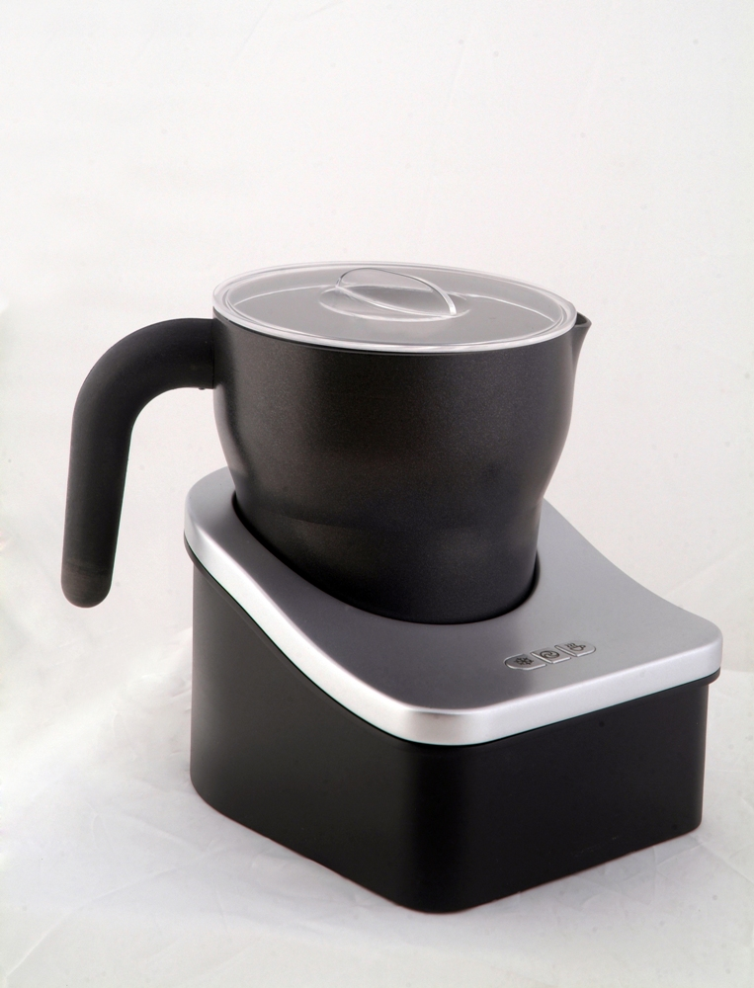

MODEL NO.RHMF3

Russell Hobbs 3-in-1 Milk Frother

Congratulations on purchasing our Russell Hobbs 3-in-1 Milk Frother. Each unit is manufactured to ensure safety and reliability. Before using this appliance for the first time, please read the instruction manual carefully and keep it for future reference.

FEATURES OF THE RUSSELL HOBBS 3-IN-1 MILK FROTHER

IMPORTANT SAFEGUARDS
When using any electrical appliance, basic safety precautions should always be followed including the following:
- Please read the instructions carefully before using any appliance.
- Always ensure that the voltage on the rating label corresponds to the mains voltage in your home.
- Incorrect operation and improper use can damage the appliance and cause injury to the user.
- The appliance is intended for household use only. Commercial use invalids the warranty and the supplier can not be held responsible for injury or damage caused when using the appliance for any other purpose than that intended.
- Avoid any contact with moving parts.
- This appliance is not intended for use by persons (including children) with reduced physical, sensory or mental capabilities, or lack of experience and knowledge, unless they have been given supervision or instruction concerning use of the appliance by a person responsible for their safety.
- Children should be supervised to ensure that they do not play with the appliance.
- Check the power cord and plug regularly for any damage. If the cord or the plug is damaged, it must be replaced by the manufacturer or a qualified person in order to avoid an electrical hazard.
- Do not use the appliance if it has been dropped or damaged in any way. In case of damage, take the unit in for examination and/or repair by an authorised service agent
- To reduce the risk of electric shock, do not immerse or expose the motor assembly, plug or the power cord to water or any other liquid.
- Never immerse the unit in water or any other liquid for cleaning purposes.
- Remove the plug from the socket by gripping the plug. Do not pull on the cord to disconnect the appliance from the mains. Always unplug the unit when not in use, before cleaning or when adding or removing parts.
- The use of accessory attachments that are not recommended or supplied by the manufacturer may result in injuries, fire or electric shock.
- A short cord is provided to reduce the hazards resulting from becoming entangled in or tripping over a longer cord.
- Do not let the cord hang over the edge of a table or counter. Ensure that the cord is not in a position where it can be pulled on inadvertently.
- Do not allow the cord to touch hot surfaces and do not place on or near a hot gas or electric burner or in a heated oven.
- Do not use the appliance on a gas or electric cooking top or over or near an open flame.
- Use of an extension cord with this appliance is not recommended. However, if it is necessary to use an extension lead, ensure that the lead is suited to the power consumption of the appliance to avoid overheating of the extension cord, appliance or plug point. Do not place the extension cord in a position where it can be pulled on by children or animals or tripped over.
- This appliance is not suitable for outdoor use. Do not use this appliance for anything other than its intended use.
- DO NOT carry the appliance by the power cord.
- Do not leave this appliance unattended during use. Always unplug the unit when not in use or before cleaning.
- Always operate the appliance on a smooth, even, stable surface. Do not place the unit on a hot surface.
- Ensure that the switch is in the “Off” position after each use.
- The manufacturer does not accept responsibility for any damage or injury caused by improper or incorrect use, or for repairs carried out by unauthorised personnel.
- In case of technical problems, switch off the machine and do not attempt to repair it yourself. Return the appliance to an authorised service facility for examination, adjustment or repair. Always insist on the use of original spare parts. Failure to comply with the above mentioned pre-cautions and instructions, could affect the safe operation of this machine.

ADDITIONAL SAFEGUARDS
- When using this appliance, please clean all parts and accessories and add the milk or hot chocolate before placing it on the base station.
- If the appliance has been previously used and is still hot, allow it to cool down completely before attempting to use it again.
- Please keep the heating disc clean at all times.
- Please do not leave anything on the surface of the heating element or at the bottom of the pot.

NOTE: This appliance has been manufactured to make milk foam and hot chocolate ONLY!

PARTS DIAGRAM

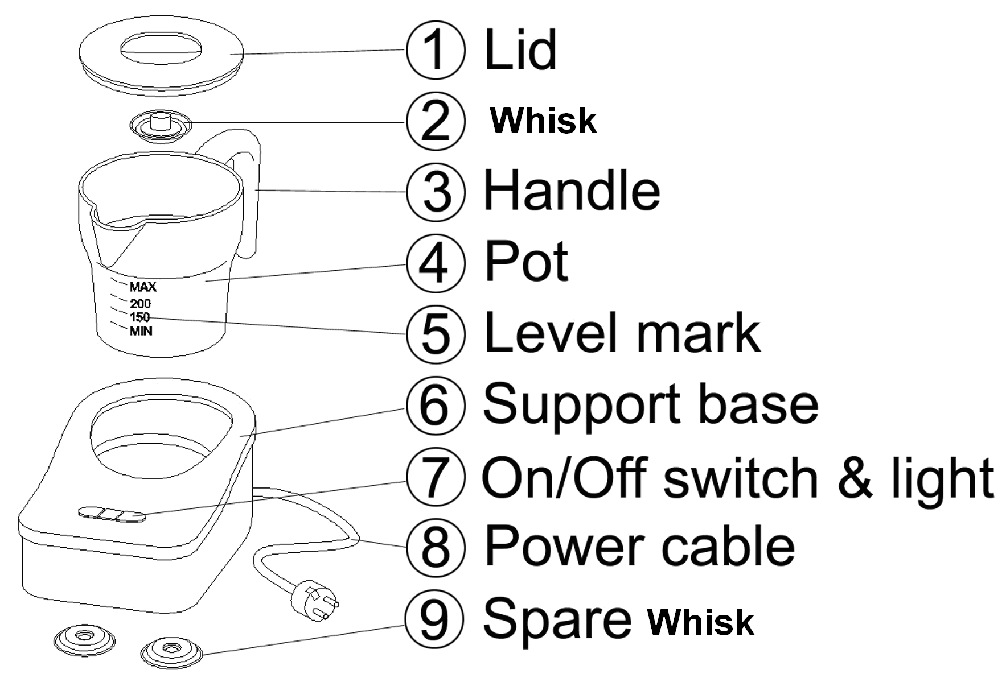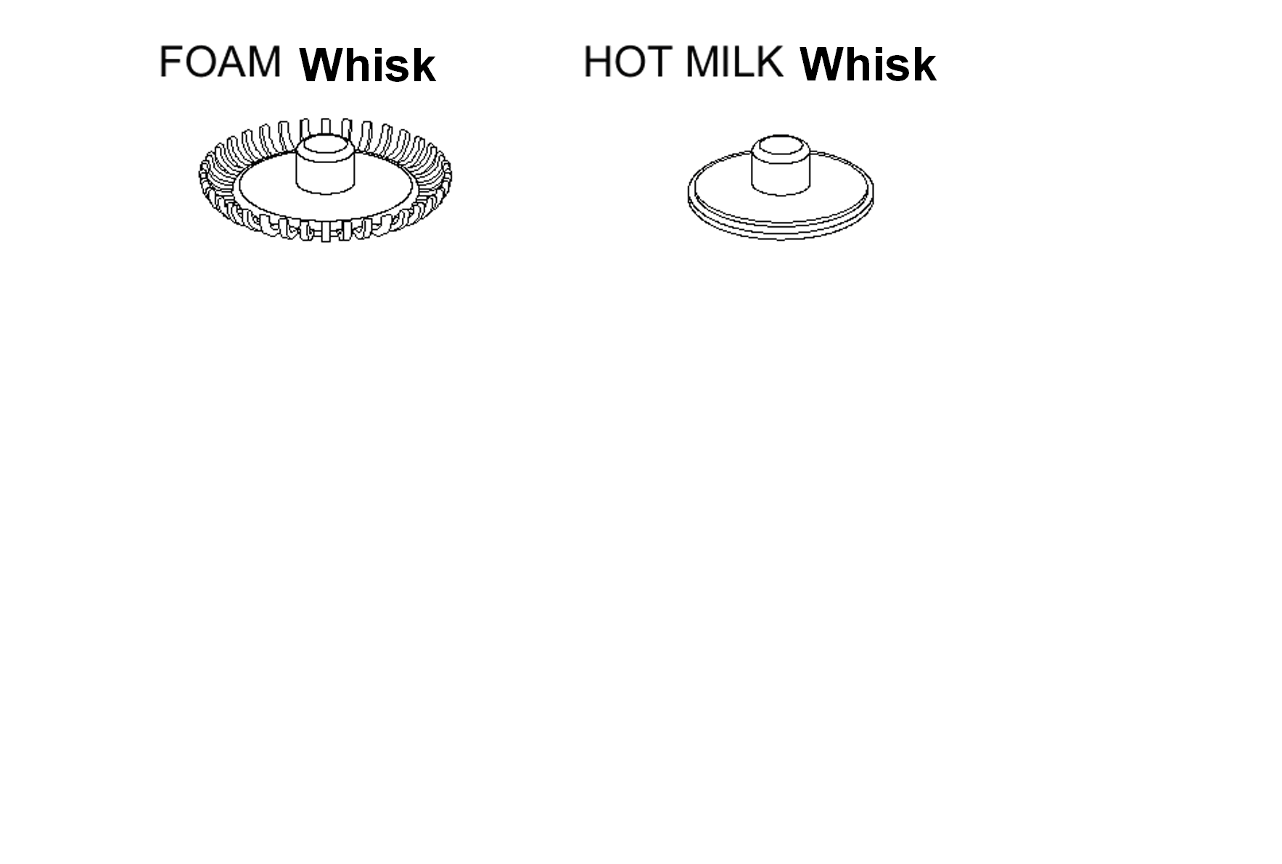
(Beneath the base)

OPERATING INSTRUCTIONS
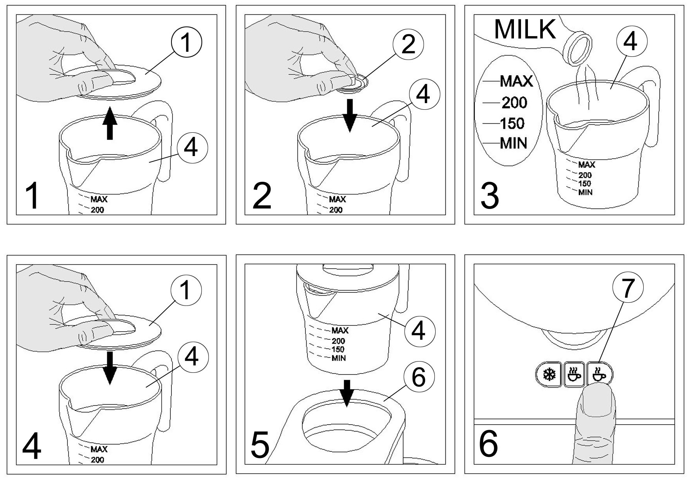
Fig 1 Open the lid of the appliance.
Fig 2 Insert the whisk into the pot.
Fig 3 Pour the milk into the pot, at a maximum of 250 ml to prevent an overflow of warm milk.
Fig 4 Make sure the lid of the appliance is placed on the pot before switching the appliance on.
Fig 5 Place the pot onto the support base. Check that the electrical plug is inserted into the main socket and is switched on.
Fig 6 On the support base,this sign  is the heating switch and the sign  is the non-heating switch.When you first start the appliance, the indicator light will switch on and the whisk will start to rotate the milk. In about 2 –3 minutes the appliance will stop automatically and the light will switch off. The pot is now filled with hot luscious milk foam that can be poured in your cup of coffee. If you need to stop the frothing process while in progress, press the switch or again.

Hot Chocolate:
Please follow the same procedure as when whisking milk.
Make sure the milk and hot chocolate powder is added before the appliance is switched on.

When you need to speed up to the appliance, please wet the bottom of the pot with little tap water. See the Fig.
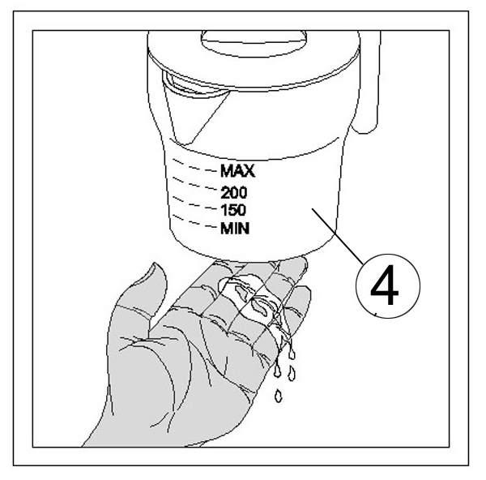

CLEANING AND MAINTENANCE
- This appliance is for household use only and is not user-serviceable.
- Do not open or change any parts by yourself. Please refer to a qualified electrical service department or return to the supplier if servicing is necessary.
- Always remember to unplug the unit from the electrical outlet when not in use and before cleaning. Ensure that the speed control is set to “0”.
- It is much easier to clean the accessories directly after they have been used. Wash them in warm, soapy water, rinse and dry well.
- The body of the appliance and the stand should be cleaned with a damp cloth. Do not let water enter the appliance or the stand.
- Do not use bleach or other abrasive substance or solvents to clean your appliance as it can be damaging to the finish.
- Do not immerse the appliance in water or any other liquid, or hold it under a running tap to clean.
- To remove stubborn spots/marks, wipe the surfaces with a cloth slightly dampened in soapy water or mild non-abrasive cleaner. Rinse and dry with a clean, dry, soft cloth.

STORING THE APPLIANCE
- Unplug the unit from the wall outlet and clean all the parts as instructed above. Ensure that all parts are dry before storing.
- Store the appliance in its box or in a clean, dry place.
- Never store the appliance while it is still wet or dirty.
- Never wrap the power cord around the appliance.

SERVICING THE APPLIANCE
There are no user serviceable parts in this appliance. If the unit is not operating correctly, please check the following:
- You have followed the instructions correctly
- That the unit has been wired correctly and that the wall socket is switched on.
- That the mains power supply is ON.
- That the plug is firmly in the mains socket.

If the appliance still does not work after checking the above:
- Consult the retailer for possible repair or replacement. If the retailer fails to resolve the problem and you need to return the appliance, make sure that:
- The unit is packed carefully back into its original packaging.
- Proof of purchase is attached.
- A reason is provided for why it is being returned.

If the supply cord is damaged, it must be replaced by the manufacturer or an authorised service agent, in order to avoid any hazard. If service becomes necessary within the warranty period, the appliance should be returned to an approved Tedelex Trading (Pty) Limited service centre. Servicing outside the warranty period is still available, but will, however, be chargeable.

CHANGING THE PLUG

Should the need arise to change the fitted plug, follow the instructions below.
This unit is designed to operate on the stated current only. Connecting to other power sources may damage the appliance. Connect a three-pin plug as follows:
The wires in this mains lead are coloured in accordance with the following code:
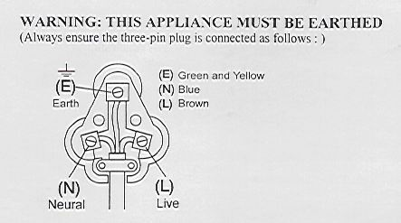
Green/Yellow = Earth
Blue = Neutral
Brown = Live

PLEASE AFFIX YOUR PROOF OF PURCHASE/RECEIPT HERE
IN THE EVENT OF A CLAIM UNDER WARRANTY THIS RECEIPT MUST BE PRODUCED.

W A R R A N T Y

- Tedelex Trading (Pty) Limited (“Tedelex”) warrants to the original purchaser of this product (“the customer”) that this product will be free of defects in quality and workmanship which under normal personal, family or household use and purpose may manifest within a period of 1 (one) year from the date of purchase (“warranty period”).
- Where the customer has purchased a product and it breaks, is defective or does not work properly for the intended purpose, the customer must notify the supplier from whom the customer bought the product (“the supplier”) thereof within the warranty period. Any claim in terms of this warranty must be supported by a proof of purchase. If proof of purchase is not available, then repair, and/or service charges may be payable by the customer to the supplier.
- The faulty product must be taken to the supplier's service centre to exercise the warranty.
- The supplier will refund, repair or exchange the product in terms of this warranty subject to legislative requirements. This warranty shall be valid only where the customer has not broken the product himself, or used the product for something that it is not supposed to be used for. The warranty does not include and will not be construed to cover products damaged as a result of disaster, misuse, tamper, abuse or any unauthorised modification or repair of the product.
- This warranty will extend only to the product provided at the date of the purchase and not to any expendables attached or installed by the customer.
- If the customer requests that the supplier repairs the product and the product breaks or fails to work properly within 3 (three) months of the repair and not as a result of misuse, tampering or modification by or on behalf of the customer, then the supplier may replace the product or pay a refund to the customer.
- The customer may be responsible for certain costs where products returned are not in the original packaging, or if the packaging is damaged. This will be deducted from any refund paid to the customer.

TEDELEX TRADING (PTY) LTD (JOHANNESBURG)

JOHANNESBURG TEL NO. (011) 490-9600

CAPE TOWN TEL NO. (021) 535-0600

DURBAN TEL NO. (031) 792-6000

www.amap.co.za

