

INSTRUCTIONS AND WARRANTY
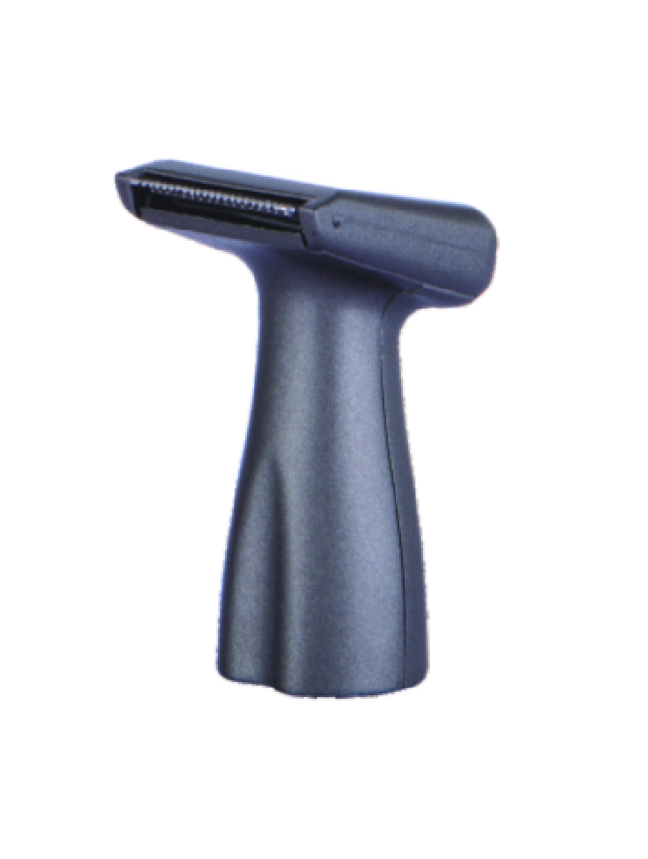
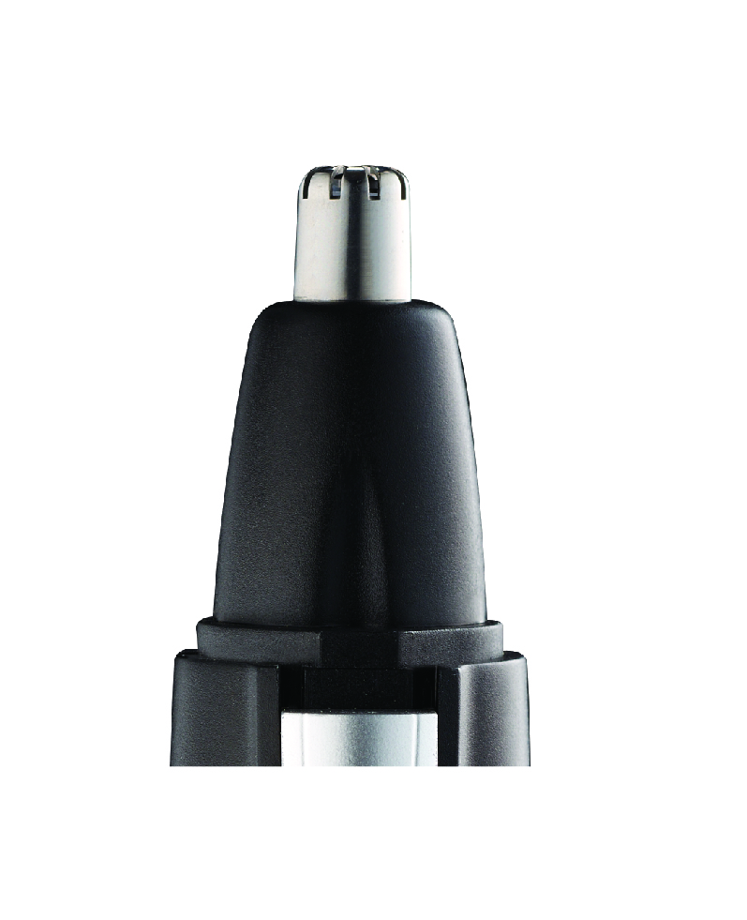
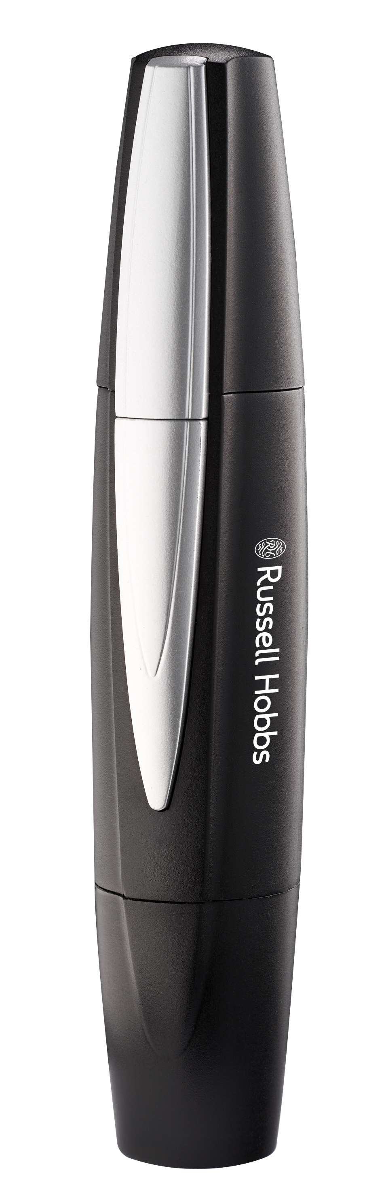

MODEL NO. RHMNBT01
RUSSELL HOBBS MAN NOSE HAIR AND BEARD TRIMMER
FEATURES OF THE RUSSELL HOBBS MAN NOSE HAIR AND BEARD TRIMMER
- Waterproof
- Motor Voltage：DC1.5V
- Battery size: AA *1 (Not included)

BATTERY INSTALLATION:
- Hold the trimmer upside down
- Rotate the battery cover counter clockwise
- Insert 1 X AA alkaline battery
- Replace cover and turn clockwise until locked into place.

USAGE (NOSE):
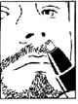
What to use: Nose/Ear trimmer head
- Make sure the nasal passages are clean
- Remove the protective cap and switch the trimmer on
- Slowly move the cutting head in and out of nostril to trim unwanted hair
- Do not insert trimmer tip more than 0.5mm into nostril

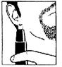
USAGE (EAR):
What to use: Nose/Ear trimmer head
- Remove the protective cap and switch the trimmer on
- Slowly move the cutting head in and out of the outer ear canal to trim unwanted hair
- Do not insert trimmer tip more than 0.5mm into the ear canal

USAGE (BEARD AND SIDE BURNS):
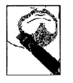
What to use: Beard/Side burn trimmer head
- Remove the nose/ear trimmer attachment.
- Attach the beard/side burn trimmer attachment.
- Turn the groomer on.
- Start under your chin and following your jaw line, trim towards your ear.
- Use upward motions.
- Allow the trimmer to follow the contours of your face.
- Thinning and tapering:
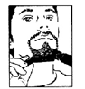
  - Use a small comb to hold the beard hairs in place while trimming.
  - Hold the groomer with the cutting blades facing away from you, move the groomer along the length of the comb.
- Beard line:
  - Hold the groomer with the cutting blades facing towards you.
  - Lightly touch the cutting blades to your face and move the groomer towards the beard line.
  - For the neck area, move the groomer away from the desired beard line.

CLEANING THE TRIMMER
- If necessary, the trimmer may be cleaned under a running water. Ensure the appliance is switched off before doing so.
- For a more thorough cleaning, remove cutting head assembly by unscrewing in a clock wise direction. Rinse under running water to remove any unwanted hairs in the head assembly.
- After cleaning and drying, replace the cutting head assembly by screwing in a anti-clockwise direction, wipe the trimmer dry with a soft cloth
- NOTE: Always replace protective cap before storing the trimmer.
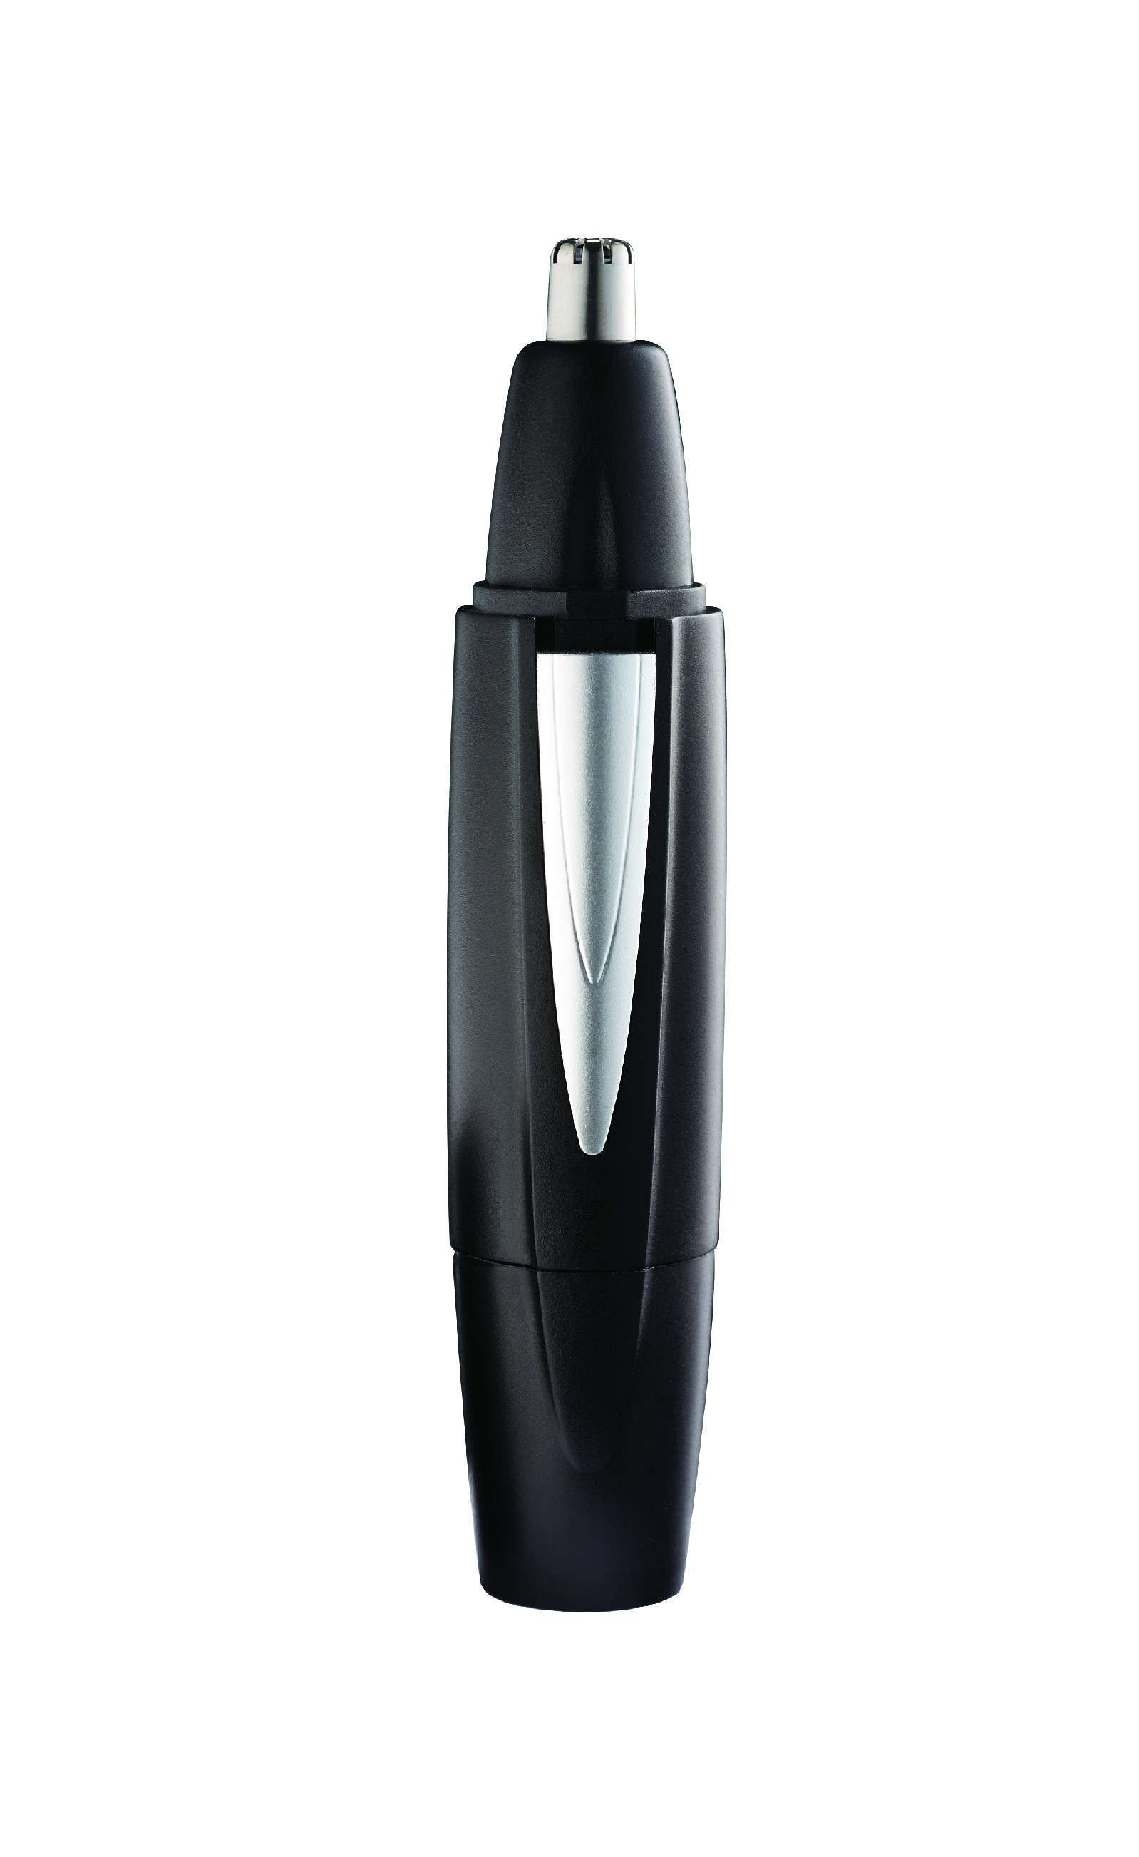
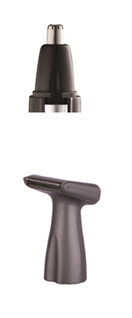
PARTS DIAGRAM:
NOSE/EAR TRIMMER
BEARD/SIDE BURN TRIMMER
ON/OFF SWITCH
TRIMMER BODY
BATTERY CAP/COVER

PLEASE AFFIX YOUR PROOF OF PURCHASE/RECEIPT HERE
IN THE EVENT OF A CLAIM UNDER WARRANTY THIS RECEIPT MUST BE PRODUCED.

WARRANTY AND EXTENDED WARRANTY

- Home of Living Brands (Pty) Limited ("Home of Living Brands ") warrants to the original purchaser of this product ("the customer") that this product will be free of defects in quality and workmanship which under normal personal, family or household use and purpose may manifest within a period of 1 (one) year from the date of purchase ("warranty period").
- Home of Living Brands shall extend the warranty period for a further period of 1 (one) year (“extended warranty period”), on condition that the purchaser registers the product on the website, within 12 months from the date of purchase of the product. The website address for registration is as follows: http://russellhobbs.co.za/info-pages/warranty-info.aspx. The extended warranty period only applies to products purchased on or after 1 October 2017.
- Where the customer has purchased a product and it breaks, is defective or does not work properly for the intended purpose, the customer must notify the supplier from whom the customer bought the product ("the supplier") thereof within the warranty period or if applicable, the extended warranty period. Any claim in terms of this warranty must be supported by a proof of purchase. If proof of purchase is not available, then repair, and/or service charges may be payable by the customer to the supplier.
- The faulty product must be taken to the supplier's service centre to exercise the warranty.
- The supplier will refund, repair or exchange the product in terms of this warranty subject to legislative requirements. This warranty shall be valid only where the customer has not broken the product themselves, or used the product for something that it is not supposed to be used for. The warranty does not include and will not be construed to cover products damaged as a result of disaster, misuse, tamper, abuse or any unauthorised modification or repair of the product.
- This warranty will extend only to the product provided at the date of the purchase and not to any expendables attached or installed by the customer.
- If the customer requests that the supplier repairs the product and the product breaks or fails to work properly within 3 (three) months of the repair and not as a result of misuse, tampering or modification by or on behalf of the customer, then the supplier may replace the product or pay a refund to the customer, subject to the supplier’s discretion.
- The customer may be responsible for certain costs where products returned are not in the original packaging, or if the packaging is damaged. This will be deducted from any refund paid to the customer.
HOME OF LIVING BRANDS (PTY) LTD (JOHANNESBURG)
JOHANNESBURG TEL NO. (011) 490 9600
CAPE TOWN TEL NO. (021) 552 5161
DURBAN TEL NO. (031) 303 1163

