INSTRUCTIONS AND WARRANTY
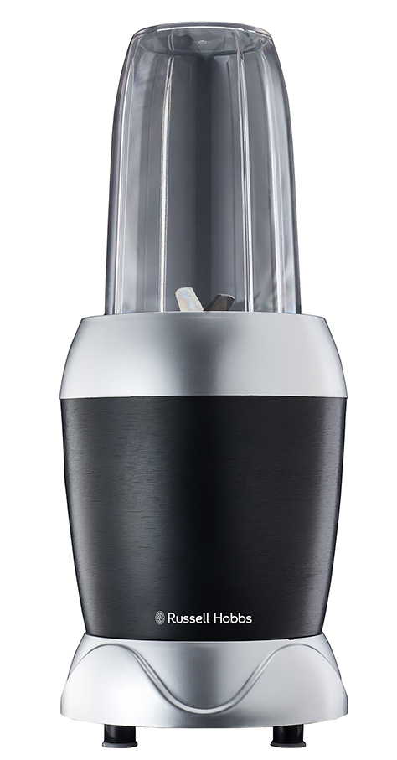

RHNB10
RUSSELL HOBBS
NUTRIBLEND

Thank you for purchasing the Russell Hobbs Nutriblend. Each unit has been manufactured to ensure safety, reliability and ease of use. Before use, please read these instructions carefully and keep them for further reference.

FEATURES OF THE RUSSELL HOBBS NUTRIBLEND
- Powerful 1000W motor
- Extracts the maximum amount of nutrients, vitamins, taste, and even enzymes from ingredients.
- Perfect for trying to maintain a balanced diet with a busy lifestyle.
- Make delicious and healthy shakes, smoothies, soups and purees.
- Accessories include:
1 X 800ml BPA free drinking cup
1 x 1000ml BPA free drinking cup
1 x 500ml BPA free mill
1 x Milling blade
1 x Flip top cover
2 x Keep fresh lids
- Non-slip feet
- Delicious recipes included
- For domestic use only
- 2 year warranty (1 year retail • 1 year extended upon online registration of product • visit www.russellhobbs.co.za)

IMPORTANT SAFEGUARDS

When using any electrical appliance, basic safety precautions should always be followed including the following:
- When using any electrical appliance, basic safety precautions should always be followed including the following:
- Please read the instructions carefully before using any appliance.
- Always ensure that the voltage on the rating label corresponds to the mains voltage in your home.
- Incorrect operation and improper use can damage the appliance and cause injury to the user.
- The appliance is intended for household use only. Commercial use invalidates the warranty and the supplier cannot be held responsible for injury or damage caused when using the appliance for any other purpose than that intended.
- Avoid any contact with moving parts.
- This appliance is not intended for use by persons (including children) with reduced physical, sensory or mental capabilities, or lack of experience and knowledge, unless they have been given supervision or instruction concerning use of the appliance by a person responsible for their safety.
- Children should be supervised to ensure that they do not play with the appliance.
- Check the power cord and plug regularly for any damage. If the cord or the plug is damaged, it must be replaced by the manufacturer or a qualified person in order to avoid an electrical hazard.
- Do not use the appliance if it has been dropped or damaged in any way. In case of damage, take the unit in for examination and/or repair by an authorised service agent.
- To prevent the risk of electric shock, do not immerse or expose the motor assembly, plug or the power cord to water or any other liquid.
- Never immerse the unit in water or any other liquid for cleaning purposes.
- Remove the plug from the socket by gripping the plug. Do not pull on the cord to disconnect the appliance from the mains. Always unplug the unit when not in use, before cleaning or when adding or removing parts.
- The use of accessory attachments that are not recommended or supplied by the manufacturer may result in injuries, fire or electric shock.
- A short cord is provided to reduce the hazards resulting from becoming entangled in or tripping over a longer cord.
- Do not let the cord hang over the edge of a table or counter. Ensure that the cord is not in a position where it can be pulled on inadvertently.
- Do not allow the cord to touch hot surfaces and do not place on or near a hot gas or electric burner or in a heated oven.
- Do not use the appliance on a gas or electric cooking top or over or near an open flame.
- Use of an extension cord with this appliance is not recommended. However, if it is necessary to use an extension lead, ensure that the lead is suited to the power consumption of the appliance to avoid overheating of the extension cord, appliance or plug point. Do not place the extension cord in a position where it can be pulled on by children or animals or tripped over.
- This appliance is not suitable for outdoor use. Do not use this appliance for anything other than its intended use.
- Do not carry the appliance by the power cord.
- Do not leave this appliance unattended during use. Always unplug the unit when not in use or before cleaning.
- Always operate the appliance on a smooth, even, stable surface. Do not place the unit on a hot surface.
- The manufacturer does not accept responsibility for any damage or injury caused by improper or incorrect use, or for repairs carried out by unauthorised personnel.
- In case of technical problems, switch off the machine and do not attempt to repair it yourself. Return the appliance to an authorised service facility for examination, adjustment or repair. Always insist on the use of original spare parts. Failure to comply with the above mentioned pre-cautions and instructions, could affect the safe operation of this machine.
- Take caution as attachments are interchangeable and blades are sharp. Use extreme caution when handling the blades. Always hold the blades by the base of the blade assembly.
- Never operate the appliance when it is empty and without liquids or ingredients in the blender.
- Do not process hot foods or hot liquids.
- Never attempt to remove the cup while the appliance is still running.
- Never leave the appliance unattended while in use.
- Remove all packaging material and labels from the appliance.
- Cups, lids and attachments are all dishwasher safe. It is recommended that the lids and attachments be placed on the top rack. Ensure that the attachments are removed from the cups before placing in the dishwasher.

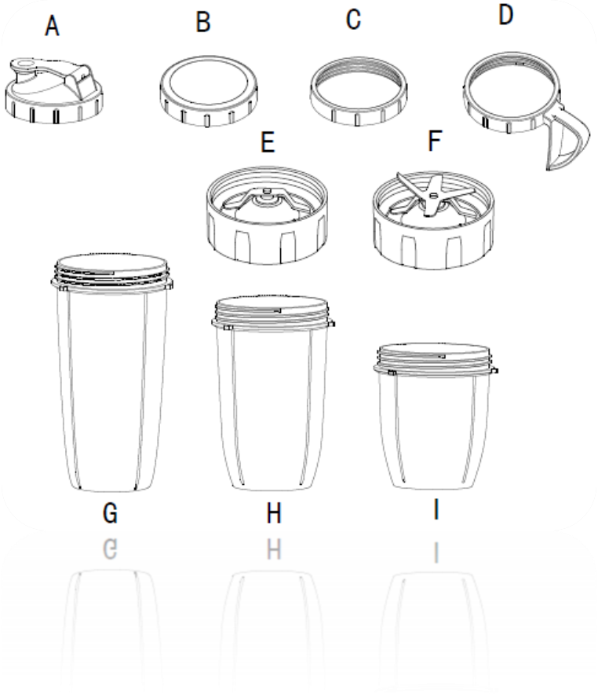
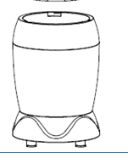
PARTS DIAGRAM
E
A
C
C
B
D
F
G
H

- Flip top lid
- Keep fresh lid
- Milling blade
- Nutriblend blade
- 1000ml BPA free drinking cup
- 800ml BPA free drinking cup
- 500ml BPA free mill
- Aluminium motor base

BEFORE FIRST USE
A
A
A

- Remove all packaging material and labels from the appliance. Do not leave protective packaging lying around, as it could be dangerous around infants.
- Wash the lids, cups and attachments in warm, soapy water with a soft cloth. Use caution when washing the blades as they are very sharp.
- Rinse and dry thoroughly.
- Cups, lids and attachments are all dishwasher safe. It is recommended that the lids and attachments be placed on the top rack of the dishwasher. Ensure that the attachments are removed from the cups before placing them in the dishwasher.
- Wipe the motor base with a damp cloth.

OPERATING INSTRUCTIONS
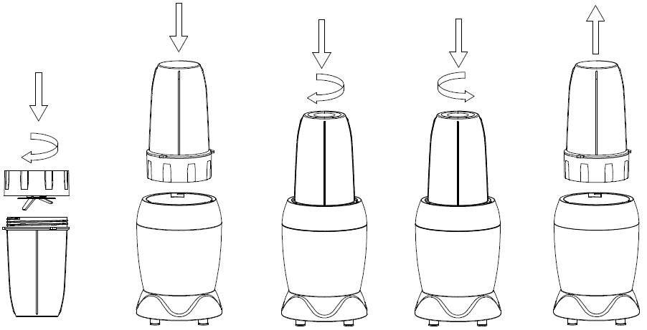
1
2
4
5
3

IMPORTANT: The Nutriblend should not be operated for more than 3 minutes at a time. After 3 minutes of operation the unit should be left to cool down for one minute. This is known as one cycle, the Nutriblend can be used for ten consecutive cycles after which the unit must be left to cool down for 30 minutes before the next operation.

- Ensure the unit is unplugged. Place the motor base on a clean, dry and level surface such as a counter or table top.
- Add required ingredients to a drinking cup or mill. Do not fill the cups or mill past the maximum level indicated.
- Place the Nutriblend blade or milling blade onto the cup or mill and twist it into place, ensure it is sealed tightly (Fig. 1).
- Plug the unit into the power outlet and ensure the power is on.
- Turn the cup upside down and place it onto the motor base, ensure the tabs on the cup are aligned with the tabs on the motor base. Press the cup down and then turn it clockwise until it is locked into place (Fig. 2 & 3). IMPORTANT: The unit will automatically start as soon as the cup or mill is locked into place.
- Once the desired consistency has been reached, stop the appliance by applying pressure downwards onto the mill or cup and turning it anti-clockwise until the tabs are aligned and the cup or mill springs out of place thus removing pressure from the cup (Fig. 4 & 5).
- Ensure the electrical outlet is switched off at the wall and unplug the unit.
- Turn the cup upright and remove the blades by twisting the blade assembly counterclockwise.
- Place the desired lid on the drinking cup or mill.

TAKE NOTE:
The blender features a unique safety system that prevents damage to the unit’s motor and drive system should the appliance be inadvertently overloaded. If the appliance has been overloaded, the motor will stop working. To reset the appliance, follow the procedure below:
- Unplug the appliance from the electrical outlet.
- Remove and empty the cup or mill and ensure that no object or ingredient is jamming the blades.
- Allow the appliance to cool for approximately 30 minutes and then proceed to use the appliance as instructed above.

NUTRIBLEND RECIPES

Peanut Butter Hummus:
Ingredients:
1 can chickpeas
3 tbsp of rice milk or almond milk
2 tbsp peanut butter
½ a lemon’s juice
3 tbsp olive oil
2 gloves garlic
1 tsp paprika
Salt and pepper to taste

Method:
- Place all the ingredients in the nutriblend 800ml cup
- Blend until smooth
- Serve with freshly cut vegetables

Pina Colada style Mocktail:
Ingredients:
2 ripe bananas - frozen
½ cup fresh pineapple
200ml pineapple juice
200ml coconut water
100g crushed ice
2 tsp chia seed
Pineapple slice for garnish

Method:
- Place all the ingredients in the Nutriblend 800ml cup
- Blend until well combined
- Serve immediately with pineapple garnish

Breakfast power smoothie:
Ingredients:
½ cup oats
1 cup spinach
1 cup berries – preferably a mix of fresh raspberry, blue berry and mulberry
1 tbsp hemp seed
1 cup yoghurt
Method:
- Place all ingredients in the Nutriblend cup
- Blend until well combined
- Serve immediately

Super food smoothie
Ingredients:
3/4cup almond milk
1 date, pitted
1 tbsp hemp seed
½ banana
½ tbsp chia seed
¾ cup kale
¼ cup ice
1 tbsp raw honey

Method:
- Add all ingredient except the honey into the Nutriblend 800ml cup
- Blend until smooth
- Serve with drizzled honey over

Basil and cream cheese dip:
Ingredients:
1 cup yoghurt
1 cup cream cheese
½ cup feta
4 basil leaves
1 clove garlic
Salt and pepper to taste

Method:
- Place all the ingredients into the Nutriblend 500ml cup
- Blend until smooth.
- Chill until serving with freshly cut vegetables

Vitamin C, Goji berry boost:
Ingredients:
2 oranges, peeled and segmented
½ cup coconut milk
½ tsp turmeric
3 tbsp goji berries
½ tsp freshly chopped ginger
1 tbsp raw agave
¾ cup ice

Method:
- Add all the ingredients into the Nutriblend
- Blend until smooth
- Serve cold

Matcha and berry Popsicle:
Ingredients:
2 cups almond milk
2 cups frozen blueberries
1 banana frozen
1 tbsp matcha powder
1 tbsp chia seed
Pinch of cinnamon ground
Pinch of ginger, ground

½ cup extra blueberries
Method:
- Add all ingredients into the Nutrilblend 800ml cup
- Blend until smooth
- Add blueberries into your popsicle mould
- Pour in the Matcha and berry mixture
- Freeze until serving

Vegan smoothie boost:
Ingredients:
2 cups almond milk
1 frozen banana
2 tsp spirulina
1 tbsp hemp protein powder
¼ cup mint

Topping:
2 tbsp chia seed
2 tbsp hemp seed
Fresh mint leaf

Method:
- Add all ingredients for the smoothie into the Nutriblend
- Blend until smooth
- Serve with hemp and chia seed as topping, mint for garnish

TROUBLESHOOTING
PROBLEMS | POSSIBLE REASONS & SOLUTIONS
1. Motor doesn’t start or attachment doesn’t rotate. | - The drinking cups or mill may not be securely attached to the base. Ensure that drinking cups or mill are correctly fitted to the base by aligning the tabs of the cups or mill with those on the base, pressing down and twisting clockwise to lock into place  .
2.Ingredients are unevenly blended | - Too many ingredients are being blended at once. Use fewer ingredients per operation cycle.
3. The mill or drinking cups are leaking. | - The blades may not be correctly fitted to the drinking cups or mill. Ensure the blade assemblies are correctly fitted and aligned onto the cups or mill. Place the blade assembly on the cup or mill and turn clockwise until it is tightly locked into place.
4. Unit doesn’t switch on. | - The drinking cups or mill may not be securely attached to the base, refer to point 3 for solution.  - The unit may not be plugged into the power outlet or the switch on the power outlet may be off. Make sure the unit is plugged into the power outlet and that the power to the outlet is on.
5. Unit doesn’t turn off. | - Unplug the power cord from the electrical outlet and call customer service for support.
6. Lid/blade assembly will not properly align to the cup or mill. | - Place the cup or mill on a level surface. Place the blade assembly on top of the cup and align the threads so that blades are positioned flat on the cup. Twist clockwise so that the blades evenly align on the cup until it is tightly sealed.

CLEANING AND MAINTENANCE

- This appliance is for household use only and is not user-serviceable.
- Always remember to unplug the unit from the electrical outlet when not in use and before cleaning.
- Detach and separate all parts from each other.
- Clean the motor base with a damp cloth and wipe dry.
- The cups, mill, lids and blades can be washed in the dishwasher but ensure the lids and blades are packed on the top rack. Use caution when handling the blades as the blades are very sharp.
- You may also wash the cups or mill by filling them to the max fill line with warm water and a drop of dish washing detergent, seal the cup or mill and proceed to use the unit as described under operating instructions. Do not fill the cups or mill past the max fill line. After operating a few times, remove the cups or mill from the motor base and rinse them, the blades and lids under running water. Allow all the parts to dry before storing.
- CAUTION: DO NOT immerse the motor base into water or any other liquid.
- Do not open or change any parts by yourself. Please refer to a qualified electrical service department or return to the supplier if servicing is necessary.
- Do not use bleach or other abrasive substance or solvents to clean your appliance as it can be damaging to the finish.
- Do not immerse the whole unit in water or any other liquid, or hold it under a running tap to clean.
- Unplug the unit from the mains before cleaning and storing away.
- Do not put the motor unit in water or any other liquid.

STORING THE APPLIANCE
- Store the unit upright and ensure nothing is placed and stored on top of the unit
- Store the cups and the attachments alongside the appliance where they will not be damaged and will not cause a hazard.
- Unplug the unit from the wall outlet and clean all the parts as instructed above.
- Ensure that all parts are dry before storing.
- Store the appliance in its box or in a clean, dry place.
- Never store the appliance while it is still wet or dirty.
- Never wrap the power cord around the appliance.

SERVICING THE APPLIANCE
There are no user serviceable parts in this appliance. If the unit is not operating correctly, please check the following:
- You have followed the instructions correctly
- That the unit has been wired correctly and that the wall socket is switched on.
- That the mains power supply is ON.
- That the plug is firmly in the mains socket.

If the appliance still does not work after checking the above:
- Consult the retailer for possible repair or replacement. If the retailer fails to resolve the problem and you need to return the appliance, make sure that:
- The unit is packed carefully back into its original packaging.
- Proof of purchase is attached.
- A reason is provided for why it is being returned.
If the supply cord is damaged it must be replaced by the manufacturer or an authorised service agent. If service becomes necessary within the warranty period, the appliance should be returned to an approved Home Of Living Brands (Pty) Limited service centre. Servicing outside the warranty period is still available, but will, however, be chargeable.

CHANGING THE PLUG

Should the need arise to change the fitted plug, follow the instructions below.
This unit is designed to operate on the stated current only. Connecting to other power sources may damage the appliance.

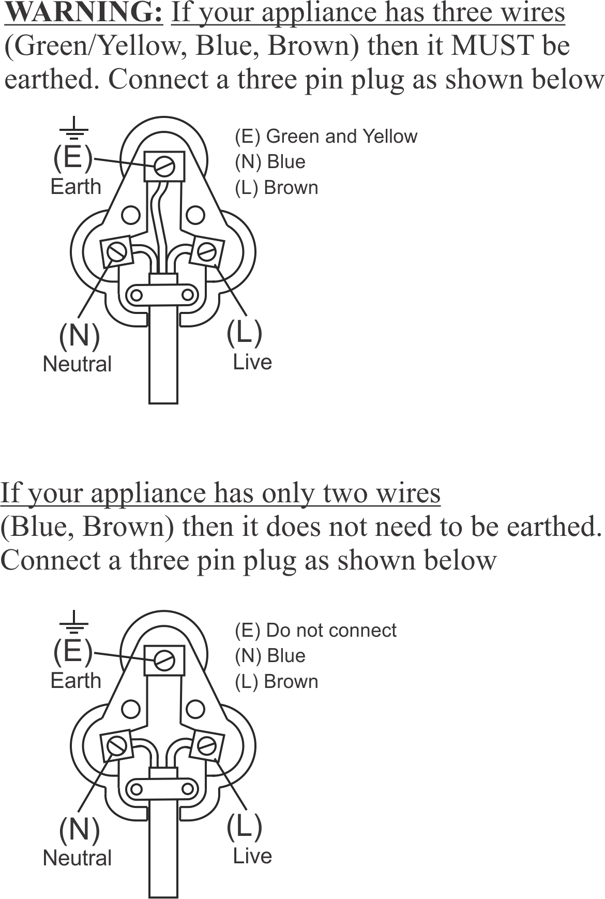

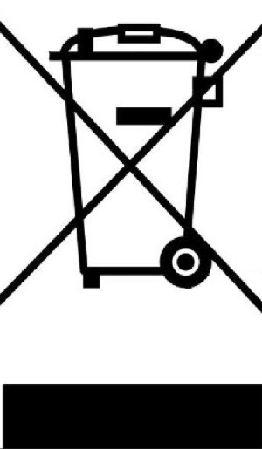
If the appliance has only a two core cable (brown and blue) do not connect anything to the Earth terminal

This marking indicates that this product should not be disposed with other household waste. To prevent possible harm to the environment or human health from uncontrolled waste disposal, recycle it responsibly to promote the sustainable reuse of material resources.
PLEASE AFFIX YOUR PROOF OF PURCHASE/RECEIPT HERE
IN THE EVENT OF A CLAIM UNDER WARRANTY THIS RECEIPT MUST BE PRODUCED.

2 YEAR WARRANTY
1 year retail ⵏ 1 year extended warranty upon registration*
visit www.russellhobbs.co.za

W A R R A N T Y AND EXTENDED WARRANTY

- Home of Living Brands (Pty) Limited ("Home of Living Brands") warrants to the original purchaser of this product ("the customer") that this product will be free of defects in quality and workmanship which under normal personal, family or household use and purpose may manifest within a period of 1 (one) year from the date of purchase ("warranty period").
- Home of Living Brands shall extend the warranty period for a further period of 1(one) year (“extended warranty period*”), on condition that the purchaser registers the product on the website, within 12 months from the date of purchase of the product. The website address for registration is as follows: http://russellhobbs.co.za/info-pages/warranty-info.aspx. The extended warranty period only applies to products purchased on or after 1 October 2017.
- Where the customer has purchased a product and it breaks, is defective or does not work properly for the intended purpose, the customer must notify the supplier from whom the customer bought the product ("the supplier") thereof within the warranty period or if applicable, the extended warranty period. Any claim in terms of this warranty must be supported by a proof of purchase. If proof of purchase is not available, then repair, and/or service charges may be payable by the customer to the supplier.
- The faulty product must be taken to the supplier's service centre to exercise the warranty.
- The supplier will refund, repair or exchange the product in terms of this warranty subject to legislative requirements. This warranty shall be valid only where (a) the customer is not the cause of the product breaking, and (b) the product has been used for the intended purpose stipulated in the product manual. The warranty does not include and will not be construed to cover products damaged as a result of disaster, misuse, tamper, abuse or any unauthorised modification or repair of the product.
- This warranty will extend only to the product provided at the date of the purchase and not to any expendables attached or installed by the customer. In this regard any accessories supplied with the product by the supplier, may be excluded in this warranty or extended warranty (see Exclusions to Warranty and Extended Warranty document).
- If the customer requests that the supplier repairs the product and the product breaks or fails to work properly within 3 (three) months of the repair and not as a result of misuse, tampering or modification by or on behalf of the customer, then the supplier may replace the product or pay a refund to the customer, subject to the supplier’s discretion.
- The customer may be responsible for certain costs where products returned are not in the original packaging, or if the packaging is damaged. This will be deducted from any refund paid to the customer.

HOME OF LIVING BRANDS (PTY) LTD (JOHANNESBURG)

JOHANNESBURG TEL NO. (011) 490-9600
CAPE TOWN TEL NO. (021) 552-5161
DURBAN TEL NO. (031) 303-1163

www.homeoflivingbrands.com
www.russellhobbs.co.za
www.facebook.com/RussellHobbsSA

EXCLUSIONS TO W A R R A N T Y AND EXTENDED WARRANTY

- Any accessories supplied with the product, including but not limited to, bowls, jugs, mills or carafes made either of glass or plastic and supplied with this appliance (hereinafter referred to as “the accessory or accessories”), is warranted to be free from material and workmanship defects for the duration of the appliance warranty.
- The accessories should give trouble free service when used in accordance with the directions described in the instruction manual. However, the accessories will be damaged if subjected to impact, and this damage is not covered by the warranty. Such impact damage can occur either from the outside (if for example it is dropped or knocked against a hard surface), or from within (if for example foreign objects are placed within the accessories and the power is switched on).
- Should you need to replace an accessory during the warranty period; a claim for a free replacement will only be considered if the item (including all shards and broken parts) is returned to the nearest HOLB service centre for examination.
- The remains of the accessory will be carefully examined by the relevant professionals and if it is determined (at the sole discretion of HOLB) that the damage was caused by impact, then the claim will be refused and will not be covered by the warranty or any extended warranty.
- Any replacement part provided in terms of clause 4 above will become a chargeable item payable by the customer.

