
INSTRUCTIONS AND WARRANTY
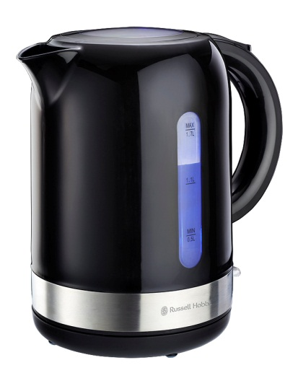

MODEL NO. RHPBK01

RUSSELL HOBBS 1,7L GLOSS BLACK KETTLE

Congratulations on purchasing our Russell Hobbs 1,7L Gloss Black Kettle. Each unit is manufactured to ensure safety and reliability. Before using this appliance for the first time, please read the instruction manual carefully and keep it for future reference.

FEATURES OF THE RUSSELL HOBBS 1,7L GLOSS BLACK KETTLE
- 1850-2200W
- Glossy black body with embossed stainless steel accents
- Striking blue illumination while boiling
- 1.7L large capacity
- 360° cordless base for left and right-handed use
- Concealed stainless steel heating element for easy cleaning
- Large spout for easy pouring
- Removable and washable limescale filter
- Automatic shut-off once boiling has completed
- Boil-dry and overheat protection
- Safety locking lid
- Tidy cord storage
- For domestic use only
- 1 year warranty

IMPORTANT SAFEGUARDS
When using any electrical appliance, basic safety precautions should always be followed including the following:
- Please read the instructions carefully before using any appliance.
- Always ensure that the voltage on the rating label corresponds to the mains voltage in your home.
- Incorrect operation and improper use can damage the appliance and cause injury to the user.
- The appliance is intended for household use only. Commercial use invalidates the warranty and the supplier cannot be held responsible for injury or damage caused when using the appliance for any other purpose than that intended.
- Avoid any contact with moving parts.
- This appliance is not intended for use by persons (including children) with reduced physical, sensory or mental capabilities, or lack of experience and knowledge, unless they have been given supervision or instruction concerning use of the appliance by a person responsible for their safety.
- Children should be supervised to ensure that they do not play with the appliance.
- Check the power cord and plug regularly for any damage. If the cord or the plug is damaged, it must be replaced by the manufacturer or a qualified person in order to avoid an electrical hazard.
- Do not use the appliance if it has been dropped or damaged in any way. In case of damage, take the unit in for examination and/or repair by an authorised service agent.
- Do not open the lid while the kettle is in use.
- Only fill the kettle with cold water. Do not fill the kettle above the MAX level (1,7L) or else boiling water may splash out if overfilled.
- Unplug from outlet when not in use and before cleaning. Allow it to cool down completely before cleaning the appliance.
- Do not insert any objects into holes or slots in this appliance.
- To reduce the risk of electric shock, do not immerse or expose the motor assembly, plug or the power cord to water or any other liquid.
- Never immerse the unit in water or any other liquid for cleaning purposes. Do not allow liquid to penetrate into the electrical parts of this kettle.
- Remove the plug from the socket by gripping the plug. Do not pull on the cord to disconnect the appliance from the mains. Always unplug the unit when not in use, before cleaning or when adding or removing parts.
- The use of accessory attachments that are not recommended or supplied by the manufacturer may result in injuries, fire or electric shock. The kettle is only to be used with the base provided.
- A short cord is provided to reduce the hazards resulting from becoming entangled in or tripping over a longer cord.
- Do not let the cord hang over the edge of a table or counter. Ensure that the cord is not in a position where it can be pulled on inadvertently.
- Do not allow the cord to touch hot surfaces and do not place on or near a hot gas or electric burner or in a heated oven.
- Cleaning and user maintenance shall not be made by children unless they are older than 8 years and supervised. Keep the appliance and its cord away from reach of children aged less than 8 years old.
- Keep the device and the cable away from heat, direct sunlight, moisture, sharp edges and the like.
- Do not use the appliance on a gas or electric cooking top or over or near an open flame.
- Use of an extension cord with this appliance is not recommended. However, if it is necessary to use an extension lead, ensure that the lead is suited to the power consumption of the appliance to avoid overheating of the extension cord, appliance or plug point. Remember to not place the extension cord in a position where it can be pulled on by children or animals or tripped over.
- This appliance is not suitable for outdoor use. Do not use this appliance for anything other than its intended use
- Never remove the kettle from the base while it is in operation, switch it off first.

PARTS DIAGRAM
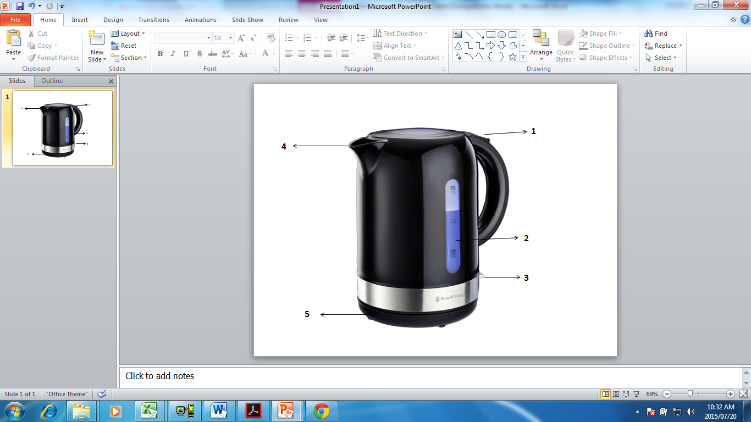

- Trigger-release lid button
- Water level indicator
- On/off Switch
- Large spout for easy pouring
- 360° cordless base with cord storage

OPERATING INSTRUCTIONS
BEFORE FIRST USE
Before first use please follow these instructions. Remove the kettle and all the accessories from the carton. It is recommended to keep the box and protective packaging until some time has passed and you are satisfied that the kettle is in good working order.
Place the kettle on a dry, smooth level surface, and adjust the cord to the desired length.
Fill the kettle to the ‘MAX’ level and boil. Discard the water and repeat this twice.

POSITIONING THE KETTLE
- Position the power base on a dry flat surface away from any potential heat source.
- The underside of the power base is fitted with a cable storage feature. Unwind the length of the mains cable required to reach the mains socket.
- Ensure the mains cable does not hang over the work surface edge.

FILLING THE KETTLE
- Remove the kettle from the power base.
- Open the lid by pressing the lid release button.
- Fill the kettle between the MIN and MAX markings on the water level indicator with cold water.
- Close the lid and place the kettle back on the power base. Make sure the lid is securely closed before boiling.
- Always remove the kettle from the power base before filling. Do not fill the kettle above the MAX mark or below the MIN mark on the water gauge.

SWITCHING ON
- Position the kettle on the power base.
- Plug the kettle into a mains supply socket.
- To start boiling the kettle, press the on/off switch down to “1” (on) position.
- The power indicator light will illuminate and the kettle will start to boil.
- Never open the lid during boiling.
- Do not operate this kettle without the filter fitted.

Please beware of escaping steam from the lid of the kettle when in use.

USAGE STEPS
- Put the power base on a flat table.
- Push the button lightly to open the lid and fill in a proper amount of water. Close the lid and put the kettle on the power base.
- Connect the power cord into a suitable power outlet.
- Move the switch to the “ON” position. The indicating light will go on indicating that the heating and boiling process has begun.
- Once the water has boiled, the switch will move to the “OFF” position. Disconnect the kettle from the power supply.
- During boiling, you can move the switch to the “OFF” mark with your hand to cut the power supply.
- Pour out the water only after you have lifted the kettle from the base.
- The kettle can be put on the power base but with power supply disconnected after using.

BOIL DRY HEATING PROTECTION
- If you have forgotten to add water or the water inside is below the minimum accepted level, the metal sheet for dry heating protection of the temperature controller will disconnect automatically when the kettle is switched on in order to protect the kettle from being damaged by dry heating.
- If the above situation happens, please turn off the power supply, unplug the kettle and wait 10 minutes for it to cool down. Once this is done, the temperature controller connects and the kettle will operate normally again.
Note: Do not add cold water in the kettle in an attempt to cool it down quicker – this will decrease the life span of the kettle’s heating plate.
SWITCHING OFF
- When the water has boiled, the kettle will switch off automatically. You can stop the boiling process at any time by lifting the on/off switch to the “0” (off) position or lifting the kettle off the base.

GENERAL
- Always remove the kettle from the base before pouring.
- To avoid the risk of splashing, pour slowly and do not over-tilt the kettle.
- Do not tilt the kettle backwards - water might get on to the control area. If this happens, let the kettle dry thoroughly before use – place it somewhere warm for 12 hours.
- When you lift the kettle, you may see moisture on the base. Do not worry – it’s the steam used to switch the kettle off automatically, which then condenses and escapes via vents under the kettle.
- You may see some discolouration on the floor of the kettle. Again, do not worry – it is due to the bonding of the element to the kettle floor.

CLEANING AND MAINTENANCE
- This appliance is for household use only and is not user-serviceable.
- Do not open or change any parts by yourself. Please refer to a qualified electrical service department or return to the supplier if servicing is necessary.
- Always remember to unplug the unit from the electrical outlet when not in use and before cleaning. Ensure that the speed control is set to “0”.
- It is much easier to clean the accessories directly after they have been used. Wash them in warm, soapy water, rinse and dry well.
- The body of the appliance and the stand should be cleaned with a damp cloth. Do not let water enter the appliance or the stand.
- Do not use bleach or other abrasive substance or solvents to clean your appliance as it can be damaging to the finish.
- Do not immerse the appliance in water or any other liquid, or hold it under a running tap to clean.
- To remove stubborn spots/marks, wipe the surfaces with a cloth slightly dampened in soapy water or mild non-abrasive cleaner. Rinse and dry a clean, dry, soft cloth.

STORING THE APPLIANCE
- Unplug the unit from the wall outlet and clean all the parts as instructed above. Ensure that all parts are dry before storing.
- Store the appliance in its box or in a clean, dry place.
- Never store the appliance while it is still wet or dirty.
- Never wrap the power cord around the appliance.

SERVICING THE APPLIANCE
There are no user serviceable parts in this appliance. If the unit is not operating correctly, please check the following:
- You have followed the instructions correctly
- That the unit has been wired correctly and that the wall socket is switched on.
- That the mains power supply is ON.
- That the plug is firmly in the mains socket.

If the appliance still does not work after checking the above:
- Consult the retailer for possible repair or replacement. If the retailer fails to resolve the problem and you need to return the appliance, make sure that:
- The unit is packed carefully back into its original packaging.
- Proof of purchase is attached.
- A reason is provided for why it is being returned.

If the supply cord is damaged, it must be replaced by the manufacturer or an authorised service agent, in order to avoid any hazard. If service becomes necessary within the warranty period, the appliance should be returned to an approved Home of Living Brands (Pty) Limited service centre. Servicing outside the warranty period is still available, but will, however, be chargeable.

CHANGING THE PLUG
Should the need arise to change the fitted plug, follow the instructions below.
This unit is designed to operate on the stated current only. Connecting to other power sources may damage the appliance. Connect a three-pin plug as follows:
The wires in this mains lead are coloured in accordance with the following code:
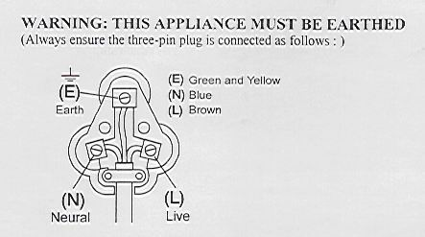
Green/Yellow = Earth
Blue = Neutral
Brown = Live

PLEASE AFFIX YOUR PROOF OF PURCHASE/RECEIPT HERE
IN THE EVENT OF A CLAIM UNDER WARRANTY THIS RECEIPT MUST BE PRODUCED.

W A R R A N T Y

- Home of Living Brands (Pty) Limited (“Home of Living Brands”) warrants to the original purchaser of this product (“the customer”) that this product will be free of defects in quality and workmanship which under normal personal, family or household use and purpose may manifest within a period of 1 (one) year from the date of purchase (“warranty period”).
- Where the customer has purchased a product and it breaks, is defective or does not work properly for the intended purpose, the customer must notify the supplier from whom the customer bought the product (“the supplier”) thereof within the warranty period. Any claim in terms of this warranty must be supported by a proof of purchase. If proof of purchase is not available, then repair, and/or service charges may be payable by the customer to the supplier.
- The faulty product must be taken to the supplier's service centre to exercise the warranty.
- The supplier will refund, repair or exchange the product in terms of this warranty subject to legislative requirements. This warranty shall be valid only where the customer has not broken the product himself, or used the product for something that it is not supposed to be used for. The warranty does not include and will not be construed to cover products damaged as a result of disaster, misuse, tamper, abuse or any unauthorised modification or repair of the product.
- This warranty will extend only to the product provided at the date of the purchase and not to any expendables attached or installed by the customer.
- If the customer requests that the supplier repairs the product and the product breaks or fails to work properly within 3 (three) months of the repair and not as a result of misuse, tampering or modification by or on behalf of the customer, then the supplier may replace the product or pay a refund to the customer.
- The customer may be responsible for certain costs where products returned are not in the original packaging, or if the packaging is damaged. This will be deducted from any refund paid to the customer.
HOME OF LIVING BRANDS (PTY) LTD (JOHANNESBURG)

JOHANNESBURG TEL NO. (011) 490-9600

CAPE TOWN TEL NO. (021) 552-5161

DURBAN TEL NO. (031) 792-6000

www.russellhobbs.co.za
www.homeoflivingbrands.com
www.facebook.com/RussellHobbsSA

