

INSTRUCTIONS AND WARRANTY

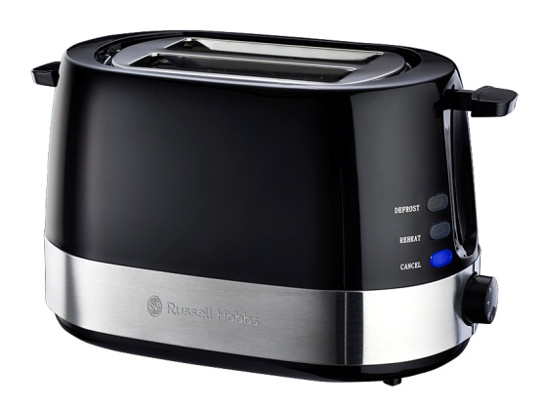

MODEL NO. RHPBT01

RUSSELL HOBBS 2-SLICE GLOSS BLACK TOASTER

Congratulations on purchasing our Russell Hobbs 2-Slice Gloss Black Toaster. Each unit is manufactured to ensure safety and reliability. Before using this appliance for the first time, please read the instruction manual carefully and keep it for future reference.

FEATURES OF THE RUSSELL HOBBS 2-SLICE GLOSS BLACK TOASTER
- 720-850W
- Glossy black body with embossed stainless steel accents
- Defrost frozen bread, reheat cold toast, and cancel mid operation with indicator lights
- Adjustable browning control with 7 heat settings
- Self-centering to automatically place your bread in optimal toasting position
- Removable crumb tray for easy cleaning
- Tidy cord storage
- For domestic use only
- 1 year warranty

IMPORTANT SAFEGUARDS
When using any electrical appliance, basic safety precautions should always be followed including the following:
- Please read the instructions carefully before using any appliance.
- Always ensure that the voltage on the rating label corresponds to the mains voltage in your home.
- Incorrect operation and improper use can damage the appliance and cause injury to the user.
- The appliance is intended for household use only. Commercial use invalids the warranty and the supplier can not be held responsible for injury or damage caused when using the appliance for any other purpose than that intended.
- Do not use this appliance outdoors.
- Avoid any contact with moving parts.
- This appliance is not intended for use by persons (including children) with reduced physical, sensory or mental capabilities, or lack of experience and knowledge, unless they have been given supervision or instruction concerning use of the appliance by a person responsible for their safety.
- Children should be supervised to ensure that they do not play with the appliance.
- Close supervision is required when any appliance is used near or by children or invalids.
- Check the power cord and plug regularly for any damage. If the cord or the plug is damaged, it must be replaced by the manufacturer or a qualified person in order to avoid an electrical hazard.
- Do not use the appliance if it has been dropped or damaged in any way. In case of damage, take the unit in for examination and/or repair by an authorised service agent
- To reduce the risk of electric shock, do not immerse or expose the motor assembly, plug or the power cord to water or any other liquid.
- Never immerse the unit in water or any other liquid for cleaning purposes.
- Remove the plug from the socket by gripping the plug. Do not pull on the cord to disconnect the appliance from the mains. Always unplug the unit when not in use, before cleaning or when adding or removing parts.
- The use of accessory attachments that are not recommended or supplied by the manufacturer may result in injuries, fire or electric shock.
- A short cord is provided to reduce the hazards resulting from becoming entangled in or tripping over a longer cord.
- Do not let the cord hang over the edge of a table or counter. Ensure that the cord is not in a position where it can be pulled on inadvertently.
- Do not allow the cord to touch hot surfaces and do not place on or near a hot gas or electric burner or in a heated oven.
- Do not use the appliance on a gas or electric cooking top or over or near an open flame.
- Use of an extension cord with this appliance is not recommended. However, if it is necessary to use an extension lead, ensure that the lead is suited to the power consumption of the appliance to avoid overheating of the extension cord, appliance or plug point. Do not place the extension cord in a position where it can be pulled on by children or animals or tripped over.
- This appliance is not suitable for outdoor use. Do not use this appliance for anything other than its intended use.
- DO NOT carry the appliance by the power cord.
- Do not leave this appliance unattended during use. Always unplug the unit when not in use or before cleaning.
- Always operate the appliance on a smooth, even, stable surface. Do not place the unit on a hot surface.
- The manufacturer does not accept responsibility for any damage or injury caused by improper or incorrect use, or for repairs carried out by unauthorised personnel.
- In case of technical problems, switch off the toaster and do not attempt to repair it yourself. Return the appliance to an authorised service facility for examination, adjustment or repair. Always insist on the use of original spare parts. Failure to comply with the above mentioned pre-cautions and instructions, could affect the safe operation of this appliance.
- When using only one of the toasting slots, do not let anything get into the other slot as both slots will become “live” when you lower the toasting lever.
- Do not cover the toasting slots during toasting.
- If bread becomes jammed, unplug the toaster from the electrical outlet, let it cool down completely, and then carefully remove the bread that is jamming it. Do not use sharp utensils as they will damage the interior of the toaster.
- Do not toast buttered bread or try to make toasted sandwiches in the toaster, as this will create a fire hazard.
- Do not use torn, curled up, or broken slices of bread, as these may jam the toaster.
- Unplug the toaster when not in use, before moving and before cleaning. Let it cool down fully before cleaning and storing away.
- Clean the crumbs out of your toaster frequently. A build up of crumbs is unhygienic, and could cause a fire hazard.
- Do not use the toaster unless the crumb tray is in place and closed.
- Uneven toasting is usually due to slices of bread of uneven thickness.
- This appliance must not be operated by an external timer or a separate remote control system.

PARTS DIAGRAM
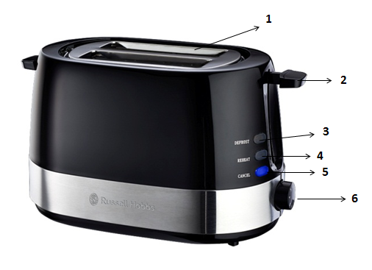
1. Toasting slots with self-centering guides
2. Toasting lever
3. Defrost button
4. Reheat button
5. Cancel button
6. Variable browning control

OPERATING INSTRUCTIONS
Before using for the first time

- Remove all packaging materials including those that may be inside the toasting slots or toasting lever slot. Wipe the exterior with a damp cloth. Dry thoroughly.
Do not use abrasive cleaners. Do not put the toaster, cord or plug in water. Make sure the crumb tray is locked in position on the bottom of the toaster and the toasting lever is in the “up” position. Unwrap power cord and plug into a suitable electrical outlet. Turn the browning selector knob to 1, the lightest setting. Lower the toasting lever until it locks in place. Operate without bread once or twice to burn off any manufacturing residue. You may notice a slight amount of smoke - this is normal and will stop as the heating elements continue to heat.

Toasting bread
- Insert one or two slices of bread inside the toaster and ensure that the toasting lever is in the “up” position.
- Set the browning control to your desired level: 1-2 light browning, 3-4 medium browning, 5-7 dark browning.
- For slightly dry bread, use a lower setting than you normally would.
- For fresh bread or whole wheat bread, use a higher setting than normal.
- Please note: very thick slices may require two cycles to toast.
- When toasting breads with raisins and/or other fruits, ensure to remove loose raisins before toasting, to prevent them from falling into the toaster and sticking onto the interior.
- Once the toasting cycle has finished, the toast will be raised automatically.
- If you wish to stop the toasting cycle before it has finished, press the “cancel” button.
- Tip: never force bread into the toasting slots, foods should fit freely between the guide wires.

Defrost function
- The defrost function is designed to firstly defrost bread, and then toast which extends the toasting cycle slightly.
- Insert bread into the toasting slots as you normally would, and ensure that the toasting lever is in the “up” position.
- Set the browning control according to your desired browning: 1-2 for refrigerated breads and thinner frozen items such as frozen pancakes, 3-4 for toaster pastries, frozen waffles, thinly sliced French toast, and refrigerated bagels, 5-7 for thicker frozen items such as bagels, hand-cut bread and thick French toast.
- Press the toasting lever down until it locks into position.
- Press the “defrost” button – the blue LED light will indicate that the defrost function is currently activated.
- Once the defrost cycle has finished, the bread will be raised automatically.
- If you wish to stop the cycle mid operation, press the “cancel” button.
- Wait for the toaster to cool down and unplug it from the electrical outlet.

Reheat function
- The reheat feature allows you to reheat bread without any further browning.
- Insert bread into the toasting slots and ensure the toasting lever is in the “up” position.
- Press down the toasting lever until it locks into position.
- Press the “reheat” button – the blue LED light will indicate that the reheat function is currently activated.
- Once the reheat cycle has finished, the bread will be raised automatically.
- If you wish to stop the cycle mid operation, press the “cancel” button.
- Wait for the toaster to cool down and unplug it from the electrical outlet.

CLEANING AND MAINTENANCE
- Always remember to unplug the toaster from the electrical outlet when not in use and before cleaning. Let it cool before cleaning and storing away.
- The body of the toaster and the crumb tray should be cleaned with a damp cloth. Do not let water enter the toaster.
- Do not let anything enter the slots, you might damage the elements.
- Do not use bleach or other abrasive substance or solvents to clean your toaster as it can be damaging to the finish.
- To remove stubborn spots/marks, wipe the surfaces with a cloth slightly dampened in soapy water or mild non-abrasive cleaner. Rinse and dry with a clean, dry, soft cloth

STORING THE APPLIANCE
- Unplug the unit from the wall outlet and clean all the parts as instructed above. Ensure that all parts are dry before storing.
- Store the appliance in its box or in a clean, dry place.
- Never store the appliance while it is still dirty.
- Never wrap the power cord around the appliance.

SERVICING THE APPLIANCE
There are no user serviceable parts in this appliance. If the unit is not operating correctly, please check the following:
- You have followed the instructions correctly
- That the unit has been wired correctly and that the wall socket is switched on.
- That the mains power supply is ON.
- That the plug is firmly in the mains socket.

If the appliance still does not work after checking the above:
- Consult the retailer for possible repair or replacement. If the retailer fails to resolve the problem and you need to return the appliance, make sure that:
- The unit is packed carefully back into its original packaging.
- Proof of purchase is attached.
- A reason is provided for why it is being returned.

If the supply cord is damaged, it must be replaced by the manufacturer or an authorised service agent, in order to avoid any hazard. If service becomes necessary within the warranty period, the appliance should be returned to an approved Home of Living Brands (Pty) Ltd service centre. Servicing outside the warranty period is still available, but will, however, be chargeable.

CHANGING THE PLUG

Should the need arise to change the fitted plug, follow the instructions below.
This unit is designed to operate on 220V-240V current only. Connecting to other power sources may damage the appliance. Connect a three-pin plug as follows:
The wires in this mains lead are coloured in accordance with the following code:
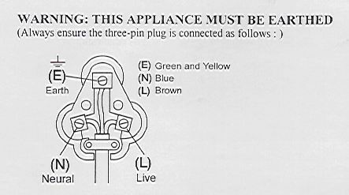
Green/Yellow = Earth
Blue = Neutral
Brown = Live

PLEASE AFFIX YOUR PROOF OF PURCHASE/RECEIPT HERE
IN THE EVENT OF A CLAIM UNDER WARRANTY THIS RECEIPT MUST BE PRODUCED.

W A R R A N T Y

- Home of Living Brands (Pty) Limited (“Home of Living Brands”) warrants to the original purchaser of this product (“the customer”) that this product will be free of defects in quality and workmanship which under normal personal, family or household use and purpose may manifest within a period of 1 (one) year from the date of purchase (“warranty period”).
- Where the customer has purchased a product and it breaks, is defective or does not work properly for the intended purpose, the customer must notify the supplier from whom the customer bought the product (“the supplier”) thereof within the warranty period. Any claim in terms of this warranty must be supported by a proof of purchase. If proof of purchase is not available, then repair, and/or service charges may be payable by the customer to the supplier.
- The faulty product must be taken to the supplier's service centre to exercise the warranty.
- The supplier will refund, repair or exchange the product in terms of this warranty subject to legislative requirements. This warranty shall be valid only where the customer has not broken the product himself, or used the product for something that it is not supposed to be used for. The warranty does not include and will not be construed to cover products damaged as a result of disaster, misuse, tamper, abuse or any unauthorised modification or repair of the product.
- This warranty will extend only to the product provided at the date of the purchase and not to any expendables attached or installed by the customer.
- If the customer requests that the supplier repairs the product and the product breaks or fails to work properly within 3 (three) months of the repair and not as a result of misuse, tampering or modification by or on behalf of the customer, then the supplier may replace the product or pay a refund to the customer.
- The customer may be responsible for certain costs where products returned are not in the original packaging, or if the packaging is damaged. This will be deducted from any refund paid to the customer.
HOME OF LIVING BRANDS (PTY) LTD (JOHANNESBURG)
JOHANNESBURG TEL NO. (011) 490-9600
CAPE TOWN TEL NO. (021) 552-5161
DURBAN TEL NO. (031) 792-6000
www.homeoflivingbrands.com
www.russellhobbs.co.za
www.facebook.com/RussellHobbsSA

