

INSTRUCTIONS AND WARRANTY

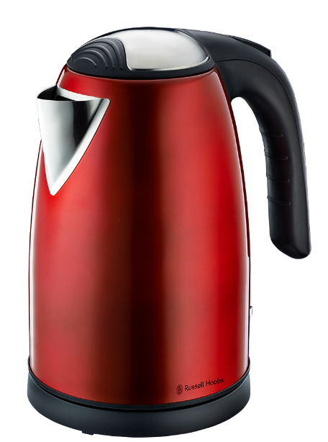

MODEL NO. RHRK01

RUSSELL HOBBS 1,7L METALLIC RED KETTLE

Congratulations on purchasing our Russell Hobbs 1,7L Metallic Red Kettle. Each unit is manufactured to ensure safety and reliability. Before using this appliance for the first time, please read the instruction manual carefully and keep it for future reference.

FEATURES OF THE RUSSELL HOBBS 1,7L METALLIC RED KETTLE
- 2500-3000W
- Metallic red body with stainless steel accents
- 1.7L large capacity
- 360° cordless base for left and right-handed use
- Concealed stainless steel heating element for easy cleaning
- Large spout for easy pouring
- Removable and washable limescale filter
- Automatic shut-off once boiling has completed
- Boil-dry and overheat protection
- Push-to-open safety locking lid
- Tidy cord storage
- For domestic use only
- 1 year warranty

IMPORTANT SAFEGUARDS
When using any electrical appliance, basic safety precautions should always be followed including the following:
- Please read the instructions carefully before using any appliance.
- Always ensure that the voltage on the rating label corresponds to the mains voltage in your home.
- Incorrect operation and improper use can damage the appliance and cause injury to the user.
- The appliance is intended for household use only. Commercial use invalidates the warranty and the supplier can not be held responsible for injury or damage caused when using the appliance for any other purpose than that intended.
- Avoid any contact with moving parts.
- This appliance is not intended for use by persons (including children) with reduced physical, sensory or mental capabilities, or lack of experience and knowledge, unless they have been given supervision or instruction concerning use of the appliance by a person responsible for their safety.
- Children should be supervised to ensure that they do not play with the appliance.
- Check the power cord and plug regularly for any damage. If the cord or the plug is damaged, it must be replaced by the manufacturer or a qualified person in order to avoid an electrical hazard.
- Do not use the appliance if it has been dropped or damaged in any way. In case of damage, take the unit in for examination and/or repair by an authorised service agent.
- Do not open the lid while the kettle is in use.
- Only fill the kettle with cold water. Do not fill the kettle above the MAX level (1.7L) or else boiling water may splash out if overfilled.
- Unplug from outlet when not in use and before cleaning. Allow it to cool down completely before cleaning the appliance.
- Do not insert any objects into holes or slots in this appliance.
- To reduce the risk of electric shock, do not immerse or expose the motor assembly, plug or the power cord to water or any other liquid.
- Never immerse the unit in water or any other liquid for cleaning purposes. Do not allow liquid to penetrate into the electrical parts of this kettle.
- Remove the plug from the socket by gripping the plug. Do not pull on the cord to disconnect the appliance from the mains. Always unplug the unit when not in use, before cleaning or when adding or removing parts.
- The use of accessory attachments that are not recommended or supplied by the manufacturer may result in injuries, fire or electric shock. The kettle is only to be used with the base provided.
- A short cord is provided to reduce the hazards resulting from becoming entangled in or tripping over a longer cord.
- Do not let the cord hang over the edge of a table or counter. Ensure that the cord is not in a position where it can be pulled on inadvertently.
- Do not allow the cord to touch hot surfaces and do not place on or near a hot gas or electric burner or in a heated oven.
- Cleaning and user maintenance shall not be made by children unless they are older than 8 years and supervised. Keep the appliance and its cord away from reach of children aged less than 8 years old.
- Keep the device and the cable away from heat, direct sunlight, moisture, sharp edges and the like.
- Do not use the appliance on a gas or electric cooking top or over or near an open flame.
- Use of an extension cord with this appliance is not recommended. However, if it is necessary to use an extension lead, ensure that the lead is suited to the power consumption of the appliance to avoid overheating of the extension cord, appliance or plug point. Remember to not place the extension cord in a position where it can be pulled on by children or animals or tripped over.
- This appliance is not suitable for outdoor use. Do not use this appliance for anything other than its intended use.
- DO NOT carry the appliance by the power cord.
- Do not leave this appliance unattended during use. Always unplug the unit when not in use or before cleaning.
- Always operate the appliance on a smooth, even, stable surface. Do not place the unit on a hot surface.
- Ensure that the switch is in the “Off” position after each use.
- The manufacturer does not accept responsibility for any damage or injury caused by improper or incorrect use, or for repairs carried out by unauthorised personnel.
- In case of technical problems, switch off the machine and do not attempt to repair it yourself. Return the appliance to an authorised service facility for examination, adjustment or repair. Always insist on the use of original spare parts. Failure to comply with the above mentioned pre-cautions and instructions, could affect the safe operation of this machine.
- Take care when pouring – pour slowly, and do not over-tilt the kettle.
- Wind excess cable beneath the base.
- Check that the lid is fully closed before switching the kettle on - otherwise it may not switch off.
- Check the kettle is properly located on the base before switching on.
- Do not switch on unless the kettle contains at least 2 cups of water.
- Do not fill past the MAX level, or it may eject boiling water.
- Remove the kettle from its base before filling or pouring.
- This appliance must not be operated by an external timer or remote control system.

OPERATING INSTRUCTIONS
BEFORE USING THE KETTLE FOR THE FIRST TIME
- Carefully remove your kettle from the box. You may wish to retain the packaging for further use.
- Before first use, fill the kettle with cold water to the MAX water level mark, bring to boil and discard the boiling water – do this twice. This will ensure that any residues left over from the manufacturing process are completely removed.

USING THE KETTLE
- Fill the kettle with your desired amount of water. You may fill the kettle through the spout or through the opening after lifting the lid.
- The water level must reach at least the minimum mark (0.5L) and must not exceed the maximum mark (1.7L)
- Never fill the kettle whilst it is still located on the base. Note: if overfilled, boiling water will splash out.
- Place the kettle securely on the base, plug the cord on the electrical outlet and ensure that the lid is closed.
- Press the “on” switch – the indicator light will be lit to indicate that boiling has started. Please be aware of escaping steam from the lid of the kettle when in use.
- Once the water has finished boiling, the kettle will switch off automatically and the indicator light will go off.

SWITCHING OFF
- Your kettle will automatically switch off once the boiling process has completed.
- If you wish to interrupt the boiling process at any time, move the “on/off” switch to the “off” position.

BOIL-DRY PROTECTION
- Should you accidentally switch on an empty kettle - the boil-dry protection will automatically switch off the power. If this occurs, allow the kettle to cool down before filling with cold water.
CLEANING AND MAINTENANCE
- Always remember to unplug the unit from the electrical outlet when not in use and before cleaning.
- Do not immerse the appliance in water or any other liquid, or hold it under a running tap to clean.
- To remove stubborn spots/marks, wipe the surfaces with a cloth slightly dampened in soapy water or mild non-abrasive cleaner. Rinse and dry with a clean, dry, soft cloth.
- Unplug the base from the electrical socket, and let the kettle cool down before cleaning.
- Wipe the kettle, inside and out, with a damp cloth. You may use a little household detergent, but if you do, rinse well.
- Wipe the base with a damp cloth.
- Keep all connectors and sockets dry.
- Do not immerse the kettle or kettle base in liquid.
- Do not use harsh or abrasive cleaning agents or solvents.

We recommend that you descale your kettle regularly, even in soft water areas. Lime scale may be white, coloured, or even rusty-looking, but it is normally visible. Phosphate scale is not generally visible, but there is always a build-up, even in soft water areas. Any build-up of scale causes overheating, which reduces the life of the element, and may trigger the boil-dry cut-out to engage. So, even in a soft water area, descale at least monthly, to help keep your kettle in working order.

To descale your kettle:
- Use a descaler suitable for plastic products (all kettles have plastic parts). Follow the instructions on the descaler, then rinse several times, fill, boil and discard the water, to remove all chemical residues.
- Products returned under guarantee with faults related to scale will be subject to a repair charge.
- If you notice your kettle getting noisier – descale it.
- Do not rely on visible scale, as phosphate scale is not visible. Rather descale the kettle for preventative purposes.
- Do not try to move or remove the diffuser – you will break it.

Water filter:
- Scale particles suspended in the water may give it a cloudy or greasy appearance.
- The filter will prevent these particles going into your drink. If you see deposits on the filter, clean it, otherwise the performance of your kettle will drop, your drinks may contain scale, and the water inside the kettle may look cloudy.

Cleaning the filter:
- The filter is located inside the kettle behind the spout.
- With the lid open, gently pull the filter out of its retaining slot.
- Lift the filter out of the kettle.
- Rinse the filter in warm water and gently remove any scale with a soft brush.
- To replace the filter, slide it down into its slot until it clicks into place.

STORING THE APPLIANCE
- Unplug the unit from the electrical outlet and clean all the parts as instructed above. Ensure that all parts are dry before storing.
- Store the appliance in its box or in a clean, dry place.
- Never store the appliance while it is still wet or dirty.
- Never wrap the power cord around the appliance.

SERVICING THE APPLIANCE
There are no user serviceable parts in this appliance. If the unit is not operating correctly, please check the following:
- You have followed the instructions correctly
- That the unit has been wired correctly and that the wall socket is switched on.
- That the mains power supply is ON.
- That the plug is firmly in the mains socket.
If the appliance still does not work after checking the above:
- Consult the retailer for possible repair or replacement. If the retailer fails to resolve the problem and you need to return the appliance, make sure that:
- The unit is packed carefully back into its original packaging.
- Proof of purchase is attached.
- A reason is provided for why it is being returned.

If the supply cord is damaged, it must be replaced by the manufacturer or an authorised service agent, in order to avoid any hazard. If service becomes necessary within the warranty period, the appliance should be returned to an approved Home of Living Brands (Pty) Limited service centre. Servicing outside the warranty period is still available, but will, however, be chargeable.

CHANGING THE PLUG

Should the need arise to change the fitted plug, follow the instructions below.
This unit is designed to operate on the stated current only. Connecting to other power sources may damage the appliance. Connect a three-pin plug as follows:
The wires in this mains lead are coloured in accordance with the following code:

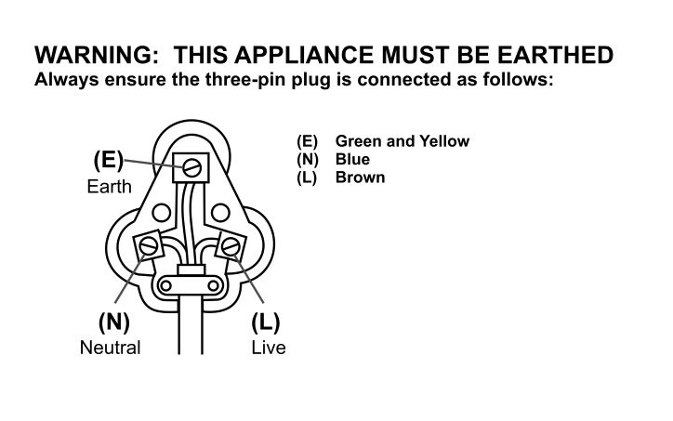

PLEASE AFFIX YOUR PROOF OF PURCHASE/RECEIPT HERE
IN THE EVENT OF A CLAIM UNDER WARRANTY THIS RECEIPT MUST BE PRODUCED.

W A R R A N T Y

- Home of Living Brands (Pty) Limited (“Home of Living Brands”) warrants to the original purchaser of this product (“the customer”) that this product will be free of defects in quality and workmanship which under normal personal, family or household use and purpose may manifest within a period of 1 (one) year from the date of purchase (“warranty period”).
- Where the customer has purchased a product and it breaks, is defective or does not work properly for the intended purpose, the customer must notify the supplier from whom the customer bought the product (“the supplier”) thereof within the warranty period. Any claim in terms of this warranty must be supported by a proof of purchase. If proof of purchase is not available, then repair, and/or service charges may be payable by the customer to the supplier.
- The faulty product must be taken to the supplier's service centre to exercise the warranty.
- The supplier will refund, repair or exchange the product in terms of this warranty subject to legislative requirements. This warranty shall be valid only where the customer has not broken the product himself, or used the product for something that it is not supposed to be used for. The warranty does not include and will not be construed to cover products damaged as a result of disaster, misuse, tamper, abuse or any unauthorised modification or repair of the product.
- This warranty will extend only to the product provided at the date of the purchase and not to any expendables attached or installed by the customer.
- If the customer requests that the supplier repairs the product and the product breaks or fails to work properly within 3 (three) months of the repair and not as a result of misuse, tampering or modification by or on behalf of the customer, then the supplier may replace the product or pay a refund to the customer.
- The customer may be responsible for certain costs where products returned are not in the original packaging, or if the packaging is damaged. This will be deducted from any refund paid to the customer.

HOME OF LIVING BRANDS (PTY) LTD (JOHANNESBURG)

JOHANNESBURG TEL NO. (011) 490-9600

CAPE TOWN TEL NO. (021) 552-5161

DURBAN TEL NO. (031) 792-6000

www.russellhobbs.co.za
www.homeoflivingbrands.com
www.facebook.com/RussellHobbsSA

