

INSTRUCTIONS AND WARRANTY

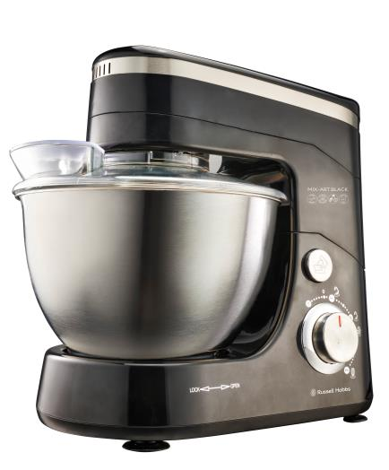

MODEL NO. RHSB240

600W MIX-ART BLACK STAND BOWL MIXER

Congratulations on purchasing our Russell Hobbs 600W Mix-Art Black Stand Bowl Mixer. Each unit is manufactured to ensure safety and reliability. Before using this appliance for the first time, please read the instruction manual carefully and keep it for future reference.

FEATURES OF THE RUSSELL HOBBS 600W MIX-ART BLACK STAND BOWL MIXER

This powerful and uber stylish stand bowl mixer has the power, capacity, precision and planetary mixing action to ensure efficient mixing and beating. Not only can it knead evenly the toughest whole grain bread, it also offers a wide usage range which is elaborated on further on this user manual. Different speeds are engineered for whipping custards, cream, meringues and so much more. Essentially, this stand bowl mixer allows you to prepare meals, snacks, desserts and so much more using its powerful 600W motor with little to no effort.

- Powerful 600W motor
- Stylish black gloss ABS housing with stainless steel accents
- Unique tilting system with planetary mixing action for increased efficiency
- Full metal gear system for perfect mixing results
- Intelligent circuitry ensures a consistent operating speed whatever load
- Oversized 4.5L stainless steel bowl with transparent splashguard
- Electronic variable stepless speed control with pulse function
- The Mix-Art includes 3 bowl accessories: a stainless steel balloon whisk, stainless steel dough hook as well as a stainless steel creamer-beater
- Built-in safety locks
- Non-slip rubber feet for added stability
- Knead, mix, cream and whip with ease
- Includes recipes
- For domestic use only
- 2 year warranty

IMPORTANT SAFEGUARDS

When using any electrical appliance, basic safety precautions should always be followed including the following:

CAUTION: When using the stand bowl mixer, the unit must not be used for longer than 5 minute cycles, as this puts pressure on the motor which could lead to overheating and product malfunction. It is recommended to allow the stand bowl mixer a 20 minute break after each cycle. This will also help to prolong the life of your stand bowl mixer.

- Please read the instructions carefully before using any appliance.
- Always ensure that the voltage on the rating label corresponds to the mains voltage in your home.
- Incorrect operation and improper use can damage the appliance and cause injury to the user.
- This appliance is intended for household use only. Commercial use invalids the warranty and the supplier cannot be held responsible for injury or damage caused when using the appliance for any other purpose than that intended.
- Avoid any contact with moving parts.
- This appliance is not intended for use by persons (including children) with reduced physical, sensory or mental capabilities, or lack of experience and knowledge, unless they have been given supervision or instruction concerning use of the appliance by a person responsible for their safety.
- Children should be supervised to ensure that they do not play with the appliance.
- Check the power cord and plug regularly for any damage. If the cord or the plug is damaged, the manufacturer or a qualified person must replace it in order to avoid an electrical hazard.
- Do not use the appliance if it has been dropped or damaged in any way. In case of damage, take the unit in for examination and/or repair by an authorised service agent
- To reduce the risk of electric shock, do not immerse or expose the motor assembly, plug or the power cord to water or any other liquid. Do not use it with wet hands.
- Never immerse the unit in water or any other liquid for cleaning purposes.
- Remove the plug from the socket by gripping the plug. Do not pull on the cord to disconnect the appliance from the mains. Always unplug the unit when not in use, before cleaning or when adding or removing parts.
- Insert and use only original parts.
- The use of accessory attachments that are not recommended or supplied by the manufacturer may result in injuries, fire or electric shock.
- A short cord is provided to reduce the hazards resulting from becoming entangled in or tripping over a longer cord.
- Do not let the cord hang over the edge of a table or counter. Ensure that the cord is not in a position where it can be pulled on inadvertently.
- Do not allow the cord to touch hot surfaces and do not place on or near a hot gas or electric burner or in a heated oven.
- Keep the appliance and cord away from direct radiant heat from the sun, from damp surfaces, from sharp edges and other dangers.
- Do not use the appliance on a gas or electric cooking top or over or near an open flame.
- Use of an extension cord with this appliance is not recommended. However, if it is necessary to use an extension lead, ensure that the lead is suited to the power consumption of the appliance to avoid overheating of the extension cord, the appliance or plug point. Do not place the extension cord in a position where it can be pulled on by children or animals or tripped over.
- This appliance is not suitable for outdoor use. Do not use this appliance for anything other than its intended use.
- Do not operate this appliance by means of an external timer.
- DO NOT carry any appliance by the power cord.
- Do not leave this appliance unattended during use. Always unplug the unit when not in use or before cleaning.
- Always operate the stand bowl mixer on a smooth, even, stable surface. Do not place the unit on a hot surface.
- Ensure the beater OR dough hook OR whisk are fitted to the stand bowl mixer before use. Please do not mix the attachments during single operation e.g. use 1 x whisk with 1 x beater accessory.
- Never attempt to eject the accessories when the appliance is in operation.
- Never touch the rotating tools while still in motion; always wait for them to come to a complete stop.
- Keep hands, clothing, as well as spatulas and other utensils away from the accessories during operation to reduce the risk of injury to persons, and/or damage to the appliance.
- It is absolutely necessary to keep this appliance clean at all times as it comes into direct contact with food.
- To avoid splashes, always put the accessories right/ deep into the mixture before running. Begin mixing at a low speed.
- Be careful when mixing hot liquids or food preparation.
- Ensure that the switch is in the “0” / “Off” position after each use.
- To avoid the danger of fire and/or explosion, do not use this appliance to stir paints or solvents.
- The manufacturer does not accept responsibility for any damage or injury caused by improper or incorrect use, or for repairs carried out by unauthorised personnel.
- In case of technical problems, switch off the machine and do not attempt to repair it yourself. Return the appliance to an authorised service facility for examination, adjustment or repair. Always insist on the use of original spare parts. Failure to comply with the above mentioned pre-cautions and instructions, could affect the safe operation of this machine.

NOTICE: This appliance is not for professional use. You should follow the requested breaks. Failure to follow this instruction carefully may result in damage to the motor. When using the stand bowl mixer, the unit must not be used for longer than 5 minute cycles, as this puts pressure on the motor which could lead to overheating and product malfunction. It is recommended to allow the stand bowl mixer a 20 minute break after each cycle. This will also help to prolong the life of your appliance.

PARTS DIAGRAM

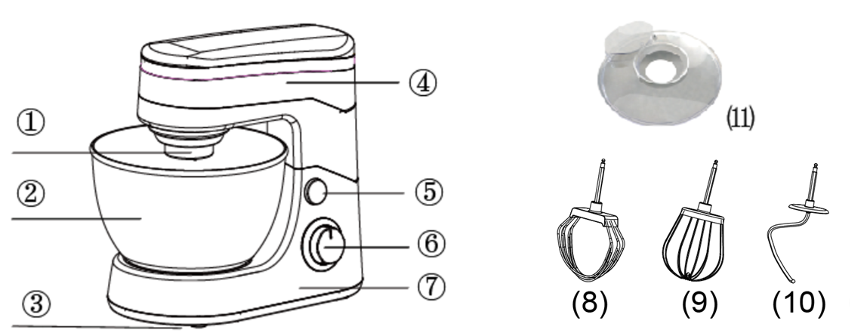

Description

1. Accessories assembly point 2. Mixing bowl
3. Non-slip rubber feet 4. Mixing head
5. Head release 6. Stepless speed control with pulse function
7. Base unit 8. Cream-beater
9. Balloon whisk 10. Dough hook
11. Bowl lid

BEFORE FIRST USE
Before using your appliance for the first time, take it out of the box and remove any protective wrappings. REMEMBER: DO NOT LEAVE PROTECTIVE PACKAGING LYING AROUND, AS IT COULD BE DANGEROUS AROUND INFANTS AND CHILDREN.

OPERATING INSTRUCTIONS

- Ensure that the unit is off at the “0” or “Off” position.
- Place the mixing bowl onto the base unit and turn the bowl until it locks into position.
- In order to unlock and lift the mixing head, press the head release button to unlock it from the base unit.
- Insert the bowl lid. Choose a pair of mixing accessories, depending on the task at hand – creamer-beater, dough hook or balloon whisk. Note: to ensure the correct safety procedure is followed, please disconnect appliance from electrical outlet before inserting or removing mixing accessories.
- Place the ingredients into the bowl through the bowl lid.
- Press “head release” button and lower the mixing head until it locks into position.
- Set the speed dial to the “0” position. Plug the power cord into the required electrical outlet.
- Select the required speed by turning the speed dial in a clock-wise direction.
- Once mixing is complete, turn speed dial to the “0” or OFF position. Once the mixing accessories have come to a complete stop, you may remove the bowl.
- If you have finished using the appliance at this time, make sure that the speed dial is set to the “0” or OFF position before unplugging the appliance from the outlet. Follow this by tilting the mixing head up and pressing the eject button to release the mixing accessories. Caution: The speed selector must be at the “0” / “OFF” position before pressing the eject button down to remove accessories. Never press the eject button when the appliance is operating.
- If necessary you can scrape the excess food preparation from the mixing accessories by rubber or wooden spatula.

Warning: Do not stick a knife, metal spoon, fork and so on into the bowl when the appliance is operating.

Depending on the nature of the ingredients, the bowl can be used to prepare up to 2 kg of dough.

CHOOSING A SPEED
- If you have ingredients in the bowl which may splash (e.g. cream or flour), start with the lowest speed, then increase it if necessary.
- If you feel that the machine is turning without enough torque, increase the speed.

This guide may help you select a speed for most tasks. These guides are manufacturer recommendations and must be considered along with user preferences and experience. Please adjust the mixer’s speed as needed.

Accessory Speed
Dough hook 1/3 of full speed
Stirrer ½ of full speed
Whisk Full speed

Alternatively, the Pulse (P) setting may be used for fast, single operations.

SUGGESTIONS FOR USE
- Refrigerated ingredients, ie. Butter and eggs should be at room temperature before mixing begins. Set these ingredients out ahead of time.
- To eliminate the possibility of shells or rotten eggs in your recipe, break the eggs into a separate container first, check them and then add them to the mixture.
- Do not over-beat. Be careful that you only mix/ blend mixtures until recommended in your recipe. Fold into dry ingredients only until they are “just” combined. Always use a low speed.
- Climatic conditions. Seasonal temperature changes, temperature of ingredients and their texture variation from area to area all play a part in the required mixing time and the results achieved.
- Always start mixing at slow speeds. Gradually increase to the recommended speed as stated in the recipe.
- If you want to clean the sides and base of the mixing bowl/ container with a hand-held utensil, first switch the machine to “0” / “OFF”.
- To avoid unnecessary splashing, immerse the attachment into the mixture before switching the appliance ON.
- Unplug the appliance when not in use, before fitting or removing the mixing attachments and before cleaning it.
- Avoid coming into contact with moving parts. Keep hands, hair, clothes, as well as spatulas and other utensils away during operation to prevent injury and/or damage to the appliance.
- The speed can be adjusted at any time. Starting from “0” / “OFF” and then adjusting the speed to the food type being mixed. For thicker mixtures, a low speed is recommended. For fine consistency, use the high-speed settings.

CLEANING AND MAINTENANCE
- This stand bowl mixer is for household use only and is not user-serviceable.
- Do not open or change any parts by yourself. Please refer to a qualified electrical service department or return to the supplier if servicing is necessary.
- Always remember to unplug the unit from the electrical outlet when not in use and before cleaning. Ensure that the speed control is set to “0” / “OFF”.
- It is much easier to clean the mixing accessories and bowl directly after they have been used. Wash them in warm, soapy water, rinse and dry well.
- The body of the appliance should be cleaned with a damp cloth. Do not let water enter the appliance.
- Do not use bleach or other abrasive substance or solvents to clean your appliance as it can be damaging to the finish.
- Do not immerse the mixer in water or any other liquid, or hold it under a running tap to clean.
- To remove stubborn spots/marks, wipe the surfaces with a cloth slightly dampened in soapy water or mild non-abrasive cleaner. Rinse and dry with a clean, dry soft cloth.

CAUTION: The main body of the appliance should never be submerged in water or held under a running tap. To clean, simply wipe with a damp cloth.

STORING THE APPLIANCE

- Ensure that the unit is switched to the OFF position. Unplug the unit from the power outlet.
- Remove all mixing accessories and bowl from appliance.
- Clean all the parts as instructed above. Ensure that all parts are dry before storing.
- Fold down the unit and place the hard shell cover over the body of the appliance as shown below for storage.
- Store the appliance in its hard shell cover or in a clean, dry place.
- Never store the appliance while it is still wet or dirty.

Never wrap the power cord around the appliance

Hints for beating egg whites:-

- Be sure that the bowl and mixing accessories are clean.
- Be sure that there is no egg yolk in the egg white.
- Egg whites should be at room temperature for maximum volume.
- Use a high setting.
- Beating time will vary according to the freshness of the eggs.

Hints for whipping cream:-

- Use a heavy cream.
- Chill the cream before whipping.
- For best results, chill both beaters and bowl.
- Start beating at a low speed to prevent spatter, increase to high as the cream thickens.
- Beating time will vary according to the fat content, age and temperature of the cream.

RECIPES

Grand Marnier Delight

Ingredients
-2 tablespoons orange rind
-½ cup Grand Marnier
-150g dark chocolate
-3 eggs separated
-100ml thickened cream
Decoration
-½ cup whipped cream
-2 teaspoons caster sugar
-Orange segments

Method
Marinate orange rind overnight in Grand Marnier. Drain and reserve marinade. Melt chocolate over hot water, do not boil water. Beat egg yolks until thick and creamy, pour onto warm chocolate. Beat well to blend mixture together, adding one tablespoon of marinated orange rind. Allow to cool, beat cream until soft peaks form. Fold cream into chocolate mixture. Whip egg whites until stiff. Fold in chocolate mixture, adding half the reserved marinade. Pour into small pots, refrigerate for 5 hours. Serve with whipped cream.

Chocolate Pecan Pudding

Ingredients
-100g dark chocolate
-75g pecan nits, finely chopped
-2 slices white bread, crumbed
-60g plain flour
-100g unsalted butter, softened
-4eggs, separated
-100g sugar

Method
Grease a large pudding bowl and dust with caster sugar.
Melt the chocolate in a small bowl over a saucepan of hot water. Combine pecan nuts, breadcrumbs and flour. Beat butter until fluffy, add chocolate, yolks and half the sugar, continue to beat until smooth. Clean beaters thoroughly-whisk egg whites until stiff, gradually adding remaining sugar. Fold the egg mixture into the butter mixture, also add the flour mixture and fold lightly to combine. Place mixture in prepared bowl. Cover with foil and secure. Lower into a saucepan of boiling water-half way up sides of bowl and steam for 45-50 minutes.

Almond fingers

Ingredients
-225g butter
-2 cups caster sugar
-1 teaspoon almond essence
-1 egg
-3 cups plain flour
-1 teaspoon baking powder

Topping
-1 egg white, beaten with 2 tablespoons caster sugar
-1/2 cup chopped almonds

Method
Cream butter and sugar for 5 minutes, or until light and fluffy. Add essence and egg, beating until combined. Add sifted flour and baking powder and working with your hands form a smooth dough. Roll out to 5mm thick, cut into finger shapes. Place on an oven tray. Bake at 150ºC for 15 minutes. Remove from oven. Brush with beaten egg white and sugar and sprinkle with almonds. Return to oven for 5 minutes. Allow to cool on tray.

Cold Lemon Soufflé

Ingredients
-5 eggs, separated
-1 cup caster sugar
-2 teaspoons grated lemon rind
¾ cup strained lemon juice
-1 tablespoon gelatine
-1/4 cup cold water
-300ml thickened cream lightly whipped

Method
Cut a piece of foil 5cm longer than circumference of a deep 16cm soufflé dish. Fold foil in half and wrap around the outside of dish. Secure foil with string. Beat egg yolks, sugar and lemon rind on until the sugar has dissolved, and the mixture is pale and thick. Heat lemon juice and gradually add to yolk mixture while beating. Combine gelatin with water in a small bowl. Stand bowl in hot water and stir until gelatin dissolves. Add gradually to lemon mixture.

Transfer mixture to a large bowl, cover and refrigerate for 15 minutes. Using a metal spoon, fold cream into the lemon mixture. Beat egg whites until soft peaks form. Fold whites quickly and lightly into the lemon mixture. Pour gently into the prepared dish and chill until set. Serve with whipped cream.

Tropical Treat

Ingredients
-125g butter, softened
-1 cup firmly packed brown sugar
-1 egg
-1 cup crushed pineapple, drained
-1 1/2 cups self-raising flour
-1 cup milk

Method
Cream the butter and sugar until creamed. Add egg and continue to beat until light and fluffy. Reduce to low speed: add pineapple, flour and milk, mixing only until combined. Place mixture in a greased pudding bowl and cover with 2 thicknesses of greaseproof paper and secure with a string. Place in a dish of water. Bake in a pre-heated 180ºC oven for 45-50 minutes. Serve with vanilla ice cream garnished with toasted shredded coconut.

SERVICING THE APPLIANCE

There are no user serviceable parts in this appliance. If the unit is not operating correctly, please check the following:
- You have followed the instructions correctly
- That the unit has been wired correctly and that the wall socket is switched on.
- That the mains power supply is ON.
- That the plug is firmly in the mains socket.

If the appliance still does not work after checking the above:
- Consult the retailer for possible repair or replacement. If the retailer fails to resolve the problem and you need to return the appliance, make sure that:
- The unit is packed carefully back into its original packaging.
- Proof of purchase is attached.
- A reason is provided for why it is being returned.

If the supply cord is damaged, it must be replaced by the manufacturer or an authorised service agent, in order to avoid any hazard. If service becomes necessary within the warranty period, the appliance should be returned to an approved Home of Living Brands (Pty) Limited service centre. Servicing outside the warranty period is still available, but will, however, be chargeable.

CHANGING THE PLUG

Should the need arise to change the fitted plug, follow the instructions below.
This unit is designed to operate on the stated current only. Connecting to other power sources may damage the appliance.

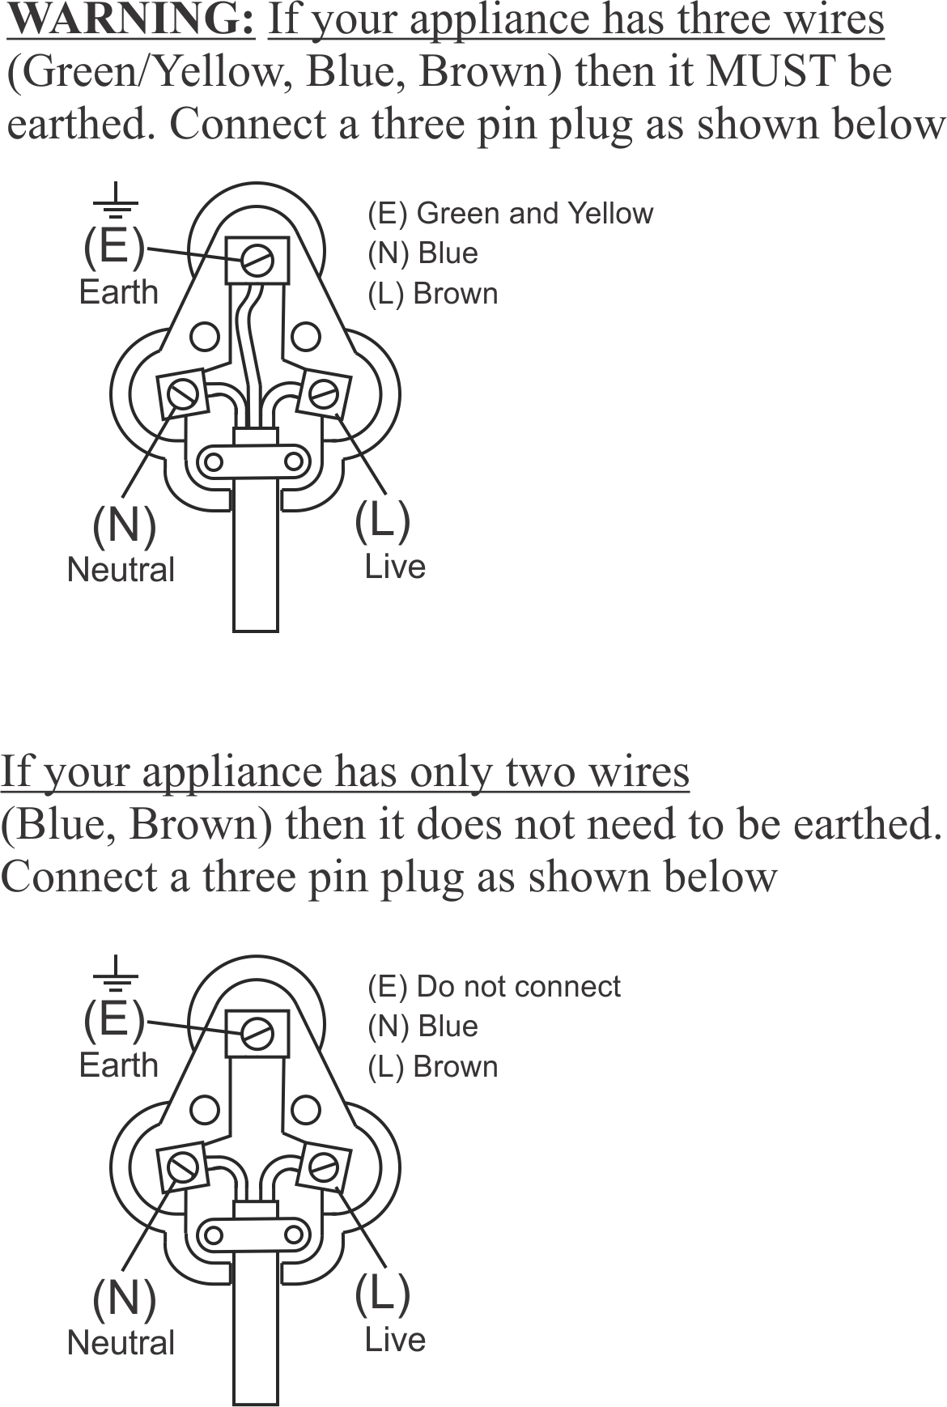

PLEASE AFFIX YOUR PROOF OF PURCHASE/RECEIPT HERE
IN THE EVENT OF A CLAIM UNDER WARRANTY THIS RECEIPT MUST BE PRODUCED.

2 YEAR WARRANTY
1 year retail ⵏ 1 year extended warranty upon registration*
visit www.russellhobbs.co.za

W A R R A N T Y AND EXTENDED WARRANTY

- Home of Living Brands (Pty) Limited ("Home of Living Brands") warrants to the original purchaser of this product ("the customer") that this product will be free of defects in quality and workmanship which under normal personal, family or household use and purpose may manifest within a period of 1 (one) year from the date of purchase ("warranty period").
- Home of Living Brands shall extend the warranty period for a further period of 1(one) year (“extended warranty period*”), on condition that the purchaser registers the product on the website, within 12 months from the date of purchase of the product. The website address for registration is as follows: http://russellhobbs.co.za/info-pages/warranty-info.aspx. The extended warranty period only applies to products purchased on or after 1 October 2017.
- Where the customer has purchased a product and it breaks, is defective or does not work properly for the intended purpose, the customer must notify the supplier from whom the customer bought the product ("the supplier") thereof within the warranty period or if applicable, the extended warranty period. Any claim in terms of this warranty must be supported by a proof of purchase. If proof of purchase is not available, then repair, and/or service charges may be payable by the customer to the supplier.
- The faulty product must be taken to the supplier's service centre to exercise the warranty.
- The supplier will refund, repair or exchange the product in terms of this warranty subject to legislative requirements. This warranty shall be valid only where (a) the customer is not the cause of the product breaking, and (b) the product has been used for the intended purpose stipulated in the product manual. The warranty does not include and will not be construed to cover products damaged as a result of disaster, misuse, tamper, abuse or any unauthorised modification or repair of the product.
- This warranty will extend only to the product provided at the date of the purchase and not to any expendables attached or installed by the customer. In this regard any accessories supplied with the product by the supplier, may be excluded in this warranty or extended warranty (see Exclusions to Warranty and Extended Warranty document).
- If the customer requests that the supplier repairs the product and the product breaks or fails to work properly within 3 (three) months of the repair and not as a result of misuse, tampering or modification by or on behalf of the customer, then the supplier may replace the product or pay a refund to the customer, subject to the supplier’s discretion.
- The customer may be responsible for certain costs where products returned are not in the original packaging, or if the packaging is damaged. This will be deducted from any refund paid to the customer.
HOME OF LIVING BRANDS (PTY) LTD (JOHANNESBURG)

JOHANNESBURG TEL NO. (011) 490-9600
CAPE TOWN TEL NO. (021) 552-5161
DURBAN TEL NO. (031) 303-1163

www.homeoflivingbrands.com
www.russellhobbs.co.za
www.facebook.com/RussellHobbsSA

EXCLUSIONS TO W A R R A N T Y AND EXTENDED WARRANTY

- Any accessories supplied with the product, including but not limited to, bowls, jugs, mills or carafes made either of glass or plastic and supplied with this appliance (hereinafter referred to as “the accessory or accessories”), is warranted to be free from material and workmanship defects for the duration of the appliance warranty.
- The accessories should give trouble free service when used in accordance with the directions described in the instruction manual. However, the accessories will be damaged if subjected to impact, and this damage is not covered by the warranty. Such impact damage can occur either from the outside (if for example it is dropped or knocked against a hard surface), or from within (if for example foreign objects are placed within the accessories and the power is switched on).
- Should you need to replace an accessory during the warranty period; a claim for a free replacement will only be considered if the item (including all shards and broken parts) is returned to the nearest HOLB service centre for examination.
- The remains of the accessory will be carefully examined by the relevant professionals and if it is determined (at the sole discretion of HOLB) that the damage was caused by impact, then the claim will be refused and will not be covered by the warranty or any extended warranty.
- Any replacement part provided in terms of clause 4 above will become a chargeable item payable by the customer.

