INSTRUCTIONS AND WARRANTY

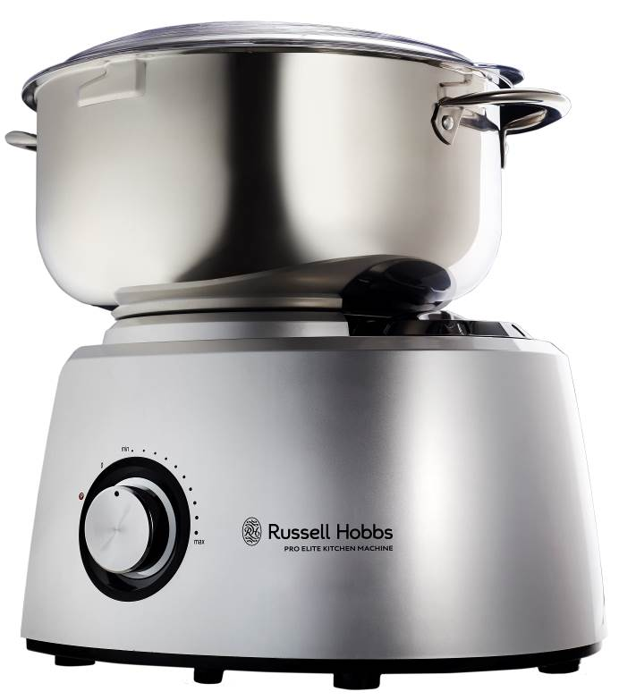

RHSB250

RUSSELL HOBBS
PRO ELITE KITCHEN MACHINE
Congratulations on purchasing our Russell Hobbs Pro Elite Kitchen Machine. Each unit is manufactured to ensure safety and reliability. Before using this appliance for the first time, please read the instruction manual carefully and keep it for future reference.

FEATURES OF THE RUSSELL HOBBS PRO ELITE KITCHEN MACHINE

- Powerful 1200W motor – low noise kitchen machine
- Stylish silver ABS housing with stainless steel and die-cast aluminium accessories
- Full metal gear system for perfect mixing results
- Dual attachment drives
- Intelligent circuitry ensures a consistent operating speed whatever load
- Oversized 5.8L stainless steel bowl with handles transparent splashguard
- Electronic step-less speed control (variable + pulse): max speed 250rpm, min speed 50rpm
- One system for mixing, kneading, blending, mincing, grinding, sausage stuffing and more!
- The Kitchen Elite includes the following accessories:
  - 1.5L Glass blending jug
  - Dry mill attachment with filter lid for coffee and spice processing
  - Mincer attachment with 3 different mincing grades, Kebbe maker as well as sausage stuffing accessory
  - Dough hook set
  - Balloon whisk set
- Unique double whisk and dough hook system for increased efficiency
- Professional grade system with safety protection locks
- With storage compartment for the mincer attachment accessories
- Non-slip rubber feet for stability as well as handy cord storage
- Includes recipes
- 2 year warranty
- For domestic use only

IMPORTANT SAFEGUARDS

When using any electrical appliance, basic safety precautions should always be followed including the following:

- Please read the instructions carefully before using any appliance.
- Always ensure that the voltage on the rating label corresponds to the mains voltage in your home.
- Incorrect operation and improper use can damage the appliance and cause injury to the user.
- The appliance is intended for household use only. Commercial use invalids the warranty and the supplier cannot be held responsible for injury or damage caused when using the appliance for any other purpose than that intended.
- Avoid any contact with moving parts. Keep hands, hair, clothing, as well as spatulas and other utensils away from whisks, blades, discs, dough hooks and/or other moving parts during operation to reduce the risk of injury to persons and/or damage to the appliance or its attachments.
- Wait until moving parts come to a complete stop and are no longer moving before you remove the splashguard/ lid/ cover of the mixing bowl or other accessories.
- Do not use the appliance if the rotating sieve is damaged.
- Always use the safety pusher when utilizing the mincer attachment
- This appliance is not intended for use by persons (including children) with reduced physical, sensory or mental capabilities, or lack of experience and knowledge, unless they have been given supervision or instruction concerning use of the appliance by a person responsible for their safety.
- Children should be supervised to ensure that they do not play with the appliance.
- Check the power cord and plug regularly for any damage. If the cord or the plug is damaged, it must be replaced by the manufacturer or a qualified person in order to avoid an electrical hazard.
- Do not use the appliance if it has been dropped or damaged in any way. In case of damage, take the unit in for examination and/or repair by an authorised service agent.
- To reduce the risk of electric shock, do not immerse or expose the motor assembly, plug or the power cord to water or any other liquid.
- Never immerse the unit in water or any other liquid for cleaning purposes.
- Remove the plug from the socket by gripping the plug. Do not pull on the cord to disconnect the appliance from the mains. Always unplug the unit when not in use, before cleaning or when adding or removing parts.
- The use of accessories that are not recommended or supplied by the manufacturer may result in injuries, fire or electric shock.
- A short cord is provided to reduce the hazards resulting from becoming entangled in or tripping over a longer cord.
- Do not let the cord hang over the edge of a table or counter. Ensure that the cord is not in a position where it can be pulled on inadvertently.
- Do not allow the cord to touch hot surfaces and do not place on or near a hot gas or electric burner or in a heated oven.
- Do not use the appliance on a gas or electric cooking top or over or near an open flame.
- Use of an extension cord with this appliance is not recommended. However, if it is necessary to use an extension lead, ensure that the lead is suited to the power consumption of the appliance to avoid overheating of the extension cord, appliance or plug point. Do not place the extension cord in a position where it can be pulled on by children or animals or tripped over.
- This appliance is not suitable for outdoor use. Do not use this appliance for anything other than its intended use.
- DO NOT carry the appliance by the power cord.
- Take care when lifting this appliance as it is heavy. Ensure that the bowl, accessories, motor drive cover and cord are secure before lifting.
- Do not leave this appliance unattended during use. Always unplug the unit when not in use or before cleaning.
- Always operate the appliance on a smooth, even, stable surface. Do not place the unit on a hot surface.
- Ensure that the switch is in the “Off” position after each use.
- Always operate the appliance with the according motor drive cover securely in place.
- Remove beaters and dough hooks from the mixing bowl before washing.
- Do not use this appliance to process any substance for which is has not been intended to process e.g. it is not intended to process paint, metals, etc.
- Do not use the jug blender accessory and other accessories at the same time.
- Do not operate this appliance by means of an external timer or separate remote control system.
- The manufacturer does not accept responsibility for any damage or injury caused by improper or incorrect use, or for repairs carried out by unauthorised personnel.
- In case of technical problems, switch off the machine and do not attempt to repair it yourself. Return the appliance to an authorised service facility for examination, adjustment or repair.
- Always insist on the use of original spare parts. Failure to comply with the above mentioned precautions and instructions, could affect the safe operation of this machine.

THIS APPLIANCE IS FOR HOUSEHOLD USE ONLY

PARTS DIAGRAM
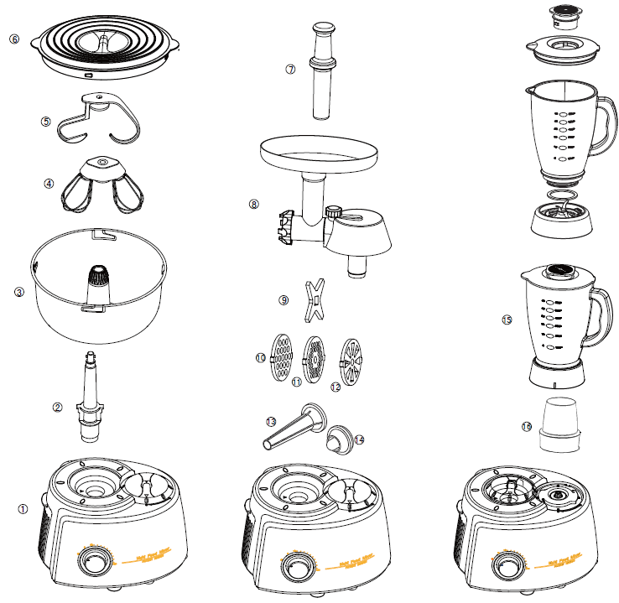

Kitchen Machine

- Power unit/ base (motor assembly)
- Detachable drive shaft
- Stainless steel mixing bowl
- Balloon whisk set
- Dough hook set
- Mixing bowl splashguard

Attachments

- Mincer safety pusher
- Mincer accessory set
- Mincer blade
- Fine mincing disc
- Medium mincing disc
- Coarse mincing disc
- Sausage stuffing nozzle
- Kebbe maker
- Glass blending jug
- Dry mill

Dual Drives:
The Pro Elite Kitchen Machine features two drives. 1. A high-speed drive directly coupled to the motor which is used to drive the glass blending jug and the dry mill. 2. A high-torque drive used to drive the balloon whisk set, dough hook set and mincer.

Motor drive cover (fig.1):
Used to cover a drive that is not in use

Convenient cord storage (fig.2):
Convenient cord storage is located on the back of the power unit/ base.

Non-slip rubber feet (fig.2):
Four non-slip rubber feet provide the ultimate in stability, while also serving to isolate the power unit/ base from hard surfaces to minimize noise and vibration.

Storage compartment (fig.3):
A convenient storage compartment for the mincer blade and discs is located on the left of the power unit/ base.

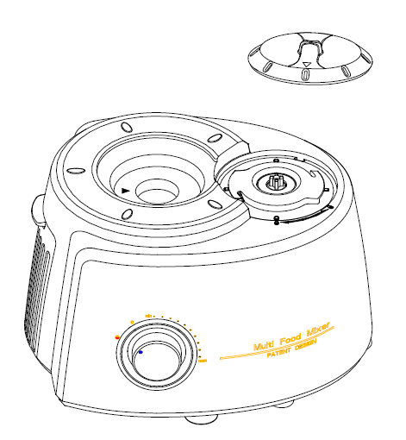  fig.1 | fig.2  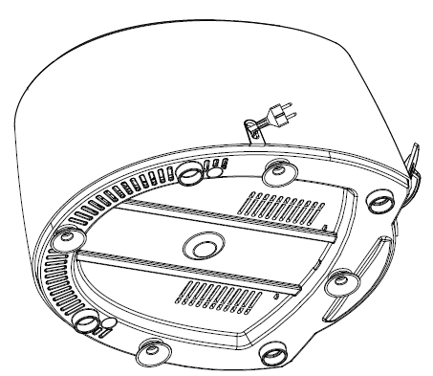 | 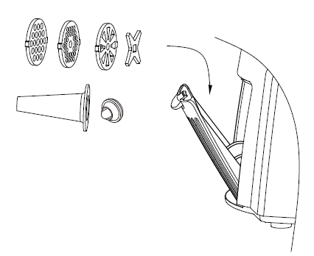  fig.3
fig.5  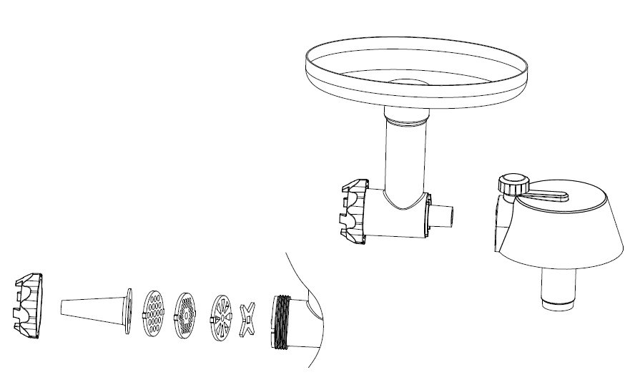 | 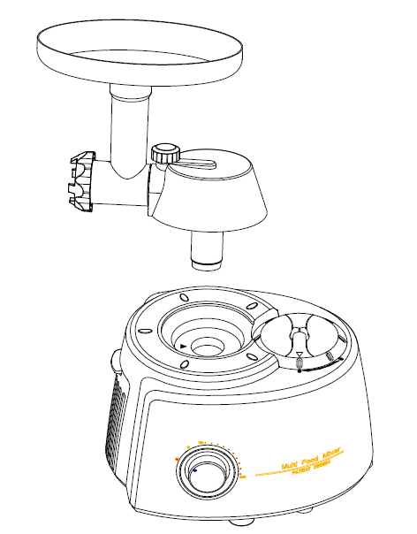  fig.6 | 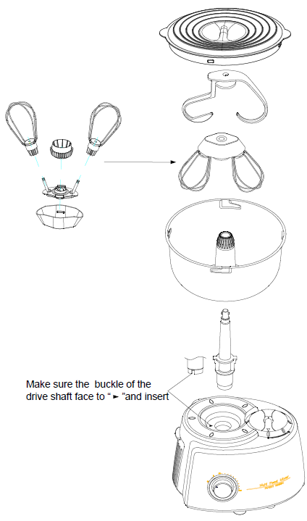  fig.4
fig.7  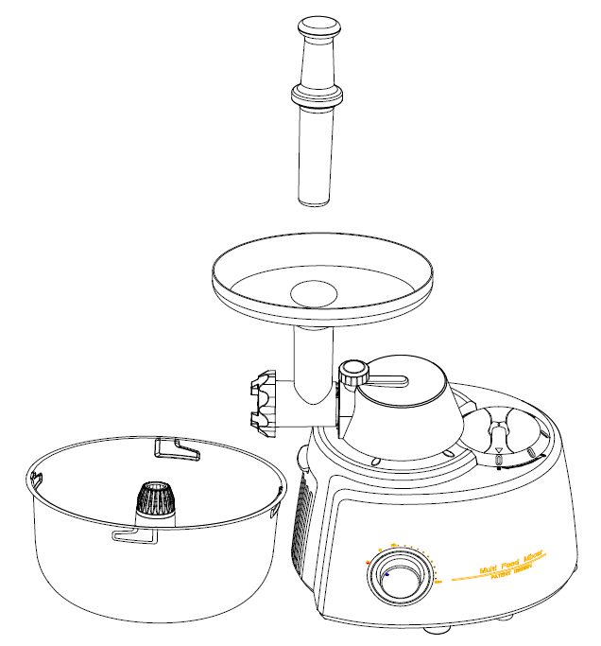 | 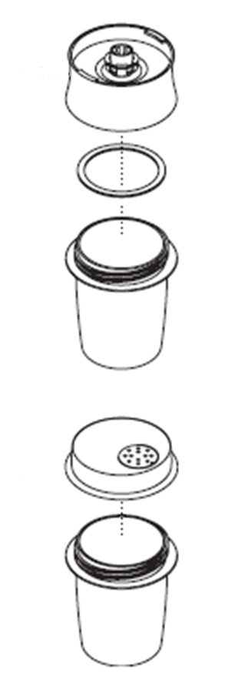  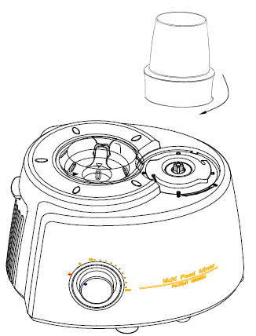  fig.8
fig.9  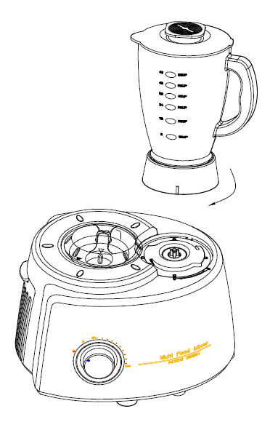  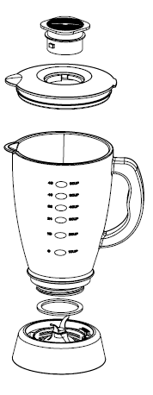 | fig.10

OPERATING INSTRUCTIONS

BEFORE FIRST USE

Before using this appliance for the first time, unpack the appliance and remove all protective packaging and wrappings.

Please ensure to discard or store the protective packaging and wrappings immediately. It is important to keep these away from babies, infants and children for safety purposes.

All parts of the kitchen machine need to be thoroughly cleaned before being used for the first time. (See “Cleaning and maintenance” section).

POSITIONING

- Place the kitchen machine on a firm, stable, level surface.
- Position the power cord away from the edge of tables or countertops so it cannot be tripped over or caught.

SPLASHGUARD

The mixing bowl should be used with the splashguard. It is recommended to use the mixing bowl with the splashguard fitted to avoid spatter. To fit the splashguard, place it on top of the mixing bowl and turn it until the small latches, sit comfortably locked into the latches of the mixing bowl.

POWER UP

▲Caution: - If the speed control is not set to ‘0' (off position), the kitchen machine will start when the power supply is connected. Please fit accessories correctly to avoid damaging the machine.

- Check that the speed control is set to "0".
- Put the plug into the wall power outlet and switch it on.
- Remove the motor drive cover and place it onto the drive that will not be used at that time.

▲NOTE: The cover, when using the high-torque drive, should be locked onto the high-speed drive by turning it clockwise. When using the high-speed drive, remove the cover by turning it anti-clockwise and place it on the high-torque drive to avoid liquids and food materials from splashing into the motor.

SPEED CONTROL

- Turn the speed control clockwise to the speed you want.
- Turn the speed control back to "0" to turn the motor off.
- Turning the speed control anti-clockwise to "P" will give you a pulse at high speed.

PULSE FUNCTION ("P")

- Turning the speed control anti-clockwise to "P" will give you a short burst at high speed.
- Use "P" as a "pulse" function, for greater control over the mixing/ blending process.

▲Caution: do not use "P" pulse function with the dough hook accessory, you may overload the motor.

▲Note: the contents of the bowl will rise when you start the motor – the higher the speed, the more they will rise. It is recommended to fill the bowl to no more than half of its capacity.

HOT LIQUIDS

Caution: Take extreme care if mixing hot liquids. The mixing accessories may splash liquids creating a scalding hazard. Ideally, you should not try mixing liquids that are hotter than you can comfortably handle i.e. temperatures below 40°C. If your recipe calls for mixing liquids hotter than 40°C, ensure you take steps to prevent scalding from possible splatter.

POWER DOWN

Turn the speed control to the ‘0’ (off position) and wait until the mixing accessory stops moving before placing hands or utensils in the bowl or cleaning.

MIXING BOWL WITH DOUGH HOOK AND BALLOON WHISK SETS

The dough hook set and mixing bowl are intended to be used to knead dough and to mix cookie and pastry dough. It is also to be used when adding nuts, chocolate chips, dried fruit, hard butter or shortening, hardened brown sugar, etc. to batters.

The dough hook set should be used for all heavier substances such as cookie dough, yeast dough, pastry dough and other heavy dough. Always use the dough hook set when adding nuts, chocolate chips, dried fruits, hard butter or other fats, hardened brown sugar, etc. to a mixture.

The balloon whisk set and mixing bowl are intended to be used for light substances, such as cream, egg whites, sauces, batters and light pastry dough that are thin enough to pour.

USING THE MIXING BOWL WITH THE DOUGH HOOK/ BALLOON WHISK SET

- Make sure that the motor drive cover is locked into the high-speed drive.
- Place the drive shaft, mixing bowl, dough hook or balloon whisk set on the power unit/ base (fig.4).
- Add the ingredients into the bowl and put the splashguard on top of the bowl to avoid splashing.
- Turn the speed control to a lower speed at the beginning and then adjust the speed and add the ingredients according to the recipe.

CAUTION!
▲ Caution: Use ONLY the mixing bowl supplied - do NOT attempt to use any other bowl. Failure to make sure that the bowl is properly placed on the drive coupling before the power unit/ base is turned ON can result in damage to the bowl and/or coupling.
▲ Fit and remove the accessories ONLY when the kitchen machine is switched off and unplugged.
- To ensure the longevity of your machine, do not use it continuously for more than 15 (fifteen) minutes. Let the motor cool down for at least 30 (thirty) minutes before its next operation.

USING THE MINCER ACCESSORY

The mincer accessory is intended to be used to process all types of meat. It also includes discs with different mincing grades to suit each preference. This accessory includes a sausage stuffing horn which allows you to make sausage or boerewors!

- Trim the meat, removing excess fat, gristle and sinew. Place the meat you plan to mince in the freezer first. This will allow it to chill, keeping the mincer from gumming up during the mincing process.
- Wash and dry the blades, augur and inside shoot of the mincer. Choose the disc and set up the grinder (fig.5 & fig.6).
- Cut the meat into 3cm cubes.
- Feed the cubes into the mincer until the feed shoot is full.
- Place the stainless steel bowl beneath the exit shoot of the mincer (fig.7).
- Turn the power ON. Press the meat into the body of the mincer using the safety pusher that came with the machine.
- Continue to feed the mincer, pushing down with the pusher, until all the meat is ground.

▲ NOTE: To ensure the longevity of your machine, please do not use it continuously for more than 15 (fifteen) minutes. Let the motor to cool down for at least 30 (thirty) minutes before its next operation.

USING THE DRY MILL

The dry mill is intended to be used for the processing of herbs, nuts and coffee beans.

- Put your ingredients into the jar. Fill it no more than half full.
- Fit the sealing ring into the blade base.
- Turn the blade base upside down. Lower it into the jar, blades down.
- Screw the blade base onto the jar until it is finger tight.
- Place the mill onto the power unit/ base and turn to lock (fig.8).
- Switch the machine on to maximum speed or use the pulse control.
- After processing, you can replace the blade unit with the filter lid and use the jar as a shaker to shake out the food.
- Once finished, clean the dry mill well. For example, should you process herbs or nuts, then move on to grinding coffee without cleaning in between, you may find that the taste of your coffee will be affected. A nice tip to thoroughly clean your mill after each use, is to process dry rice through it.

▲NOTE: To ensure the longevity of your machine, please do not use it continuously for more than 3 (three) minutes. Let the motor cool down for at least 10 (ten) minutes before its next operation.

USING THE GLASS JUG BLENDER

Use the blender jug for blending soups, sauces, smoothies and cocktails. Why not try making mayonnaise, hollandaise, breadcrumbs and pesto!

- Fit the sealing ring into the blade base and ensuring the seal is located correctly. The blender will leak if the seal is damaged or not fitted correctly.
- Screw the jug onto the blade base.
- Put your ingredients into the jug. Max. 600 g food and 0.9L of water is to be use.
- Put the filler cap in the lid, then turn.
- Turn the lid in a clockwise direction to lock onto the jug (fig.9).
- Place the blender onto power unit/ base and turn to lock (fig.10).
- Select a speed or use the pulse control.
- Don’t move the jug, lid or filler cap whilst the machine is ON and processing.
.
▲NOTE: Do not use the jug without fitting the lid.
▲The cutting blades are very sharp. Handle the blender with extreme care and
caution.
▲Do not operate the blender accessory empty for more than 1 (one) minute.
▲Never fill the glass jug with boiling liquid. Allow liquids to cool down to ambient
room temperature.
▲To ensure the longevity of your machine, please do not use it continuously for more
than 3 (three) minutes. Let the motor cool down for at least 10 (ten) minutes before
its next operation. By not following this caution, the appliance could overheat
and the glass of the jug could crack.

ADDING INGREDIENTS INTO THE BLENDER

Ensure that larger pieces of food are cut into small pieces before blending. Their approximate size should be 2 cm × 2cm × 2cm.

If you need to add solid ingredients after you have started blending:

- Turn the speed control to “0” (off position)
- Wait until the blades stop moving.
- Remove the lid.
- Add the ingredients.
- Replace the lid.
- Start the motor.

You may add liquid ingredients (such as oil, cream, water, etc.) to the food when blending. To do so, use the small hole located on the top of the blender jug lid, by the filler cap. Ensure to replace the filler cap after adding additional ingredients.

Caution: Check that the added ingredients do not push the volume over the MAX mark.

HOT LIQUIDS

▲Caution: Pouring hot liquids into a cold blender jug could cause the jug to break.
Before pouring into the jug, let the liquid cool down to a temperature you can comfortably handle – i.e. keep the liquid temperature below 40°C.

THE BLADE UNIT

REMOVING THE BLADE UNIT

- Remove the lid and turn the jug upside down.
- Use the grips to turn the blade unit anti-clockwise to release the latches on the blade unit from the tabs on the inside of the jug.
- Lift the blade unit out of the jug.

▲ Caution: The cutting blades are very sharp. Handle the blade unit with extreme
care and caution, using only the plastic parts.

FITTING THE BLADE UNIT

- Lower the blade unit into the upturned jug.
- Use the grips to turn the blade unit clockwise to engage the latches on the blade unit with the tabs on the inside of the jug.

PROCESSING GUIDE

General

- Switch the kitchen machine off and scrape the bowl with the spatula frequently.
- Use cold ingredients for pastry unless your recipe says otherwise.
- Tips for bread making:
  - Never exceed the maximum capacities; otherwise you will overload the appliance.
  - If you hear the appliance motor is taking strain/ labouring - switch the kitchen machine off, remove half the dough and do each half separately.
  - The ingredients mix best if you put the liquid in first.

Hints for beating egg whites:-

- Before whisking egg whites, make sure that there’s no grease or egg yolk on the whisk or bowl.
- Be sure that the bowl and mixing accessories are clean.
- Be sure that there is no egg yolk in the egg white.
- Egg whites should be at room temperature for maximum volume.
- Use a high setting.
- Beating time will vary according to the freshness of the eggs.

Hints for whipping cream:-

- Use a heavy cream.
- Chill the cream before whipping.
- For best results, chill both beaters and bowl.
- Start beating at a low speed to prevent spatter, increase to high as the cream thickens.
- Beating time will vary according to the fat content, age and temperature of the cream.

Important: Guidelines given in the processing guide are approximate. Due to personal differences in taste, some foods may be desired more or less processed, etc. Therefore, duration may be increased, decreased or varied in any way to suit individual preference.

CLEANING AND MAINTENANCE

General

- Ensure that the kitchen machine is switched off and unplugged before cleaning. Give it a few minutes to cool down.
- Clean the kitchen machine as soon after use as possible to prevent residues setting.
- Clean the stainless steel bowl and its components. These are dishwasher safe. It is recommended that the drive pin be removed from the bowl for cleaning purposes. After cleaning, a little vegetable oil placed on the drive pin will help to lubricate the surface. Wash the bowl and accessories in warm soapy water, rinse well. Leave them to drain and towel dry as soon as possible.
- Of the accessories supplied, all parts, except the whisk holder for the balloon whisk set and the blender’s blade/ base assembly, are dishwasher safe:
  - The whisk holder should be hand washed in warm soapy water, rinsed and dried.
  - The blender’s blade/ base assembly should be washed under running water and dried.
  - Note: It is recommended that the blender’s blade/ base assembly never be left to stand in water or soap solution, to prevent the bearing lubricant from being washed out.
- Due to the nature of the environment of a dishwasher; using this cleaning method may affect the finish of your accessories over time. They are not damaged but the cosmetic finish will change and may dull over time.
- Wipe the external surfaces of the kitchen machine (the power unit/ base) with a clean damp cloth and immediately buff with a soft dry cloth.
- Do not immerse the power unit/ base in water or any other liquid.
- Some foods may discolour the plastic. This is perfectly normal and won’t harm the plastic or affect the flavour of your food. Rub with a cloth dipped in vegetable oil to remove the discolouration and clean the surfaces which are in contact with food.
- Do not use harsh or abrasive cleaning agents or solvents.

Blender

- Wash the jug and lid in warm soapy water and rinse well. Leave them to drain and air dry.
- Remove the blade unit, (See “Removing the blade unit” section) and wash it in warm soapy water using a nylon brush to clean the blades.

STORING THE APPLIANCE

- Complete cleaning and maintenance as instructed above.
- Ensure that all parts are dry before storing.
- Store the appliance in its box or in a clean, dry place.
- Never store the appliance while it is still wet or dirty.
- Never wrap the power cord around the appliance.

SERVICING THE APPLIANCE

There are no user serviceable parts in this appliance. If the unit is not operating correctly, please check the following:
- You have followed the instructions correctly
- That the unit has been wired correctly and that the wall socket is switched on.
- That the mains power supply is ON.
- That the plug is firmly in the mains socket.

If the appliance still does not work after checking the above:
- Consult the retailer for possible repair or replacement. If the retailer fails to resolve the problem and you need to return the appliance, make sure that:
- The unit is packed carefully back into its original packaging.
- Proof of purchase is attached.
- A reason is provided for why it is being returned.

If the supply cord is damaged, it must be replaced by the manufacturer or an authorised service agent, in order to avoid any hazard. If service becomes necessary within the warranty period, the appliance should be returned to an approved Home of Living Brands (Pty) Limited service centre. Servicing outside the warranty period is still available, but will, however, be chargeable.

WEEE

This product contains recyclable materials. Do not dispose this product as unsorted municipal waste. Please contact your local municipality for the nearest collection point.

CHANGING THE PLUG

Should the need arise to change the fitted plug, follow the instructions below.
This unit is designed to operate on the stated current only. Connecting to other power sources may damage the appliance. Connect a three-pin plug as follows:
The wires in this mains lead are coloured in accordance with the following code:
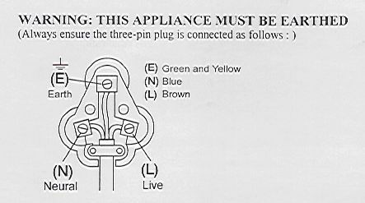
Green/Yellow = Earth
Blue = Neutral
Brown = Live

PLEASE AFFIX YOUR PROOF OF PURCHASE/RECEIPT HERE
IN THE EVENT OF A CLAIM UNDER WARRANTY THIS RECEIPT MUST BE PRODUCED.

W A R R A N T Y

- Home of Living Brands (Pty) Limited (“Home of Living Brands”) warrants to the original purchaser of this product (“the customer”) that this product will be free of defects in quality and workmanship which under normal personal, family or household use and purpose may manifest within a period of 2 (two) years from the date of purchase (“warranty period”).
- Where the customer has purchased a product and it breaks, is defective or does not work properly for the intended purpose, the customer must notify the supplier from whom the customer bought the product (“the supplier”) thereof within the warranty period. Any claim in terms of this warranty must be supported by a proof of purchase. If proof of purchase is not available, then repair, and/or service charges may be payable by the customer to the supplier.
- The faulty product must be taken to the supplier's service centre to exercise the warranty.
- The supplier will refund, repair or exchange the product in terms of this warranty subject to legislative requirements. This warranty shall be valid only where the customer has not broken the product himself, or used the product for something that it is not supposed to be used for. The warranty does not include and will not be construed to cover products damaged as a result of disaster, misuse, tamper, abuse or any unauthorised modification or repair of the product.
- This warranty will extend only to the product provided at the date of the purchase and not to any expendables attached or installed by the customer.
- If the customer requests that the supplier repairs the product and the product breaks or fails to work properly within 3 (three) months of the repair and not as a result of misuse, tampering or modification by or on behalf of the customer, then the supplier may replace the product or pay a refund to the customer.
- The customer may be responsible for certain costs where products returned are not in the original packaging, or if the packaging is damaged. This will be deducted from any refund paid to the customer.

HOME OF LIVING BRANDS (PTY) LTD (JOHANNESBURG)

JOHANNESBURG TEL NO. (011) 490-9600
CAPE TOWN TEL NO. (021) 552-5161
DURBAN TEL NO. (031) 792-6000
www.homeoflivingbrands.com
www.russellhobbs.co.za
www.facebook.com/RussellHobbsSA

