

INSTRUCTIONS AND WARRANTY

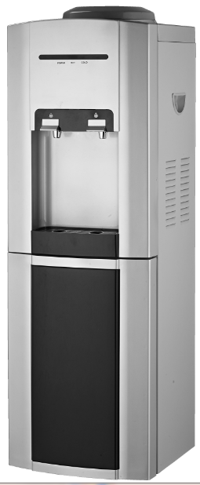

MODEL NO.: RHSWD1

Russell Hobbs Cold and Ambient Free Standing
Water Dispenser

Congratulations on purchasing our Russell Hobbs Water Dispenser. Each unit is manufactured to ensure safety and reliability. Before using this appliance for the first time, please read the instruction manual carefully and keep it for future reference.

FEATURES OF THE RUSSELL HOBBS WATER DISPENSER
- Cold and ambient water temperature
- Cold Water Temperature and Cooling Capacity: 8-12℃ 2L/h .
- Cooling Power: 85W/90W
- Over-Current Protection
- Automatic Thermostat Technology
- Stylish silver and black finish
- Can be used with the P&M Bottle or a universal pre-filtered water bottle
- Storage cabinet
- All the plastic parts are made of anti-bacteria ABS
- For domestic use only
- 2 year warranty

IMPORTANT SAFEGUARDS

- Always ensure that the voltage on the rating label corresponds to the mains voltage in your home.
- Your appliance has been designed for household and workplace use only.
- Your close supervision is necessary when the appliance is used by children, people having insufficient experience and knowledge, physically (audio, visual) or mentally handicapped people. Make sure that children do not play with the appliance.
- Use of an extension cord with this appliance is not recommended. However, if it is necessary to use an extension cord, ensure that the cord is suited to the power consumption of the appliance to avoid overheating of the extension cord, appliance or plug point. Do not place the extension cord in a position where it can be pulled on by children or animals or tripped over.
- Your water dispenser should be at least 30 cm away from heat sources such as furnace, oven, heater core, stove and electric oven, and should not be kept under direct sunlight.
- For efficient operation of your water dispenser, ambient temperature should be minimum 6°C and maximum 30°C.
- Safe operating temperature of the appliance is 45°C.
- Leave sufficient space (10-20cm) behind the water dispenser to allow for good ventilation
- If two water dispensers are placed side by side, at least 2 cm space should be left between them.
- Ensure that your water dispenser stands balanced on the flat, level ground. This should be done before the dispenser water bottle is placed.
- Before using your water dispenser, rinse out any dust (due to transportation).This can be done by running water through the dispenser taps. Empty at least one dispenser water bottle. Then empty the tanks completely by opening the water discharge stopper at the back of the water dispenser.
- While using the product, do not put a new dispenser water bottle before water in the current dispenser water bottle is completely finished. This maintains the water level inside the water dispenser.
- In case of technical problems, switch off the machine and do not attempt to repair it yourself. Return the appliance to an authorized service facility for examination, adjustment or repair. Always insist on the use of original spare parts. Failure to comply with the above mentioned pre-cautions and instructions, could affect the safe operation of this machine.
- Remove the plug from the socket by gripping the plug. Do not pull on the cord to disconnect the water dispenser from the mains. Always unplug the water dispenser when it is not in use, before cleaning, during maintenance or when removing/adding parts.
- Only use dispenser water bottles that have been designed for this water dispenser. The use of accessory attachments that are not recommended or supplied by the manufacturer may result in injury, fire/electric shock or may damage the water dispenser.
- Tear the hygienic label off the pre-filtered water bottle. Alternatively assemble the Russell Hobbs Purification and Mineralization bottle (RHPM1) suited especially for this unit.
- Place the bottle reversely into the water protector on the top part of the water dispenser.
- Keep away from other electronic appliance, e.g. TV, CD player or Stereo system.
- Store the water dispenser in a cool, shadowed area .
- Do not use the water dispenser as a supportive structure.
- Do not use the water dispenser if it has been dropped or damaged in any way.
- Do not puncture or damage the gas channels at the back of the water dispenser. If cooling gas comes into contact with skin or eyes it may cause irritation or injury. Please contact a health practitioner.
- Do not cover the water dispenser or place objects where they can block the top of the water dispenser.
- Children should be supervised to ensure that they do not play with the water dispenser.
- This product has been produced only for water heating and cooling purpose. Do not use it for cooling buttermilk drink, lemonade or drinks with high percentage of alcohol.
- Never keep products containing flammable gas (e.g. spray) and explosive materials near your appliance.
- Do not tilt your appliance more than 45° during transportation or relocation.
- Do not use damaged dispenser water bottles
- If water trap fills during daily use, please empty accumulated water.
- Do not switch the cooling function between on and off positions within 3 minutes. This is important to protect the compressor.
- In case of technical problems, switch off the water dispenser and do not attempt to repair it on your own. Take the water dispenser to an authorized service facility for examination, adjustment or repair. Always insist on the use of original spare parts. Failure to comply with the above mentioned precautions and instructions could affect the safe operation of the water dispenser.

PARTS DIAGRAM
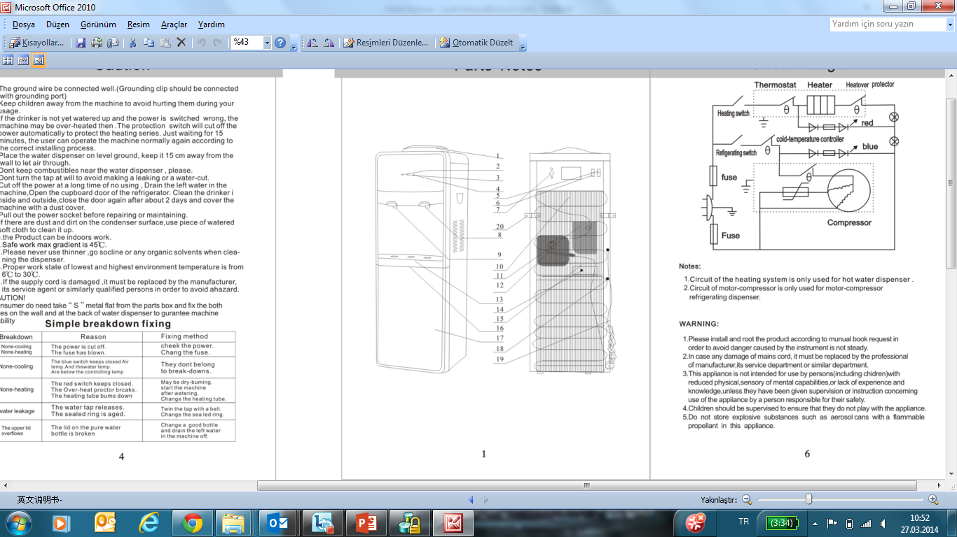

1-Top cover
2-Power indicator
4-Cooling indicator light
6-Cooling switch
7-Cold thermostat
8-Cold water taps
10-Cold water tank
12-Compressor
13-Drip box
14-Fuse
15-Condenser
16-Door
17-Cabinet
18-Drain valve
19-Power wire
20-Fixing stands

PAY ATTENTION TO THE FOLLOWING POINTS IN THE FIRST OPERATION OF THE WATER DISPENSER:

DURING THE TRANSPORTATION

Original packages and foams may be required for transportation of your water dispenser.
Points to consider during re-transportation of the product;
- Your water dispenser should be emptied and cleaned before the transportation.
- Accessories of your water dispenser should be taped down to prevent movement during transportation.
- Condenser pipes on the back of the water dispenser should be protected against impact and perforation before the packaging.
- The packaged water dispenser should be securely packed into the transportation vehicle. Packaging instructions on the box should be adhered to.
- Your appliance should not be tilted more than 45° during the transportation. Should the water dispenser be tilted more than 45˚ or stored horizontally, it should be kept in a vertical (upright position) for a minimum of 6 hours before operating.

NECESSARY ACTIONS FOR ENERGY SAVING

- Do not put hot water into the water dispenser.
- Do not place your water dispenser near heat emitting appliances such as an oven, dishwasher or heater, or in direct sunlight.
- Be sure to switch off the water dispenser if it is not going to be in use for a long period of time.

NOTE: Empty the water dispenser completely, by opening the tap and letting all the water drain out. Then open the drain valve at the back of the water dispenser and let the water drain out completely. If water is left in the water dispenser for long periods of time, it will begin to smell and may cause damage to the water tank.

PREPARATION OF THE WATER DISPENSER USING A PRE-FILTERED WATER BOTTLE:
- Tear the hygienic label on the water bottle.
- Place the bottle reversely into the water protector on the top part of the water dispenser.
- Internal center of the water protector opens and clogs the valve automatically. As the bottle moves in this time, it will automatically turn off in order to prevent probable water leakage on the valve.
- Push the water taps, bubbles which indicate that water in the bottle flows into the water tanks will occur. Continue pressing the water tap until water flow terminates.

PREPARATION OF THE WATER DISPENSER USING A RUSSELL HOBBS P&M BOTTLE:
- Assemble Water the Russell Hobbs P&M Bottle as per assembly instructions leaflet
- Add water to the Upper Barrel of your Russell Hobbs P&M Bottle and allow water to filter through the system

PLEASE NOTE: Do not switch on your appliance until water has flown through the taps for the first time.

INSTALLATION
- The Water Dispenser has two taps namely, ambient water and cold water.
- Turn on the ‘blue’ cold water power switch found at the back of your unit.
- The cold water indicator light will illuminate ‘green’ and the power indicator light will illuminate ‘yellow’, indicating that the cooling system has started to operate.
- When the power indicator light turns off automatically, the water will have reached its maximum cooling temperature of 8°C.

CLEANING AND CARE

- Before cleaning, disconnect the power of your water dispenser by unplugging it from the wall socket.
- Never use vapor or steam cleaning materials for cleaning purpose. Do not spray water directly onto the water dispenser. This may cause a short circuit or electric shock, should the water/ water vapour come into contact with the electrical circuits.
- Clean the outer surfaces of the water dispenser by wiping with a soft damp cloth. Do not use abrasive cleaners such as bleach or detergents. Use a little baking soda dissolved in warm water.
- Keep the area around the water dispenser free of dust by using a brush or vacuum cleaner. If the condenser becomes dirty, clean with a soft damp cloth.
- Dry the appliance completely after cleaning.

CAUTION: In case of sudden power failure after first use, unplug the unit, as the pressure of gas in the cooling system of your appliance has not been balanced yet.

IN CASE OF ANY POWER FAILURE
- Within the first six hours of the first use, unplug the water dispenser, wait for one hour then plug in the water dispenser.
- If it occurs after the first six hours of operation, your appliance will start to operate automatically after 10 minutes.
- If your appliance has not started to cool after the above mentioned time periods, call the Authorized Service Centre.

TROUBLESHOOTING

Trouble | Probable Cause
Water dispenser does not operate | It is not plugged in.  Fuse has blown or failed.
Tap water is not sufficiently cold | Ensure that cold water button on the back is open.  Water dispenser has been placed incorrectly, distance between the wall and appliance is not sufficient.
Compressor is operating and stopping frequently | Room temperature is over the normal temperature.  Water dispenser has been placed incorrectly, distance between the wall and appliance is not sufficient.
It vibrates | Ensure that the water dispenser is placed in a balanced manner.
Produces noise during operation. | Noise may be caused from flow of cooling agent, this is normal.  You can hear a flow sound at the end of each circulation.  Clinking sounds may occur as a result of contradiction and expansion because of heating and cooling of water tanks.  Ensure that the water dispenser is placed in a balanced manner.

SERVICING THE APPLIANCE
There are no user serviceable parts in this appliance. If the unit is not operating correctly, please check the following:
- You have followed the instructions correctly
- That the unit has been wired correctly and that the wall socket is switched on.
- That the mains power supply is ON.
- That the plug is firmly in the mains socket.

If the appliance still does not work after checking the above:
- Consult the retailer for possible repair or replacement. If the retailer fails to resolve the problem and you need to return the appliance, make sure that:
- The unit is packed carefully back into its original packaging.
-Proof of purchase is attached.
-A reason is provided for why it is being returned.

If the supply cord is damaged, it must be replaced by the manufacturer or an authorised service agent, in order to avoid any hazard. If service becomes necessary within the warranty period, the appliance should be returned to an approved Home of Living Brands (Pty) Ltd service centre. Servicing outside the warranty period is still available, but will, however, be chargeable.
CHANGING THE PLUG
Should the need arise to change the fitted plug, follow the instructions below.
Connecting to other power sources may damage the appliance. Connect a three-pin plug as follows: The wires in this mains lead are coloured in accordance with the following code:
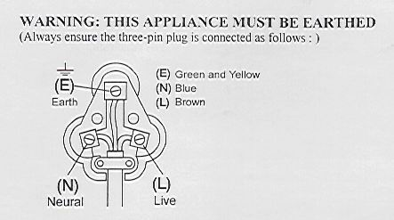
Green/Yellow = Earth
Blue = Neutral
Brown = Live

PLEASE AFFIX YOUR PROOF OF PURCHASE/RECEIPT HERE
IN THE EVENT OF A CLAIM UNDER WARRANTY THIS RECEIPT MUST BE PRODUCED.

2 YEAR WARRANTY
1 year retail ⵏ 1 year extended warranty upon registration*
visit www.russellhobbs.co.za

W A R R A N T Y AND EXTENDED WARRANTY

- Home of Living Brands (Pty) Limited ("Home of Living Brands") warrants to the original purchaser of this product ("the customer") that this product will be free of defects in quality and workmanship which under normal personal, family or household use and purpose may manifest within a period of 1 (one) year from the date of purchase ("warranty period").
- Home of Living Brands shall extend the warranty period for a further period of 1(one) year (“extended warranty period*”), on condition that the purchaser registers the product on the website, within 12 months from the date of purchase of the product. The website address for registration is as follows: http://russellhobbs.co.za/info-pages/warranty-info.aspx. The extended warranty period only applies to products purchased on or after 1 October 2017.
- Where the customer has purchased a product and it breaks, is defective or does not work properly for the intended purpose, the customer must notify the supplier from whom the customer bought the product ("the supplier") thereof within the warranty period or if applicable, the extended warranty period. Any claim in terms of this warranty must be supported by a proof of purchase. If proof of purchase is not available, then repair, and/or service charges may be payable by the customer to the supplier.
- The faulty product must be taken to the supplier's service centre to exercise the warranty.
- The supplier will refund, repair or exchange the product in terms of this warranty subject to legislative requirements. This warranty shall be valid only where the customer has not broken the product themselves, or used the product for something that it is not supposed to be used for. The warranty does not include and will not be construed to cover products damaged as a result of disaster, misuse, tamper, abuse or any unauthorised modification or repair of the product.
- This warranty will extend only to the product provided at the date of the purchase and not to any expendables attached or installed by the customer.
- If the customer requests that the supplier repairs the product and the product breaks or fails to work properly within 3 (three) months of the repair and not as a result of misuse, tampering or modification by or on behalf of the customer, then the supplier may replace the product or pay a refund to the customer, subject to the supplier’s discretion.
- The customer may be responsible for certain costs where products returned are not in the original packaging, or if the packaging is damaged. This will be deducted from any refund paid to the customer.

HOME OF LIVING BRANDS (PTY) LTD (JOHANNESBURG)
JOHANNESBURG TEL NO. (011) 490-9600
CAPE TOWN TEL NO. (021) 552-5161
DURBAN TEL NO. (031) 303-1163
www.homeoflivingbrands.com
www.russellhobbs.co.za
www.facebook.com/RussellHobbsSA

