

INSTRUCTIONS AND WARRANTY

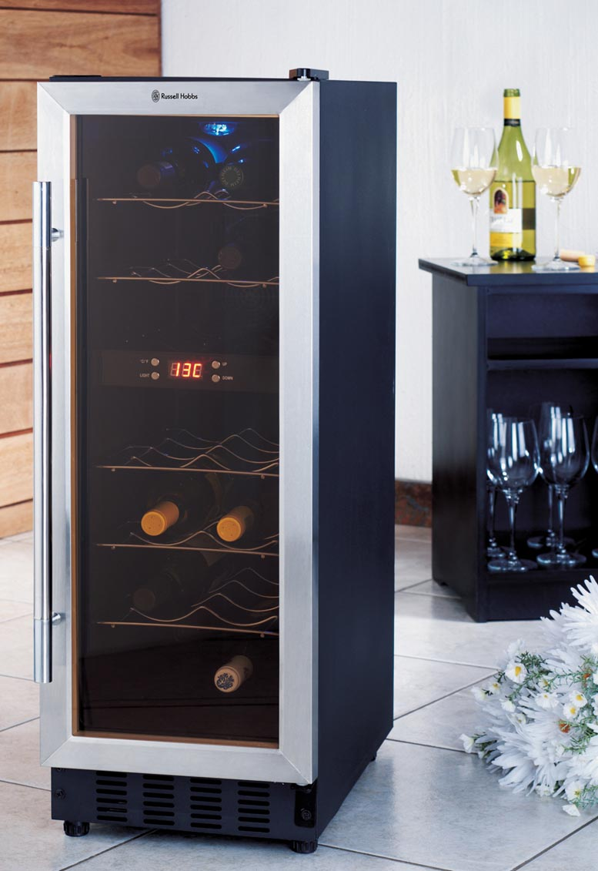

MODEL NO. RHWC14

RUSSELL HOBBS THERMOELECTRIC

WINE COOLER (14 BOTTLES)

Congratulations on purchasing our RUSSELL HOBBS WINE COOLER. Each unit is manufactured to ensure safety and reliability. Before using this appliance for the first time, please read the instruction manual carefully and keep it for future reference.

IMPORTANT SAFEGUARDS
When using any electrical appliance, basic safety precautions should always be followed including the following:

- Please read the instructions carefully before using any appliance.
- Always ensure that the voltage on the rating label corresponds to the mains voltage in your home.
- Incorrect operation and improper use can damage the appliance and cause injury to the user.
- The appliance is intended for household use only. Commercial use invalids the warranty and the supplier cannot be held responsible for injury or damage caused when using the appliance for any other purpose than that intended.
- Avoid any contact with moving parts.
- Close supervision is required when any appliance is used near or by children or invalids.
- Check the power cord and plug regularly for any damage. If the cord or the plug is damaged, it must be replaced by the manufacturer or a qualified person in order to avoid an electrical hazard.
- Do not use the appliance if it has been dropped or damaged in any way. In case of damage, take the unit in for examination and/or repair by an authorised service agent.
- To reduce the risk of electric shock, do not immerse or expose the motor assembly, plug or the power cord to water or any other liquid.
- Never immerse the unit in water or any other liquid for cleaning purposes.
- Remove the plug from the socket by gripping the plug. Do not pull on the cord to disconnect the appliance from the mains. Always unplug the unit when not in use, before cleaning or when adding or removing parts.
- The use of accessory attachments that are not recommended or supplied by the manufacturer may result in injuries, fire or electric shock.
- A short cord is provided to reduce the hazards resulting from becoming entangled in or tripping over a longer cord.
- Do not let the cord hang over the edge of a table or counter. Ensure that the cord is not in a position where it can be pulled on inadvertently.
- Do not allow the cord to touch hot surfaces and do not place on or near a hot gas or electric burner or in a heated oven.
- Do not use the appliance on a gas or electric cooking top or over or near an open flame.
- Use of an extension cord with this appliance is not recommended. However, if it is necessary to use an extension lead, ensure that the lead is suited to the power consumption of the appliance to avoid overheating of the extension cord, appliance or plug point. Do not place the extension cord in a position where it can be pulled on by children or animals or tripped over.
- This appliance is not suitable for outdoor use. Do not use this appliance for anything other than its intended use.
- DO NOT carry the appliance by the power cord.
- Do not leave this appliance unattended during use. Always unplug the unit when not in use or before cleaning.
- Always operate the appliance on a smooth, even, stable surface. Do not place the unit on a hot surface.
- Ensure that the switch is in the “Off” position after each use.
- The manufacturer does not accept responsibility for any damage or injury caused by improper or incorrect use, or for repairs carried out by unauthorised personnel.
- In case of technical problems, switch off the machine and do not attempt to repair it yourself. Return the appliance to an authorised service facility for examination, adjustment or repair. Always insist on the use of original spare parts. Failure to comply with the above mentioned pre-cautions and instructions, could affect the safe operation of this machine.
- This appliance is not intended for use by persons (including children) with reduced physical, sensory or mental capabilities, or lack of experience and knowledge, unless they have been given supervision or instruction concerning use of the appliance by a person responsible for their safety.

Please NOTE!
After removing the refrigerator from the package, make sure it is in good condition. In case of doubt, do not use it and contact an authorized service center.
Plastic bags, nails, etc should be kept out of reach of children. Read the operation manual carefully and check that the voltage rating is corresponding to your local power supply.
This refrigerator should only be used as specified. The manufacturer will not be held responsible for any damage due to improper use or repairs made by unqualified personnel.

Caution!
- To reduce the risk of fire, replace only with the same type of fuse.
- Do not use extension cords.

TECHNICAL DATA
Type
Volume(liter) |  | 42L
Material | Case | Iron
Material | Door | Glass
Unit Dimension  (WxHxD)(mm) |  | 300x864x554
Packaging Dimension  (WxHxD)(mm) |  | 340x900x600
Net Weight(KG) |  | 20
Gross weight(KG) |  | 22
Power Consumption |  | 65-70W
Fitting ambient temperature range of working |  | ＜25℃
Temperature range |  | 8℃-22℃
Rated Voltage |  | AC230V
Rated Frequency |  | 50Hz

ILLUSTRATED STRUCTURE
- Door
- Ream cover
- Light
- Shelf
- Fan mask
- Control PCB
- Window
- Foot

OPERATION OF WINE COOLER

This product is for storage purposes, for items with temperature ranges from 10℃ to 18℃. The control panel is in the middle of the box with LED temperature display window.

You can use this wine cooler as follows:
Button 1 for choice Celsius or Fahrenheit scale.
Button 2 for setting the temperature up.
Button 3 for setting the temperature down.
Button 4 for turning on/off the light.

PARTICULAR PRECAUTIONS
- In order to function at its highest potential, this wine cooler needs be placed on a flat surface, with 10cm space at the back side.
- Avoid direct sunshine and high temperatures.

MAINTENANCE
- Shut off power supply before cleaning cabinet.
- Take out wine and shelves, and then clean the cabinet with soda water first and with fresh water.
- Do not use soap or detergent for the cabinet.
- Clean the cellar regularly.

TROUBLE SHOOTING
Symptoms | Possible cause | solutions
No cooling | - Plug not put in  - Low voltage  - Fuse broken | - Put in plug  - Ensure normal voltage  - Change fuse
Temperature inside not cold enough | - The refrigerator is placed too close to a heat source  - Bad ventilation  - Fans don’t work  - The door is not closed tightly or opened too frequently or for too long time. | - Keep the refrigerator away from sunshine or other heat source  - Place the refrigerator in the area with good ventilation and keep things away from the fans  - Check whether the plug is connected or change the fan  - Close the door tightly and don’t open the door too frequently or for too long time
Peculiar smell inside refrigerator | Check whether there is anything sour inside | Wrap the source or take it out
Inside light flashes | - Set temperature higher than inner  - The automatic defrost function start to work | - Adjust the adjustor  - Normal function. No repair needed
Frost on the cold sink | Too much humidity or too low temperature inside the case | Output the plug, stop the power, and defrost by hand, connect power again when the ice thaws.

SERVICING THE APPLIANCE
There are no user serviceable parts in this appliance. If the unit is not operating correctly, please check the following:
- You have followed the instructions correctly.
- That the unit has been wired correctly and that the wall socket is switched on.
- That the mains power supply is ON.
- That the plug is firmly in the mains socket.

If the appliance still does not work after checking the above:
Consult the retailer for possible repair or replacement. If the retailer fails to resolve the problem and you need to return the appliance, make sure that:
- The unit is packed carefully back into its original packaging.
- Proof of purchase is attached.
- A reason is provided for why it is being returned.

If the supply cord is damaged, it must be replaced by the manufacturer or an authorised service agent, in order to avoid any hazard. If service becomes necessary within the warranty period, the appliance should be returned to an approved Amalgamated Appliances / Tedelex Trading (Pty) Ltd service centre. Servicing outside the warranty period is still available, but will, however, be chargeable.

CHANGING THE PLUG
Should the need arise to change the fitted plug, follow the instructions below.
This unit is designed to operate on the specified current (on the rating label of the product) only. Connecting to other power sources may damage the appliance. Connect a three-pin plug as follows:
The wires in this mains lead are coloured in accordance with the following code:
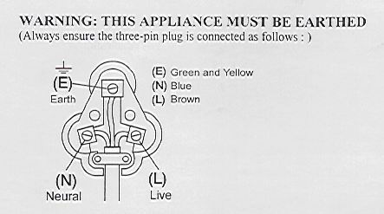
Green/Yellow = Earth
Blue = Neutral
Brown = Live

PLEASE AFFIX YOUR PROOF OF PURCHASE/RECEIPT HERE
IN THE EVENT OF A CLAIM UNDER WARRANTY THIS RECEIPT MUST BE PRODUCED.

W A R R A N T Y
Amalgamated Appliances (Pty) Limited (“the Supplier”) warrants to the original purchaser of this product (“the Customer”) that this product will be free of defects in material and workmanship which under normal, personal, family or household purpose manifest themselves within a period of 365 days from the date of purchase or in respect of commercial or professional purposes, manifest themselves within a period of 90 days from the date of purchase. Any claim in terms of the warranty must be supported by a proof of purchase. If such proof is not available, then notwithstanding anything to the contrary herein, the Supplier’s normal charge for service and/or spares will be payable by the Customer upon collection of the repaired product. If a claim is made in terms of the aforesaid warranty within the first 7 days from the date of purchase, the faulty product will be exchanged (provided that the product is in its original packaging with all accessories). Failing return of the product within 7 days, the Supplier’s liability shall be limited on return to the Supplier of the product or parts thereof, to the replacement or repair (in the sole discretion of the Supplier, or its duly authorised service dealer) of the product to eliminate any defect in workmanship or materials found to be due exclusively to any acts or omissions on the parts of the Suppliers, of which defects the Supplier shall have been notified in writing by the Customer within the aforesaid warranty period. The warranty provided herein and the obligations of the Supplier as aforesaid are in lieu of, and the Customer waives, all other warranties, guarantees, conditions or liabilities, express or implied, arising by law or otherwise, including without limitation, any obligation of the Supplier in respect of any injury, loss or damage (direct, indirect or consequential) arising out of the use of, or inability to use, this product and whether or not occasioned by the Supplier’s negligence (gross or otherwise) or any act or omission on its part. The warranty does not include and will not be construed to cover products damaged as a result of disaster, misuse, abuse or any non-authorised modification of the product. The warranty does not include replacement of light bulbs, heater bars, paper bags or any glass, plastic bowl or jug or other expendables. During the warranty period the product should be taken to a service centre of the Supplier or one of its duly authorised service agents. The Supplier neither assumes nor authorises any other person to assume for it, any additional liability in connection with the sale or servicing of its products.

AMALGAMATED APPLIANCES/ TEDELEX TRADING (PTY) LTD
JOHANNESBURG TEL NO. (011) 490-9000
29 HERONMERE ROAD
P O BOX 39186
BOOYSENS, JOHANNESBURG, 2016
CAPE TOWN TEL NO. (021) 535-0600
DURBAN TEL NO. (031) 792-6000

