

INSTRUCTIONS AND WARRANTY
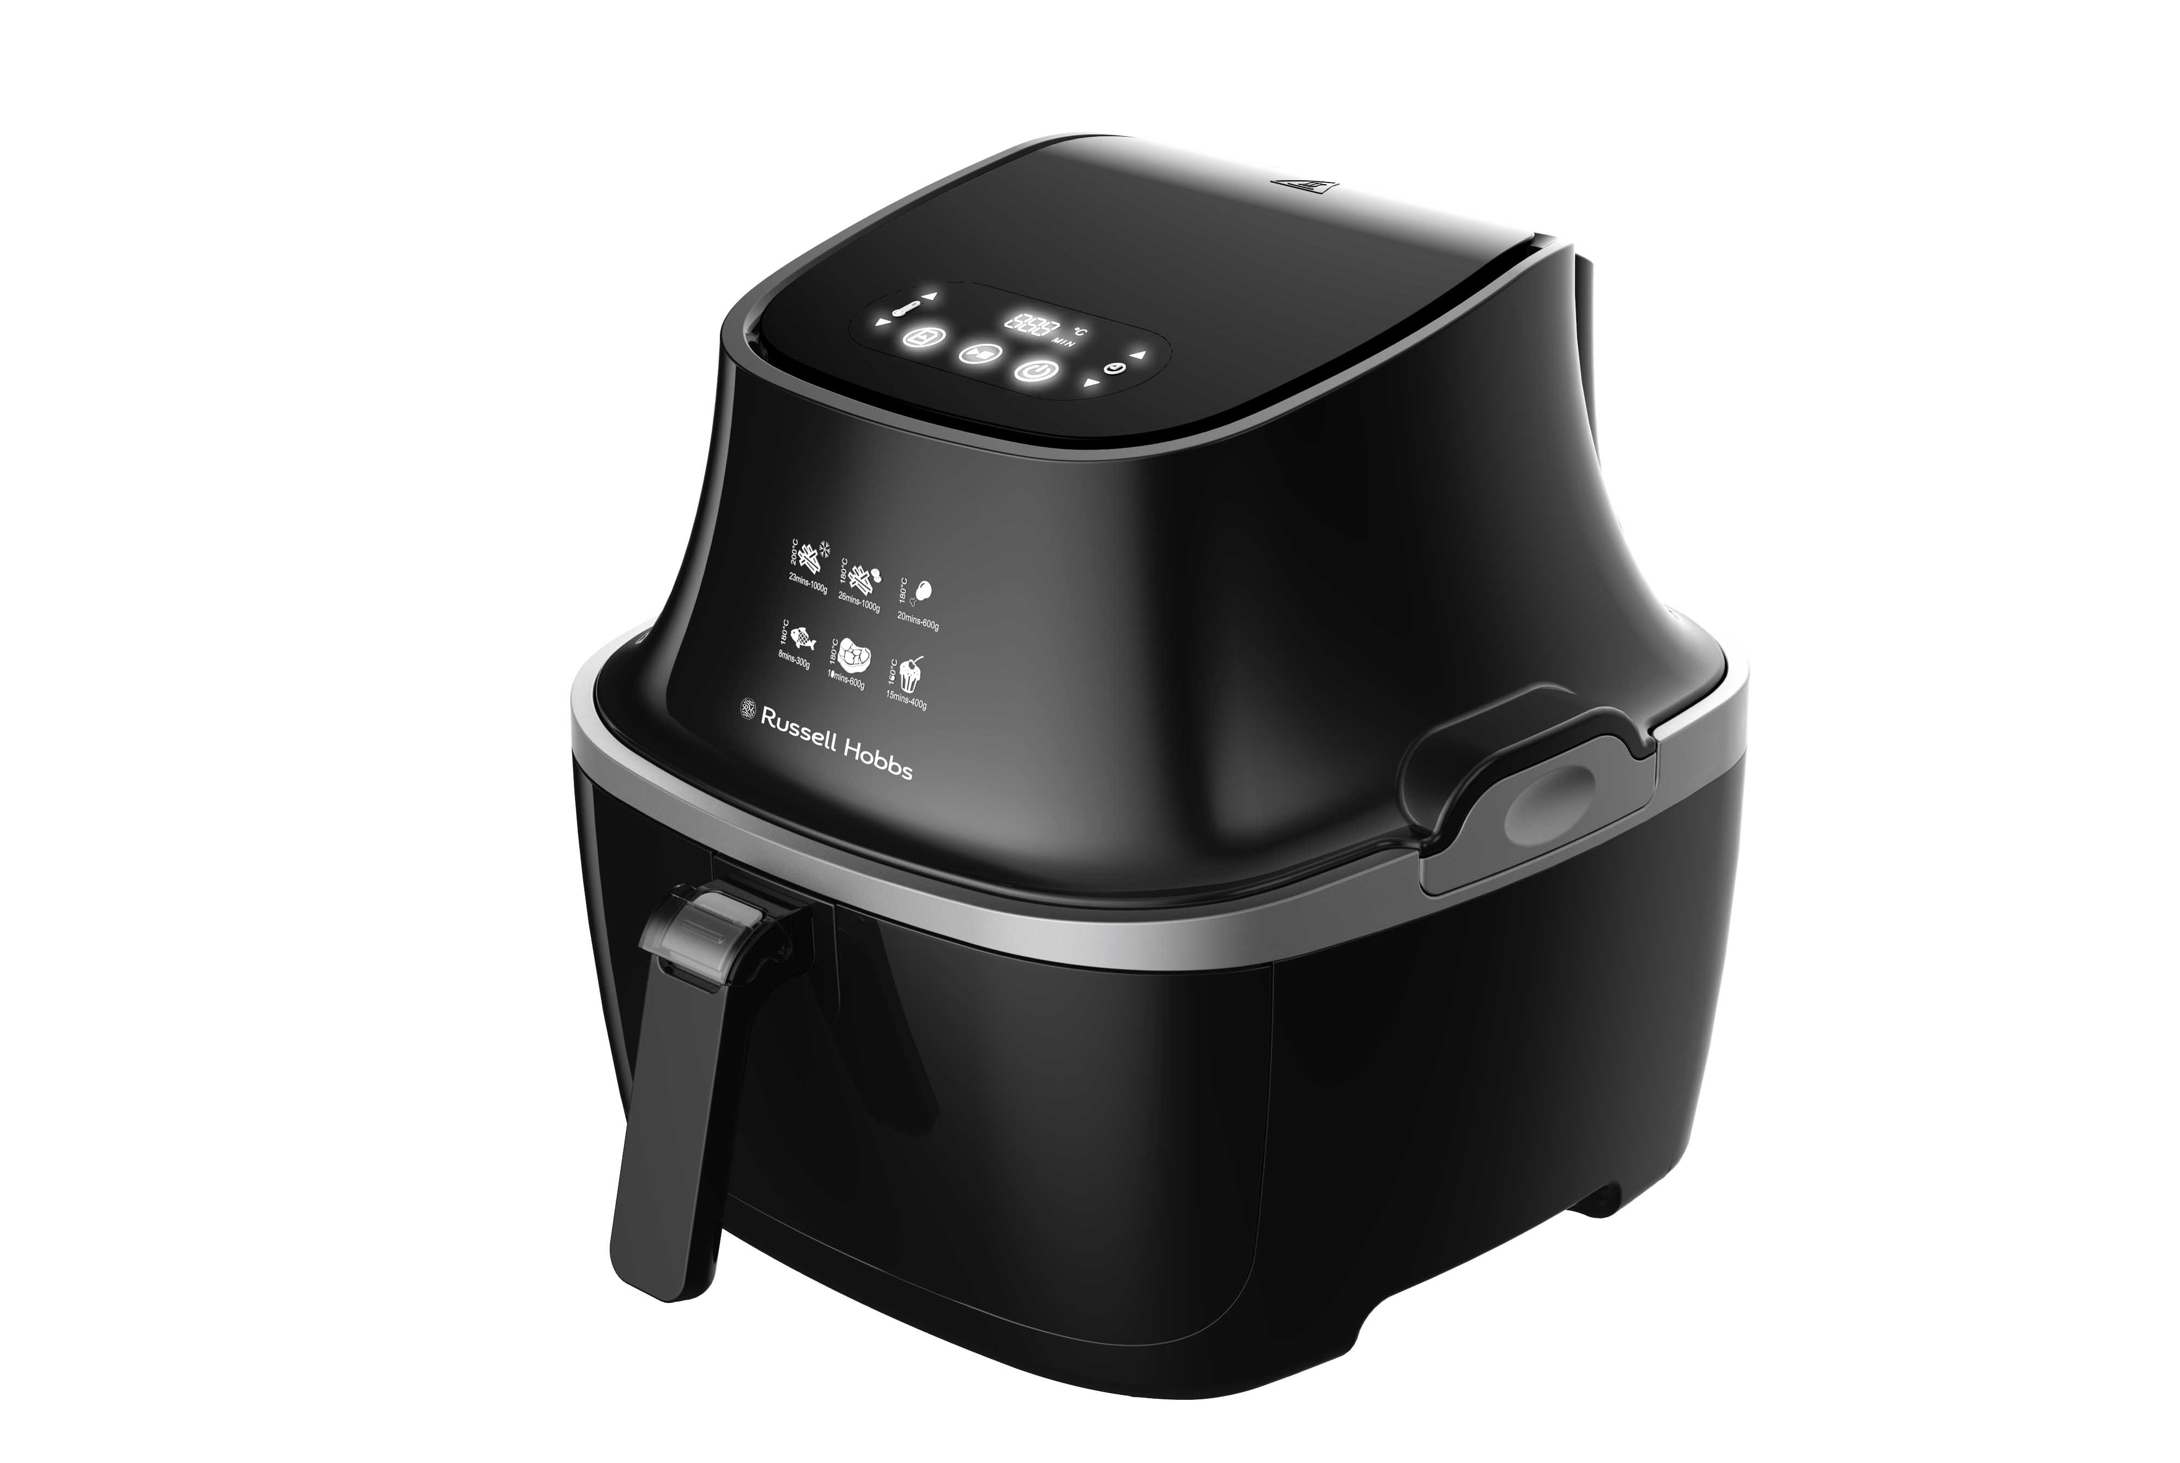

MODEL NO. RHXL3000

PURIFRY MAX AIR FRYER

Congratulations on purchasing our Russell Hobbs Purifry Max Air Fryer. Each unit is manufactured to ensure safety and reliability. Before using this appliance for the first time, please read the instruction manual carefully and keep it for future reference.

FEATURES OF THE RUSSELL HOBBS PURIFRY MAX AIR FRYER
The Purifry Max Air Fryer from Russell Hobbs uses clever technology to harness the cooking power of pure, fast-circulating air to cook family favourites like chips or chicken nuggets without using oil or fat. The coatings are still crispy and the taste will speak for itself.

- Powerful 2050W Air fryer for the fastest and crispiest cooking results
- Large family size 3.2L capacity: fits whole chicken or 500g of fries
- Crispy and tasty fried food with little to no oil
- Innovative detachable and dish-washable heating element for easy cleaning
- Simple to use, easy to clean - unlock and lift up for easy cleaning
- Digital Touch screen
- Adjustable timer and temperature for customized cooking
- Heats up to 200℃ for fast and evenly cooked meals
- Smart Memory Technology - Save your desired time and temperature settings for all your favorite meals
- Intelligent pause and stop button - able to remove pot whilst cooking and machine will pause and resume cooking once the pot is put back into the tray
- Uses patented "Cyclone Heating Technology": Provides 80% faster and oil less cooking
- Provides crispy and delicious meals for the whole family
- Versatile, fast & family sized
- Fry, bake, grill and roast your favorite and tastiest meals at home
- Recipes included
- For domestic use only
- 2 years warranty

IMPORTANT SAFEGUARDS
When using any electrical appliance, basic safety precautions should always be followed including the following:

- Please read the instructions carefully before using any appliance.
- Always ensure that the voltage on the rating label corresponds to the mains voltage in your home.
- Incorrect operation and improper use can damage the appliance and cause injury to the user.
- The appliance is intended for household use only. Commercial use invalids the warranty and the supplier cannot be held responsible for injury or damage caused when using the appliance for any other purpose than that intended.
- Avoid any contact with moving parts.
- This appliance is not intended for use by persons (including children) with reduced physical, sensory or mental capabilities, or lack of experience and knowledge, unless they have been given supervision or instruction concerning use of the appliance by a person responsible for their safety.
- Children should be supervised to ensure that they do not play with the appliance.
- Check the power cord and plug regularly for any damage. If the cord or the plug is damaged, the manufacturer or a qualified person must replace it in order to avoid an electrical hazard.
- Do not allow this appliance to touch curtains, wall coverings, clothing, dishtowels or other flammable materials during use. Allow a minimum of 200mm distance. Caution is required on surfaces where heat may cause damage - an insulated heat pad is recommended. Never place the appliance on a plastic, fabric or carpeted surface while cooking.
- The appliance is not intended to be operated by means of an external timer or separate remote control system.
- Do not touch hot surfaces – use the handles and knobs.
- Let the unit cool down completely before you clean or store it.
- Extreme caution must be used when moving the unit. It is recommended that you do not move it when it is switched on or before it has cooled down.
- Do not use the appliance if it has been dropped or damaged in any way. In case of damage, take the unit in for examination and/or repair by an authorised service agent.
- Do not use harsh abrasives, caustic cleaners or oven cleaners when cleaning this appliance.
- To reduce the risk of electric shock, do not immerse or expose the body, plug or the power cord to water or any other liquid.
- Remove the plug from the socket by gripping the plug. Do not pull on the cord to disconnect the appliance from the mains. Always unplug the unit when not in use, before cleaning or when adding or removing parts.
- A short detachable cord is provided to reduce the hazards resulting from becoming entangled in or tripping over a longer cord.
- Do not let the cord hang over the edge of a table or counter. Ensure that the cord is not in a position where it can be pulled on inadvertently.
- Do not allow the cord to touch hot surfaces and do not place on or near a hot gas or electric burner or in a heated oven.
- Do not use the appliance on a gas or electric cooking top or over or near an open flame.
- Use of an extension cord with the appliance is not recommended. However, if it is necessary to use an extension lead, ensure that the lead is suited to the power consumption of the appliance to avoid overheating of the extension cord, appliance or plug point. Do not place the extension cord in a position where it can be pulled on by children or animals, or tripped over.
- This appliance is not suitable for outdoor use. For household use only. Do not use this appliance for anything other than its intended use.
- DO NOT carry the appliance by the power cord.
- Do not leave the appliance unattended during use. Always unplug the unit when not in use or before cleaning.
- Ensure that the switch is in the “OFF” or “O” position after each use.
- The manufacturer does not accept responsibility for any damage or injury caused by improper or incorrect use, or for repairs carried out by unauthorised personnel.
- In case of technical problems, switch off the machine and do not attempt to repair it yourself. Return the appliance to an authorised service facility for examination, adjustment or repair. Always insist on the use of original spare parts. Failure to comply with the above mentioned pre-cautions and instructions, could affect the safe operation of this machine.
- Do not use accessories or attachments other than those we supply.
- Do not use anything metal or sharp, you will damage the non-stick surfaces.
- Keep clear of the vent at the rear of the appliance – hot air will immerse from it.
IMPORTANT: In case your Purifry Health Fryer switches off before cooking has completed, there is a reset button located at the bottom of the unit that you must press to proceed with cooking. Please use a non-metallic rod such as a toothpick or plastic knitting needle.

PARTS DIAGRAM

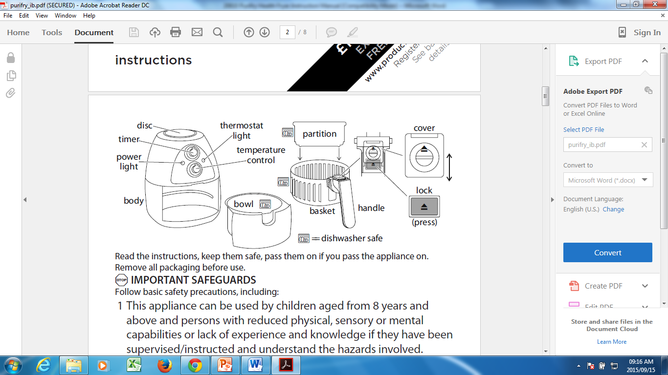

BEFORE FIRST USE
- Before using the unit for the first time, remove any packaging material and carefully clean it using warm, soapy water - rinse and dry.

REMOVING THE BOWL AND BASKET
- The handle serves the bowl and the basket.
- To remove the bowl from the body, place one hand on the disc on top of the body, grip the handle with the other hand, and pull the bowl out of the body.
- Rest the bowl out on an insulated heat pad.
- To remove the basket from the bowl, slide the cover away from the handle to expose most of the lock and press the lock down.
- To unlock the handle from the bowl, lift the handle and basket up and out of the bowl.

HOW TO USE
- Sit the unit on a heat-resistant surface.
- Insert the plug into a power socket and switch the power socket on.
- Set the temperature to your desired level. In addition, set the timer for 3-5 minutes to preheat the appliance.
- The power light will go on, showing that the unit is now on.
- The thermostat light will go on, then cycle on and off as it maintains the right temperature.
- Once the thermostat light goes off, carefully remove the bowl as per the previous instruction.
- If you are preparing two different meals at the same time, fit the partition.
- Put the food into the basket, ensuring not to overfill.
- Leave enough space between pieces of food to allow the hot air to circulate.
- Slide the bowl back into the body.
- Set the timer to the time you need – see “RECOMMENDED COOKING TIMES”.

HALF-WAY THROUGH COOKING
- About half way through cooking, remove the bowl as per the previous instruction, give it a bit of a shake, and/or turn the food over, and then place the bowl in the body again.
- The thermostat light will switch off when you remove the bowl, however, it will switch on again when you re-place the bowl. The timer will continue to count down.
- When the timer returns to 0 and the bell sounds, switch the unit off from the power socket and unplug the unit.
- If you wish to switch the unit off manually, simply turn the timer to 0.
- Remove the bowl as per the previous instruction and carefully place it on an insulated heat pad.
- Press the lock down, and lift the handle and basket up and out of the bowl.

RECOMMENDED COOKING TIMES
food | b °C | time (min) | shake/turn the food half way through cooking
frozen chips/potato wedges | 200 | 12-20 | a single layer of chips – 12 minutes basket half full – 15 minutes  basket full (loosely, not packed) – 20 minutes
fresh chips | 200 | 20 | peel, cut, rinse, towel dry, toss in salt, pepper and 1 tsp oil
fresh potato wedges | 200 | 20 | rinse, towel dry, cut, toss in salt, pepper, and 1 tsp oil
jacket potatoes | 180 | 30-40 | for a crispy jacket, rub with oil
roast potatoes | 180 | 25-35 | peel, cut, rinse, towel dry, toss in salt, pepper, crushed rosemary (optional) and 1 tsp oil
frozen onion rings | 180 | 15
frozen fishcakes large | 180 | 20-25
frozen fishcakes small | 180 | 15-20
fresh fishcakes large | 180 | 15-20
fresh fishcakes small | 180 | 10
frozen scampi (in crumbs) | 180 | 10-15
fish goujons | 180 | 10 | cut fish in strips, roll in egg, then in seasoned crumb
frozen samosas | 180 | 20
fresh samosas | 180 | 10-15
frozen duck rolls | 180 | 20
fresh duck rolls | 180 | 10-15
boneless preformed chicken products (frozen) | 180 | 15
fresh chicken goujons | 180 | 10-15 | cut meat in strips, roll in egg, then in seasoned crumb
schnitzel (chicken/veal/ pork) | 180 | 15 | hammer meat flat, coat in egg, then in seasoned crumb
chicken thighs | 180 | 25-30 | cooking time depends on size
tortillas | 200 | 5-10 | for a crispy finish, rub with oil
Scotch eggs | 170 | 15-20 | cooking time depends on size
stir fry | 180 | 25-30 | toss in salt, pepper, and 1 tsp oil, add a little sauce 5 minutes before the end (chilli, sweet chilli, garlic, etc)
sausages | 180 | 10 | the fat drips into the bowl, away from the sausages

RECIPES

Onion Rings
White onion(s)
Milk
Seasoned flour
Oil
Slice the onion(s), dip in milk, then seasoned flour, drizzle with oil and cook at 180 for 12-15 minutes.

Mini Salmon Fishcakes
½ onion
2 sprigs fresh parsley pinch of chilli
1 good sized salmon fillet
5-6 tbsp breadcrumbs
Egg, lightly beaten
Seasoned flour
Salt and pepper
Preheat at 180.
Blend the onion and parsley for a few seconds, add the salmon, chilli, a generous pinch of both salt and pepper, and blend for 5-10 seconds. Transfer to a bowl, and fold in 2 tbsp breadcrumbs. Divide the mix into 10 portions (or 4 portions, if you want large fishcakes).
Roll each portion into a ball, coat in egg, then breadcrumbs, flatten the balls and cook for 10-15 minutes for small fishcakes, or 15-20 minutes for large fishcakes, turning them about half way through cooking.

Chicken Kiev
Skinned chicken breasts
2 cloves fresh garlic
50g salted butter
2 sprigs fresh parsley
1 egg lightly beaten
Breadcrumbs (either packet or home-made)
Pepper to taste
Preheat at 180.
Blend the garlic, parsley and a generous pinch of pepper for 10-20 seconds, add the butter, and blend for 15 seconds.
Slice each chicken breast along the long edge (do not cut completely in half) and open into a butterfly shape. Cover with cling film and hit with a rolling pin to flatten slightly.
Put a good spoonful of the mixture in the middle of each breast, and then roll the chicken over the mix so it overlaps and leaves no exit for the mix to escape. You will now have a tight roll in the shape of a chicken breast (a fat version of its original shape). Dip the chicken into the seasoned flour, then into the egg and finally roll in the breadcrumbs, coating the chicken completely.
Repeat this for the second breast.
If you have time, leave the chicken on greaseproof paper in the fridge for an hour to rest. Cook for 30-35 minutes. Turn after 15-20 minutes, to ensure a lovely golden colour all over.

Victoria Sponge
100g self raising flour
100g soft butter
100g caster sugar
2 eggs
Mix everything together with a hand or stand mixer for 2 minutes. Put a large paper case in the basket. Spoon the mixture into the paper case. Smooth with a spoon or spatula, leaving a small dent in the centre, to stop the cake from rising too much in the middle. Cook for 15 - 20 minutes. Don’t check till at least 10 minutes baking time has passed, or you will collapse the sponge.

Scotch Eggs
500g beef (for mincing) or 500g minced beef
1 onion
2 sprigs thyme
2 sprigs parsley
Pinch cayenne pepper salt and pepper
5 eggs (one for egg wash) breadcrumbs
Flour for coating oil for cooking
If you’re using a mincer, mince the beef and onion together. If you’ve bought mince, chop or blend the onion finely, and mix into the mince with the salt, pepper, cayenne pepper and chopped herbs.
Boil 4 eggs till soft boiled with slightly runny yolks. Carefully peel the shells from the eggs. Coat the eggs in flour then cover completely in the minced meat. Roll the ball in the egg, then the breadcrumbs. Cook at 170 for about 15 minutes, turning occasionally.

Mustard and Honey Pork Loin with Roasted Vegetables
Piece pork loin, about the thickness of 4 chops
2 carrots, peeled and cut into chunks
Parsnips, peeled and cut into chunks
2 red onions, quartered
6 large cherry tomatoes
2 courgettes, cut into chunks
2 tbsp grainy mustard
Tbsp runny honey
1 tbsp oil
Salt and pepper
Preheat at 170.
Stir the vegetables in a bowl with the oil, salt and pepper, ensuring all are well coated. Mix the mustard and honey in a dish, then smear all over the loin.
Put the loin in the centre of the basket, and spoon the vegetables round it. Cook at 170 for 40 minutes to 1 hour, depending upon the size of the loin. Turn the loin after 15 minutes and stir the vegetables. Check again at 30 minutes.

Chicken Schnitzel
2 large chicken breasts
1 large egg
2 tbsp seasoned flour
75g breadcrumbs
Dried zest of ½ a lemon
15g parmesan, grated
1 heaped tbsp parsley, finely chopped
Olive oil spray
Salt and freshly ground black pepper
Preheat at 180.
Slice each chicken breast along the long edge (do not cut completely in half) and open into a butterfly shape. Cover with cling film and hit with a rolling pin to flatten slightly.
Beat the egg in a bowl. Sprinkle the seasoned flour on a plate. Mix the breadcrumbs with the lemon zest, parmesan and parsley. Coat each piece of chicken in flour, then beaten egg, then the breadcrumb mixture. Drizzle a little oil over the schnitzels and cook at 180 for 15-20 minutes.

Veal/Pork Schnitzel
Follow the recipe for chicken schnitzel, but substitute 2 pieces of breast of veal or two pieces of pork, bones and fat removed.

Yorkshire Pudding Batter
1 egg
85g self raising flour
25ml milk
1 tsp oil
1 tsp butter
Salt and pepper
Whisk the egg, then whisk in the flour, oil, butter, salt and pepper to create a thick paste. Whisk in the milk till it becomes a thin batter. Rest in the fridge for a couple of hours, or overnight if possible. This allows the batter to thicken, however if it is too thick when it comes out of the fridge, you can add a drop of milk.
Preheat at 200.
Pour a little oil into small metal cake containers or foil pastry cases and heat in the basket for 2 minutes. Carefully pour the batter into the containers, till they are about a third full. Cook for 10- 15 minutes, depending upon the size and number in the fryer. Turn to 165 after 5 minutes. They should be golden brown and double in size.
Top tip: Freeze the Yorkshire puddings and bring out when required. Just pop them in the fryer for a couple of minutes to heat through.
Christmas tip: If you make mini Yorkshire puddings you can use them as Christmas canapés, just add a small slice of rare roast beef and a blob of horseradish.

CLEANING AND MAINTENANCE
- Before cleaning, switch the unit off and disconnect the plug from the power socket.
- Allow the unit to cool.
- Wipe the unit with warm, soapy water using a sponge or dishcloth only. Normal dish washing liquid should be sufficient.
- Use a non-abrasive sponge or damp dish cloth to clean the exterior of the unit. Do not use bleach, solvents, abrasive cleaners or scouring pads to clean the exterior of your appliance as it can be damaging to the finish.
- You may wash the removable parts in a dishwasher from time to time, but hand wash is recommended. A dishwasher may cause the surface to deteriorate, however, this will not affect the operation of the appliance.
- This appliance is for household use only and is not user-serviceable.
- Do not open or change any parts by yourself. Please refer to a qualified electrical service department or return to the supplier if servicing is necessary.
- Let parts dry completely before reassembling.

STORING THE APPLIANCE
- Unplug the unit from the power socket and clean all the parts as instructed above. Ensure that all parts are dry before storing.
- Store the appliance in its box or in a clean, dry place.
- Never store the appliance while it is still wet or dirty.
- Never wrap the power cord around the appliance.
- Take caution when storing the temperature control knob – do not knock or drop it as that may damage it. If damage is suspected, report it to customer services.

SERVICING THE APPLIANCE
There are no user serviceable parts in this appliance. If the unit is not operating correctly, please check the following:
- You have followed the instructions correctly
- That the unit has been wired correctly and that the wall socket is switched on.
- That the mains power supply is ON.
- That the plug is firmly in the mains socket.

If the appliance still does not work after checking the above:
Consult the retailer for possible repair or replacement. If the retailer fails to resolve the problem and you need to return the appliance, make sure that:
- The unit is packed carefully back into its original packaging.
- Proof of purchase is attached.
- A reason is provided for why it is being returned.

If the supply cord is damaged, it must be replaced by the manufacturer or an authorised service agent, in order to avoid any hazard. If service becomes necessary within the warranty period, the appliance should be returned to an approved Home of Living Brands (Pty) Limited service centre. Servicing outside the warranty period is still available, but will, however, be chargeable.

CHANGING THE PLUG
Should the need arise to change the fitted plug, follow the instructions below.
This unit is designed to operate on the stated current only. Connecting to other power sources may damage the appliance. Connect a three-pin plug as follows:
The wires in this mains lead are coloured in accordance with the following code:
Green/Yellow = Earth
Blue = Neutral
Brown = Live
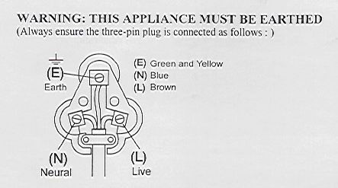

PLEASE AFFIX YOUR PROOF OF PURCHASE/RECEIPT HERE
IN THE EVENT OF A CLAIM UNDER WARRANTY THIS RECEIPT MUST BE PRODUCED.

W A R R A N T Y
- Home of Living Brands (Pty) Limited (“Home of Living Brands”) warrants to the original purchaser of this product (“the customer”) that this product will be free of defects in quality and workmanship which under normal personal, family or household use and purpose may manifest within a period of 1 (one) year from the date of purchase (“warranty period”).
- Where the customer has purchased a product and it breaks, is defective or does not work properly for the intended purpose, the customer must notify the supplier from whom the customer bought the product (“the supplier”) thereof within the warranty period. Any claim in terms of this warranty must be supported by a proof of purchase. If proof of purchase is not available, then repair, and/or service charges may be payable by the customer to the supplier.
- The faulty product must be taken to the supplier's service centre to exercise the warranty.
- The supplier will refund, repair or exchange the product in terms of this warranty subject to legislative requirements. This warranty shall be valid only where the customer has not broken the product himself, or used the product for something that it is not supposed to be used for. The warranty does not include and will not be construed to cover products damaged as a result of disaster, misuse, tamper, abuse or any unauthorised modification or repair of the product.
- This warranty will extend only to the product provided at the date of the purchase and not to any expendables attached or installed by the customer.
- If the customer requests that the supplier repairs the product and the product breaks or fails to work properly within 3 (three) months of the repair and not as a result of misuse, tampering or modification by or on behalf of the customer, then the supplier may replace the product or pay a refund to the customer.
- The customer may be responsible for certain costs where products returned are not in the original packaging, or if the packaging is damaged. This will be deducted from any refund paid to the customer.
HOME OF LIVING BRANDS (PTY) LTD (JOHANNESBURG)
JOHANNESBURG TEL NO. (011) 490-9600
CAPE TOWN TEL NO. (021) 552-5161
DURBAN TEL NO. (031) 792-6000
www.homeoflivingbrands.com
www.russellhobbs.co.za
www.facebook.com/RussellHobbsSA

